CAUTI Module:

Indwelling Urinary Catheter Maintenance
Facilitator Guide | Slide Number and Image
This module, titled “Indwelling Urinary Catheter Maintenance,” is part of the Agency for Healthcare Research and Quality’s Safety Program for Intensive Care Units (ICUs) and addresses catheter-associated urinary tract infections, also known as CAUTIs.  This module will explain the importance of proper care of an indwelling urinary catheter as a means to prevent infection. | Slide 1  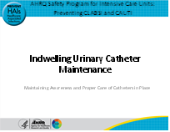
Here is an image of the life cycle of the catheter. In cases of an indwelling urinary catheter, maintaining awareness and proper care of a catheter in place is critical to preventing a CAUTI. There other modules in this series reviewed avoiding insertion and alternatives to indwelling urinary catheters, as well as proper aseptic insertion.  So, we will focus on step 2, Maintain Awareness and Proper Care of Catheters in Place, which is an important part of the lifecycle of a catheter. | Slide 2  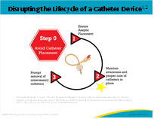

Facilitator Guide | Slide Number and Image
Although the primary method of preventing CAUTI is to limit the use of indwelling urinary catheters, many ICU patients still require an indwelling urinary catheter (IUC). Risk of catheter-associated urinary tract infection (CAUTI) increases by 3 to 7 percent each day a catheter is in place.  Up to 50 percent of patients with an indwelling urinary catheter for 5 days or more will have asymptomatic bacteriuria (ASB) or fungus in their urine, and 100 percent will have bacteriuria by day 30. Therefore, once an IUC is inserted, careful attention is needed to reduce the risk of infection.  In addition to proper insertion, contamination can occur due to breaks in the collection system. This usually occurs as a result of contamination with the patient’s own endogenous flora or through the contamination from the hands of healthcare workers. | Slide 3  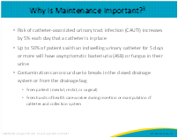
The list on the right side of the slide highlights specific information to pay attention to when caring for a patient with an IUC. The list includes the following recommendations:  - Use appropriate hand hygiene and gloves;  - Properly secure catheters to prevent movement and urethral traction;  - Maintain a sterile closed drainage system;  - Maintain good hygiene at the catheter-urethral interface;  - Maintain unobstructed urine flow;  - Maintain the drainage bag below the level of bladder at all times; and  - Do not change indwelling urinary catheters or drainage bags at arbitrary fixed intervals; and finally,  - Document indication for indwelling urinary catheter on each day of its use.  So, let’s begin to address these interventions in more detail. | Slide 4  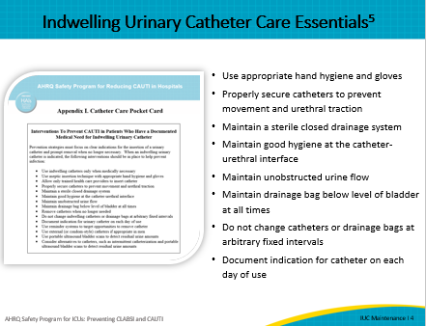
The compendium of strategies to prevent CAUTIs highlights that the Centers for Disease Control and Prevention (CDC) Guideline for Prevention of Catheter-Associated Urinary Tract Infections emphasizes the need for hand hygiene. As emphasized previously, IUCs can be contaminated by the hands of healthcare workers. Hand hygiene is performed before each and every patient contact and before any manipulation of the catheter device or site. Unless hands are visibly soiled, an alcohol-based hand rub is preferred over soap and water in most clinical situations due to evidence of better compliance compared to soap and water. Hand rubs are generally less irritating to hands and, in the absence of a sink, are an effective method of cleaning hands. Antiseptic gels should be rubbed in thoroughly in between finger and the palm of the hand. Handwashing with soap and water should be performed for 20 seconds.  The CDC 2009 Healthcare Infection Control Practices Advisory Committee (HICPAC) guidelines also emphasize the use of standard precautions during any manipulation of the catheter or collection system. The next few slides will discuss barriers and opportunities. | Slide 5  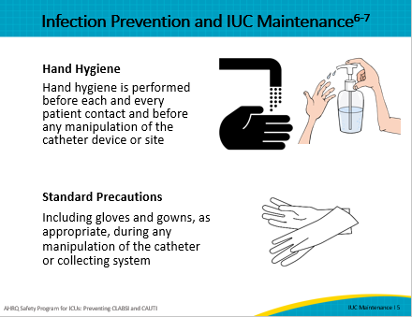
Given the complexity and criticality of ICU patients, staff may unintentionally overlook hand hygiene when caring for an indwelling urinary catheter, or they may not use or change gloves, especially if they are performing multiple tasks prior to handling the catheter.  Both the CDC HICPAC Guidelines and the 2014 Compendium of Strategies to prevent HAIs recommend that healthcare workers who are involved in both insertion and maintenance of an IUC receive education. Furthermore, auditing compliance and providing feedback is important. In a true safety culture, anyone who identifies someone handling an indwelling urinary catheter without hand hygiene or use of standard precautions should be encouraged to speak up and remind the other person. Staff should be aware that when possible, the catheter should be inserted in a controlled setting. | Slide 6  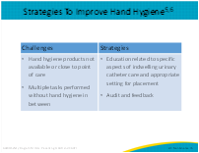
The 2009 CDC HICPAC Guideline also emphasizes two important points associated with maintaining a sterile, closed system at all times and recommends that if breaks or leakage occur that the catheter be replaced. In addition, they recommend using IUCs with preconnected, sealed tubing-catheter junctions. Although this may seem like a basic practice in the ICU, there are many barriers to maintaining a closed system. It is important to consider replacing the indwelling urinary catheter if breaks or leakage occur. Likewise, preconnected sealed catheters are recommended. If breaks in the aseptic technique, disconnection, or leakage occur, replace the catheter using aseptic technique and sterile equipment. When rounding, look for breaks in the tamper-resistant seal. It is not uncommon to find that these breaks occurred and were not evaluated at that time. In the next slide, we’ll examine some challenges related to maintaining a closed system. | Slide 7  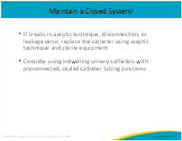
One recommended strategy is to make routine rounds on a periodic basis. Maintenance rounds can be fairly quick and simple, yet can identify problems in maintenance of catheters. This can provide valuable feedback to care providers and management. Once identified, the following slides provide strategies to overcome barriers in these areas. This checklist can be combined with CLABSI checklists to enhance rounding opportunities. | Slide 8  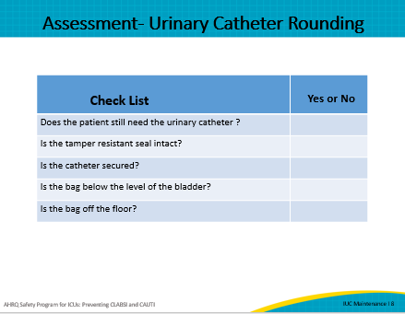
Although maintaining a closed system sounds intuitive, there are often barriers to maintaining the closed system, especially in the ICU setting. It is not uncommon that a critically ill patient is admitted to the ICU from the emergency department (ED) or even from the general medical-surgical unit with an indwelling urinary catheter already in place. In the ICU setting, this could mean that hourly intake and output monitoring would require a urimeter. It is possible that the nurse could break the tamper-resistant seal and connect a urimeter directly to the pre-existing catheter. We also know that some specialty catheters, such as the coude, may not come preconnected.  So, what can we do about all this? Well, on the right side of the slide, you’ll see some strategies to overcome these barriers. Some examples include implementing a process that requires all ICU patients to have a urimeter placed in the ED or even to consider an approach in which only urimeters are used for all indwelling urinary catheters. Some hospitals do not insert an indwelling urinary catheter on ICU patients admitted from the ED unless it’s absolutely necessary, and they allow the ICU to decide, thus eliminating the potential to break the system. Irrigation is always a challenge, but if the seal is broken, it is advisable to change the system. A preconnected three-way catheter should be used if frequent flushing is required. ICU teams should work with urology to develop protocols. And finally, if indicated, work with your supply chain to request preconnected specialty catheters like ones that monitor temperature or intra-abdominal pressure. | Slide 9  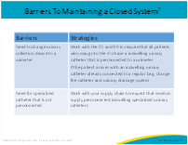
In this slide, we’ll address some important issues related to maintaining unobstructed urine flow. It is important to secure the catheter to prevent accidental removal and reduce trauma to the urethra and bladder by preventing excessive pull or traction.  Why is keeping the bag below the level of the bladder so important? When an indwelling urinary catheter is not managed appropriately, contaminated urine from the drainage bag or tubing may reflux into the bladder, or organisms may be introduced when there are breaks in the closed drainage system. The bulb of the indwelling urinary catheter prevents complete bladder drainage, and a residual pool of undrained urine remains in the bladder. Organisms, once introduced, persist in this pool of urine, putting that patient at risk for infection. | Slide 10  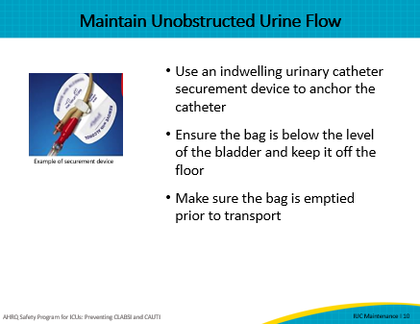
Although an ICU nurse usually accompanies a patient who is going for diagnostic tests or procedures, the indwelling urinary catheter may not be a high priority, particularly with patients who need continued care or emergent diagnostic tests or procedures. Catheters may inadvertently be placed above the level of the bladder or become full during the procedure. There are some strategies, however, that may help raise awareness. The ICU may decide to develop a process to routinely monitor the securement of the catheter and the placement of the bag on daily rounds. This would include checking all lines including urinary catheters before transfer. For example, the ICU nurse could perform a simple check prior to transport to ensure that the indwelling urinary catheter is patent and the urinary drainage bag is below the level of the bladder. Emptying the drainage bag prior to transport each time will help avoid reflux. | Slide 11  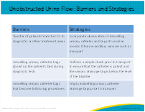
Let’s take a look at some of these maintenance strategies. It is important to perform catheter care at regular intervals, and your facility policy should describe the frequency and process. The 2009 HICPAC Guideline for Prevention of Catheter-Associated Urinary Tract Infections recommend not cleaning the periurethral area with antiseptics to prevent CAUTI while the catheter is in place. However, a subsequent meta-analysis suggests that tap water contamination could lead to higher rates of infection. There is emerging evidence of the role of some specific antiseptics (chlorhexidine) prior to urinary catheterization, in reducing CAUTIs, and some potential benefit to the role of antiseptics more generally in reducing bacteriuria. Routine hygiene—cleansing of the meatal surface during daily CHG bathing—is appropriate.  Secondly, irrigation should be avoided when possible. When irrigation is required, aseptic irrigation can be challenging. However, if the seal is broken, it is advisable to change the catheter and the collection system. A preconnected three-way catheter should be used if frequent flushing is required. Collecting a urine sample aseptically is of utmost importance. Urine from the drainage bag should not be used for a specimen, since it is not fresh and may be colonized with microorganisms. The catheter sampling port must be disinfected and allowed to dry.  And finally, do not routinely change catheters unless clinically indicated. Routine changing of catheters can introduce bacteria into the urine. | Slide 12  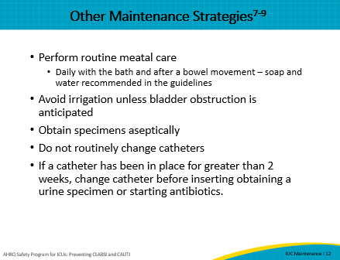
Slide 13
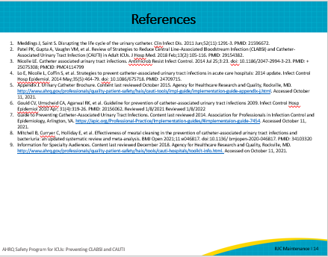
AHRQ Pub. No. 17(22)-0019
April 2022

