CAUTI Module:

Indwelling Urinary Catheter Removal
Facilitator Guide | Slide Number and Image
This module, titled “Indwelling Urinary Catheter Removal,” is part of the Agency for Healthcare Research and Quality’s Safety Program for Intensive Care Units (ICUs) and addresses catheter-associated urinary tract infection, also known as CAUTI.  This module will review when to promptly remove unnecessary indwelling catheters by reviewing clinical indications for use and focusing on strategies to facilitate prompt removal. | Slide 1  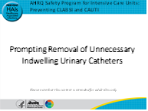
Interventions to prevent CAUTI focus on disrupting the lifecycle of the urinary catheter. This module will focus on interventions that help in two steps: step 2, maintaining awareness of urinary catheters in place to prompt recognition of unnecessary urinary catheters, and step 3, prompting urinary catheter removal. | Slide 2  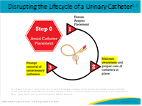

Facilitator Guide | Slide Number and Image
Urinary catheters are often placed unnecessarily, may be in place without physician awareness, and may not be removed promptly when no longer needed. In the past, 30 to 50 percent of continued catheterization days have been found to be unnecessary. Prolonged catheterization is the number one risk factor for catheter-associated urinary tract infection (CAUTI).  So why does this happen? Let’s review the traditional steps for removing a catheter.  First, the provider needs to recognize the catheter is present...and studies show this a big challenge because often providers aren’t aware that the patient has a catheter.  Second, the provider needs to recognize the catheter is no longer needed.  Third, an order is written to remove the catheter.  Fourth, the nurse sees the order and plans to remove the catheter, based upon the patient’s and nurse’s schedules for the day, or there is a nurse-driven protocol for removal but it is not being used because of barriers within the clinical environment.  And fifth, the urinary catheter is finally removed.  So, as you may expect, many hours and sometimes days pass between when the catheter is recognized as present and when it is removed. The default state is the urinary catheter remains in place unless all the steps are performed.  So, an intervention should be focused on facilitating all these steps and making catheter removal the default rather than the exception. | Slide 3  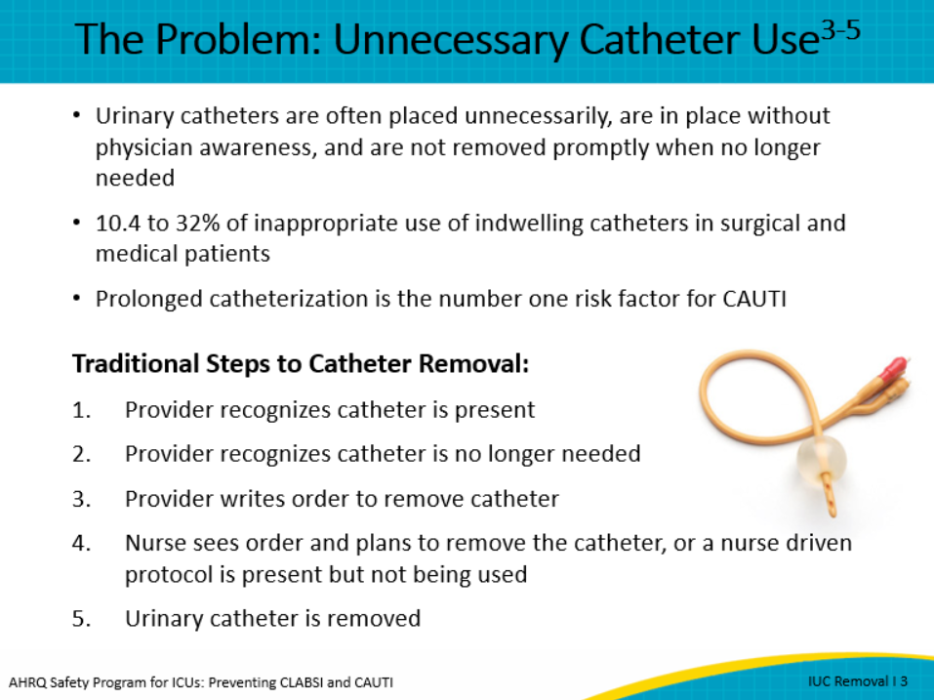
The challenges to removal of the indwelling catheter involve significant socio-adaptive components.  Communication between the disciplines and the unit’s view of the importance of managing catheter use and removal practices are often based on the unit culture.  While many organizations have nurse-driven removal protocols, they are often not fully actualized because the nurse does not feel comfortable or the environment does not promote empowered behavior. For example, with implementation of a nurse-driven protocol, one large academic medical center started seeing provider orders of “do not remove the catheter.” This can create confusion and uncertainty within the environment.  Multi-professional rounding structures and the process for how the rounds occur can limit participation of all disciplines and the opportunity to include a discussion that goes beyond “the patient has a catheter” to duration and indication of need to facilitate early removal.  There are clear-cut responsibilities for ordering the indwelling urinary catheter, but responsibility for removal overlaps within the staff, which can create confusion and result in no one owning the process and catheters staying in place longer than necessary. | Slide 4  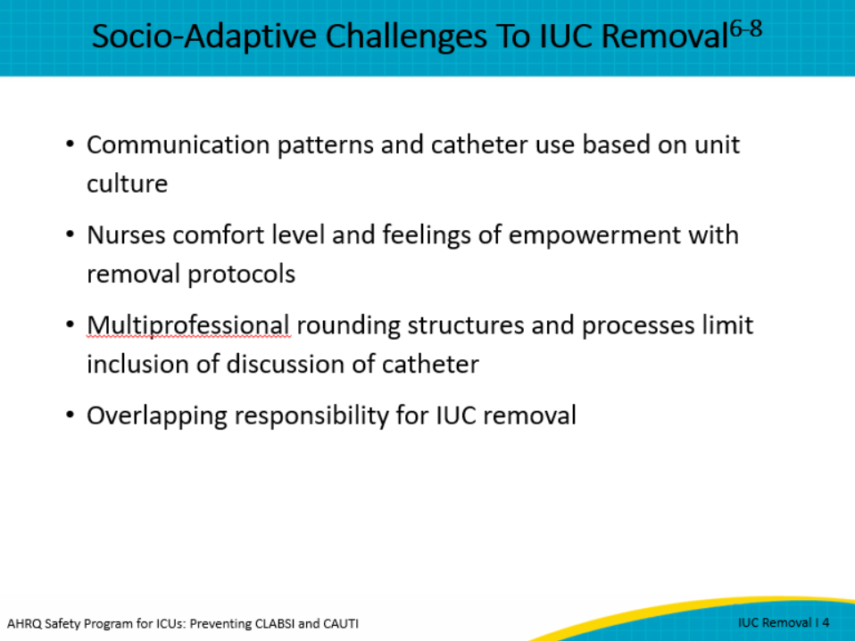
There are two main interventions to prompt catheter removal.  - Reminders are interventions that alert staff and physicians that a urinary catheter is still in place. These reminders may also prompt the staff about appropriate indications to continue catheterization, so they can serve an educational role as well.  - Stop orders are another strategy that go a step further. Stop orders prompt removal of urinary catheters based on a specific time after placement, such as 24 hours, and when certain clinical criteria are met.  Both reminders and stop orders can be implemented using a range of resources with either limited or extensive budgets and technology, ranging from rarely used verbal orders, which are essentially free of cost and technology, to written or electronic or “smart” orders, which have the expense of programming and tech support but are low-cost interventions after they have been developed. | Slide 5  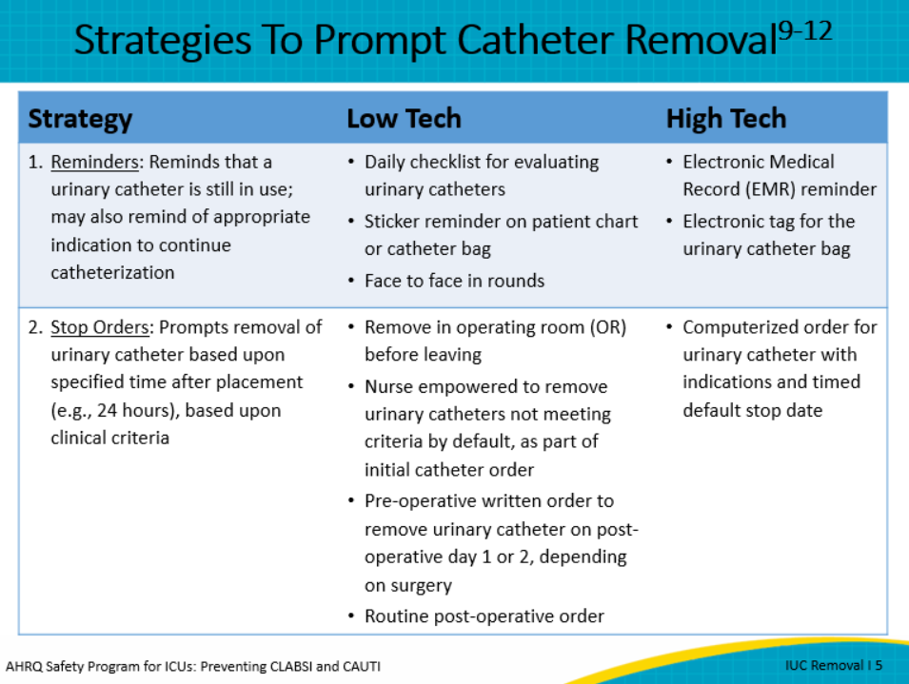
Both reminders and stop orders can be directed at the physician or the nursing staff.  Examples of physician strategies include a daily physician assessment of catheter need, by protocol, or a computerized order entry system to prompt physicians to remove or reorder the catheter if it was placed in the emergency department—or if it’s been in place for more than 24 hours. Processes to remove the catheter in the OR and/or orders for specific lengths of time for the catheter to remain post-op are additional provider driven strategies to facilitate early removal.  Examples of nurse strategies include:  - A nurse-led protocol to remove all urinary catheters that do not meet criteria, meaning that they are empowered, and the culture supports that empowerment.  - Daily review by nurses for indication of catheter need to make recommendations for removal; they could be empowered to remove by using a nurse-driven protocol, or  - Nurse-generated daily bedside reminders to encourage physicians to remove unnecessary urinary catheters.  - And finally, nurse-to-nurse communication during transitions of care, such as from the emergency department or from the ICU by asking, “Does the patient have a urinary catheter and why?” If not indicated, ask for the catheter to be removed before transfer.  We highly recommend nurse-driven protocols that empower nurses to remove unnecessary urinary catheters. | Slide 6  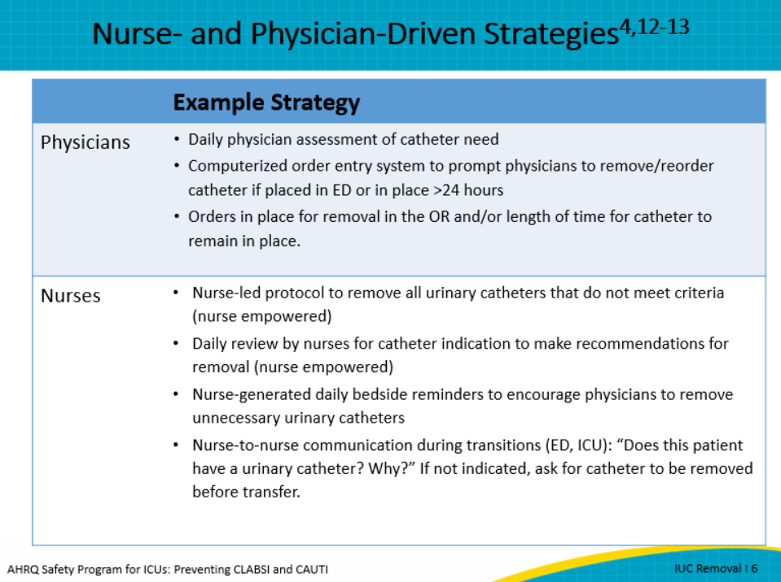
The literature strongly supports team strategies for communication, and creating a culture of safety and empowerment will aid in the early removal of catheters.  Strategies that include data on urinary catheter indication and duration present and easily accessible in the electronic medical record (EMR) will promote discussions in rounds. By incorporating creative technological strategies, you can easily facilitate team conversations during rounds. In addition, creating scripting within structure handoffs and rounds that includes discussions of duration and indication maintains the awareness of a catheter in place and promotes opportunities for early removal.  Having a Comprehensive Unit-based Safety Program (CUSP) team or a unit multi-professional quality committee will help address any communication challenges and help build team strength and mutual respect. It will be a place where the Learn From Defects data can come for multi-professional process improvement. In addition, the CUSP team, often composed of ICU nurse manager, physicians, nursing staff, infection preventionist, and quality team members, can help to clarify the roles and authority for the various components of the life cycle of the catheter to prevent confusion.  Visual nursing leadership supporting frontline staff in addressing challenges and removing obstacles from nurse-driven removal protocols will result in successful implementation. | Slide 7  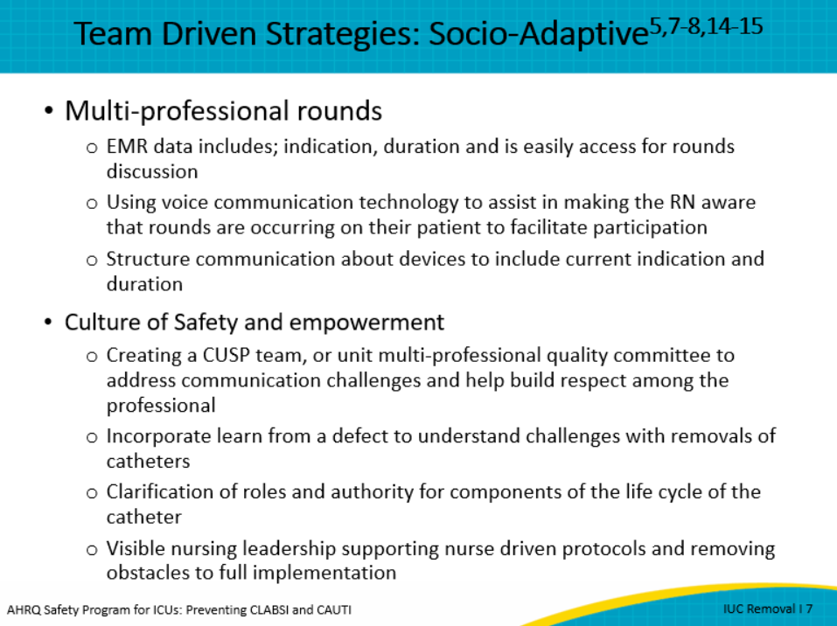
Here is an example of a written urinary catheter reminder. This intervention was employed as a sticker attached to physician notes before the age of electronic medical records. As you can see, this reminder helped inform physician teams how long the catheter was in place and reminded them of appropriate indications and the need to discontinue the urinary catheter if indications were no longer met. This is still used as bedside reminder visual cue for the nurse as an educational tool. Currently, this type of low-tech tool has now been successfully incorporated into the EMR to provide daily reminders to either the healthcare provider or the nurse and requires documentation that indication for use still meets criteria. However, this is just one method of reminder. It is best to incorporate both technical (electronic reminder) and adaptive strategies (multidisciplinary rounds) to achieve the best results. | Slide 8  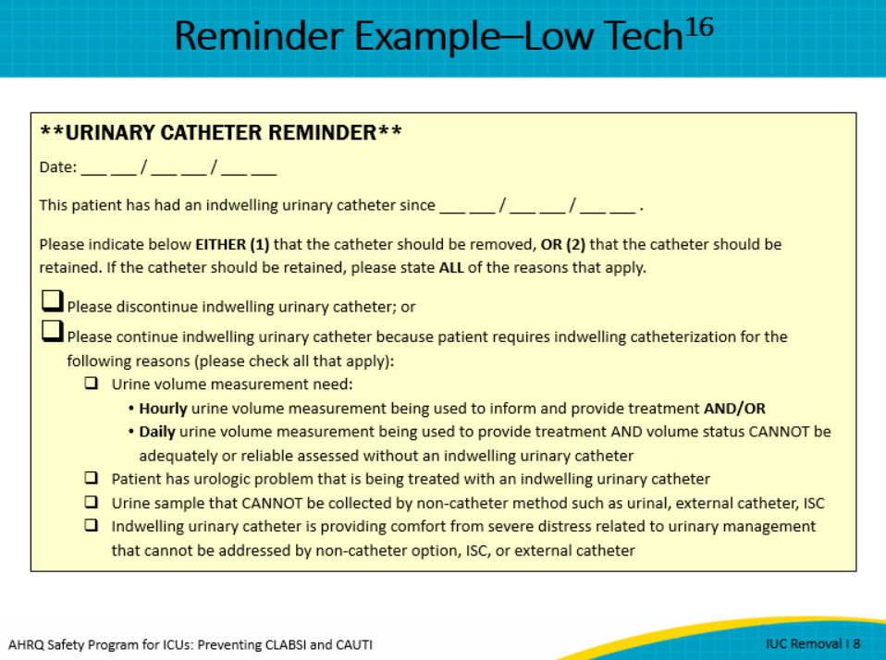
Here is an example of a surgical stop order embedded in an EMR. This prompt shows up in nursing tasks as part of the nurse-driven protocol and is used along with daily catheter discussion rounds. Examples like this are a high-tech reminder for surgical patients in an ICU. This type of stop order can help address concerns related to removing an unnecessary urinary catheter in patients with specialty surgical needs. | Slide 9  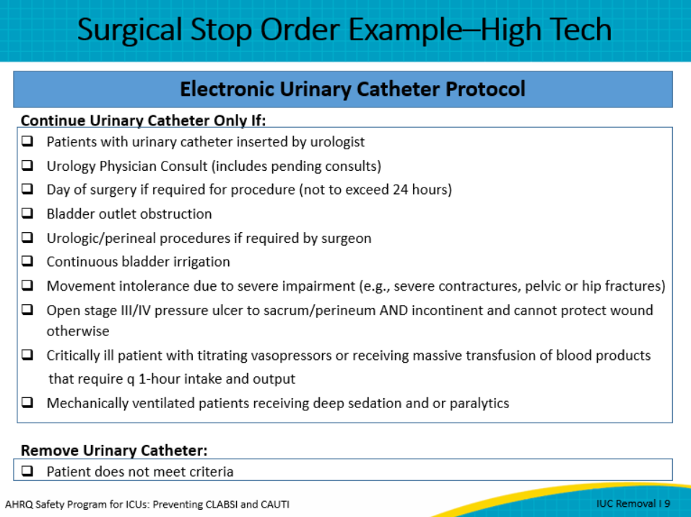
So the next question is, how effective are reminders and stop orders to decrease CAUTI rates?  Very effective. In a systematic literature review of 30 studies, including five studies of only ICU patients, these interventions reduced CAUTI significantly—by 53 percent.  How many CAUTIs could your unit avoid? Look at this table and consider your CAUTI baseline rate. For example, if your baseline rate was 5 CAUTIs per 1,000 catheter days, you could avoid 2.7 CAUTIs by using these interventions. Or, if your baseline was 20 CAUTIs per 1,000 catheter days, you could avoid 10.6 CAUTIs.  So, since these seem like simple and effective interventions, how often are reminders and stop orders already being used? Well, according to a large national survey of hospital practices conducted in 2010, catheter reminders or stop orders were only used in about 50 percent of hospitals, so there is plenty of room for improvement. | Slide 10  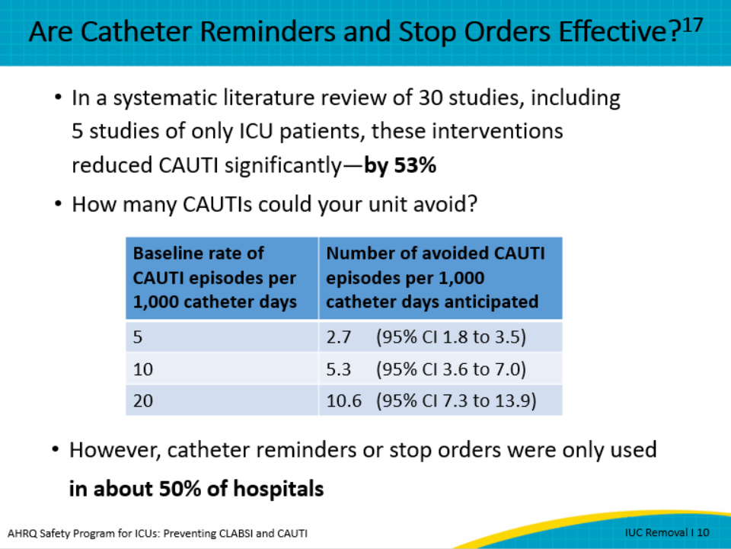
The good news is that even though it is challenging to implement urinary catheter stop orders and reminders, you don’t need to start from scratch, because there have been studies that used interventions designed for the unique needs of many clinical environments. Here are some examples of interventions for the ICU setting. For example, in the ICU, most interventions have employed a daily checklist to remind staff about appropriate catheter use. This checklist can be easily incorporated into the daily multi-professional rounds, and different team members could be responsible for using the checklist. This includes teams that work across peri-procedure areas as well. | Slide 11  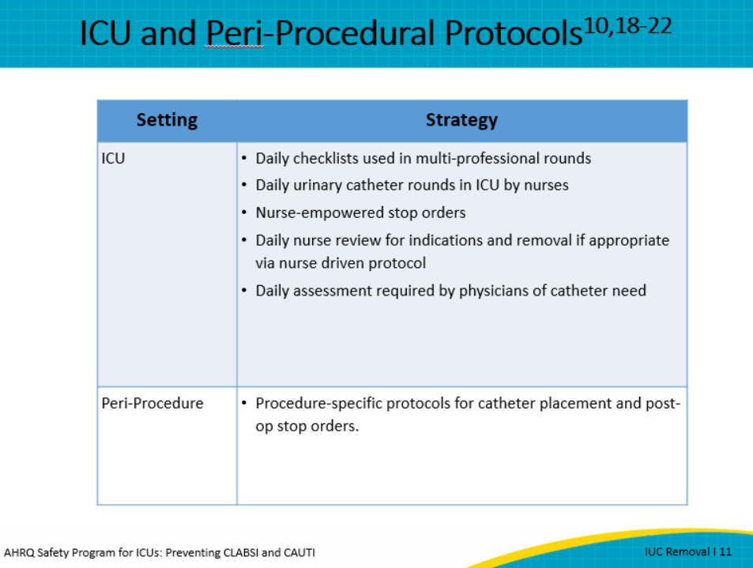
Let’s review a clinical scenario. Mr. Jones is a 57-year-old man who has been in the surgical ICU for 24 hours status post an esophagectomy for adenocarcinoma of the mid-esophagus. He’s hemodynamically stable, is on pressure support ventilation, and has urine output averaging 80 cc/hr. With this information, on rounds can you remove the urinary catheter, using alternatives to urinary catheter for measuring urinary output? The choices are:  - No, indwelling urinary catheter is needed because he was admitted to the ICU and requires hourly urine measurement  - No, because he had a major thoracic procedure  - No, because he is still on a mechanical ventilator, or  - Yes, because hourly urine output is no longer needed to guide his care  The best answer is D. Even with a complicated surgical procedure, once hourly input and outputs are not needed, the urinary catheter can be removed. In cases such as trauma and organ transplantation, the urinary catheters can also be removed once hourly outputs are no longer needed to guide care. The alternatives for indwelling urinary catheters, such as condom catheters, bladder scanners, and incontinence pads, can be successfully utilized to evaluate daily or shift intake and output, particularly with the use of weighing incontinence pads. | Slide 12  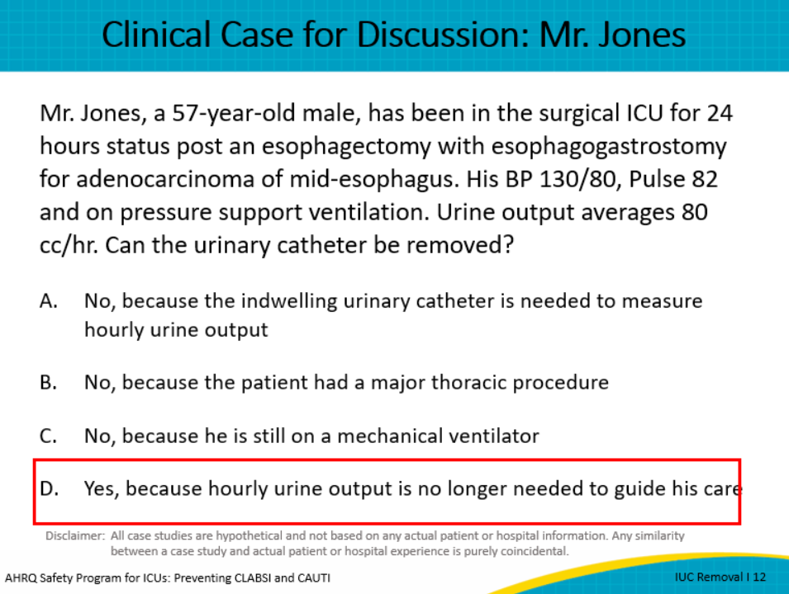
The RAND corporation/UCLA method was used to assess appropriateness of indwelling catheter placement and different timings of removal for routine general and orthopedic procedures. For example, routine catheter placement was rated inappropriate for laparoscopic cholecystectomy, open appendectomy, and some bariatric procedures.  Standardizing removal of catheters post-op is critical to reducing catheter use. Most catheters can be removed in the operating room or under 48 hours postoperatively. The majority of catheters needed for the operating room (OR) procedure, such as laparoscopic procedures with a suprapubic port and various orthopedic procedures such as unilateral open reduction and internal fixation of hip fracture or knee arthroplasty, can be removed before leaving the operating room. Consider incorporating the discussion in the debrief prior to patient leaving the OR.  Procedures such as open subtotal colectomy are recommended to be removed post-op day 1. Alternatives should be used based on the patient’s need for detailed urine output.  Even patients with thoracic epidural catheters can often have urinary catheters removed, usually within 48 hours after surgery. Consider using mobilization and sedation vacation to help prevent urinary retention while epidurals are in place and once epidurals are removed. Also consider replacing or removing urinary catheters within 24 hours of placement if the catheter was inserted emergently with suspected poor sterility. | Slide 13  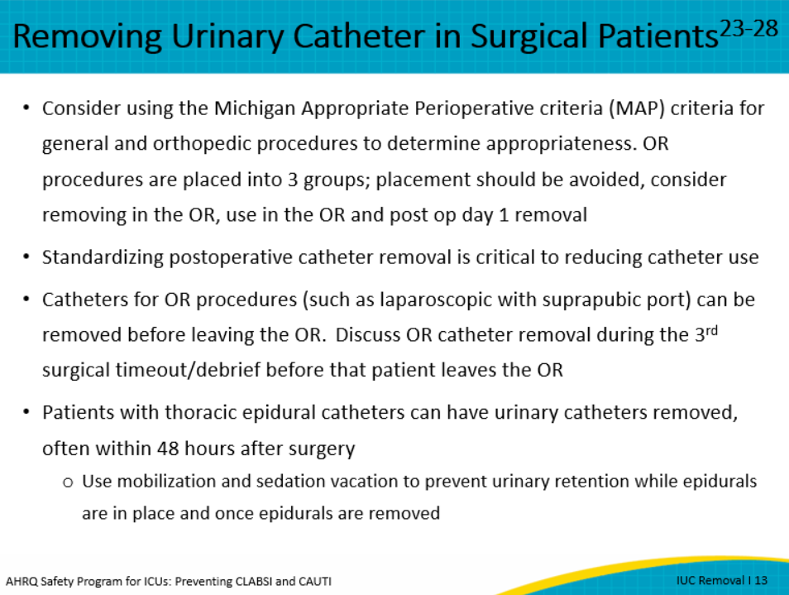
The World Health Organization has a Surgical Safety Checklist that many operating rooms have used to prompt the surgical team to verify key components of the case before and after surgery. The surgical checklist can include a “Procedure Time Out” of tasks to perform before the patient leaves the OR. This is usually the third timeout or debrief before the patient leaves the OR. Discussing and removing unnecessary urinary catheters before the patient leaves the OR is a significant step in decreasing utilization of indwelling urinary catheters. Use of surgical safety checklists is endorsed by AORN, the Association of Perioperative Registered Nurses. | Slide 14  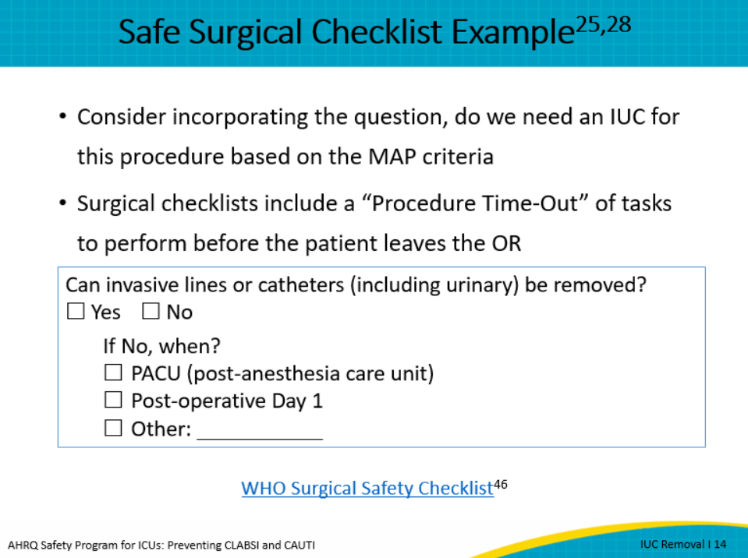
Let’s look at another clinical scenario.  Mr. Grant is a 66-year-old man admitted to the ICU with fluid overload from congestive heart failure and renal insufficiency. He initially required a diuretic drip but is now clinically much improved with intermittent diuretic dosing. He is getting transferred to the floor today. Does he need an indwelling urinary catheter?  - Yes, because all patients on diuretics need a urinary catheter  - Yes, because the floor physician will use hourly urine output to guide diuretic dosing  - No, as long as Mr. Grant is able to urinate by other means (urinal, external catheter, or bladder scanning and intermittent catheterization), the staff can measure urine output/volume status without a catheter (such as by daily standing weights)  - Yes, because the urinary catheter will decrease Mr. Grant’s risk of falling when getting up to urinate frequently  The answer is C, No, as long as Mr. Grant is able to urinate by other means, such as a urinal or with a condom catheter, and the staff can measure urine output or assess volume status without a urinary catheter. | Slide 15  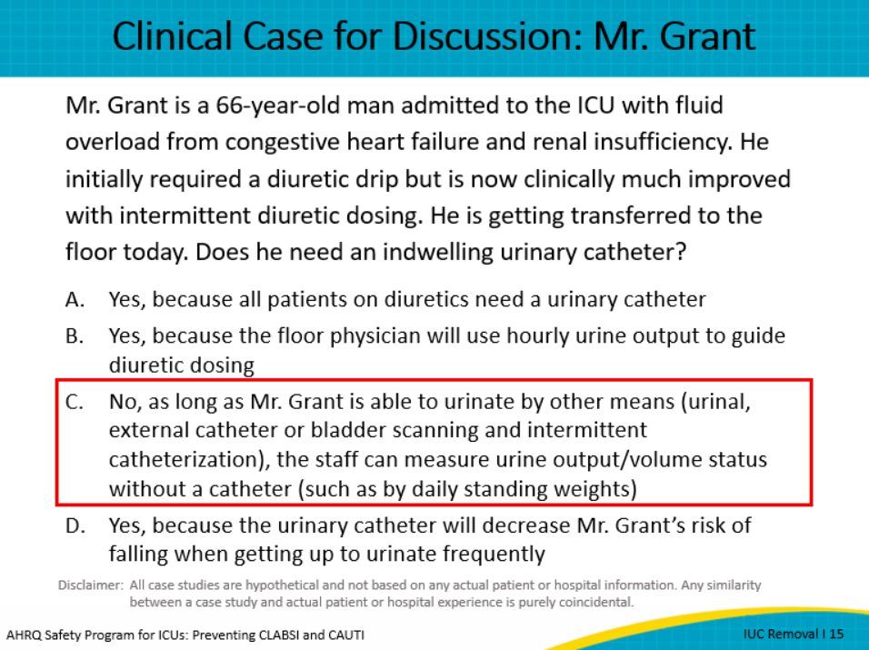
Now, a few pearls or points of guidance and pitfalls to keep in mind when considering urinary catheter reminders and stop orders.  Some pearls include:  Be sure to tailor the type of reminder to the care setting. For example, you can use stickers or electronic reminders based on how effective these approaches have been in your unit. If you are in a unit where catheters are commonly placed before an electronic order has even been reviewed or submitted, such as in an emergency department setting, you may consider using stickers on the catheter boxes to get the attention of the staff placing the catheters, to reduce unnecessary placement. In ICUs, you may consider developing automated or timed reminders or stop orders.  Also, embed appropriate indications for urinary catheter use into existing or new checklists or forms. Use these forms during multi-professional rounds to prompt removal discussions.  Also remember to include urinary catheter alternatives when considering removal in the nurse driven removal protocol.  When the nurse-driven protocol is present, consider strategies to empower nurses to remove the urinary catheter without obtaining an additional physician order when criteria are met.  And finally, use periodic audits, such as “catheter rounds” by nurse leadership, to verify appropriateness and improve implementation of catheter removal strategies. Displaying catheter information data at the bedside or easily located in the electronic medical record (EMR) may facilitate discussion during shift handoff or multi-professional rounds.  Some pitfalls include:  - Recognizing that reminders may be ignored, particularly ill-timed electronic medical alerts that, for example, pop up on clinicians’ screens when they are busy with a different patient or accessing the chart for a different reason.  - Also, some electronic medical records can make it difficult to order catheter alternatives but make it easier to order the indwelling urinary catheter.  - Last, it is important to employ strategies that combine the use of electronic reminders and socio-adaptive strategies to improve buy-in and implementation. The pitfall would be to address only one of these strategies therefore not providing full support.  Consider these pearls and pitfalls as you develop processes in your unit to always follow the best practices for removal of unnecessary urinary catheters. | Slide 16  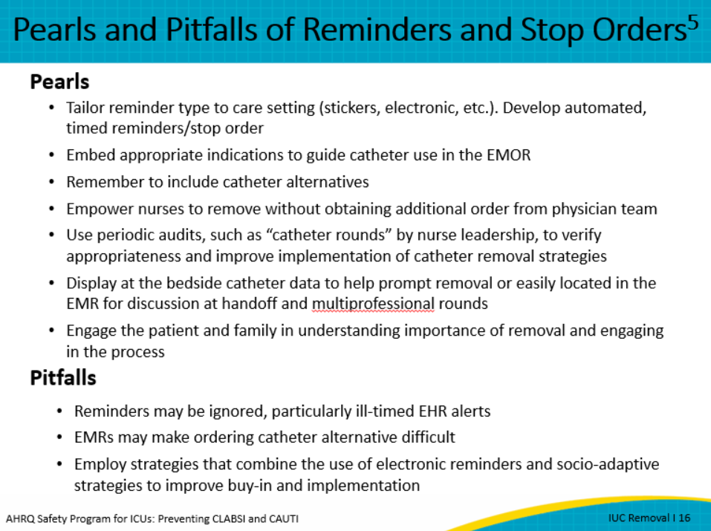
There are other factors that may affect the success of reminders and stop orders, such as:  Communication patterns and unit culture relative to urinary catheter use. For example, if the clinicians’ routine already includes daily face-to-face nurse-to-physician communication about patient needs, then incorporating a reminder about urinary catheter use into this communication has a higher chance of success than a strategy that reminds either the nurse or physician when they are not discussing it face-to-face.  Nurse comfort with urinary catheter removal protocols also impacts success, and it is difficult to implement nurse-driven protocols without first engaging staff in discussing how they may be more comfortable developing, implementing, and evaluating the use of this approach and addressing barriers before the launch of the protocol.  Staff knowledge of and skills in best practices and the use of alternatives to urinary catheters can impact whether or not they consistently follow best practices. The availability of effective alternatives can impact utilization as well.  The level of respect among nurses and physicians can also impact whether physicians are receptive to staff requesting urinary catheters be removed. Also, this can affect whether nurses are willing to challenge existing physician orders that do not promote removal of unnecessary urinary catheters or impact how comfortable a nurse feels to enact the nurse-driven protocol for removing the catheter.  Having ownership by frontline staff, local leadership, and quality staff or infection preventionist to review, remind about, and reinforce indications for urinary catheters and early removal is helpful.  Information technology support for data collection is important and can either help or hinder efforts depending on the complexity and how easily reports can be generated to provide feedback about catheter use to bedside clinicians.  Finally, the ICU team’s recognition of the hazard of urinary catheters can influence “buy-in” and implementation. | Slide 17  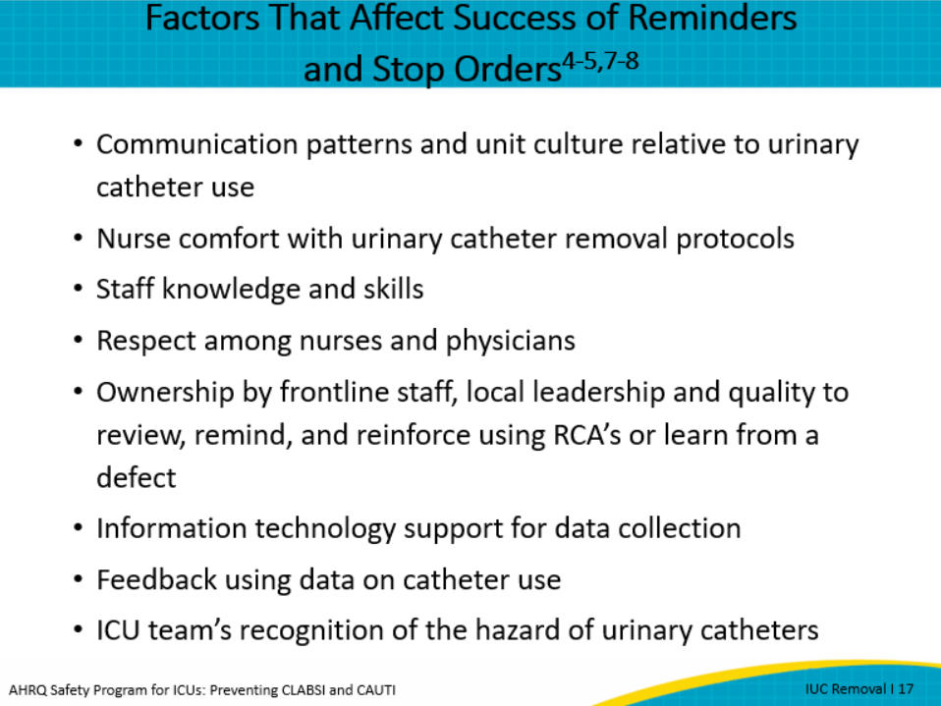
Here are a few take-home points to remember.  Actions to target removal of unnecessary urinary catheters are key to breaking the life cycle of the urinary catheter. Reminders and stop orders can improve awareness of urinary catheters and prompt removal of unnecessary urinary catheters.  This module has provided several low-tech and high-tech strategies your unit can use to implement removal prompts and stop orders. Nurse and physician “buy-in” is extremely important to overcoming barriers to removing unnecessary indwelling urinary catheters, especially since so many of the strategies to enhance removal of unnecessary urinary catheters depend on open, timely, and evidence-based communication among nurses and physicians.  Sustaining improvements in CAUTI prevention requires monitoring and feedback of catheter use and CAUTI rates. Finally, socio-adaptive strategies, such as including catheter removal in routine clinical nurse-to-physician discussions such as rounds and timeouts can improve and sustain implementation. | Slide 18  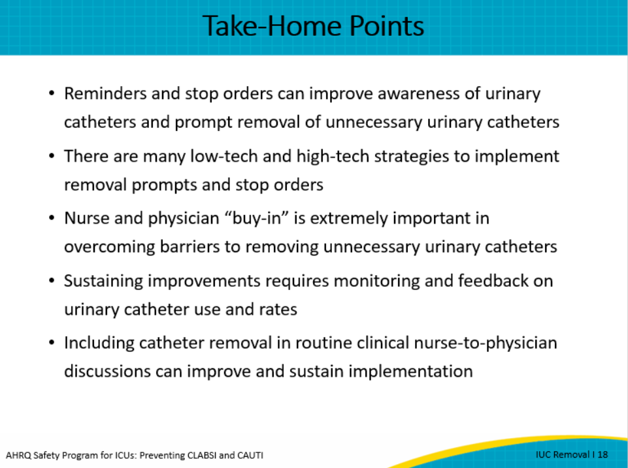
Slide 19
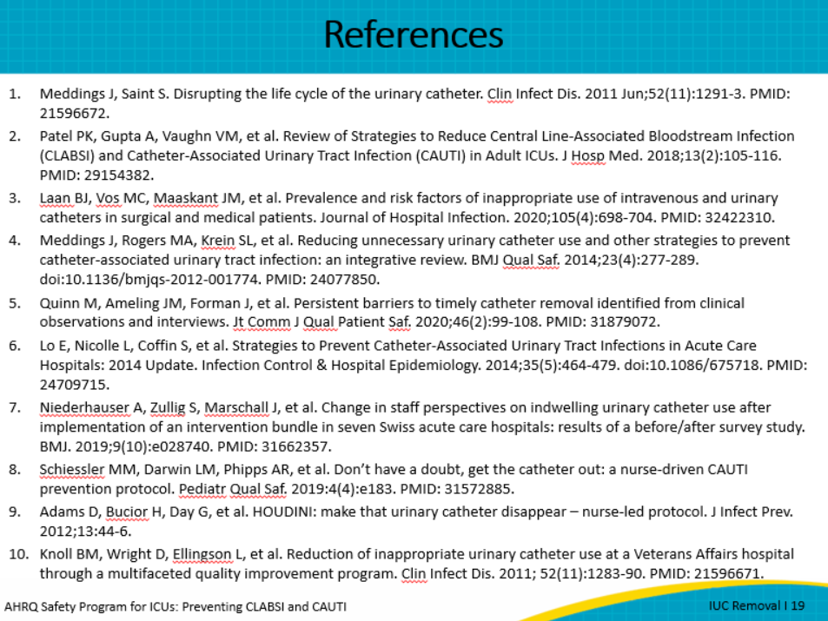
Slide 20
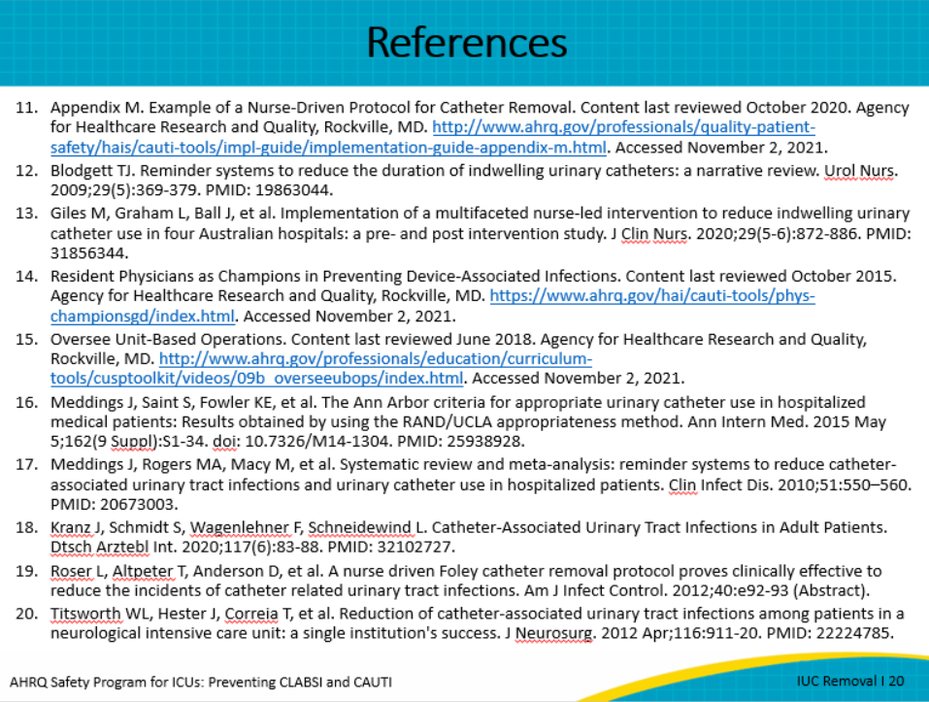
Slide 21
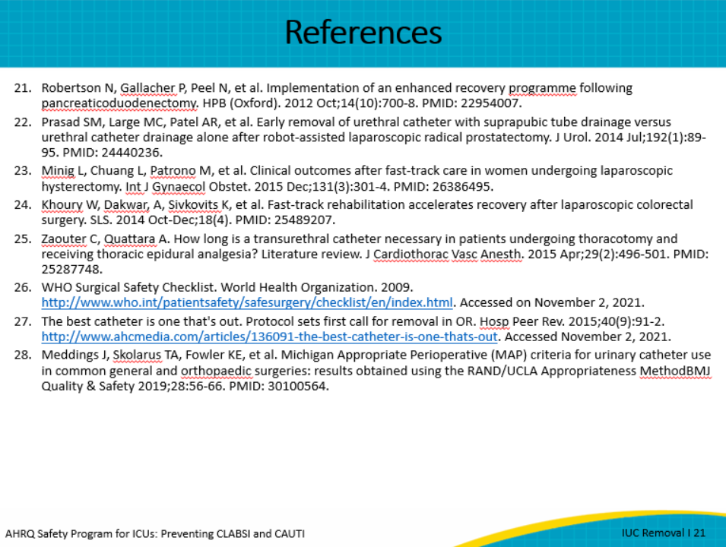
AHRQ Pub. No. 17(22)-0019
April 2022

