CAUTI Module:

Urine Culturing Stewardship in the ICU Setting
Facilitator Guide | Slide Number and Image
This module, titled “Urine Culturing Stewardship in the ICU Setting” is part of the Agency for Healthcare Research and Quality’s Safety Program for ICUs (intensive care units). The module addresses urine culturing stewardship to prevent CAUTI (catheter-associated urinary tract infections) in the ICU setting.  This module will identify the situations in which urine cultures are appropriate or inappropriate. By preventing inappropriate urine culturing, this module may help your team avoid CAUTIs. | Slide 1  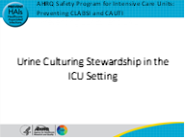
Here is a presentation of a case study. Ms. Allen is a 65-year-old woman with atrial fibrillation on warfarin and urine retention from multiple sclerosis, which requires a chronic indwelling urinary catheter. She is admitted to the ICU with an upper GI bleed from a high INR. Her temperature is 100.8 degrees Fahrenheit, heart rate 130, respiratory rate 22, and blood pressure 97/42. Her white blood cell count is 11, and her hemoglobin is now 7.6 g/dL. Physical exam reveals cloudy urine in her catheter tubing.  Should Ms. Allen have a urinalysis or UA and urine culture? We will return to this case study to answer the question. | Slide 2  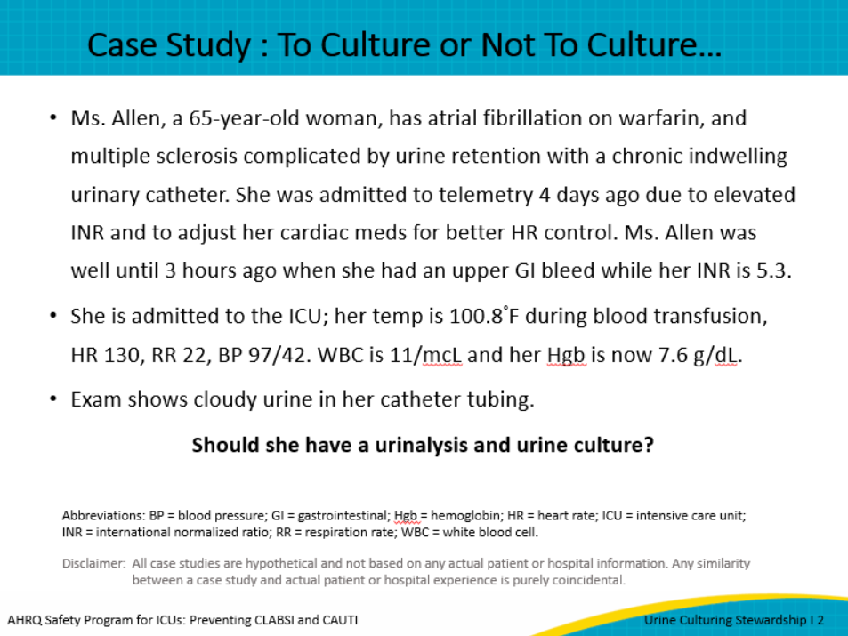

Facilitator Guide | Slide Number and Image
Urine culturing stewardship means ordering urine cultures thoughtfully, so they inform the care of individual patients. It is needed because urine cultures can be harmful if they’re ordered in the wrong situation. They can contribute to misdiagnosis, overtreatment with antibiotics, multidrug-resistant infections, increased rates of hospital-acquired Clostridioides difficile and overreporting of CAUTI, all which can increase the hospitals’ financial burden.  Ideally, stewardship applies to the ordering, collection, processing, interpretation, and clinical application of urine cultures. We will focus on the urine culture process, including the order and collection, because these are the steps that affect the patients most often. | Slide 3  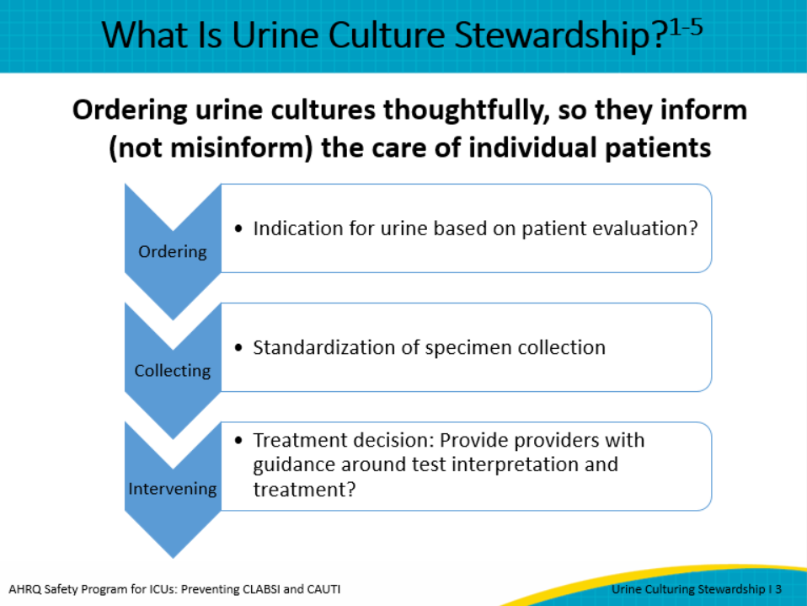
You may be wondering why we’re talking about urine culturing as it relates to preventing CAUTI. White blood cells may be found in a urine sample for many reasons beside infection, including colonization or irritation from the catheter itself. Urine in the presence of a catheter is frequently colonized by bacteria; this is called biofilm, which may never cause an infection. In fact, the risk of bacteriuria in a catheterized patient increases 3 to 8 percent per day. Within 30 days, 98 percent of catheterized patients will have bacteriuria.  Bacteriuria diagnosed by a UA or a culture without signs or symptoms is defined as asymptomatic bacteriuria (ASB), which should rarely be treated in catheterized patients, especially in the ICU setting. ASB occurs as much as 50 percent of the time in patients with an indwelling urinary catheter. However, when a urine culture is ordered and comes back positive, many practitioners will treat it as a true infection. Treatment of ASB is one of the most common cause of inappropriate antibiotic prescription in hospitals.  While there are exceptions to rules about treating ASB, such as pregnancy and urologic procedures, these are rare in the ICU setting. | Slide 4  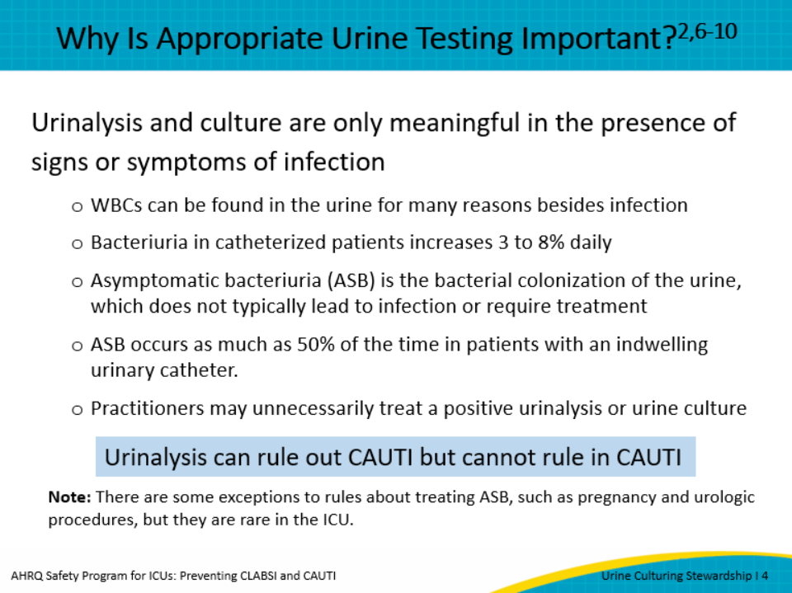
Returning to the case of Ms. Allen, one must evaluate her for signs and symptoms of CAUTI. Does she have symptoms suggestive of a CAUTI, including flank pain or CVA (costovertebral angle) tenderness, presence of acute hematuria, or new pelvic discomfort of pain?  Does she have a new onset or worsening of sepsis without evidence of another source from the history, physical exam, or labs? Is she experiencing a fever or altered mental status without another source by history, physical exam, or labs? Lastly, in spinal cord patients similar to her, does she demonstrate increased spasticity, autonomic dysreflexia, or a sense of unease?  In addition—it is important to note that patients whose catheters have been recently removed can experience dysuria, urgency, or frequency. | Slide 5  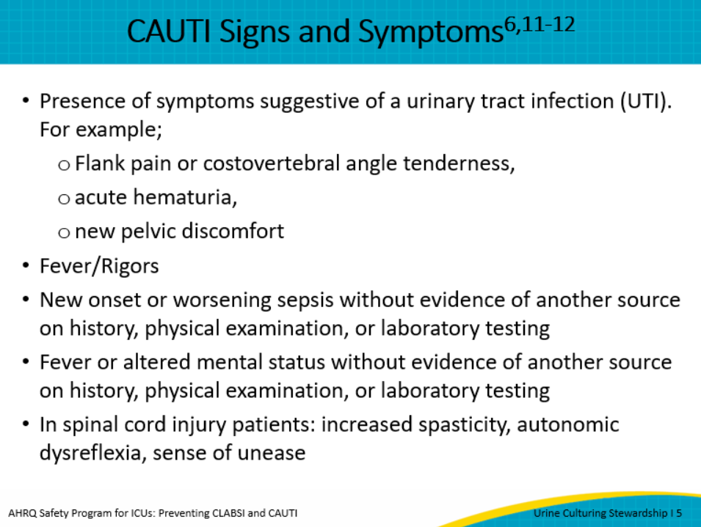
In contrast, the appearance or odor of urine does not suggest the presence of CAUTI. This includes color, smell, urine cloudiness, or sediment.  Pyuria is also not predictive of urine infection. Pyuria, or pus in the urine, does not distinguish between ASB and CAUTI. Pyuria is nonspecific and can be caused by other things such as the catheter itself, bladder distension, or the presence of asymptomatic bacteriuria. As stated previously, with the rate of colonization of the catheter at 3 to 6 percent per day, the presence of asymptomatic bacteriuria increases daily with almost all patients’ catheters colonized for the first month. Thus, the presence, absence, or degree of pyuria should not be used to differentiate ASB from CAUTI.  Because bacteriuria should not be treated in the absence of symptoms, none of these findings should trigger a urine culture, and patients should NOT be screened for CAUTI on admission to the hospital or ICU or when a new catheter is put in place.  One strategy to eliminate the last inappropriate trigger is to request that specimen containers be removed from the catheter insertion kits to help prevent a culture from being obtained. | Slide 6  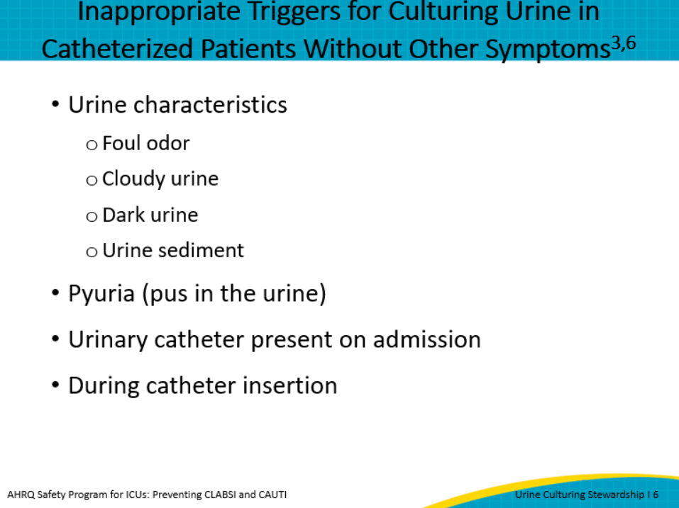
In a study examining knowledge and practices of physicians and nurses related to urine cultures in catheterized patients in an academic center and community hospital, over a 2-year period, the investigators identified 184 CAUTIs, of which 86 percent of these CAUTI cases, the cultures were ordered inappropriately.  Sixty-two percent of cultures were obtained through pan culturing practices rather than symptom-directed testing.  When physicians and nurses were surveyed as to what prompted urine culture ordering, appearance and odor drove nurses to request a urine culture between 61 and 74 percent of the time.  With physicians, presence of dysuria and/or pain while catheterized and presence of WBC in the UA drove culture decisions. Both nurses and physician equally used pan culturing or including urine along with blood and sputum versus focusing on patient-specific symptoms of a CAUTI. | Slide 7  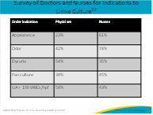
When making decisions about whether to culture urine in the event of a new fever in an adult patient in the ICU who has previously been afebrile and in whom the source of fever is not initially obvious, it is important to understand that catheter-associated bacteriuria usually represents colonization. It is rarely symptomatic and rarely the cause of fever or secondary blood-stream infection, even in immunocompromised patients. This is true unless there is urinary obstruction or if the patient has had recent urologic manipulation or surgery, or the patient is granulocytopenic.  Symptoms of UTI are rarely reported in ICU patients, which can be a barrier to patient evaluation for UTI.  Therefore, if sepsis is suspected without a clear source, a urine culture may be appropriate because CAUTI is often a diagnosis of exclusion in such situations, and in most ICUs, UTIs are related to urinary catheters. | Slide 8  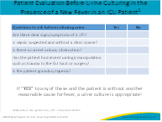
With a greater understanding of how and why inappropriate cultures are ordered and why it is important to decide to culture based on a patient's clinical signs and symptoms, it becomes necessary to incorporate both technical and socio-adaptive strategies into your diagnostic stewardship program.  The first step is to develop unit or institutional evidence-based guidelines for UC indications, collection, processing, and reporting of results. Once the ground rules are laid out, the next step is education of all providers and nurses on key components of the guideline.  Active review of culture ordering and peer feedback is an effective way to begin changing ordering practices. | Slide 9  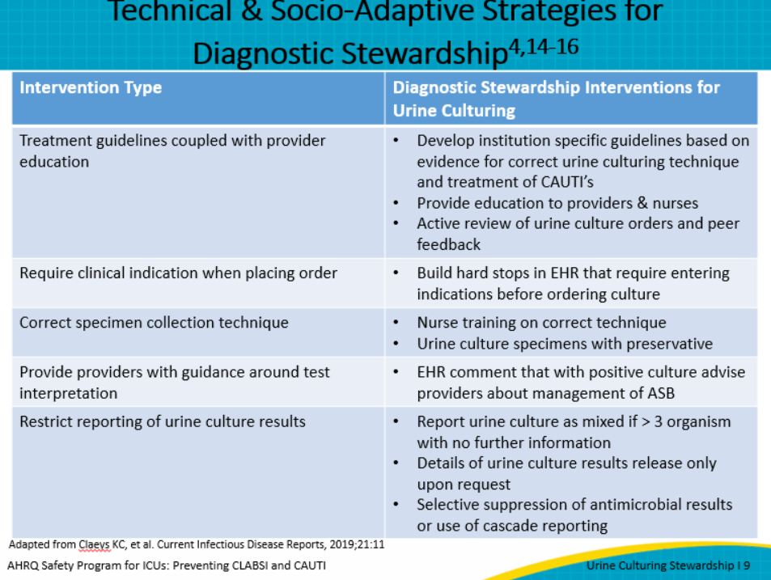
The slide shows an example tool from the Massachusetts Coalition for the Prevention of Medical Errors project. This was created as a tool for emergency departments. Underneath is an infographic poster from the AHRQ Toolkit for Reducing CAUTI in Hospitals. Posters can be displayed on the unit, in break rooms, or even staff restrooms, to keep the topic on everyone’s mind.  Remember that education is always by itself a necessary but weak intervention. Physicians order most cultures, and you can reach out to them at their gatherings like grand rounds, conferences, and staff meetings with brief presentations that emphasize the role of physician evaluation. Nurses might have skills workshops or required competencies through the hospital that provide a good opportunity to add information about urine culture stewardship. You can create a strong culture of safety by discussing quality pearls like culturing stewardship at change of shift huddles.  Most staff can be reached with informational pocket or ID badge cards, as well as with posters on the unit. These will be more impactful if they contain feedback on how the unit is doing; individualized feedback should be sent privately.  Don’t forget to educate new staff during orientation, including when residents or nursing students rotate through the unit.  All of this education is hard work, but once you change the culture, you have to maintain the improvement. This means periodic reminders, but changing the ordering process will provide ongoing reminders to staff with no more effort on your part. | Slide 10  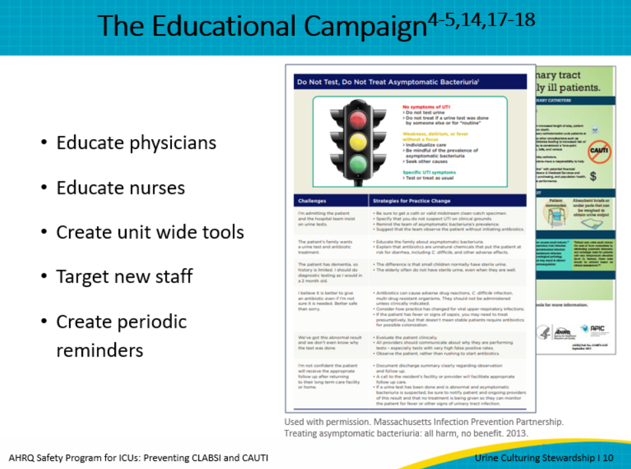
The next step in your diagnostic stewardship journey is to make it easier for the provider to do the right thing by incorporating preculture strategies into the electronic health record (EHR). This means prework before the culture is drawn to ensure correct indications are used. The CUSP team can work with the organizational CAUTI committee and the antibiotic stewardship committee to help get this prioritized into the EHR. | Slide 11  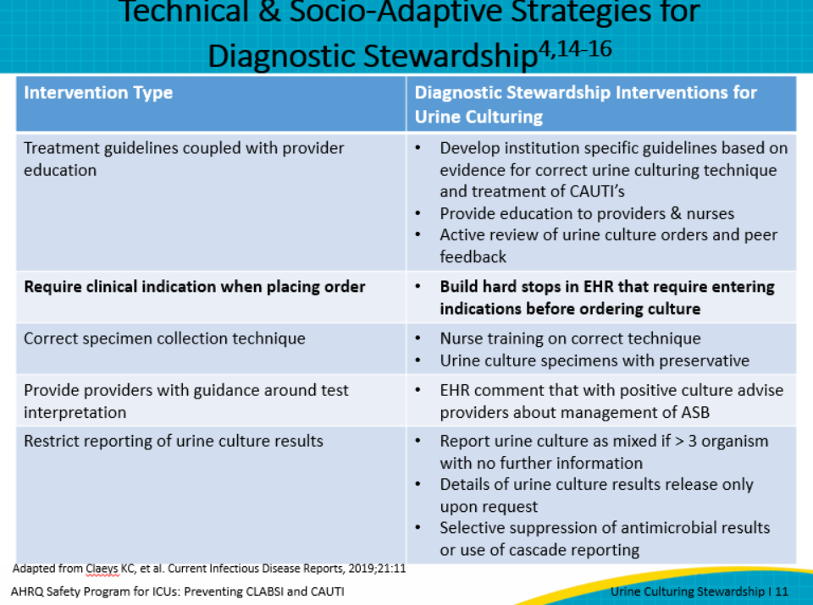
Instead of addressing issues after the UA or culture is finalized, consider designing strategies to prevent urine from being cultured inappropriately by incorporating indications into the EHR.  Consider modifying your EHR to include appropriate indications for UA and urine cultures that clearly address patient symptomatology.  Try to minimize all automatic orders that might contribute to incorrect ordering of urine culture where it's appropriate.  There are positives and negatives to reflex culturing. Multiple studies have shown that it decreases the number of cultures done in both the emergency department and the hospital. However, there is inconsistency in the published literature of what criteria a UA reflexes to a culture. Positive leukocyte esterase, positive nitrite, presence of bacteria, and the amount of white blood cells seem to vary significantly from > 6 to > 20 WBC/HPF. Even with this variation, this should be considered ASB unless it is connected to patients' signs and symptoms. Some institutions have required labs to contact the ordering provider to identify patients’ signs and symptoms to see if the UA meets criteria before culturing the urine. Other hospitals have helped to hardwire practice by requiring the provider to specify if it is a UA reflex to culture with or without patient symptoms, and some organizations have completely removed the practice of reflex cultures.  Remember, lower urine culture rates equal lower CAUTI rates and fewer complications related to treating ASB. | Slide 12  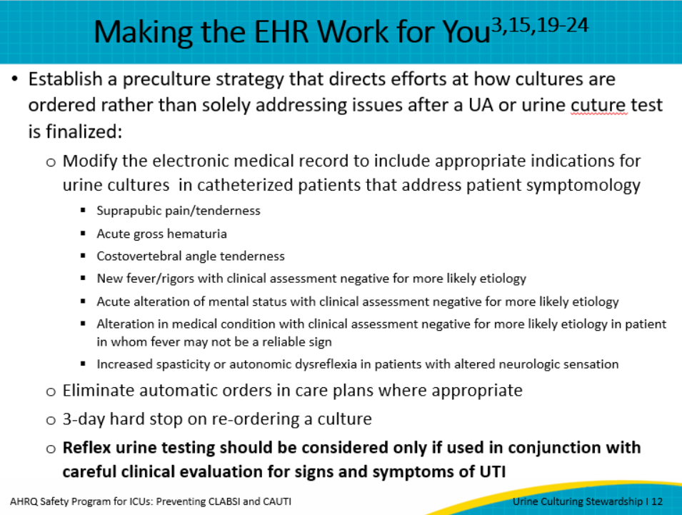
The next areas to focus on your journey of stewardship is specimen collection and transport. This includes how a culture is collected, what container is used and how transport time can impact culture results. | Slide 13  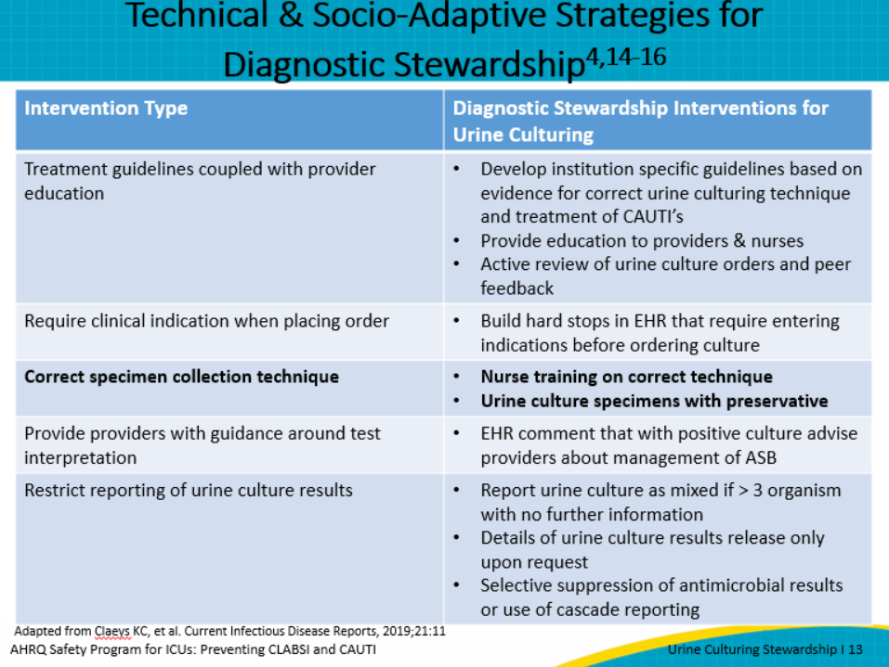
When collecting a urine specimen from a catheterized patient, it is important to know the length of time the catheter has been in because of the buildup of bacteria biofilm on the catheter itself. The Association for Professionals in Infection Control and Epidemiology in 2014 recommend changing the catheter prior to obtaining a culture if it has been in place more than 2 weeks. This provides another opportunity besides daily evaluation to assess if the patient still meets the criteria for an indwelling catheter. If removed, a sample can be obtained by straight catheterization, or if replaced, a sample can be obtained from the new catheter.  Davies et al found that as part of a comprehensive CAUTI reduction plan, changing the catheter prior to sampling if it has been in more than 3–5 days showed a significant reduction in false positive urine cultures. Many hospitals have conducted quality improvement projects assessing cultures before and after replacement at a much shorter time frame than the APIC guidelines recommend. Because the literature is sparse, it is important to test this strategy within your own organization prior to adoption so you have evidence to support the change.  When collecting the specimen, kink the tubing 12 inches below the sample port, allowing urine to fill the tube. Scrub the hub with antiseptic, aspirate urine from the sampling port. Follow by unkinking the tube.  Transport time and type of container can significantly impact contamination rates and false positives. They are two ways to help ensure a correct process. If the specimen transport time to the lab is greater than 2 hours, the specimen should be refrigerated. However, it is difficult to identify how long the specimen has been at air temperature prior to transport to the lab. One strategy to prevent contamination through a force function behavior is to collect all urine specimens in a tube with a preservative. Therefore, if transport time is longer than expected or a UA is reflex to culture, it is in a preservative container. The same would apply for add-on culture to a UA.  More than 40 percent of contaminated cultures lead to additional diagnostic evaluation and inappropriate antibiotic administration. | Slide 14  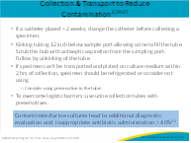
The last strategy is giving providers guidance about test interpretation. This can be done in several ways:  - By inserting a comment popup in the EHR for positive urine cultures to remind providers about management of ASB  - By restricting the way culture results are reported, such as through the following steps:  - If a UC is mixed with more than three organisms, no further information is provided  - UC results are only released upon request  - Selective suppression of antimicrobial results or cascading result reporting based on findings | Slide 15  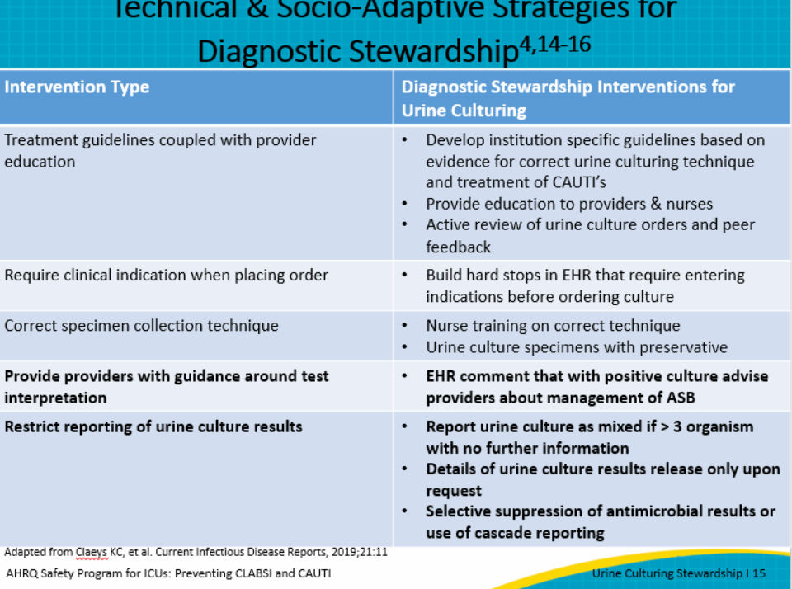
In 2018, a survey was completed by 122 members of the Society for Healthcare Epidemiology of America research network to examine acute care hospitals’ practices around urine culture stewardship. The total response rate was 43 percent, with 75 percent from U.S. hospitals and the remainder from Canadian facilities.  Only 44 percent of facilities had published indications for ordering urine cultures, and only 17 percent of them integrated the indications into the EHR. In the United States, 66 percent of the labs offered reflex cultures at the top of the order set or prechecked.  All but one of the organizations could order a urine culture without a UA. Thirty-nine percent of the labs proceeded with culture analysis, even with the delay in transport, while only 35 percent used a preservative in urine collection tubes. Over 90 percent of the organization’s laboratories reported mixture of urine cultures with no further organism workup when three or more uropathogens were recovered. | Slide 16  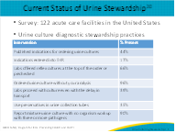
Many clinicians don’t perceive CAUTI as a dangerous problem, so an inappropriate urine culture hardly seems significant. When teaching culturing stewardship, emphasize the risks associated with misdiagnosis in a memorable way. Perhaps the most obvious harms are allergies and adverse effects (like renal failure) from antibiotics. Also, there is Clostridioides difficile diarrhea, the harm and discomfort of central access for antibiotics, and the increasing rate of drug resistance. Humanize these harms if you can. Talk about patients that had a debilitating C. diff infection related to inappropriate antibiotic use, because human stories drive home the facts. For example, after being treated for an inappropriate urine culture result, the patient received a course of antibiotic. In this picture, the patient’s arm shows an antibiotic rash. This patient went on to suffer toxic epidermal necrolysis, was transferred to the burn unit, and died from his antibiotics. | Slide 17  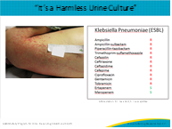
Here is a summary of the harms of culturing urine when it’s not necessary. The harms include antibiotic overuse, C. diff, more resistant organisms, overinflated CAUTI rates, inappropriate treatment, exposure to drug allergies, and potential renal failure. The slide also notes the cost of misdiagnosis, a loss of CMS (Centers for Medicare & Medicaid Services) reimbursement. If a fever is mistakenly blamed on a positive urine culture, then there is a delay in reaching the patient’s real diagnosis. | Slide 18  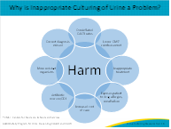
Putting together everything we’ve discussed, it’s clear that erroneous culturing is a multistep process. There are inaccurate beliefs and rote behaviors. These are influenced by relationships and hierarchies. When the orders are placed, computerized physician order entry shapes the decisions made. The harms that occur can be mistakenly considered an unavoidable “cost of doing business” instead of understood as avoidable, tragic injury. How should you intervene?  Beliefs can be corrected with stewardship education. Relationships can be improved by promoting nurse collaboration and a “speak up” culture, or by including an infection preventionist on rounds. Some units leverage attending expertise by requiring the attending physician’s approval for urine catheters and/or urine cultures.  You can improve computer order sets to prompt more thoughtful culturing practices. This provides “guidance at the point of care” so the providers don’t have to remember stewardship on their own.  However, to improve retention, tell stories about adverse events so they feel real and personal to ICU staff. | Slide 19  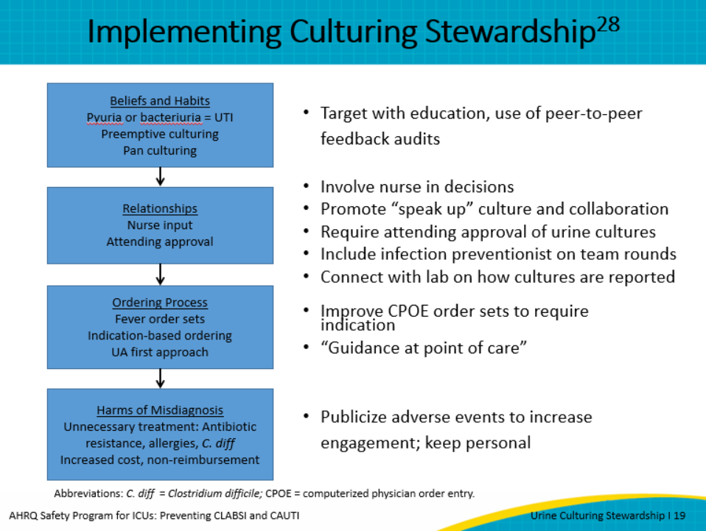
Audit culturing practices on your unit. Consider following up with the ordering provider if the culture was inappropriate.  Try to get eliminate these if they’re present at your hospital:  - Screening urine culture on admission,  - Automatic UA when catheters are inserted,  - Pan-culture fever workups–encourage careful clinical assessments instead, and  - UA with “reflex” cultures unless these are limited to patients with symptoms.  If possible, try to get a fever workup protocol adopted, one that emphasizes careful clinical assessment. | Slide 20  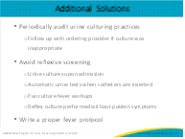
Sometimes the discussion won’t really be about the facts, but about attitudes or other social issues, like hierarchies. If a nurse appropriately questions a urine culture order and the provider feels challenged, try to redirect the concern to the evidence and the patient’s benefit. “ [provider name], the CAUTI committee, chaired by your partner, met and developed this new practice pathway around the culture of culturing and shows the best evidence for culturing to protect our ICU patients from drug-resistant bacteria."  Some clinicians may resist culturing stewardship because they think it’s about money and not about patients. Help them reframe the concern by responding, “Yes, this does help us avoid financial penalties, but more importantly, it’s what is best to prevent harm to the patient.” | Slide 21  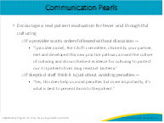
Let’s return to the case of Ms. Allen. What happened with her? A urine culture was done based on the presence of cloudy urine and a chronic indwelling urinary catheter. When she was interviewed, she said that she had low back pain, chills, and rigors with urinary tract infections, but did not have them at the time. On physical exam, she did not have costovertebral tenderness. Her elevated WBC was probably from the stress of GI bleeding, and the mild increase in her temperature was probably due to her blood transfusion.  Due to her chronic indwelling urinary catheter, Ms. Allen had asymptomatic bacteriuria, not a true CAUTI. Remember that within 30 days of catheterization, almost all patients with catheters have bacteriuria. In this case, several harms occurred due to inappropriate culturing of her urine: she was started on unnecessary antibiotics, the cost of hospitalization was increased, and she was placed at risk for drug-related complications. Also, the hospital infection preventionist had to document a CAUTI, which impacts CMS reimbursement. National Healthcare Safety Network CAUTI definitions state that fever is a nonspecific symptom of infection and cannot be excluded from UTI determination because it is clinically determined to be due to another recognized cause. Lastly, Ms. Allen developed C. diff infection—resulting in additional pain, suffering, costs, and health risks. | Slide 22  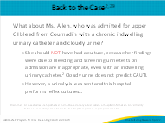
In conclusion, here are the key points to remember and actions to take:  - Do not order a urine culture if the patient is asymptomatic.  - Make sure staff know and understand that inappropriate urine culturing causes harm on the multiple levels that have been discussed: risk to the individual patient; increased cost of care; decreased reimbursement; and worsening antibiotic resistance. Teach your staff how to assess the need for a urine culture. Develop a decision algorithm to support decision making and make that a collaborative effort between physicians, midlevel practitioners, and nursing staff to drive understanding and willingness to use the algorithm.  - Make it easy for the provider and staff to do the right thing by incorporating cues into the EHR like indications for culturing.  - Assess culturing practices in your unit through audits and provide feedback from those audits to staff, physicians, and midlevel providers. Encourage discussions and work through cultural influences that drive inappropriate urine culturing such as embedded habits. These may include standing orders or protocols for pan culturing for fever and/or for reflex culturing of urine. Remember that many providers feel pressured to treat positive urine cultures, even when symptoms are absent.  - If the catheter is in place longer than 2 weeks and a culture is needed, change the catheter before obtaining a culture to prevent culturing the colonization on the catheter. In many organizations, the practice has moved to 3–5 days of the catheter in place before changing to obtain a culture. This is another opportunity besides daily assessment of need to evaluate whether the indwelling catheter is still needed based on indications.  - Ensure staff feel empowered and supported to speak up and appropriately challenge inappropriate urine culture orders. This support can drive shared accountability, which is a powerful social influence to change practice. This may require skill building and education for staff, which can be part of a comprehensive safety culture project. You may find that specific resources like TeamSTEPPS, a set of evidence-based teamwork tools aimed at optimizing patient outcomes by improving communication and teamwork skills, can help with such an effort. TeamSTEPPS is available on the AHRQ website at https://www.ahrq.gov/teamstepps/index.html. | Slide 23
Slide 24
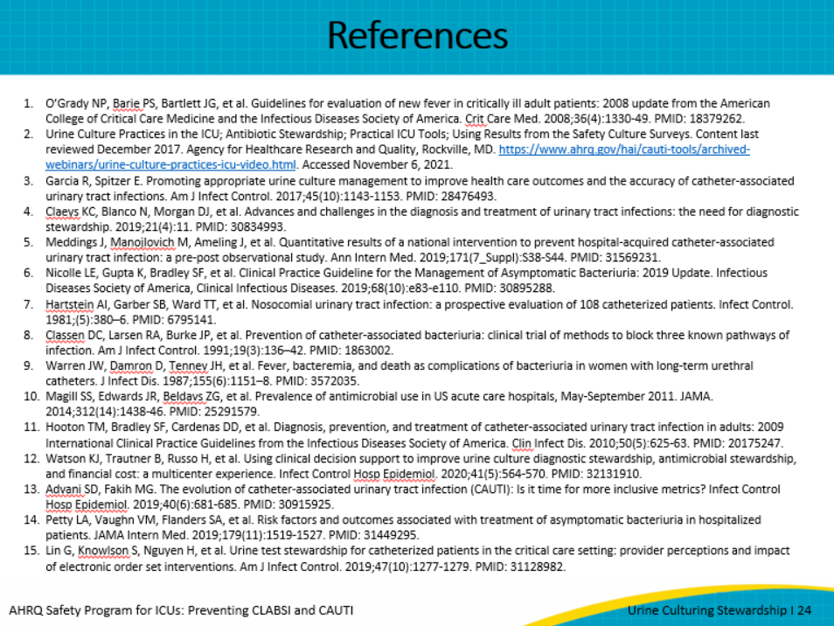
Slide 25
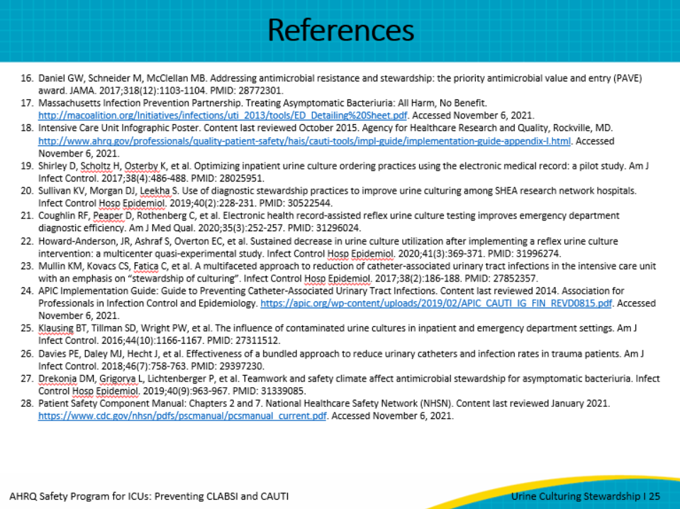
AHRQ Pub. No. 17(22)-0019
April 2022

