Identifying Stakeholders: How To Do a Stakeholder Analysis for Your Improving Surgical Care and Recovery Program
Slide Title and Commentary | Slide Number and Slide
Identifying Stakeholders – Title Slide  Welcome to the presentation, “Identifying Stakeholders: How To Do a Stakeholder Analysis for Your Improving Surgical Care and Recovery Program.” | Slide 1  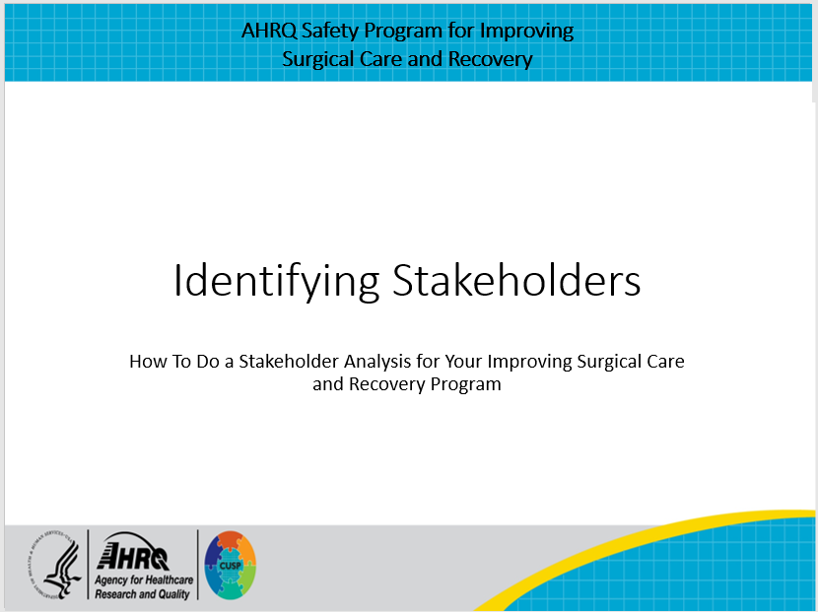
Introduction to ISCR  The Agency for Healthcare Research and Quality (AHRQ) Safety Program for Improving Surgical Care and Recovery (ISCR) incorporates AHRQ’s Comprehensive Unit-based Safety Program, or CUSP, to help introduce, embed, and sustain an enhanced recovery program at our hospital. One of the many concepts of CUSP integrated into the AHRQ Safety Program for Improving Surgical Care and Recovery is the development of a multidisciplinary team that includes everyone impacted by the planned changes. Assembling a multidisciplinary team that includes clinicians involved in the continuum of care is recommended to engage them in the perioperative care of the patients. | Slide 2  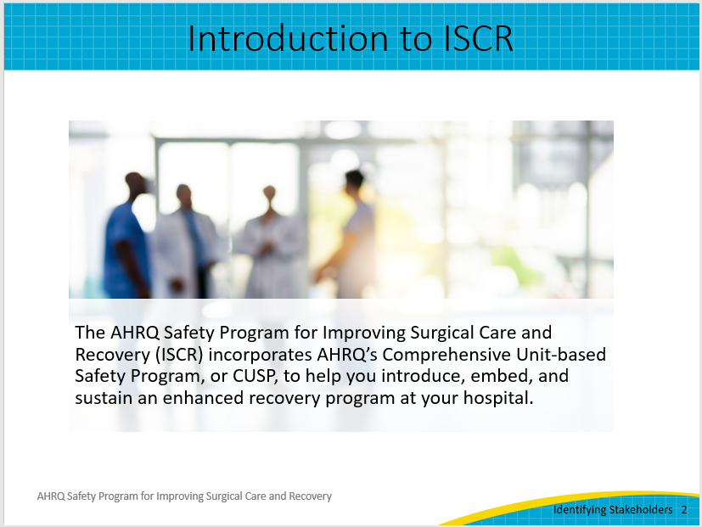
How do we know who to engage in this work?  But how do we know whom to engage in this work? That is one of the main questions asked in the stakeholder analysis worksheet your team can use to fully understand whom to approach when planning to implement the ISCR program at your hospital. Insights garnered from your analysis can be helpful in guiding your conversations with individual stakeholders.  Collectively, the goal of implementing the ISCR program in hospitals is to improve the perioperative care of patients by reducing complications, improving the patient experience, and reducing unnecessary healthcare utilization. | Slide 3  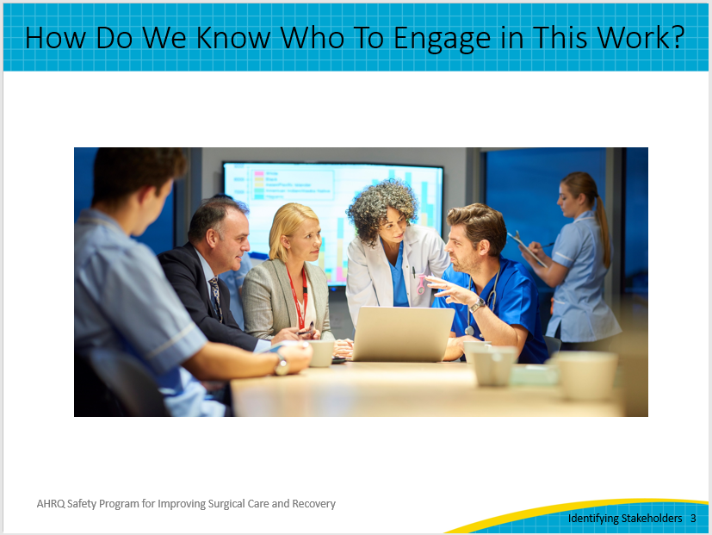
Timing for Stakeholder Analysis  Performing a stakeholder analysis early on can help set up your program for success by ensuring you have representation from a multidisciplinary team from the start. The process does not take long—5- to 10-minute conversations with stakeholders and less than an hour to conduct the analysis. One reason some programs fail is that the proponents may not have understood the importance of or the time needed for performing a stakeholder analysis. | Slide 4
What is the purpose of a stakeholder analysis?  So then, what is a stakeholder analysis?  First, it is an exercise for gathering qualitative information about the impacts, both positive and negative, that a program may have on others.  Second, it is a process for gathering information about how your ISCR program may be impacted by the absence of input. We know that better decisions are made when the wisdom of others is taken into consideration.  Finally, it is also a process for understanding the complexity of the change effort before you, and resisting oversimplification. Having the opportunity to step into others’ shoes always provides new perspectives. | Slide 5  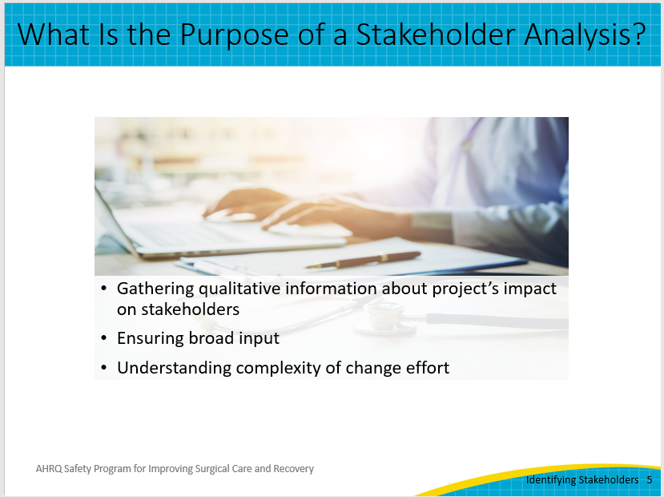
Creating the Right Temperature for Change  Any change initiative thrives when there is just the right temperature for change. Too hot, and stakeholders may avoid the change altogether—stick their head in the sand or simply say, “This is too much!”  Too cold,—and the status quo is comfortable—there is no urgency to alter their habits: “This change may hurt my patients. I’ve always done it my way, and my patients do fine!”  A robust stakeholder analysis provides the framework for change and helps you understand the landscape so you can meet the needs of the stakeholders and increase your chances of success. A stakeholder analysis helps you figure out who are the early adopters and who might need more time and extra discussion to bring them on board. | Slide 6  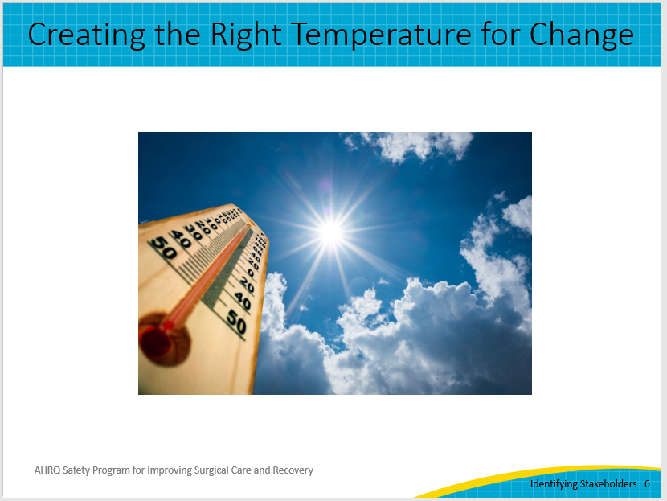
Stakeholder Analysis Buy-in  It’s tempting to simplify quality improvement work as identifying a “best practice protocol,” putting it into a standardized order set, and then pushing a button and “rolling it out.” But, simply “rolling it out” may have the consequence of exactly what the phrase suggests…rolling out like a steamroller, right over those who are doing the work.  The successful implementation of a quality improvement initiative like the ISCR program is more complex. If new processes are rolled out without engaging stakeholders early on, chances are you will not have the support you need to implement and sustain your work. It’s important to ensure that implementation is done in concert with stakeholders. | Slide 7  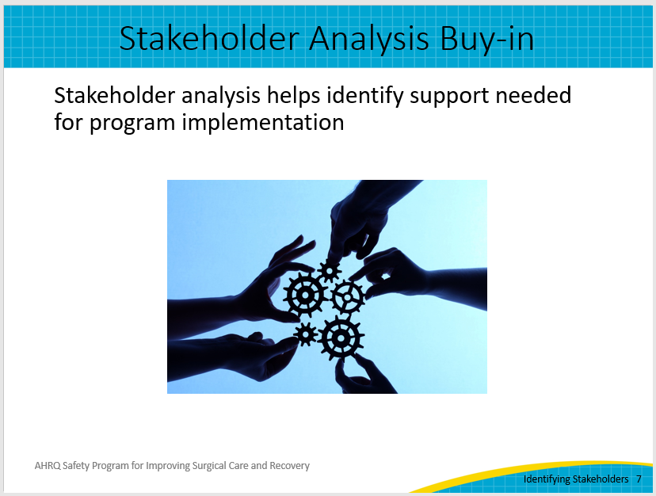
Asking Questions To Facilitate Understanding  A stakeholder analysis helps you better understand the social lay of your land. It often involves many one-on-one conversations. These conversations may utilize the skill and art of humble inquiry—that is, asking questions for which we do not already know the answers—to build a relationship based on the curiosity and interest of the other person.  These conversations are more about inquiring and learning about the world the stakeholders live in, not telling them about the ISCR program. Knowing your team and all involved in taking care of the patients, ask these questions in the break room, at huddle boards, or any other time that works best for your stakeholders. Here are some examples of possible inquiries:  “What puzzles you about how we take care of our surgical patients?”  “How might your patients benefit from an enhanced recovery program?”  “When do you find yourself wasting time while taking care of our surgical patients?”  “What ideas do you have to make this effort successful?”  “What might be our blind spots?”  “If we were to help make your work easier in this next year, what might that mean?”  “Tell me about a surgical patient who made you smile.” | Slide 8  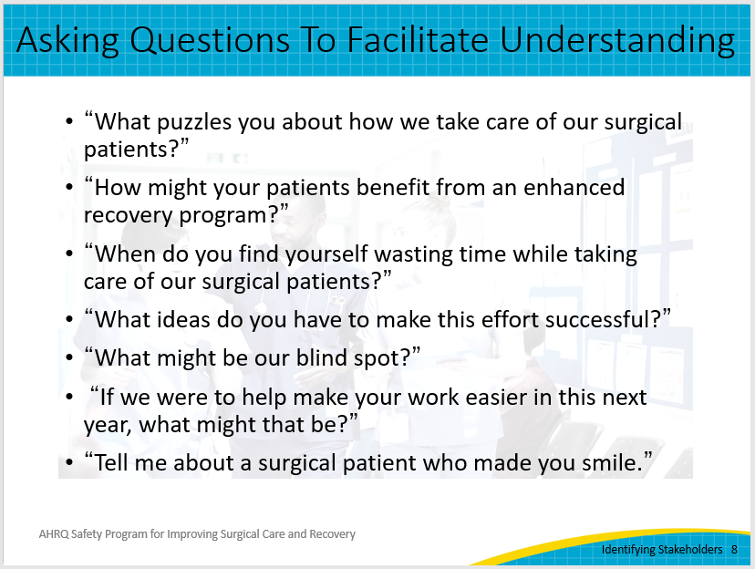
The Stakeholder Analysis Worksheet  A stakeholder analysis worksheet was created for the ISCR program and is available in the ISCR toolkit on the AHRQ website. It includes the following areas to think about for each stakeholder:  Key issues raised by stakeholders (e.g., barriers to be aware of and opportunities to improve)  The stakeholder’s current stance on the ISCR program (e.g., in favor, opposed or ambivalent)  How will this program impact them directly?  What level of influence or control does the stakeholder have over this program (e.g., high, medium, low)?  How will we keep this stakeholder engaged? How does this stakeholder want to be updated about the program? | Slide 9  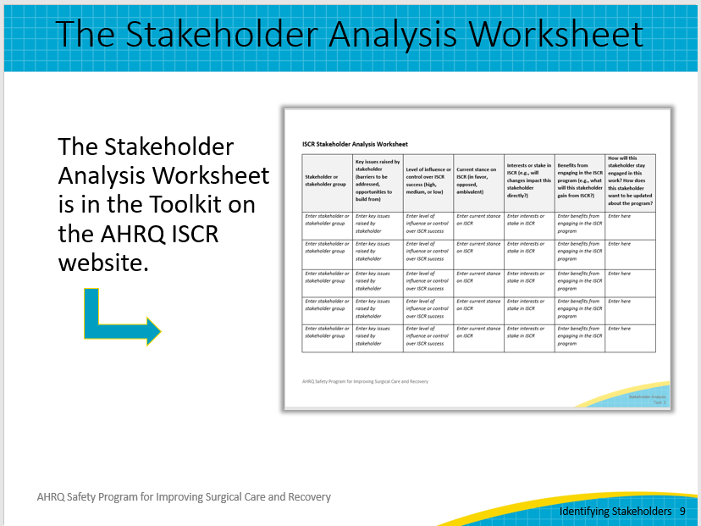
Questions To Consider  You are encouraged to modify this worksheet as needed and think of other questions that might be valuable to consider to fully understand your stakeholders, including—  How much will this work impact this stakeholder?  How much influence does this stakeholder have in the success of this work?  What matters to this stakeholder?  How might this stakeholder contribute to this work?  How might this stakeholder block this work?  As you review your findings with your ISCR core team, those stakeholders with the highest impact and the highest influence will be critical resources to tap for your success.  There may be a situation where you have someone who has high influence that lets you know that they plan to block the work. Before dismissing that individual, first listen intently to make sure no unintended risks or perspectives were missed. Then, if you learn they are dissenting just for dissention’s sake, consider saying, “Thank you for your input. I understand that you do not want to support this effort right now. We won’t ask you to do so. However, could I ask for your commitment and promise not to block us as we move forward?” This approach was recommended by a surgeon who is a quality leader and could be useful in this situation. | Slide 10  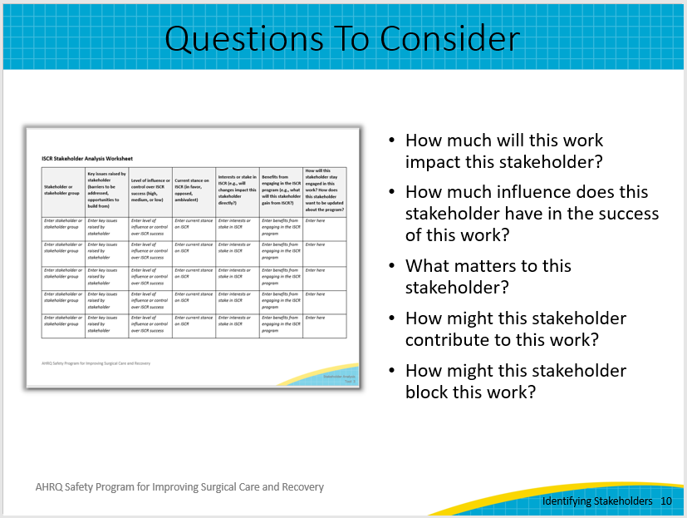
Additional Considerations  To conclude, here are a couple of other key points to keep in mind as you are identifying your stakeholders and conducting your stakeholder analysis:  Remember, there are both internal and external stakeholders. So, also consider who the stakeholders outside of the surgical arena may be. They may include hospital staff outside the surgical service line, clinicians’ office staff, and most importantly, patients.  Finally, remember that one of the key takeaways when conducting the stakeholder analysis is how to keep the stakeholder engaged. The one-on-one conversation is a perfect opportunity to ask individuals how best to communicate with them on changes, updates, and obtaining feedback as you implement your ISCR work. Creating an effective communication system is critical for the success of a change initiative. | Slide 11  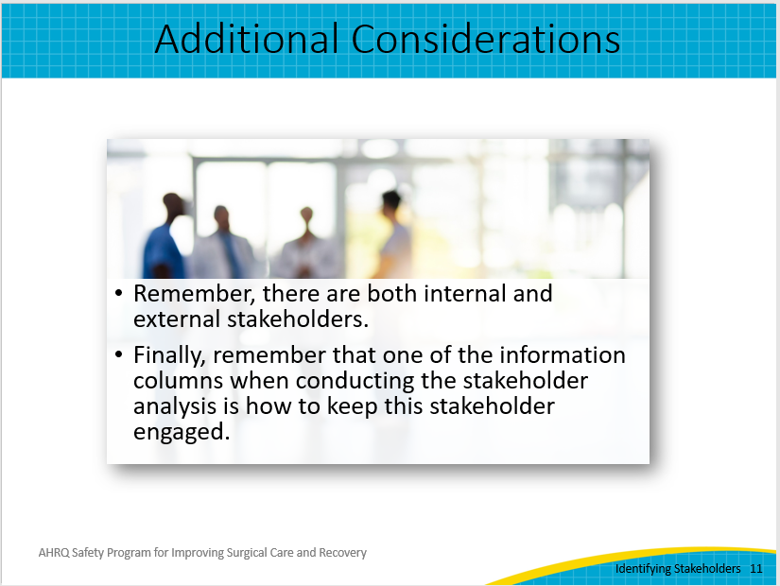
Available Resources  Remember to access the Stakeholder Analysis Worksheet in the ISCR Program Toolkit on the AHRQ website. Once you’ve identified your stakeholders, consider reviewing the resources available on engaging your stakeholders, which are also available in the ISCR Program Toolkit (PowerPoint presentation and facilitator guide; Developing an Elevator Pitch tool). We hope these resources will set your program up to be implemented smoothly and successfully. | Slide 12  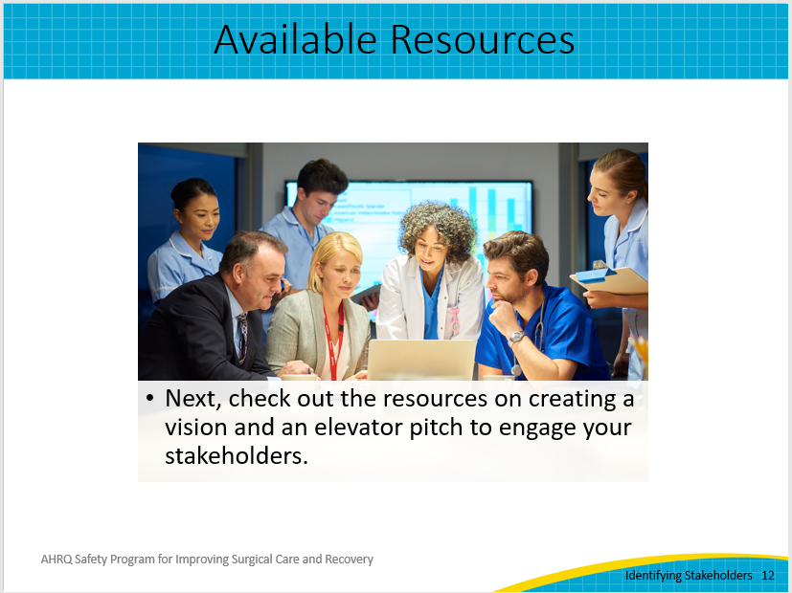
Thank You and Contact Information  Thank you for your time today. Do you have any questions?  If you want to know more about the ISCR program, my contact information is listed on this slide. | Slide 13  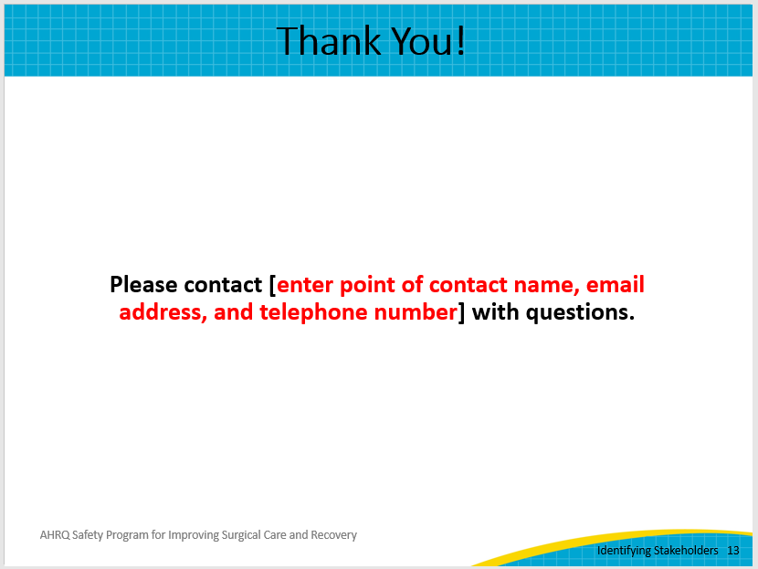
AHRQ Pub. No. 23-0052
June 2023

