Program Overview
This guide provides a high-level overview of the entire Agency for Healthcare Research and Quality (AHRQ) Safety Program for Improving Surgical Care and Recovery (ISCR) and toolkit.
In addition to this guide, consider reviewing the ISCR overview presentation and facilitator guide to learn about ISCR and the toolkit.
What Is the Program for Improving Surgical Care and Recovery?
ISCR seeks to improve surgical outcomes by supporting hospitals in the implementation of evidence-based enhanced recovery pathways within the framework of AHRQ’s Comprehensive Unit-based Safety Program (CUSP). CUSP is a well-known model for sustainable safety improvement that has been associated with preventing harm in multiple areas. ISCR integrates both technical and adaptive approaches into a holistic, team-based approach to perioperative quality improvement for patients.
Why Use the Program for Improving Surgical Care and Recovery?
ISCR provides information and tools that hospitals can use to make enhanced recovery a priority and to select and implement pathways that address the specific needs of their hospital. ISCR promotes the delivery of evidence-based perioperative care and reduces variability.
Using this toolkit, hospitals can establish an ISCR program within the following service lines: colorectal surgery, hip fracture surgery, hip and knee replacement surgery, gynecologic surgery, and emergency general surgery (major abdominal surgery, appendectomy, and cholecystectomy).

The Program for Improving Surgical Care and Recovery Pathway Roadmap
Below is the program’s pathway roadmap that highlights some of the common elements across the program’s service lines, for both elective and emergency/urgent surgeries. Hospitals should refer to the other sections within this toolkit for additional material and tools to assist with their standardization efforts.
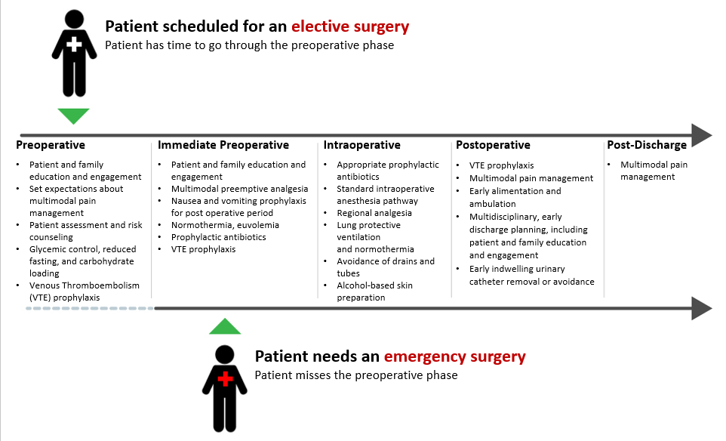
The Program for Improving Surgical Care and Recovery Implementation Phaseline
While the efforts to standardize your perioperative processes are continuous and never ending, this toolkit recommends taking certain steps during the first 12 months to set up your team for success. These steps are highlighted in the phaseline below and expanded on in more detail, along with resources to use at each step, in the Implementation Guide of this toolkit.
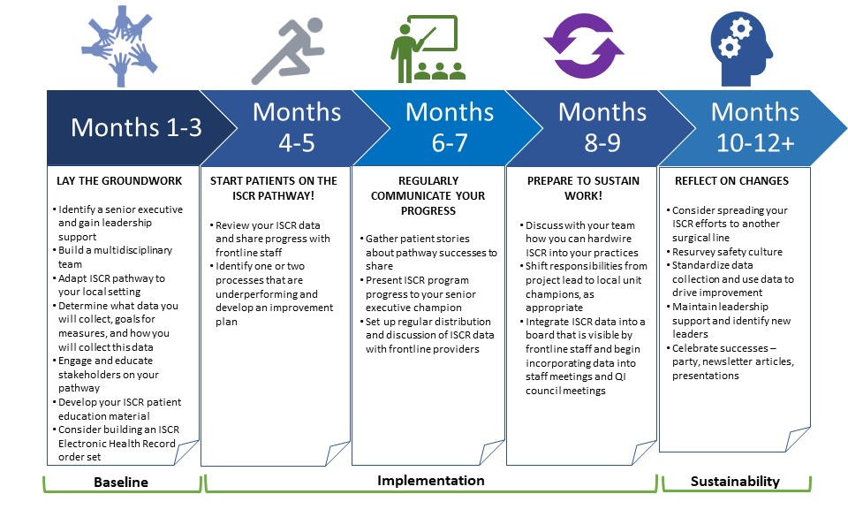
What does the Program for Improving Surgical Care and Recovery toolkit include?
The toolkit includes step-by-step instructions and ready-to-use materials that hospitals can use to plan, implement, and sustain an ISCR program. Hospitals can choose which tools, or components of tools, best suit their needs. Every tool is intended to be adapted to suit each hospital.
This program contains four sections, which are described below.
Choosing a Service Line for Improving Surgical Care and Recovery
This section is designed to help a hospital identify focus areas for their ISCR program. The section includes the following tools:
- The Red Light, Green Light tool to help you identify where you have buy-in from front-line staff, leaders, and other key stakeholders. This tool also helps you spot where you have existing barriers and facilitators to quality improvement.
- A Gap Analysis and Goal Setting Form will help you identify which areas are most in need of improvement and set measurable goals for performance improvement.

Implementing a Safety Program for Improving Surgical Care and Recovery
This section contains three subsections designed to help a hospital engage stakeholders, plan, and introduce an ISCR program. The section includes the following tools:
Engaging Stakeholders and Planning for Your Pathway
- An ISCR Implementation Guide that provides monthly goals and tasks to help hospitals integrate an enhanced recovery pathway into their perioperative area.
- The Building Your ISCR Core Team tool will help you understand the roles and responsibilities of your ISCR core team to help you identify members who are best positioned to work with you to implement, lead, and monitor progress toward improving surgical outcomes.
- A PowerPoint presentation and facilitator guide on Identifying Your ISCR stakeholders. This presentation will review who your ISCR stakeholders are, what role they play in ISCR, and what the value of a doing a stakeholder analysis is. The Stakeholder Analysis tool will help you identify and understand the perspectives of your key stakeholders.
- A PowerPoint presentation and facilitator guide on Engaging Your ISCR Stakeholders. This presentation will discuss how to create a compelling message and vision for your ISCR program so that you can engage your stakeholders in this effort. The Developing an Elevator Pitch tool will help you develop and communicate your vision in a concise, clear, and compelling way.
- A Sample ISCR Presentation for Senior Executives and an accompanying facilitator guide to onboard and engage leadership in your efforts.
- A Sample ISCR Presentation for Frontline Provider Education and accompanying facilitator guide to use to engage frontline staff in the ISCR pathway early on and/or to share progress with them throughout the initiative to support sustainability.
- The Template for Building and Implementing Your ISCR Pathway provides a visual for the ISCR pathway that is relatable to frontline staff, as well as for building order sets in the electronic health record.
- An Engaging Frontline Staff With ISCR Process and Outcome Data tool to help you identify which ISCR measures to share and think about the best way to share them with key stakeholders at your hospital.
Presentations on the ISCR Evidence
- A PowerPoint presentation and facilitator guide on Oral Antibiotics and Mechanical Bowel Prep for SSI Prevention for Colorectal Surgery
- A PowerPoint presentation and facilitator guide on Multimodal Analgesia Tips
A PowerPoint presentation and facilitator guide on Regional Analgesia for Joint Replacement
Implementing Your ISCR Pathway
- The ISCR Pathway Worksheet to help teams develop an ISCR pathway for use at their hospital. The ISCR Pathway Worksheet has been condensed into core components that span all ISCR pathways for either emergent or nonemergent procedures with supplemental sections and notes for service line or patient population specific components. The information in this tool is based on evidence reviews conducted for AHRQ.
- A Sample ISCR Pathway Checklist that clinicians can use as they provide care within their own area and handoff care to other teams. The Sample ISCR Pathway Checklist can also be used for real-time data collection to monitor pathway compliance.
- A Guide to Leading Successful Perioperative Teams presents critical behaviors for leading successful perioperative teams as well as practical tips on how to replicate these behaviors in your organization.
- ISCR Surgery Patient Education Booklets to help you create your local patient education material. Sample books for each service line were developed by surgeons with input from patients and family members.

Measuring the Impact of Your Program for Improving Surgical Care and Recovery
This section consists of four tools that can be modified based on the service line chosen by the hospital (colorectal surgery, hip fracture surgery, hip/knee replacement surgery, gynecologic surgery, or emergency general surgery). The tools help teams use data to monitor progress and evaluate the impact of their ISCR program. This section includes the tools described below.
- The ISCR Pathway Worksheet to help teams develop an ISCR pathway for use at their hospital. The information in this tool is based on evidence reviews conducted for AHRQ.
- A Sample ISCR Pathway Checklist that clinicians can use as they provide care within their own area and handoff care to other teams. The Sample ISCR Pathway Checklist can also be used for real-time data collection to monitor pathway compliance.
- A Pathway Audit Tool to help you measure compliance with ISCR process measures.
- An Engaging Frontline Staff With ISCR Process and Outcome Data tool to help you track the ISCR measures you’ve shared with stakeholders so you can provide regular updates on changes in process measure compliance and outcome measures over time.

Sustaining and Spreading a Program for Improving Surgical Care and Recovery
This section is designed to help a hospital sustain and spread their ISCR program. The section includes the following tools:
- An Identifying Facilitators and Barriers to Sustaining Gains in Enhanced Recovery tool with references to publications and other AHRQ sustainability tools that hospitals can use to plan for the long-term sustainment of their ISCR program.
- The Gap Analysis and Goal Setting Form will help you identify the next area that needs improvement.
AHRQ Pub. No. 23-0052
June 2023

