ISCR Overview: Facilitator Guide
AHRQ Safety Program for Improving
Surgical Care and Recovery
Slide Title and Commentary | Slide Number and Slide
Title slide: ISCR Overview  Hello, and thank you for joining me. Today I'll be providing an overview of the Agency for Healthcare Research and Quality’s, or AHRQ’s, Safety Program for Improving Surgical Care and Recovery, or ISCR. | Slide 1  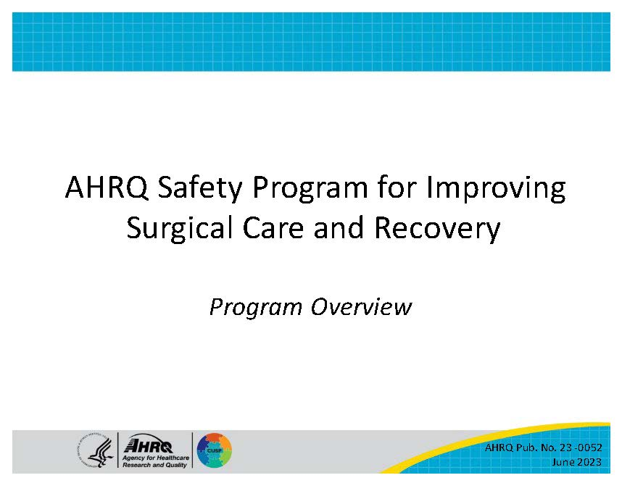
Introduction  What is ISCR?  ISCR seeks to improve surgical outcomes by supporting hospitals in the implementation of evidence-based enhanced recovery pathways within the framework of the Comprehensive Unit-based Safety Program (CUSP). CUSP is a well-known model for sustainable safety improvement that has been associated with preventing harm in multiple areas. | Slide 2  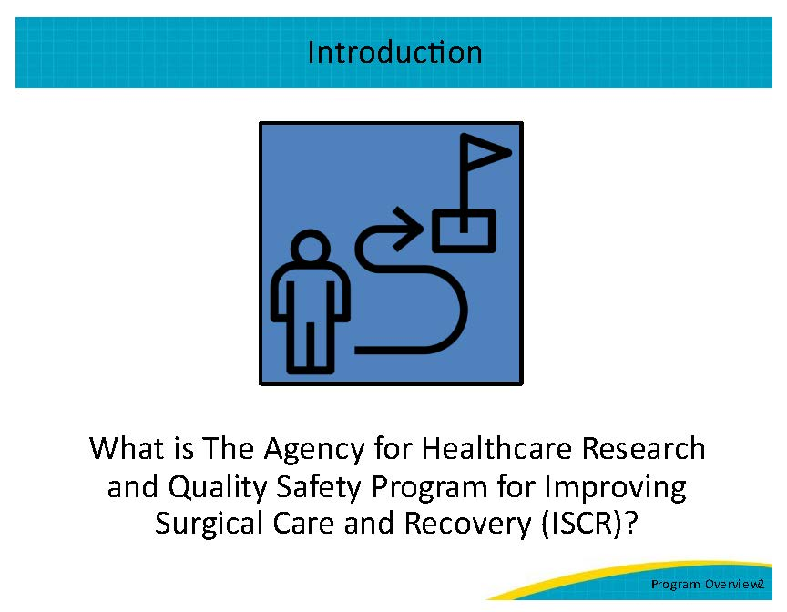
A Balanced Approach Is Key to Success  ISCR integrates both technical and adaptive components into a holistic, team-based approach to perioperative quality improvement for surgical patients. Hospitals can use the toolkit to apply the evidence supporting ISCR within the proven principles and methods of CUSP to improve outcomes and reduce complications such as surgical site infections (SSI), venous thromboembolism (VTE), and urinary tract infections (UTI). ISCR and CUSP methodologies can also help to improve overall patient experience and your perioperative safety culture. | Slide 3  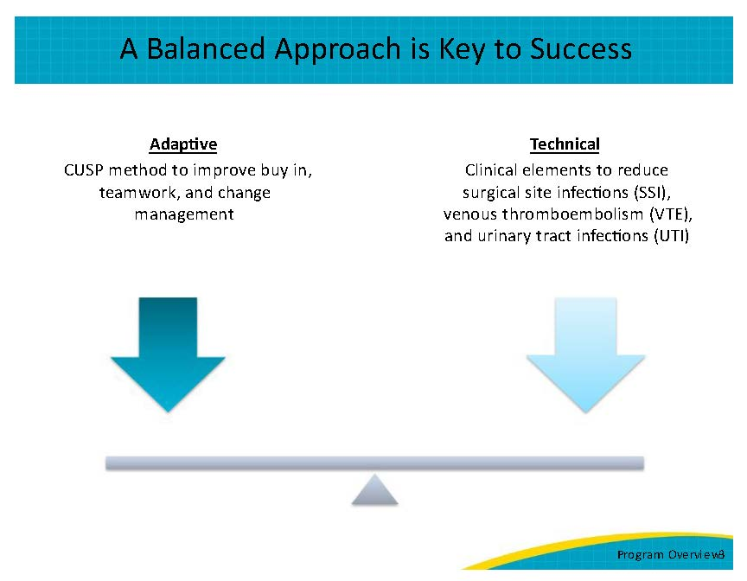
Why Use the AHRQ Safety Program for Improving Surgical Care and Recovery?  ISCR provides information and tools that hospitals can use to make enhanced recovery surgeries a priority and to select and implement pathways that address the specific needs of their hospital. These pathways promote the delivery of evidence-based perioperative care and reduce variability.  The ISCR toolkit can help hospitals establish pathways within the following service lines: colorectal surgery, hip fracture surgery, hip/knee replacement surgery, gynecologic surgery, and emergency general surgery, which includes appendectomies, cholecystectomies, and major abdominal procedures, such as hernia repair. | Slide 4  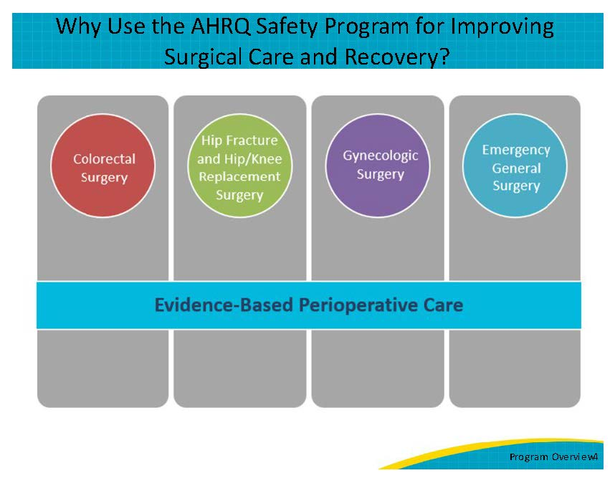
Who Should Use This Toolkit?  This toolkit can be used by perioperative staff, surgical quality improvement specialists, and hospital leadership who are ready to learn more about the importance and impact of standardizing their perioperative care using the ISCR program. A hospital may eventually have multiple ISCR teams working to implement and sustain processes in each clinical area (e.g., colorectal surgery, gynecologic surgery, etc.). Let’s take a look at some of these standardized processes. | Slide 5  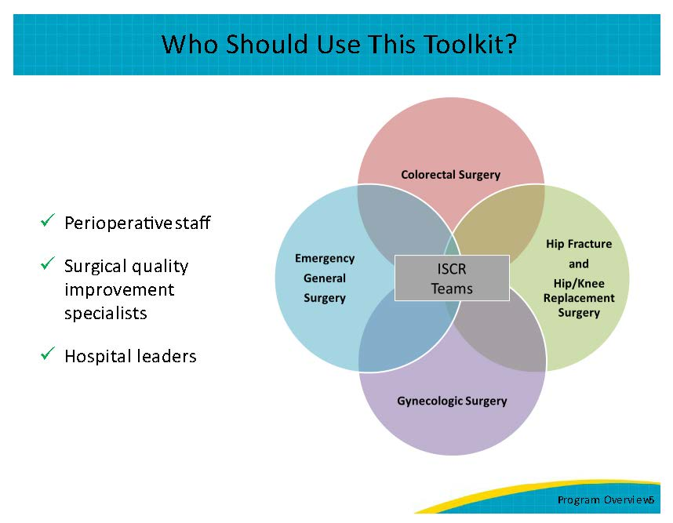
The AHRQ Safety Program for ISCR Pathway Roadmap  The program’s pathway roadmap highlights the common components that span the program’s service lines, for patients undergoing elective or emergency surgeries. Examples include patient and family education, use of multimodal pain management, avoidance of drains and tubes, VTE prophylaxis, early alimentation and ambulation, and early discharge planning by a multidisciplinary team. Hospitals should refer to sections within this toolkit for additional material and tools to assist with their standardization efforts. | Slide 6  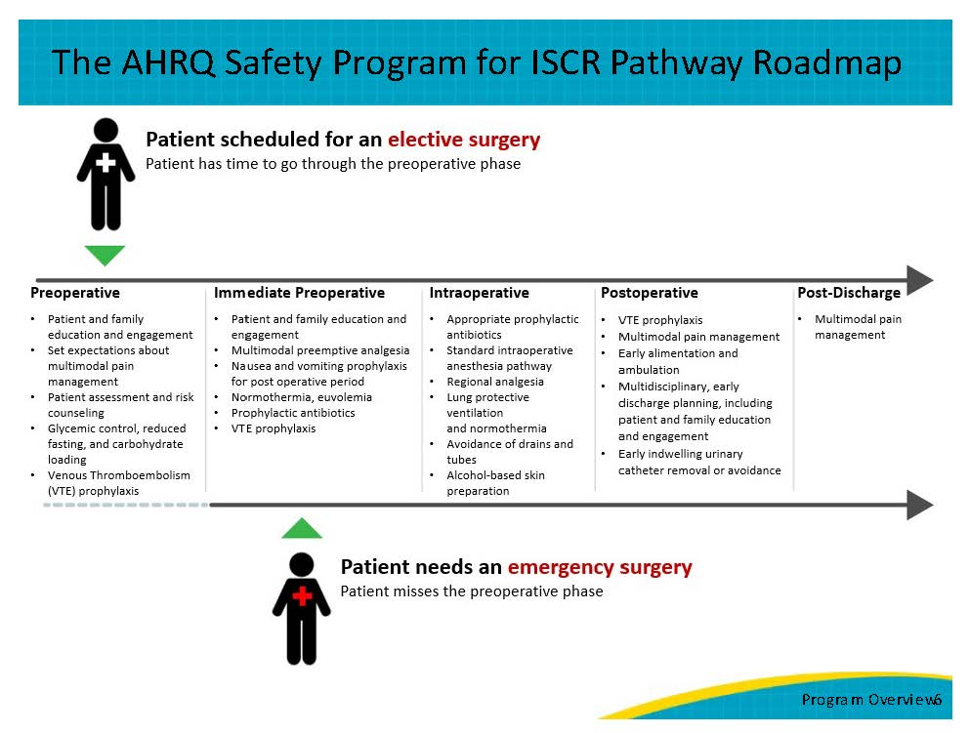
The ISCR Implementation Phaseline  While efforts to standardize your perioperative practices are continuous, this toolkit recommends taking specific steps during the first 12 months of your program to set your team up for success. These steps are highlighted in the ISCR Implementation Phaseline and expanded on in more detail in the Implementation Guide of this toolkit. Keep in mind that this is just a guide to help you develop a timeline, but sometimes it may take a month or two longer or shorter for each step of the Phaseline. You will also find links to other tools and resources in the Implementation Guide. | Slide 7  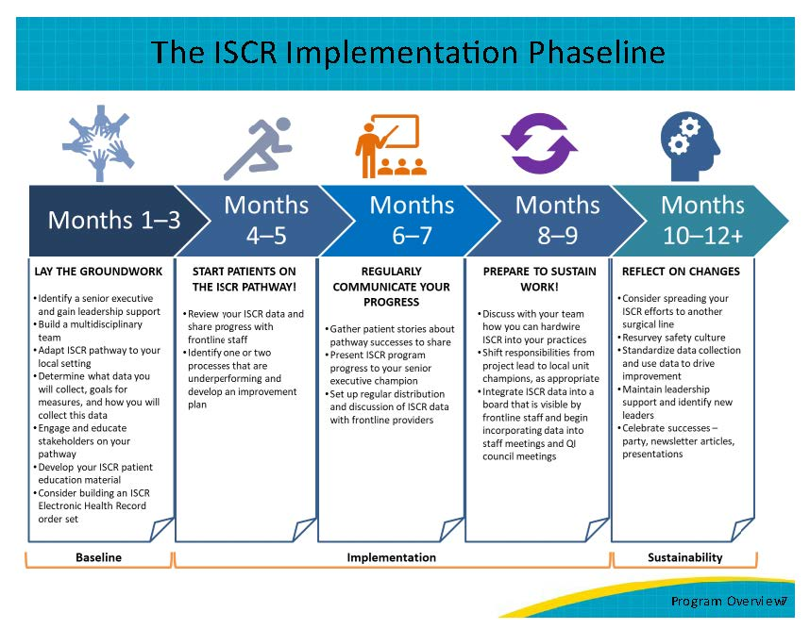
How To Use This Toolkit and What Is Included  The toolkit includes step-by-step instructions and ready-to-use materials that hospitals can use to plan, implement, evaluate, and sustain their ISCR program. The toolkit is organized into four sections that your hospital’s perioperative team can use to promote consistent use of evidence-based processes within the framework of CUSP. The overview is a short introduction to orient your team to the program.  Hospitals can choose which tools, or parts of tools, best suit their needs. All materials are publicly available and downloadable. And every tool is intended to be adapted to suit each hospital. | Slide 8  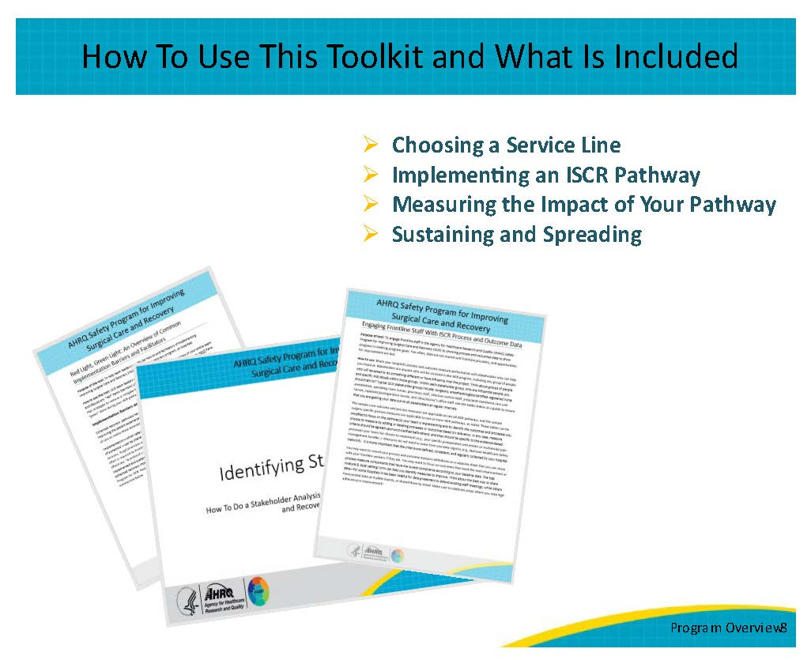
Toolkit and Pathway Development  These evidence-based resources were developed throughout a 5-year national quality improvement collaborative that brought together subject matter experts and participating hospitals across the country. Subject matter experts conducted 15 evidence reviews during the course of developing the program to identify the components of ISCR and relevant measures.  The goal was to develop a comprehensive pathway that spans the continuum of care and can be successfully implemented by a multidisciplinary team.  The next few slides provide brief summaries of a few of the evidence reviews conducted for the ISCR program and highlight some of the important outcomes that can be improved by incorporating the components of a comprehensive, evidence-based pathway into your perioperative care. | Slide 9  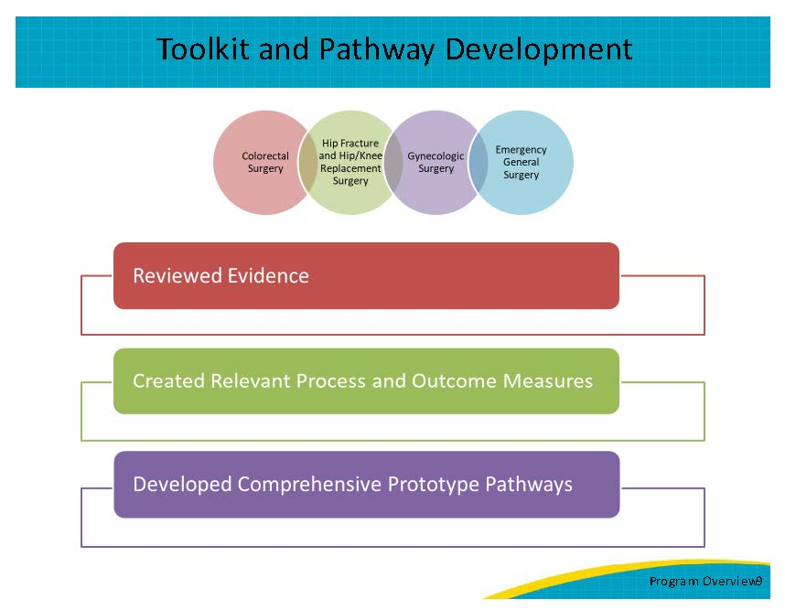
Evidence Reviews: Colorectal Surgery Snapshot  This slide summarizes some of the key findings from the evidence reviews conducted for colorectal surgery.  The immediate preoperative interventions resulted in decreased ileus, decreased insulin resistance, faster return of bowel function, decreased length of stay, decreased opioid use, decreased pain, and decreased postoperative nausea and vomiting.  The intraoperative interventions resulted in decreased length of stay, decreased morbidity, decreased opioid use, decreased pain, decreased postoperative nausea and vomiting, and decreased surgical site infections.  The postoperative interventions resulted in decreased pain, decreased postoperative nausea and vomiting, and decreased opioid use.  For those interested in exploring the publication shown on the slide, all references for the evidence reviews mentioned here are listed in the reference slide at the end. | Slide 10  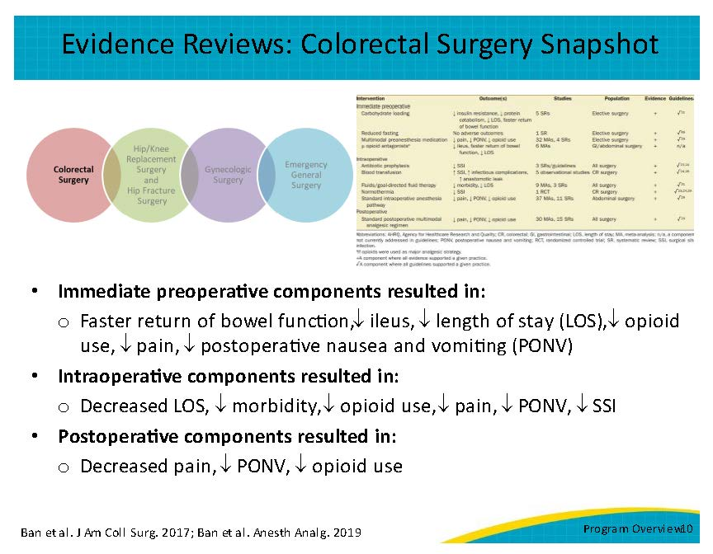
Evidence Reviews: Hip/Knee Replacement Surgery Snapshot  This slide summarizes some of the key findings from the evidence reviews conducted for hip and knee replacement surgery.  The preoperative interventions resulted in decreased complications (wound, cardiovascular, and reoperation), decreased length of stay, decreased pain, and decreased surgical site infections.  The postoperative interventions resulted in decreased length of stay, decreased overall venous thromboembolism rate, and decreased deep vein thrombosis. | Slide 11  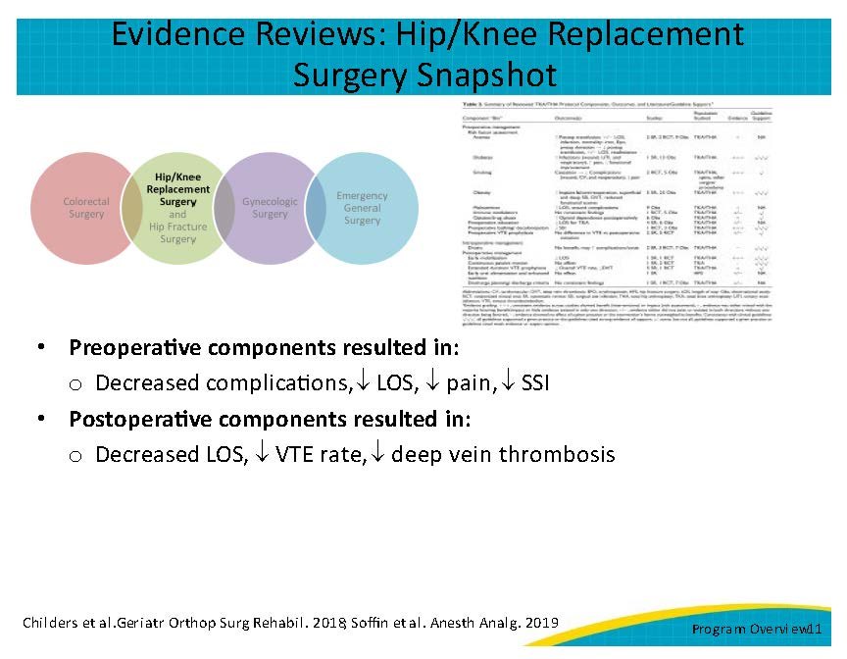
Evidence Reviews: Hip Fracture Surgery Snapshot  This slide summarizes some of the key findings from the evidence reviews conducted for hip fracture surgery.  Preoperative medical assessment and counseling on smoking cessation, weight loss, and other factors that may increase complications resulted in decreased pain postoperatively and improved healing.  The evidence indicated that surgery within 24–48 hours of admission is beneficial and the perioperative interventions decreased venous thromboembolism, improved functional outcomes, improved quality of life, and improved functional independence.  Ambulation by postoperative day 1 may decrease complications and hospital length of stay. | Slide 12  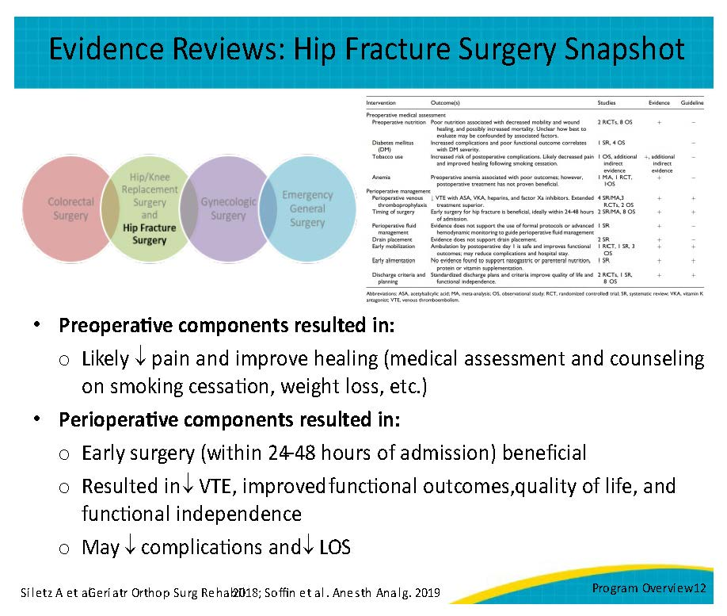
Evidence Reviews: Gynecologic Surgery Snapshot  This slide summarizes some of the key findings from the evidence reviews conducted for gynecologic surgery.  The immediate preoperative interventions show that: carbohydrate loading resulted in decreased insulin resistance and faster return of bowel function, and decreased length of stay. Multimodal pre-anesthesia medication resulted in decreased pain, decreased postoperative nausea and vomiting, and decreased opioid use.  The intraoperative interventions show that: the standard intraoperative anesthesia pathway resulted in decreased pain, decreased postoperative nausea and vomiting, and decreased opioid use. The protective ventilation strategy decreased pulmonary complications. And goal-directed fluid therapy decreased morbidity and length of stay.  The postoperative intervention standard postoperative multimodal analgesic regimens resulted in decreased pain, decreased postoperative nausea and vomiting, and decreased opioid use. | Slide 13  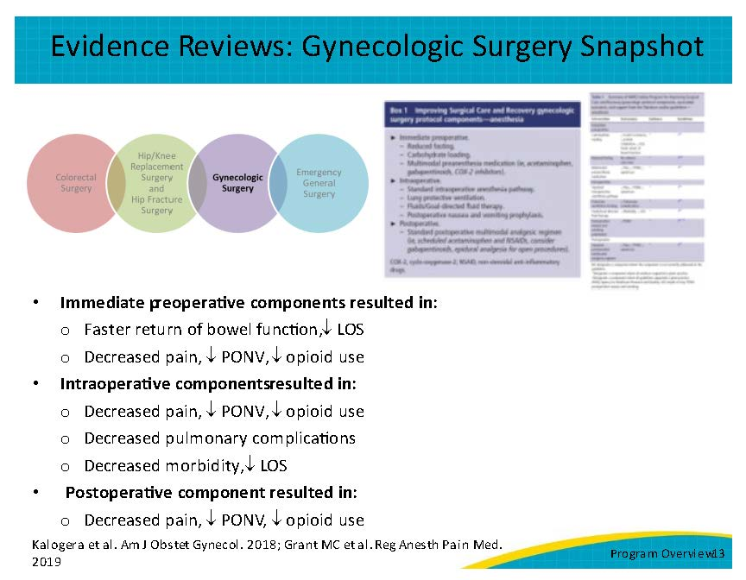
Evidence Reviews: Appendectomy Snapshot  This slide summarizes some of the key findings from the evidence review conducted for acute appendectomy.  The preoperative interventions resulted in decreased infectious complications and decreased postoperative morbidity. The laparoscopic surgical technique resulted in decreased surgical site infections, decreased postoperative pain, and decreased length of stay.  The postoperative interventions showed that postoperative antibiotics resulted in reduced infectious complications for complicated appendicitis and early mobilization can improve gastrointestinal function and reduce length of stay for any type of appendicitis.  Separate evidence reviews for acute cholecystectomy and emergency major abdominal surgeries were conducted, and their references are provided in the ISCR Pathway Worksheet. | Slide 14  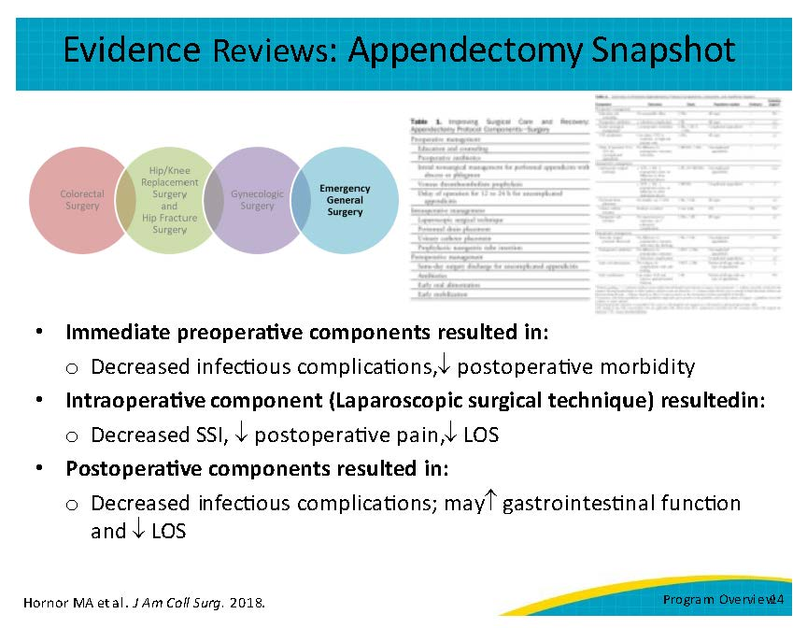
Final Thoughts  In summary, ISCR integrates both technical and adaptive methodologies into a holistic, multidisciplinary team-focused approach to perioperative quality improvement for patients. The program provides a toolkit with step-by-step instructions and ready-to-use materials, such as a form to help you build your ISCR team or the pathway worksheet to help you develop your standardized pathway. Hospitals can use these tools to plan, implement, evaluate, and sustain their ISCR program in colorectal surgery, hip fracture surgery, hip/knee replacement surgery, gynecologic surgery, or emergency general surgery. This toolkit can be used by perioperative staff, surgical quality improvement specialists, and hospital leadership who can refer to the various sections for specific tools and additional resources to support the delivery of evidence-based perioperative care and promote standardization efforts to reduce variability. Hospitals can choose which tools, or parts of tools, best suit their needs as every tool is intended to be adapted to suit each hospital.  For additional information, please read the various evidence reviews conducted for the ISCR program, listed on the references slides, and visit the ISCR toolkit website for more resources to help you implement your ISCR program. All toolkit materials are publicly available and downloadable. | Slide 15  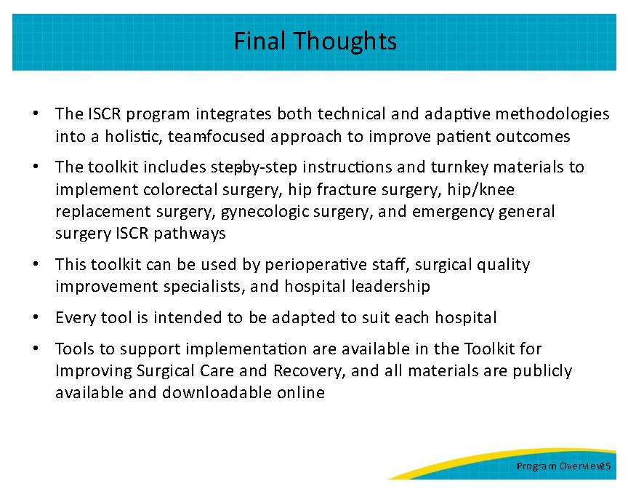
Thank You!  Thank you for your time today. Do you have any questions?  If you want to know more about the ISCR program, my contact information is listed on this slide. | Slide 16  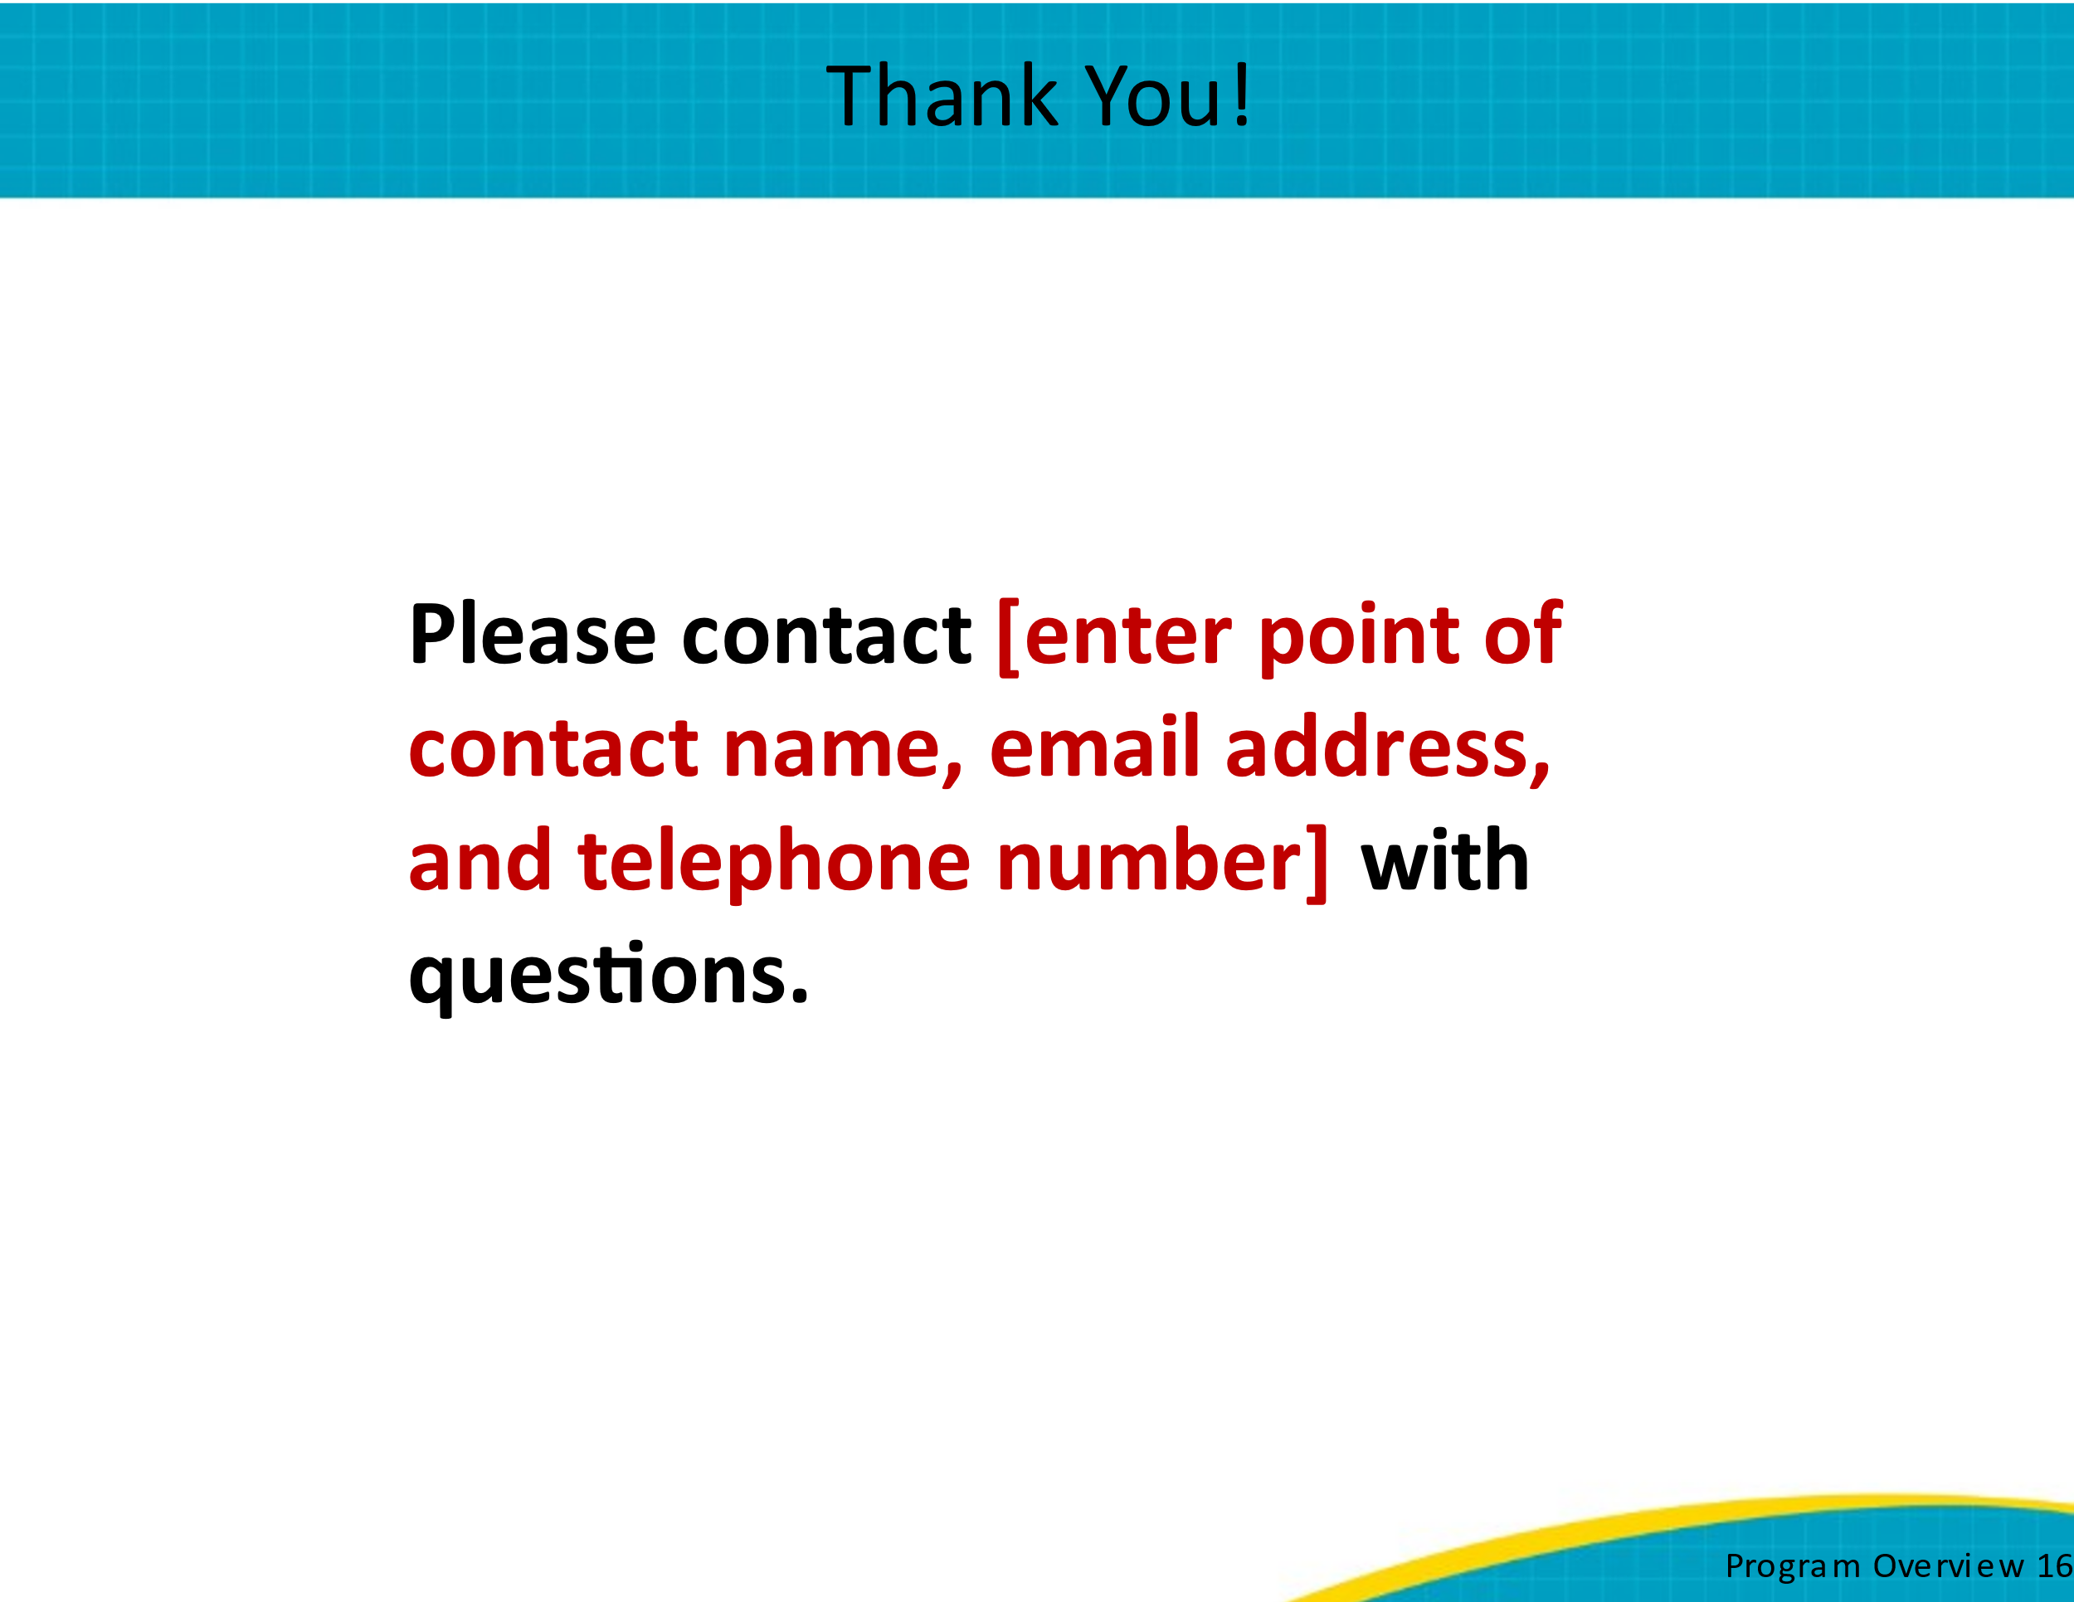
References  References for this presentation are listed on slides 17 and 18. | Slide 17  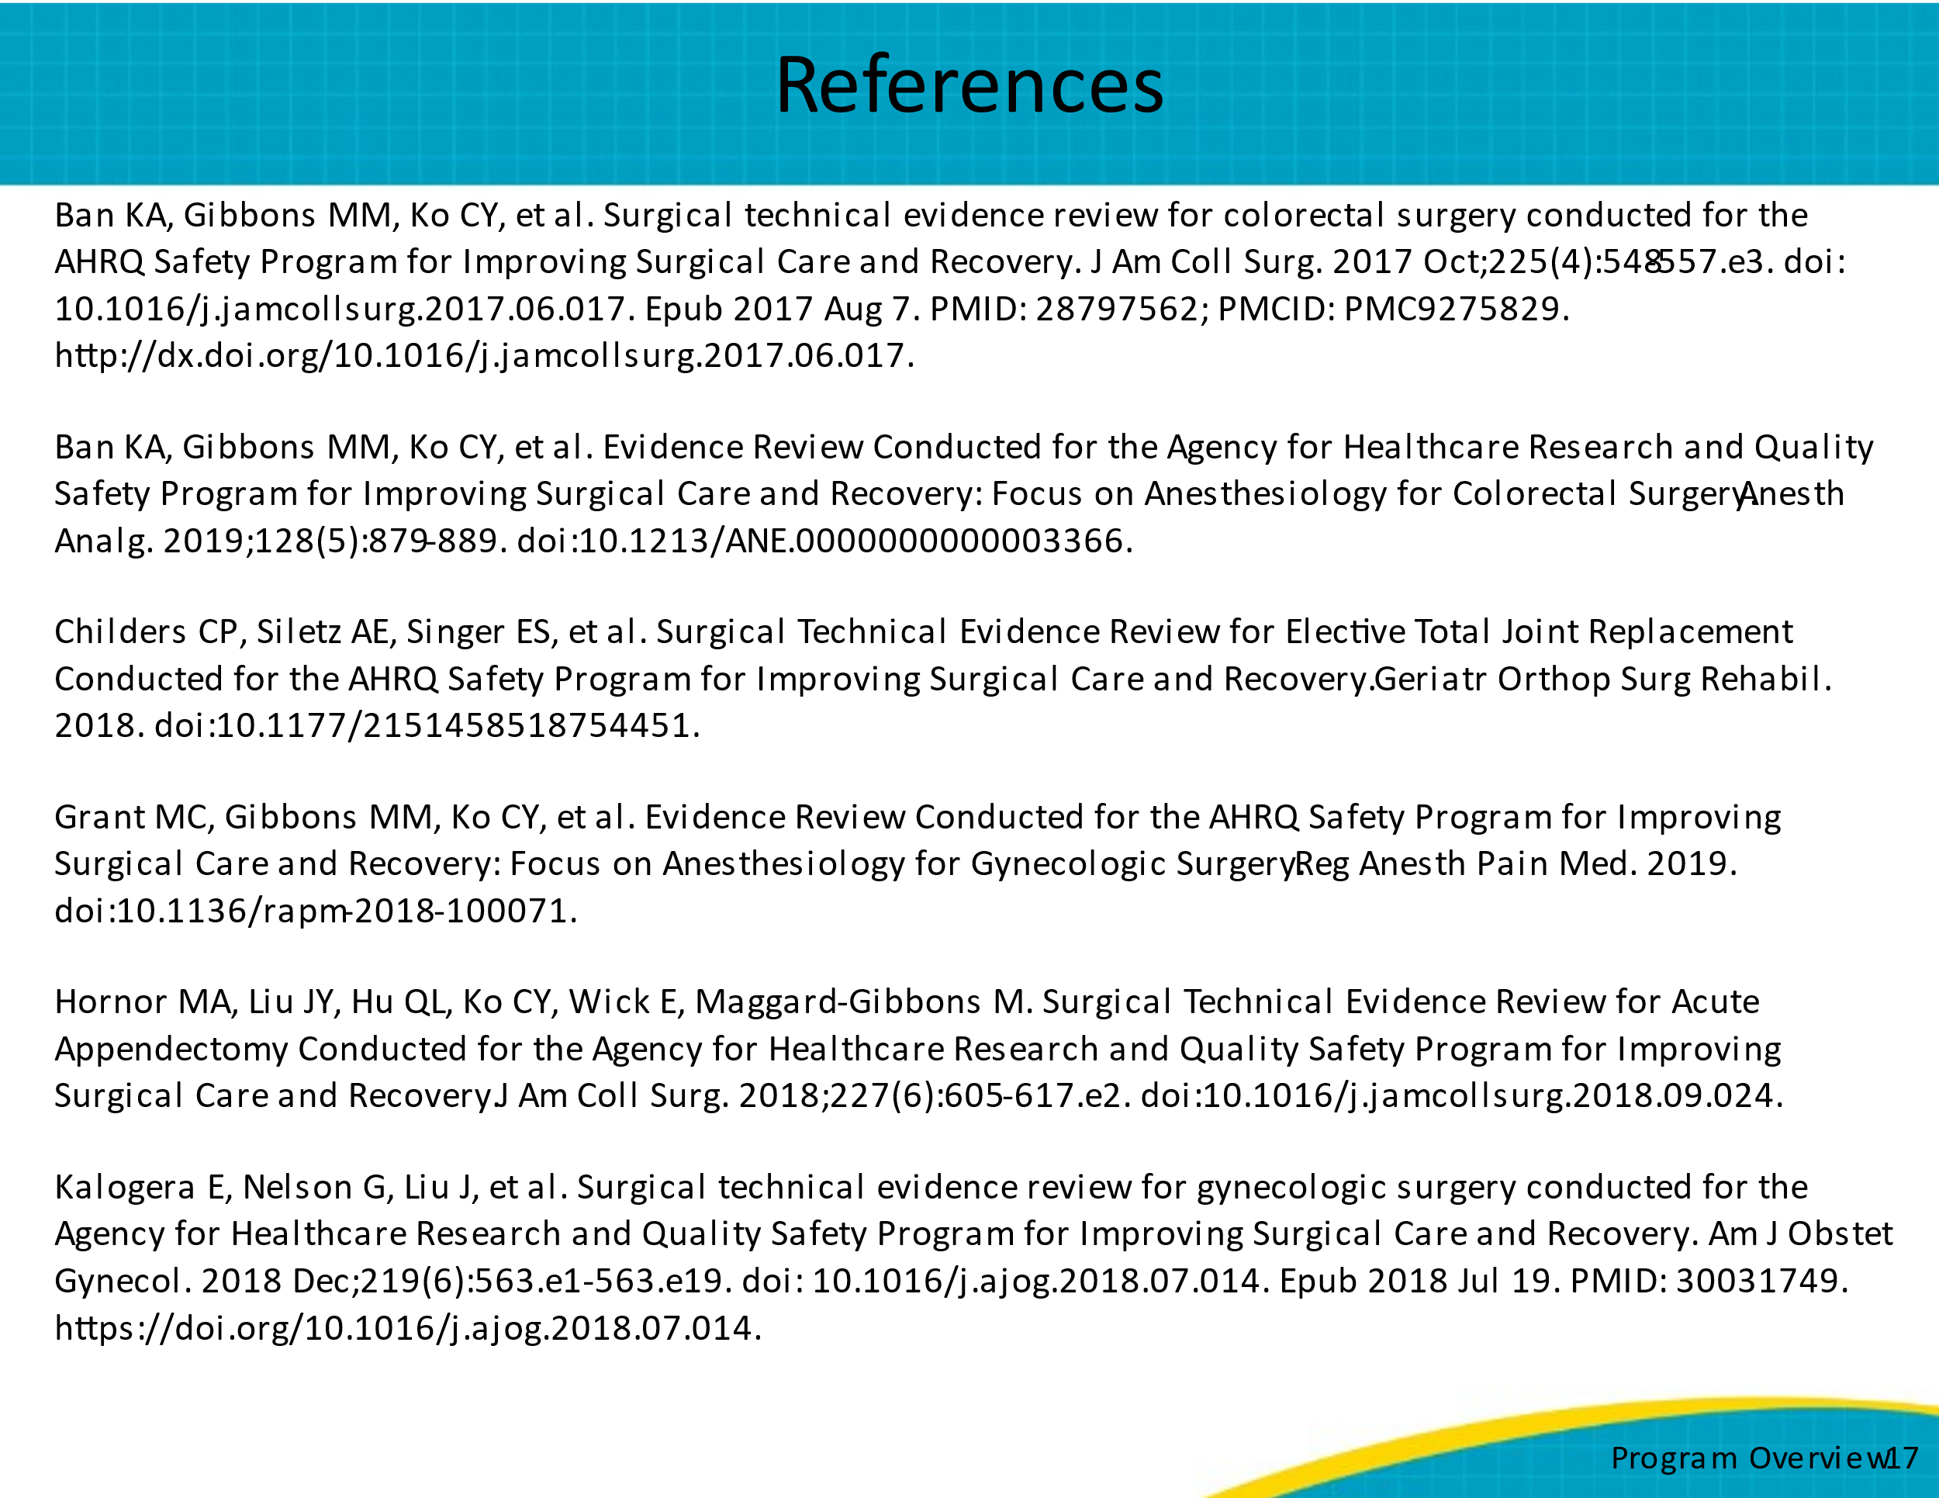
References  Here is the second half of the references. | Slide 18  