Oral Antibiotics and Mechanical Bowel Prep for SSI Prevention for Colorectal Surgery: Facilitator Guide
AHRQ Safety Program for Improving Surgical
Care and Recovery
Slide Title and Commentary | Slide Number and Slide
Title slide: Oral Antibiotics and Mechanical Bowel Prep for SSI Prevention for Colorectal Surgery  Hello, and thank you for joining me. Today I will provide you with an overview of the use of oral antibiotics and mechanical bowel preparation to help reduce surgical site infection, SSI, in colorectal surgery. This practice is one component of the Agency for Healthcare Research and Quality’s Safety Program for Improving Surgical Care Recovery, or ISCR. We’ll review a bit of the history for a better understanding of our practices today. | Slide 1  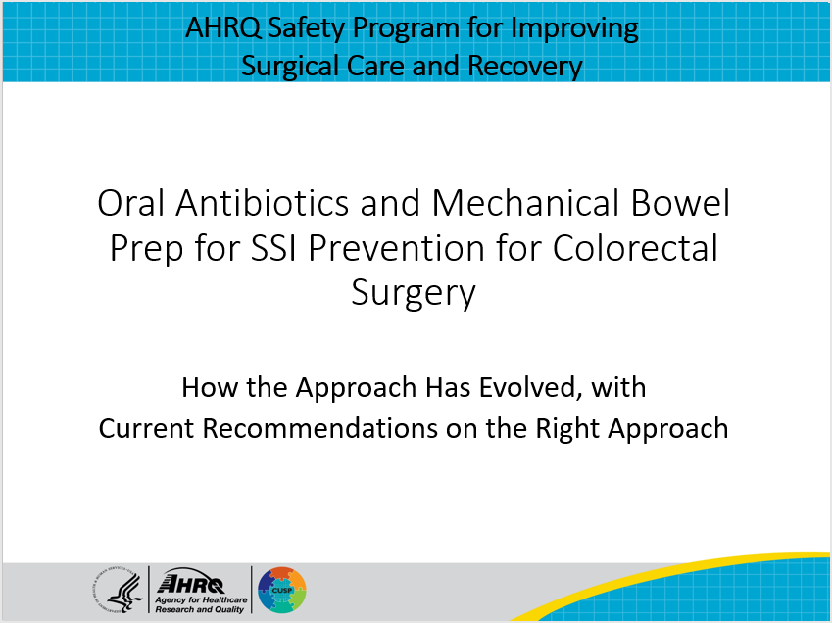
Antibiotic and Mechanical Bowel Prep in the 1970s  The issue of mechanical bowel prep and oral antibiotics before scheduled colorectal procedure is one that has generated considerable confusion and misunderstanding among U.S. and Canadian surgeons.  In the early 1970s, it was assumed that all colon procedures should be preceded by mechanical cleansing of the bowel, while oral antibiotics were not typically used.  However, a 1971 study by Dr. Ron Nichols showed that mechanical bowel prep did not reduce the quantity of bacteria found on the mucosa of the colon. Between 1974 and 1979, four high-quality prospective randomized trials revealed statistically and clinically significant reduction in colorectal SSI when preoperative oral antibiotics were combined with mechanical bowel prep in the absence of intravenous antibiotic prophylaxis.  It was at this time that many surgeons began providing both bowel prep and oral antibiotics for their patients. | Slide 2  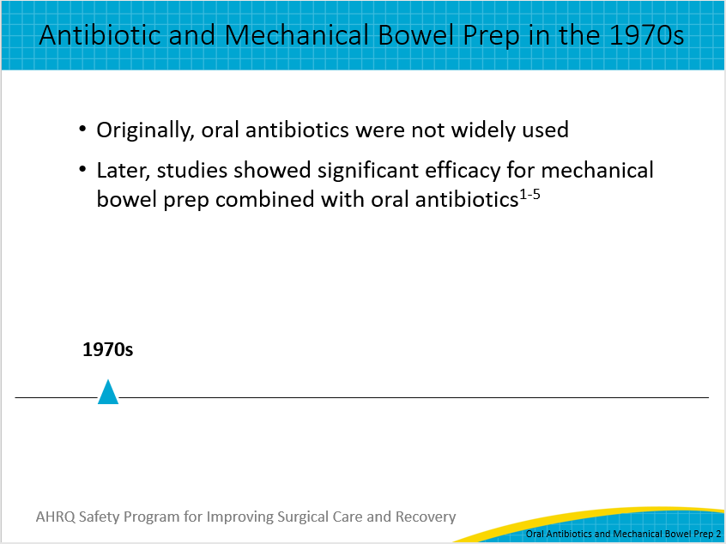
Antibiotic and Mechanical Bowel Prep in the 1980s  As expected, some surgeons wondered whether both oral and intravenous antibiotics, a widely used method of bowel prep, were needed or whether one was superior to the other. This led to a seriously flawed study in England by a prominent colorectal surgeon who compared an effective intravenous prophylactic regimen with a flawed oral preoperative regimen and saw a significant difference favoring intravenous prophylaxis. Following this, most surgeons in Europe abandoned preoperative oral antibiotic regimens. Use of oral antibiotics in the United States became controversial, and prophylactic guidelines were followed approximately half of the time. | Slide 3  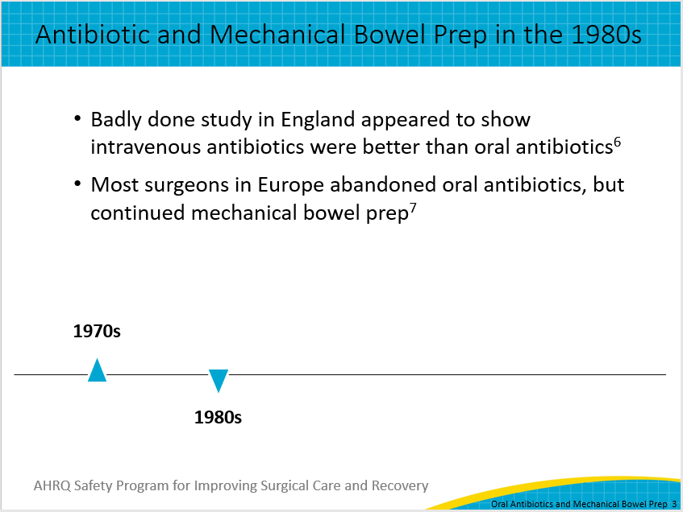
Antibiotic and Mechanical Bowel Prep in the 1990s  Beginning in the 1990s, a number of studies were performed in Europe comparing preoperative mechanical bowel prep with no mechanical prep, with all patients getting intravenous prophylaxis and none getting oral antibiotics, and these trials, once again, showed no advantage for the mechanical prep. Despite this, mechanical bowel prep remained the standard of care for patients undergoing elective colorectal surgery in the United States and Europe. | Slide 4  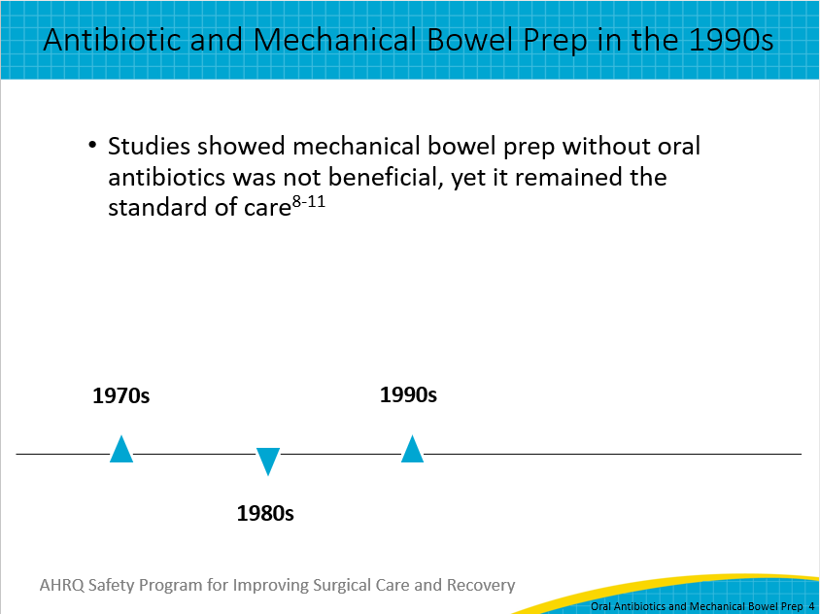
Antibiotic and Mechanical Bowel Prep in the 2000s  Subsequently, there have been a series of Cochrane Reviews confirming that mechanical bowel prep when administered with only intravenous prophylactic antibiotics does not reduce infectious complications. At the same time, a series of Cochrane Reviews by Nelson et al. have shown that when you compare patients receiving mechanical bowel prep and intravenous prophylactic antibiotics with patients who are given preoperative oral antibiotics, mechanical bowel prep, and intravenous prophylactic antibiotics, the addition of oral antibiotics results in a predictable 50 percent reduction in surgical site infections. | Slide 5  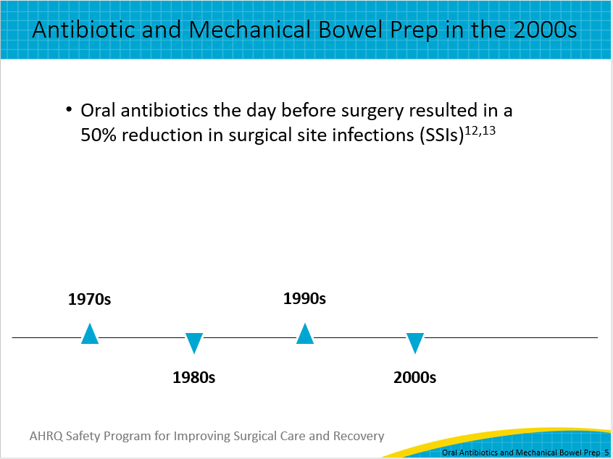
Antibiotic and Mechanical Bowel Prep in the 2010s  Between 2010 and 2020, in the United States multiple observational studies employing very large databases with thousands of colorectal surgical patients and highly reliable data such as the Michigan Surgical Quality Collaborative, the Veterans Affairs Surgical Quality Improvement Program, and National Surgical Quality Improvement Program consistently demonstrated roughly 50 percent reductions in SSIs when patients receiving oral antibiotics were compared with those without oral antibiotics. Another surprising fact to note in those reports is that up to 43 percent of patients continued to receive a mechanical bowel prep without oral antibiotics. This protocol resulted in SSI rates similar to having no bowel prep at all.  And finally, a 2018 meta-analysis from Toh and colleagues compared mechanical bowel prep and oral antibiotics with oral antibiotics alone, mechanical bowel prep alone, or no preparation, all combined with intravenous antibiotic prophylaxis before incision. Their findings added to the evidence showing that mechanical bowel prep combined with oral antibiotics and intravenous antibiotic prophylaxis before incision is associated with the lowest risk of surgical site infection. | Slide 6  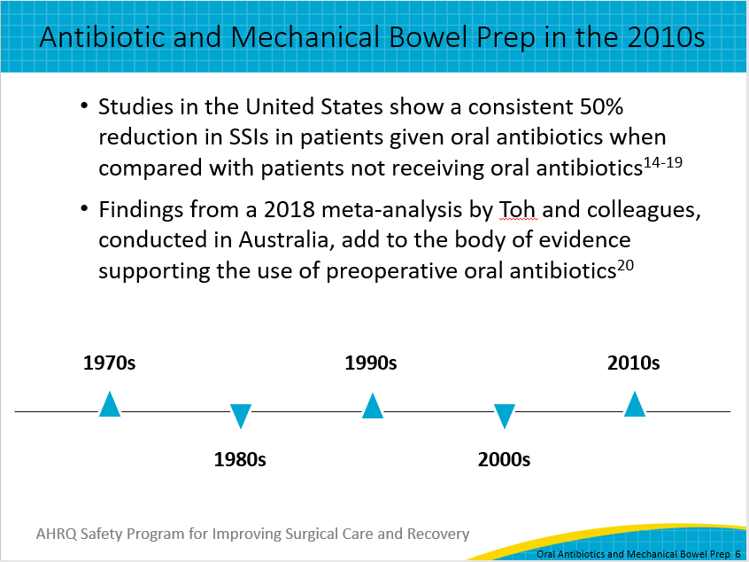
Current ISCR Recommendation and Guidelines  To reduce surgical site infections in patients undergoing colorectal or gynecologic procedures with a planned bowel resection, the ISCR program supports an approach that combines mechanical bowel preparation with oral antibiotics.  Evidence-based guidelines published in 2017 and 2019 have more information about mechanical bowel preparation and oral antibiotics protocols and can be found at the two websites listed on the slide. Citations are listed on the References slides.  The first is from the Centers for Disease Control and Prevention’s Healthcare Infection Control Practices Advisory Committee, or HICPAC.  The second is from the American Society of Colon and Rectal Surgeons. This link will take you to the landing page for its Clinical Practice Guidelines, where you can find its 2019 guidelines for the use of bowel preparation in elective colorectal surgery. Updates will be added to this main landing page.  These recommendations and guidelines are intended to be adapted locally based on collective review by stakeholders including surgeons, nurses, pharmacists, and other healthcare providers. | Slide 7  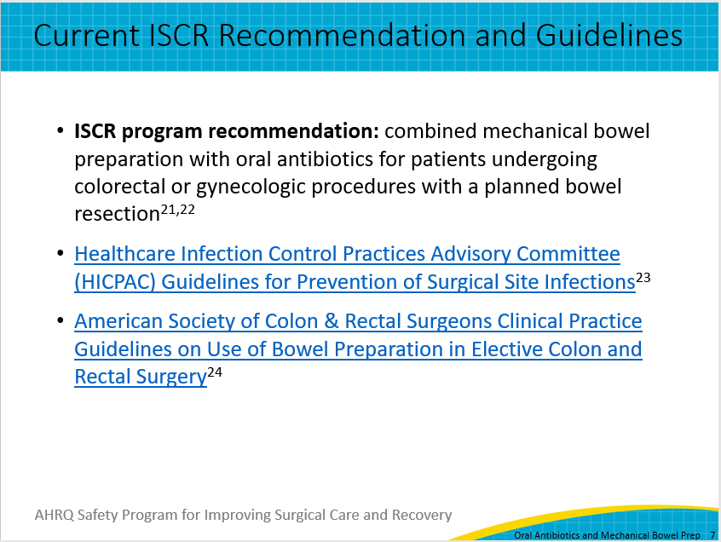
Ongoing Studies To Watch  There are ongoing studies to watch that may reinforce or result in changes to guidelines in the future.  The first is a randomized controlled trial titled, Is Mechanical Bowel Preparation Necessary to Reduce Surgical Site Infection Following Colon Surgery? This study compares SSI rates following colon surgery when a combination of intravenous antibiotics, mechanical bowel preparation, and oral antibiotics is used versus the use of just intravenous antibiotics and oral antibiotics, omitting mechanical bowl preparation. This study is expected to conclude in March 2026.  The second is also a randomized controlled trial titled Mechanical Bowel Preparation and Oral Antibiotics Versus Mechanical Bowel Preparation Only Prior Rectal Surgery, or MOBILE2 study. This study compares mechanical and oral antibiotic bowel preparation with mechanical bowel preparation only. The estimated completion date is March 2027. | Slide 8  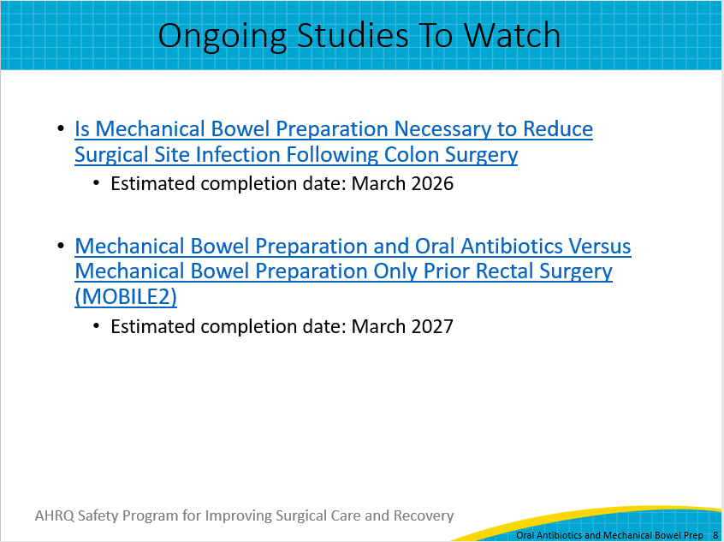
Thank You!  Thank you for your time today. Do you have any questions?  My information is listed on this slide if you have any followup questions about what I’ve shared. Please don’t hesitate to contact me by email or phone. | Slide 9  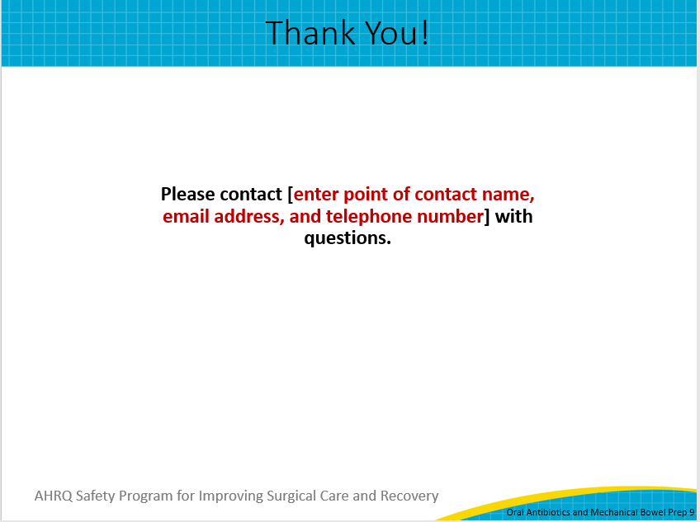
References (Part 1)  References for this presentation are included on slides 10, 11, and 12. | Slide 10  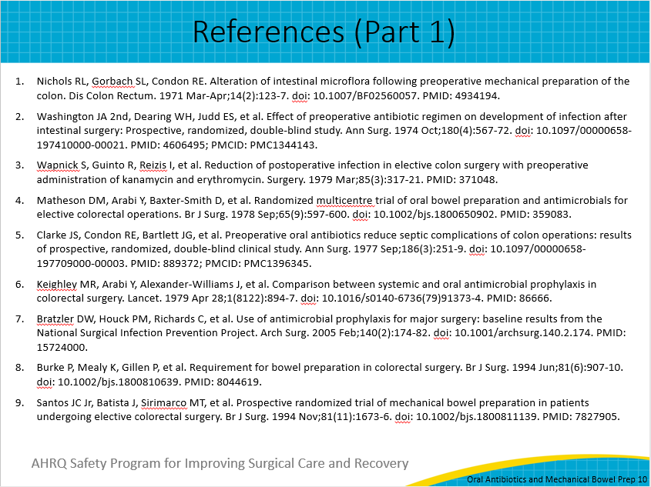
References (Part 2)  Here is the second group of references. | Slide 11  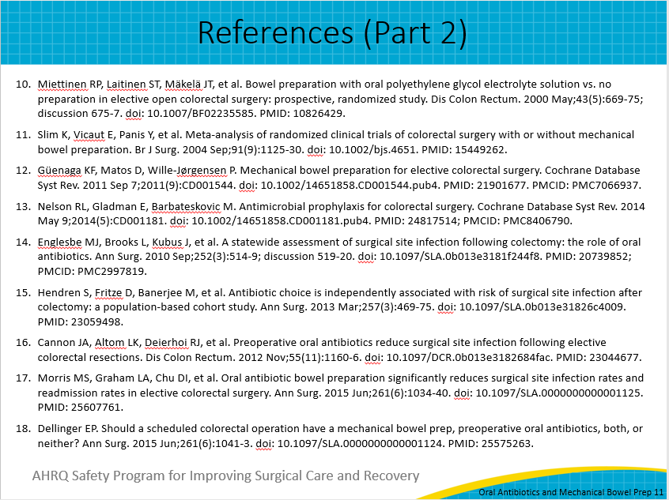
References (Part 3)  Here is the third group of references. | Slide 12  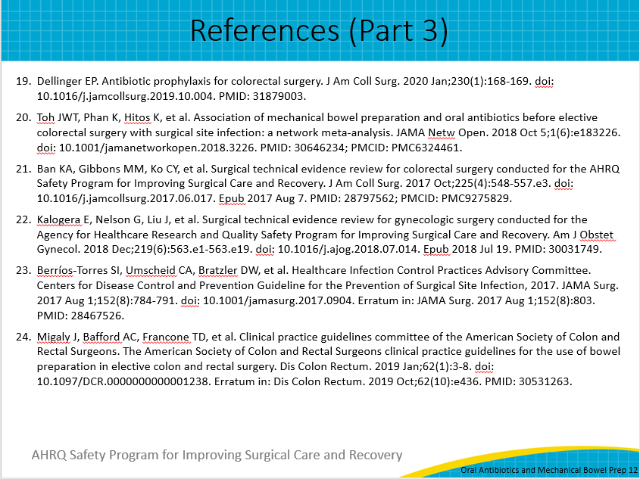
AHRQ Pub. No. 23-0052
June 2023

