Multimodal Analgesia Tips: Facilitator Guide
AHRQ Safety Program for Improving
Surgical Care and Recovery
Slide Title and Commentary | Slide Number and Slide
Title slide: Multimodal Analgesia Tips  Hello and thank you for joining me. Today I will be providing some useful tips to help you adopt multimodal analgesia concepts from the Agency for Healthcare Research and Quality, AHRQ, Safety Program for Improving Surgical Care and Recovery, or ISCR, into your practice. These concepts were developed based on evidence reviews conducted for the ISCR program as well as other enhanced-recovery reviews. | Slide 1  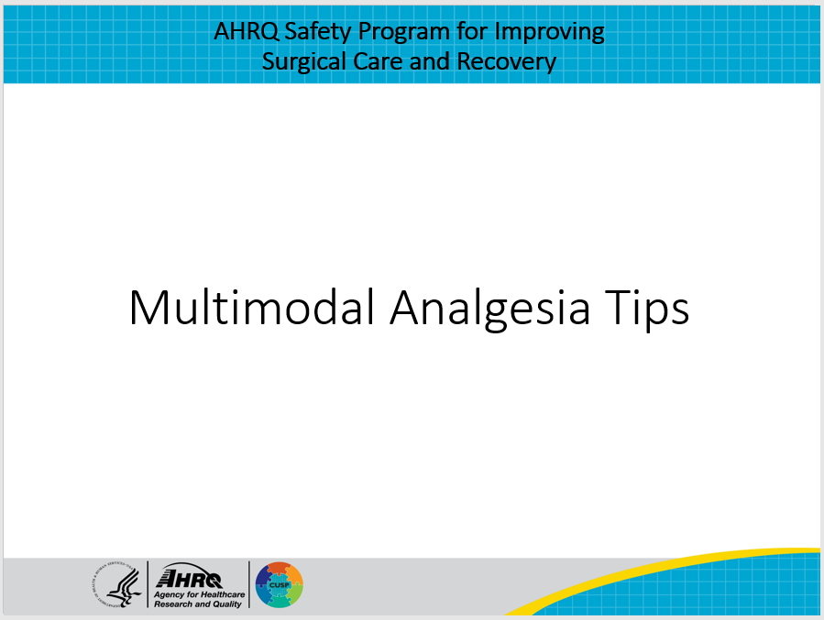
Defining Multimodal Analgesia  Multimodal analgesia, in essence, is the use of a combination of different drugs or techniques which will provide pain relief through different mechanisms or modes of action. Although perioperative multimodal analgesia typically refers to the use of nonopioids, with the goal to minimize overall opioid use and therefore decrease opiate related side effects and facilitate patient recovery, strategic use of opioids, where necessary, are still appropriate if administered in a thoughtful fashion. | Slide 2  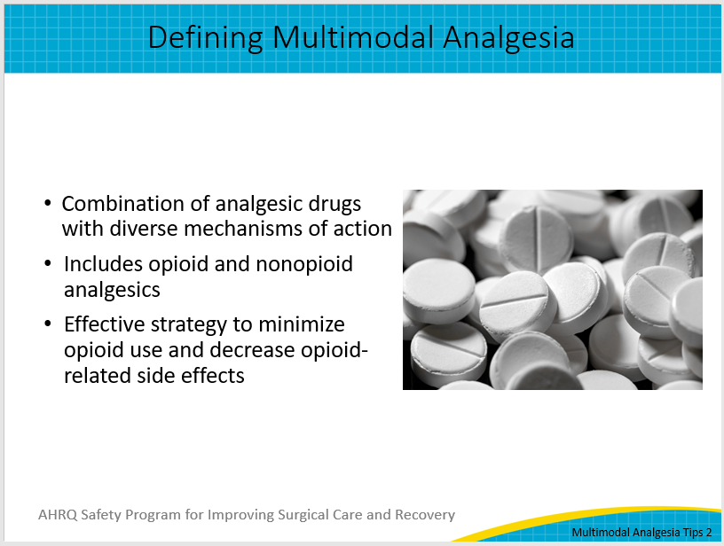
Multimodal Analgesia Strategies  Many commonly used analgesic agents and techniques can be incorporated throughout each the perioperative phases of care, including the pre-, intra- and postoperative settings. While we won't have time to discuss all of them, we'll try to hit some of the highlights. These include: nonsteroidal anti-inflammatory drugs or NSAIDs, acetaminophen, gabapentinoids—which may include gabapentin and pregabalin, other agents such as tramadol, ketamine, and dexmedetomidine. There are also various regional analgesia techniques which may include neural axial and peripheral nerve blocks. | Slide 3  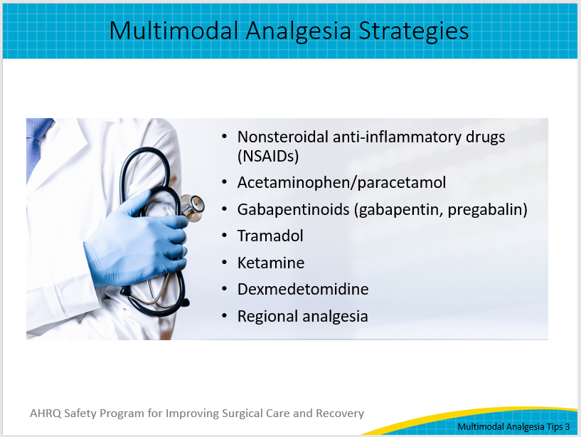
NSAIDs and Acetaminophen  NSAIDs and acetaminophen are the backbone of the multimodal analgesic approach. They are most effective when administered on a scheduled rather than on an as-needed basis, or PRN, and their combination provides at least an additive, if not synergistic, effect on efficacy. Unless there are contraindications, for instance, hepatic insufficiency for acetaminophen, or history of severe renal or gastrointestinal bleeding issues for NSAIDs, your first-line agents for multimodal pain management should include these two agents. | Slide 4  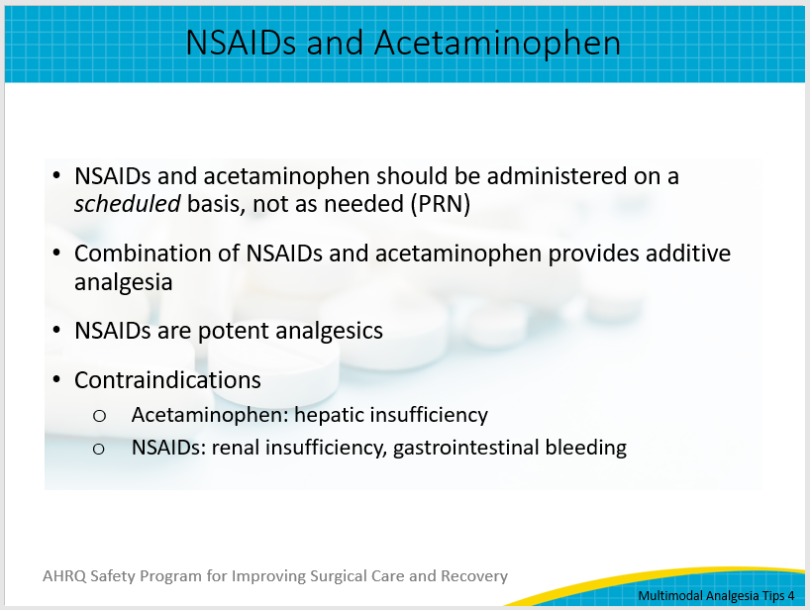
Single-Dose Analgesics  What is often misunderstood is how effective NSAIDs and acetaminophen are for analgesia. This slide shows the relative potencies, expressed as NNT or the number of patients needed to treat to achieve a meaningful reduction in pain, of certain single-dose analgesics, or single-dose combination analgesics in the case of codeine and acetaminophen. For reference, an NNT less than 4 has strong efficacy for pain management. As you can see, even though ibuprofen or acetaminophen are available over the counter, these agents are quite potent. In fact, as indicated in the two red entries in the slide, 600 mg of ibuprofen provides similar pain relief to about 15 mg of oxycodone. As a result, these medications are as effective as opioids when provided in sufficient doses and should be considered first-line therapy for pain management. | Slide 5  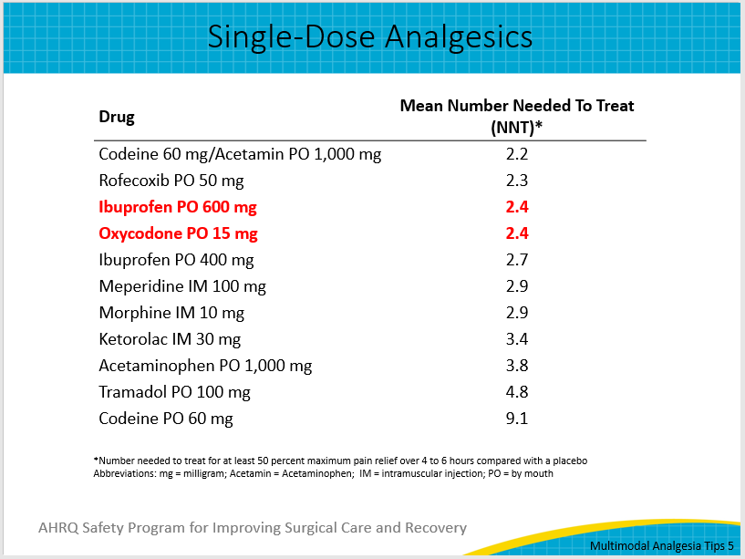
Gabapentinoids and Tramadol  Two other commonly utilized agents include gabapentinoids (gabapentin/pregabalin) and tramadol. These are weaker analgesics, although they may still play a role in multimodal analgesia given that their mechanism of action differs from those of other analgesics, including opioids. While these agents may play a role, their use comes with some important caveats. Gabapentanoids are renally excreted, and dosing should be adjusted based on a patient’s kidney function and age. They can also be very sedating, and a recent meta-analysis revealed a significant risk of respiratory depression with their use. Tramadol, which has a weak opioid receptor activity compared to morphine, works primarily through the blockade of reuptake of serotonin and norepinephrine. As a result, tramadol should be avoided in patients with a history of seizures or those taking antidepressants such as selective serotonin reuptake inhibitors (SSRIs). The use of tramadol in such patients may cause a life-threatening reaction called serotonin syndrome. In this situation, confusion, fever, hypertension, and high heart rate may result from the interaction between two serotonergic drugs that work by different mechanisms. | Slide 6  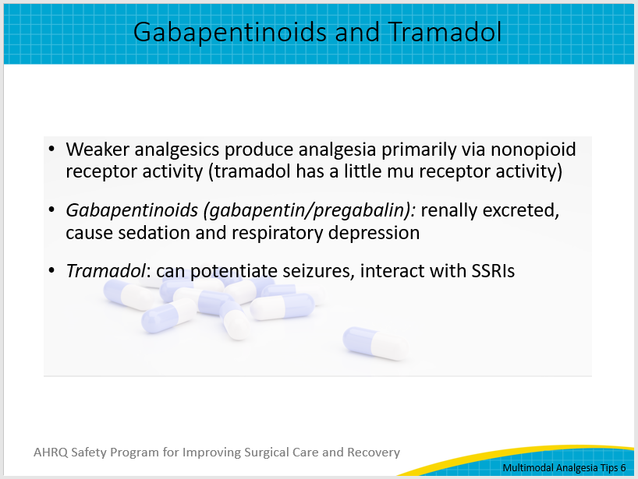
Ketamine and Dexmedetomidine  The majority of perioperative pain can be reasonably managed with the use of the agents we have already mentioned. However, if pain remains poorly managed or patients present with a history of chronic opioid use, additional medications can employed. Ketamine, an N-methyl-D-aspartate (NMDA) receptor antagonist, is typically provided as a low-dose infusion to avoid side effects. The most troubling of these is hallucinations, which may occur when ketamine is administered at excessive levels.  Dexmedetomidine, whose alpha2 agonist action closely mimics that of clonidine, has been shown to reduce opioid requirements when administered as a low-dose, titratable infusion. Its primary side effects include hemodynamic instability, particularly when provided as a bolus rather than an infusion. Both ketamine and dexmedetomidine are best administered under the close guidance of pain management professionals and, as mentioned, are best applied when pain is poorly controlled using first- or second-line agents. | Slide 7  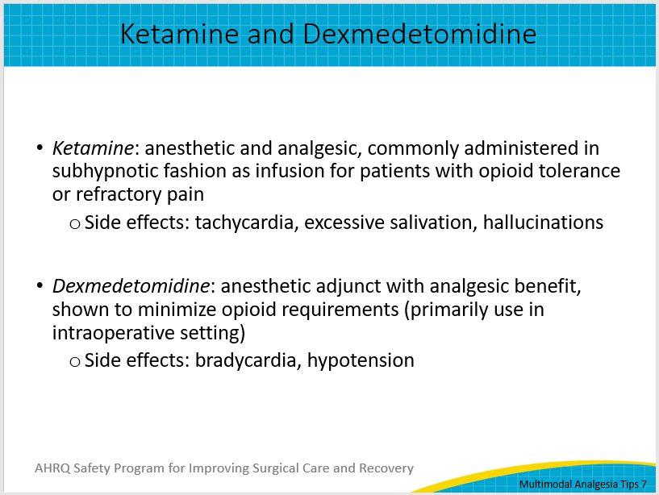
Regional Analgesic Techniques  Finally, no discussion of multimodal analgesia is complete without mentioning regional analgesia, which includes both neuraxial (epidural and spinal) and peripheral nerve block techniques. The data consistently show that these techniques provide superior pain control while minimizing the need for opioid use. Typically, these regional analgesic techniques include primarily using local anesthetic that can be administered at the site as a single dose or using catheter-based techniques. Catheter-based regional analgesia thus provides a long-term benefit. Particularly for neuraxial regional pain control, providers must be aware of the concurrent use of anticoagulation (even venous thromboembolism prophylaxis) because it can potentially cause devastating neurological injury in the form of epidural hematoma. | Slide 8  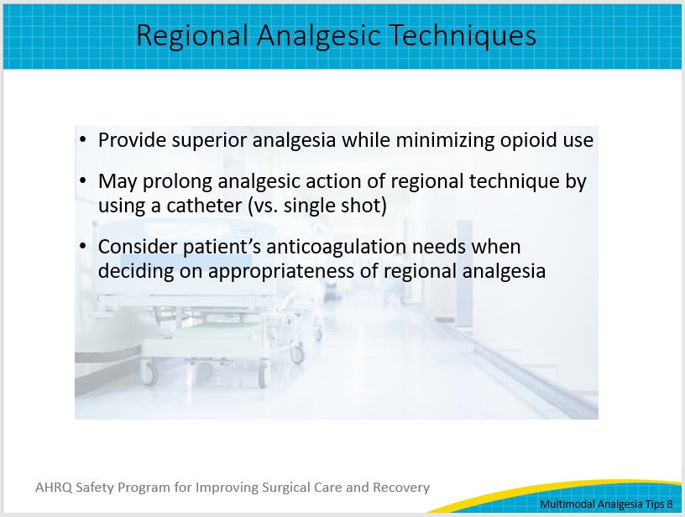
Final Thoughts  In closing, multimodal analgesia has been shown to provide better pain control than single-agent alternatives while minimizing opiate-related side effects and facilitating patient recovery.  Remember that each agent and technique have a unique benefit-to-risk profile, which should be tailored to each individual's patient's needs.  For additional information on multimodal analgesia options, please read the various evidence reviews conducted by the AHRQ Safety Program for Improving Surgical and Recovery Program, listed on the references slide, and visit the toolkit website for more resources to help you implement your ISCR program. | Slide 9  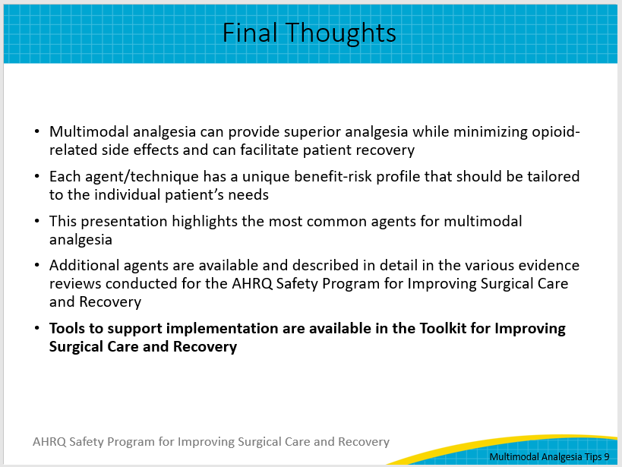
Thank You  Thank you for your time today. Do you have any questions?  If you want to know more about the ISCR program, my contact information is listed on this slide. | Slide 10  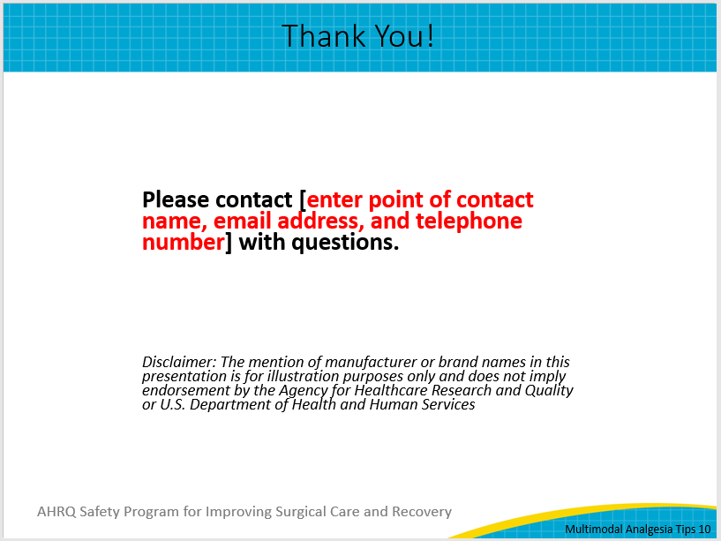
AHRQ Pub. No. 23-0052
June 2023

