Regional Analgesia for Total Hip Arthroplasty and Total Knee Arthroplasty: Facilitator Guide
AHRQ Safety Program for Improving
Surgical Care and Recovery
Slide Title and Commentary | Slide Number and Slide
Title slide: Regional Analgesia for  Total Hip Arthroplasty and Total Knee Arthroplasty  Hello, and thank you for joining me. Today I'll be discussing regional analgesia for total knee and total hip replacement surgery, components of the Agency for Healthcare Research and Quality’s, or AHRQ’s, Safety Program for Improving Surgical Care and Recovery, or ISCR. The ISCR program provides evidence-based recommendations for perioperative care. | Slide 1  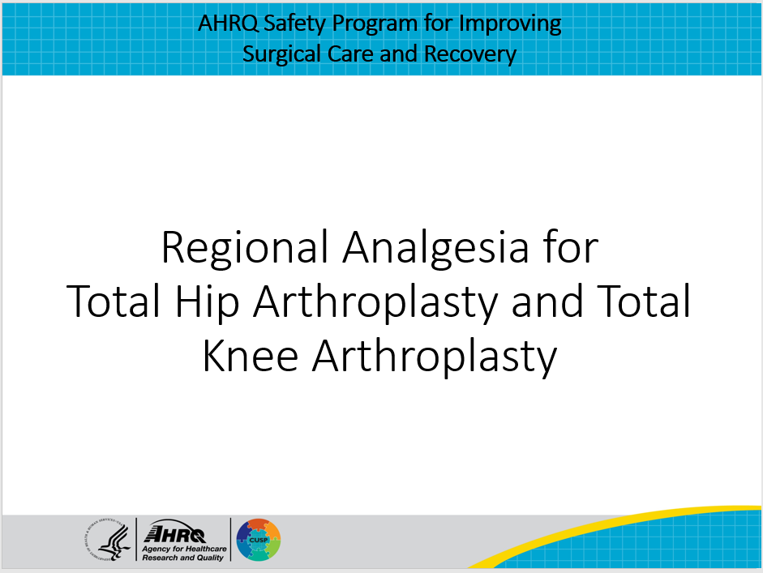
Why Use Regional Analgesia?  Regional analgesia is commonly employed to optimize pain management as it involves the administration of local anesthetic directly to the nerves that carry pain impulses. This reduces reliance upon opioid-based medications, which have a number of unwanted side effects, including nausea/vomiting, constipation, and respiratory depression. Regional is ideal for orthopedic procedures because it can target discrete surgical incisions and the anatomy is predictable. Finally, both elective and nonelective procedures are amenable to regional analgesia provided the patient doesn’t have certain contraindications, which are discussed later in this presentation. | Slide 2  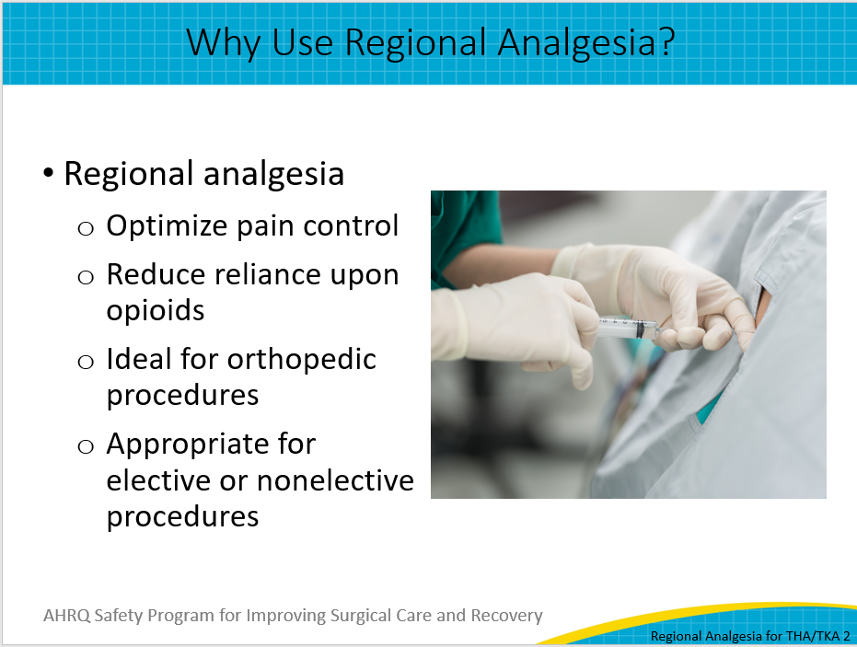
Types of Regional Techniques  When you consider the use of regional analgesia techniques for both elective hip and knee replacement surgery, note that there are two broad categories: neuraxial, which includes epidurals and spinals, and peripheral nerve blocks. Epidurals and spinals provide a broad, indiscriminate blockade to nerves below the level where they are placed, whereas peripheral nerve blocks specifically target a nerve or group of nerves and provide more discrete coverage. For example, if you look to target the femoral nerve distribution, you might consider the lumbar plexus, femoral, or abductor canal block. If, however, you wish to target the sciatic distribution, you might consider the sciatic or popliteal nerve blocks. | Slide 3  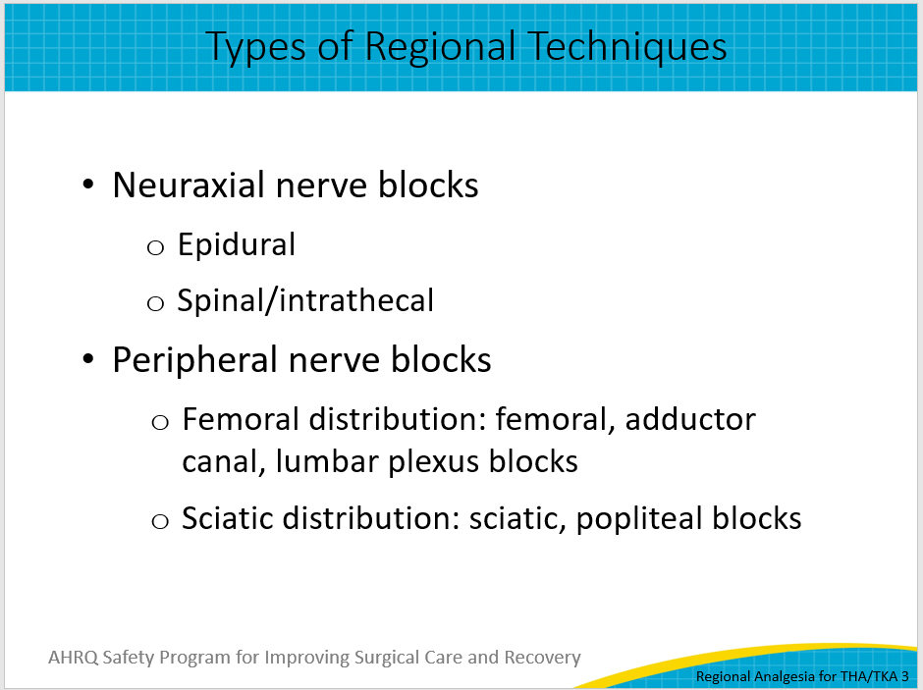
What Block To Use? (Part 1)  When deciding what type of block one should use, there are several major factors to consider. These include the match of the anatomical nerve distribution of a block to the surgical site, the side effect profiles for each block, and finally your own local expertise and resources. | Slide 4  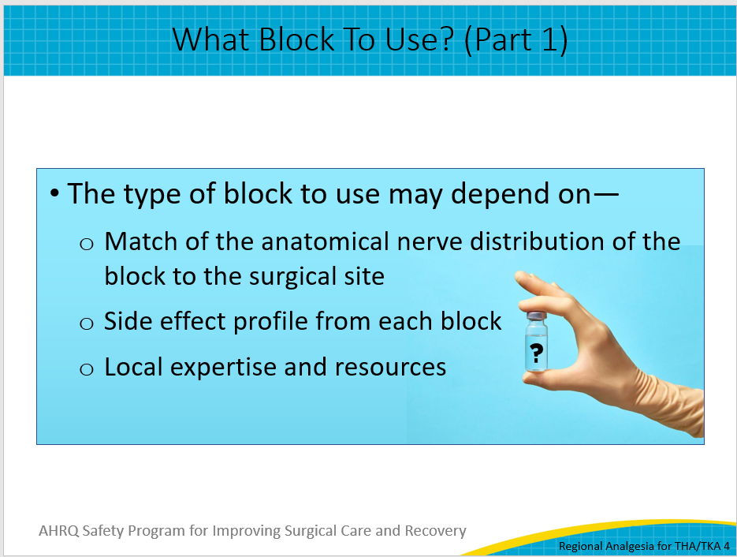
What Block To Use? (Part 2)  Something important to remember is to match the anatomic distribution of the block to the surgical site. Hip and knee replacement surgeries require coverage of slightly different nerve distributions.  Providers may choose a neuraxial technique, which blocks all nerves from that level of the spine downward, in order to cover each of these surgical approaches. This technique is often technically more straightforward than a peripheral nerve block, but won’t specifically block a single nerve distribution area.  Therefore, if you desire to only specifically cover the side and site of the incision for a hip replacement, which primarily involves the femoral nerve distribution, you would perform a peripheral femoral nerve block. A knee replacement, in contrast, requires both the femoral nerve and sciatic nerve to be covered and therefore may require two separate peripheral nerve-blocking techniques.  As you can see, several regional options are available to appropriately cover these two types of procedures. The decision to use one technique over another will therefore depend on the potential side effects of those regional techniques and your local resources and expertise. | Slide 5  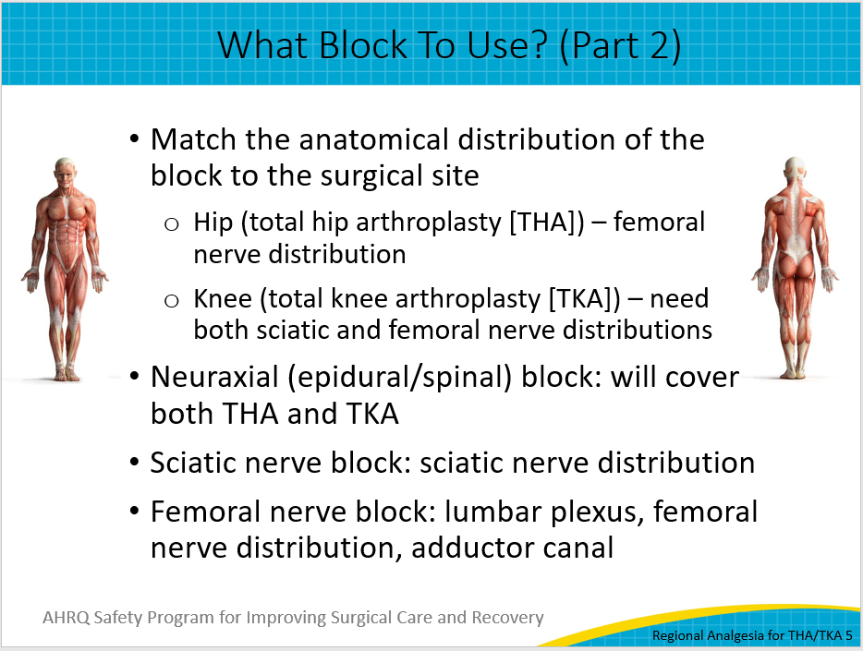
Side Effect Profile  Aside from the nerve distribution, one must also consider the side effect profile of each block type. The individual agents used in the block injectate can cause their own side effects, including hypotension for local anesthetics, nausea/vomiting and itching for opioids, and more. But the site of action of a nerve technique carries additional considerations. Neuraxial blocks can lead to decreased blood pressure and profound motor nerve block, which may not be desirable for certain patients. Peripheral nerve blocks have fewer of these side effects because of more precise selection of the desired nerve distribution. Depending on the peripheral nerve block, unilateral motor weakness can result, though rarely to the same extent as is found with neuraxial analgesia. | Slide 6  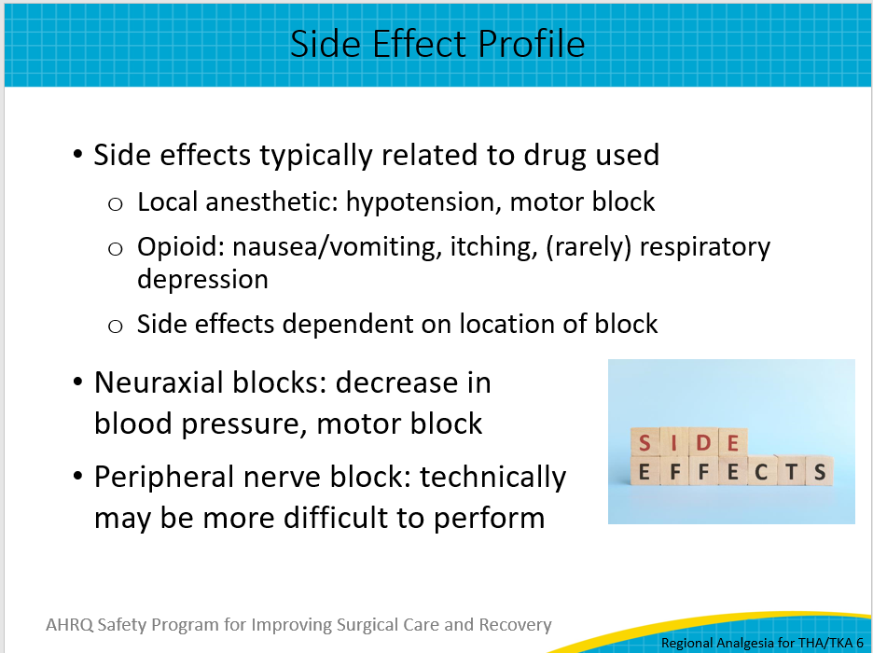
Local Expertise and Resources  One of the most important considerations in considering what block to use is the availability of local expertise and resources. Not every clinician is fully trained or comfortable with providing these blocks, and often subspecialty training is desirable to be proficient in them. To properly manage patients with indwelling catheters (either epidural or peripheral nerve catheters) or intrathecal opioid administration, it is necessary to have appropriate monitoring and followup. It is also true that peripheral nerve blocks require even more technical training and even ultrasound guidance to ensure success, which may represent an additional barrier to their adoption. Given the labor and resource-intensive aspects of regional analgesia, certain institutions may not be fully equipped to adopt a broad regional analgesia program to their individual service lines. Thus, it is important to tailor your choice of regional analgesia based on not only what you have and what your experts are comfortable with, but also what the hospital has in terms of resources and coverage. | Slide 7  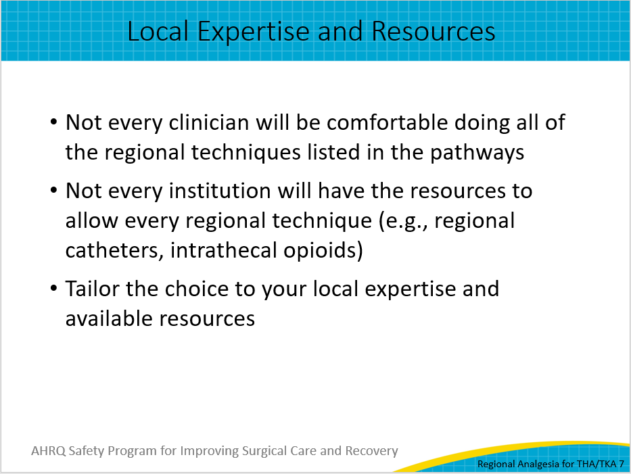
Anticoagulation  One particularly vital aspect to consider is the concurrent use of anticoagulation. Certainly, patients who undergo joint replacement surgery are at an elevated risk for DVT/PE, and one might anticipate that they will need perioperative anticoagulation. Guidelines from the American Society of Regional Anesthesia and Pain Medicine help guide clinicians on timing of neuraxial placement and recommendations regarding the use of regional analgesia in the setting of anticoagulation to avoid the potential risk of neurological injury from epidural hematoma formation. | Slide 8  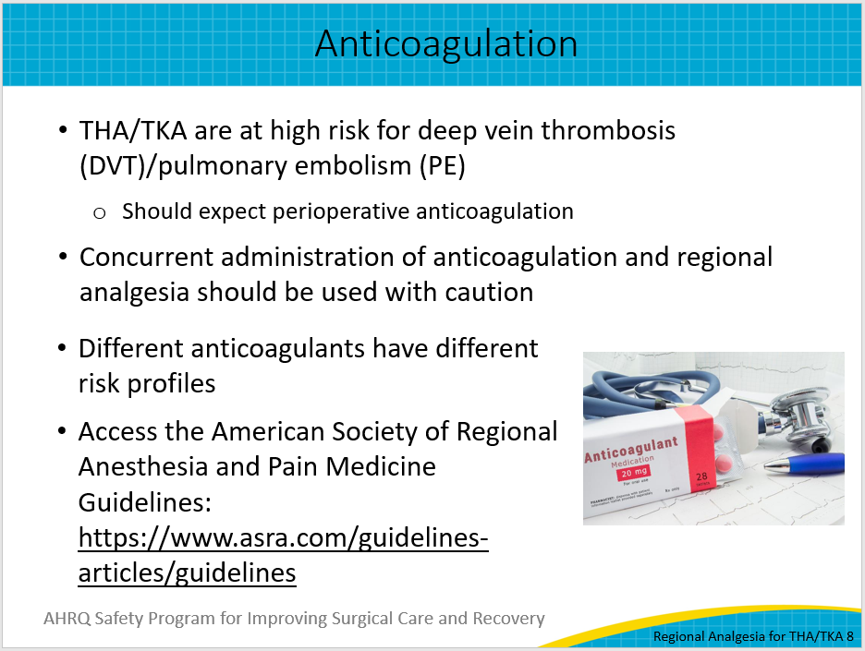
Final Thoughts  In general, the use of regional techniques is recommended, when feasible, for both hip and knee arthroplasty. The type of regional technique depends on the location of the surgery, the side effect profile of the agents, and the constraints of your local institution. Caution is necessary, particularly in the setting of concurrent use of anticoagulation.  For additional information, read the various evidence reviews conducted for the AHRQ Safety Program for Improving Surgical and Recovery, listed on the reference slide, and visit the toolkit website for more resources to help you implement your ISCR program. | Slide 9  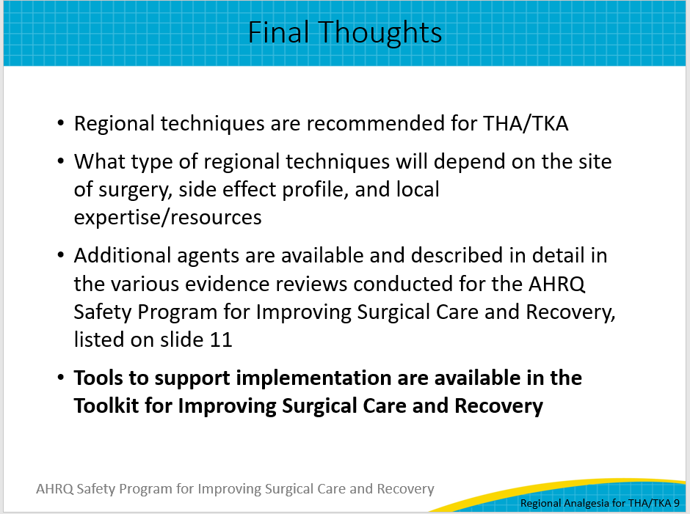
Thank You!  Thank you for your time today. Do you have any questions?  My information is listed on this slide if you have any follow-up questions about what I’ve shared. Please don’t hesitate to contact me by email or phone. | Slide 10  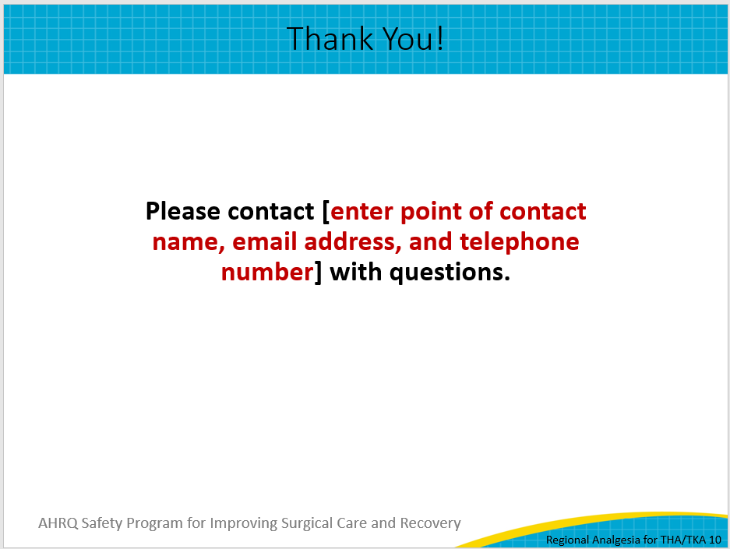
References  References for this presentation are included on slide 11. | Slide 11  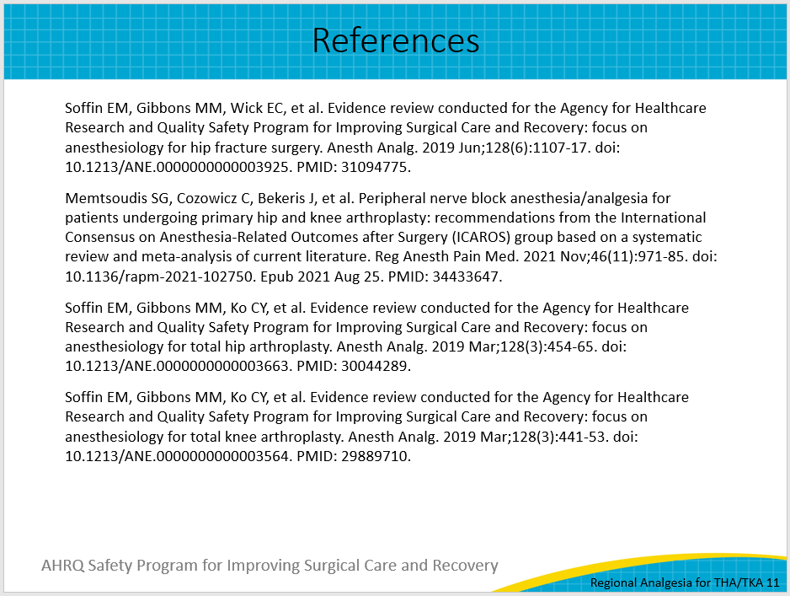
AHRQ Pub. No. 23-0052
June 2023

