AHRQ Safety Program for Improving
Surgical Care and Recovery

Facilitator Guide for Engaging Senior Executives Presentation Template
Slide Title and Commentary | Slide Number and Slide
Engaging the Senior Executive  Presentation Template  Title slide for the tool – delete this slide from the presentation to your senior executive | Slide 1  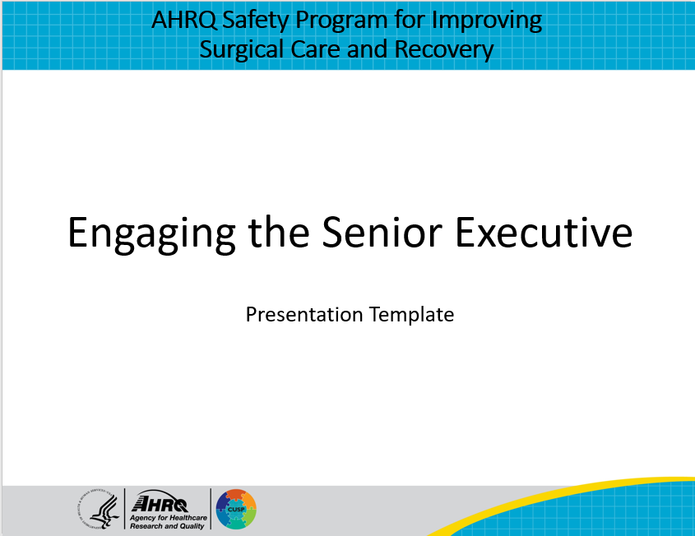
Purpose and Use of This Presentation Template  Information about this tool – delete this slide from the presentation to your senior executive | Slide 2  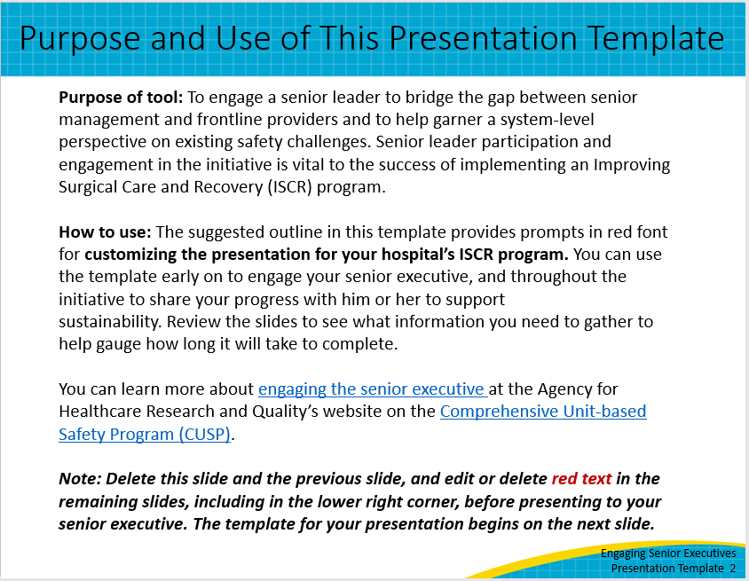
Title slide: [Hospital Name] Improving Surgical Care and Recovery of Patients: [Service Line] Pathway  Hello, and thank you for meeting with me today to discuss the Agency for Healthcare Research and Quality’s Safety Program for Improving Surgical Care and Recovery, or ISCR, initiative at [hospital name]. Today we will be reviewing the [service line] pathway. | Slide 3 of template; slide 1 of actual presentation to senior executives  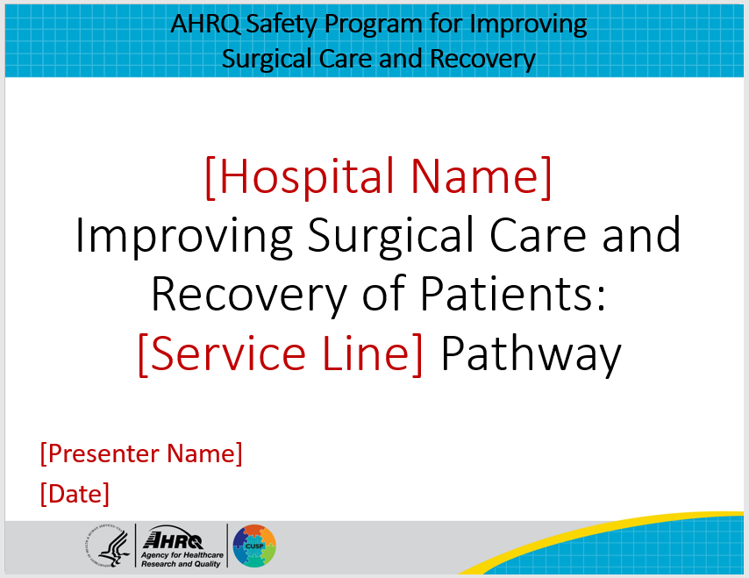
Objectives  Objectives for today’s presentation are to:  - Learn about the ISCR program;  - Review the current state of perioperative care at [insert hospital name];  - Examine changes in process compliance and outcomes;  - And discuss next steps for the ISCR initiative | Slide 4  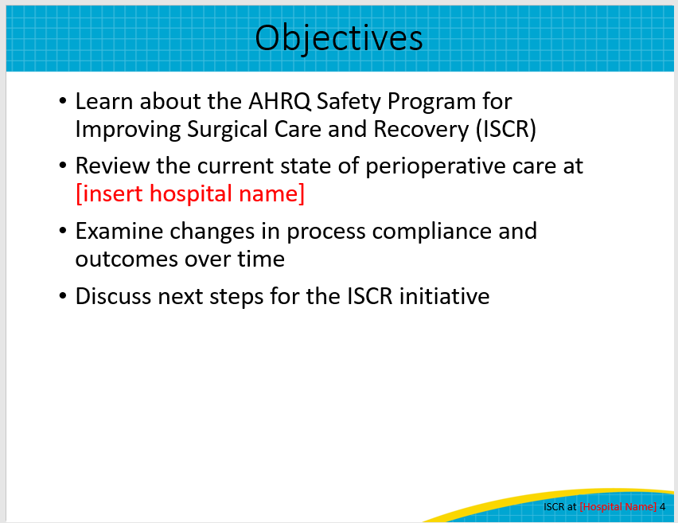
ISCR Goals  The goals of ISCR are to improve patient outcomes, make perioperative processes more efficient, and make perioperative care more collaborative with our colleagues and patients. | Slide 5  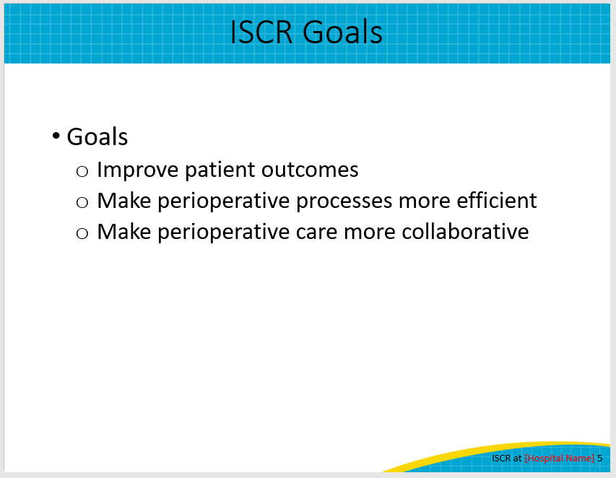
Balanced Approach to Adaptive and Technical Work  The ISCR program can help us achieve these goals through a balanced approach to the adaptive and technical components of quality improvement.  ISCR incorporates principles and methods from the Comprehensive Unit-based Safety Program (CUSP), a patient safety method that improves safety culture, teamwork, and communication to promote use of evidence-based practices.  This adaptive work is balanced by the clinical, evidence-based recommendations that were developed as part of a national collaborative with more than 340 participating hospitals nationwide. The ISCR national project team consisted of researchers and clinicians from the American College of Surgeons, University of California San Francisco, the Johns Hopkins Armstrong Institute for Patient Safety and Quality, and the AHRQ Center for Quality Improvement and Patient Safety, working with a Technical Expert Panel. | Slide 6  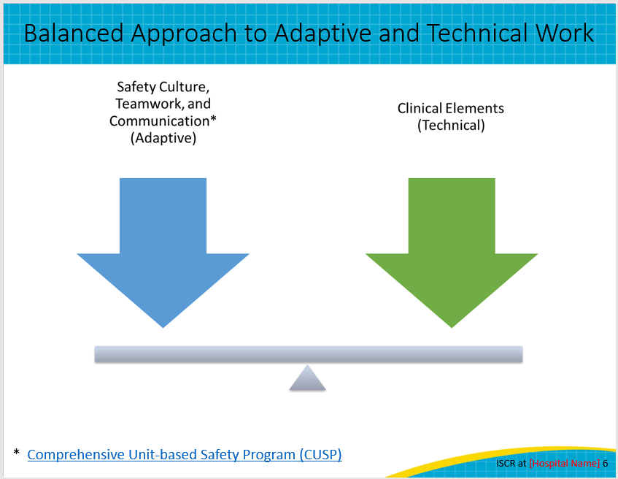
Opportunity To Improve  Why should we use the AHRQ ISCR Program? It provides us with an opportunity to improve.  Engaging patients and their families through education and counselling on how they can better prepare for and recover from their surgery is at its core.  The evidence-based best practices in ISCR improve surgical outcomes for our patients, leading to reduced length of stay and fewer adverse events such as surgical site infections, venous thromboembolism (VTE), and catheter-associated urinary tract infection (CAUTI).¹  Use of multimodal pain management and opioid sparing regimens helps set expectations about pain control following surgery. Avoidance of prolonged fasting periods and early mobilization and restoration of functional status help improve the patient’s experience.  Collectively, these processes can lower cost of care, compared to non–enhanced-recovery processes. A 2021 study found that enhanced recovery processes, like those in the ISCR program, can generate savings ranging from $655 to $16,447 per patient and a return-on-investment ratio of up to 7.3 for every dollar invested.¹  ISCR provides evidence-based recommendations for these and many other elements to improve our current processes and patient outcomes. | Slide 7  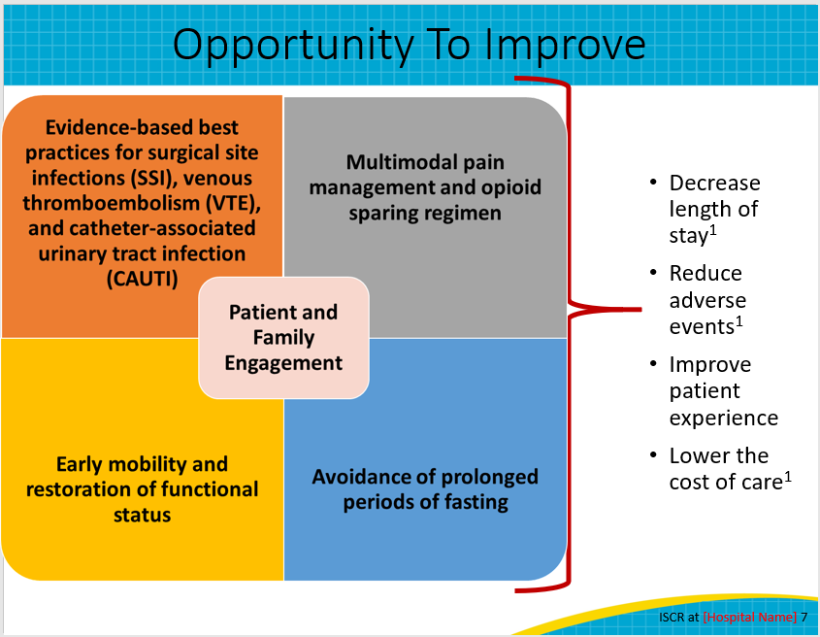
Current State  I’d like to share with you where we are today. [Service line] surgery procedures may have high morbidity and longer than necessary lengths of stay.  Care for [service line] surgery patients can be highly variable for preoperative patient education, anesthesia practices, pain management, fluid resuscitation, resumption of oral intake, and mobility.  ISCR provides recommendations that reduce variation in processes and improve collaboration and buy in from perioperative care team members in surgery, anesthesiology, and nursing. | Slide 8  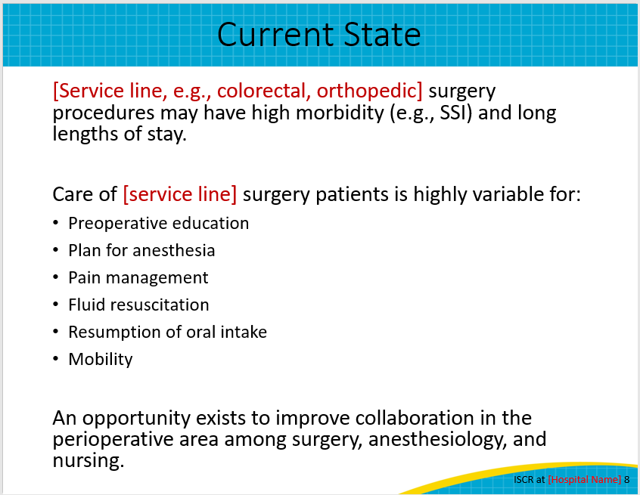
ISCR at [Hospital Name] Overview  To date, our ISCR team has:  Enter steps your ISCR team has taken since beginning your ISCR program. Examples can include:  - We conducted a gap analysis to help us identify areas for improvement and set goals for outcome measure improvements. I’ll review those with you on the next few slides.  - The ISCR team has also reviewed evidence and recommendations on [standardizing preoperative patient education, shortening the preoperative fasting period, etc.] and we have created processes for each of these components, incorporating recommendations from nursing, pharmacy, surgery, and others. Gaining buy-in from a multidisciplinary team when developing our processes improves the likelihood that they will be adopted and sustained by our perioperative teams.  - If your ISCR team has implemented process and you have data to share, consider sharing some of the examples on slide 12 of this template. | Slide 9  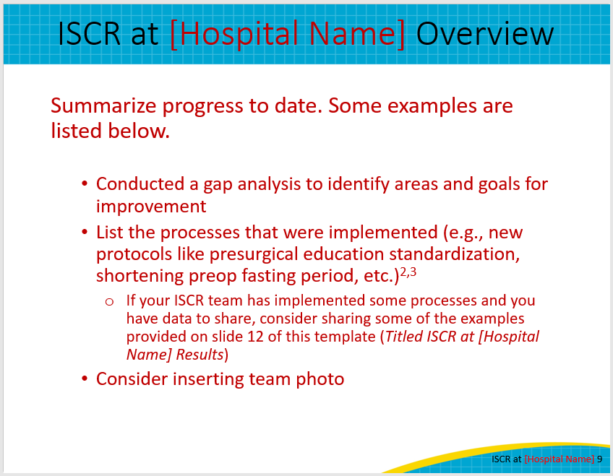
Overview of Gap Analysis and Goal Setting for [Service Line] Surgery  One of the first steps in the ISCR program is collecting baseline data to identify areas for improvement, such as our [enter example (e.g., surgical site infection rate)], and setting goals for improvement.  When our team conducted our gap analysis for [service line] surgeries in CY[XXXX], we found that we performed a total of [number of] cases.  Our mean and median length of stay are [X and X], respectively.  Our unplanned 30-day readmission rate (post-discharge) is [rate].  Our SSI rate for deep tissue is [rate] and [rate] for organ space.  Our all-cause inpatient mortality rate is [rate].  We also reviewed [provide details on any other measures that were reviewed, for example, patient satisfaction]. | Slide 10  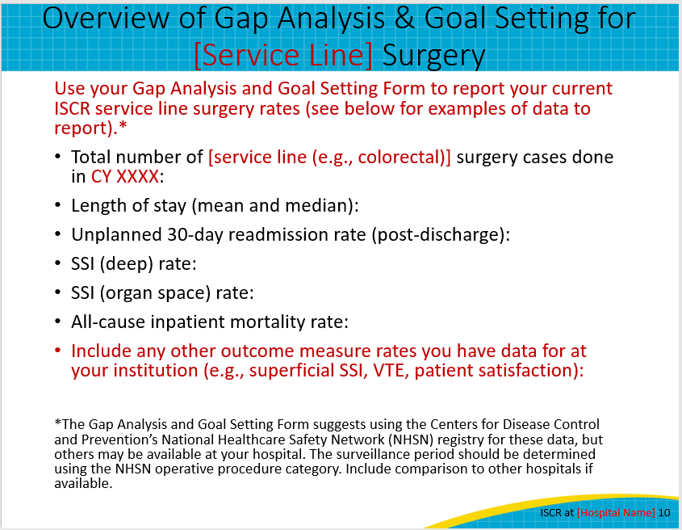
Top Three Goals  The results from our gap analysis helped us identify three specific goals for improvement over the next calendar year.  The first is:  Explain the three goals identified by your ISCR team. An example might be reducing your deep incisional SSI rate from 12 percent in the current calendar year to 7 percent in the next calendar year for patients undergoing abdominal surgery. | Slide 11  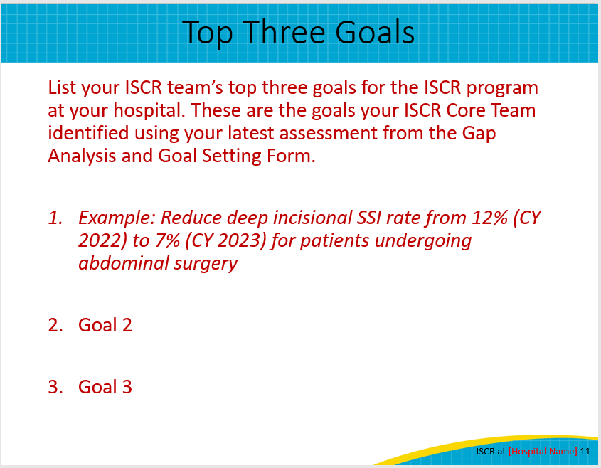
ISCR at [Hospital Name] Results  If your ISCR team has implemented process and you have data to share, consider sharing some of the examples on this slide.  To date, we have implemented processes to improve [components of the ISCR pathway]. Adherence to these processes have [explain trends in data].  Our patient outcomes have [explain data for outcomes].  Highlight successes and challenges. Engaging leadership is a way to lobby for resources that will make the initiative more successful, so let the executive know what you need and what areas need more attention. | Slide 12  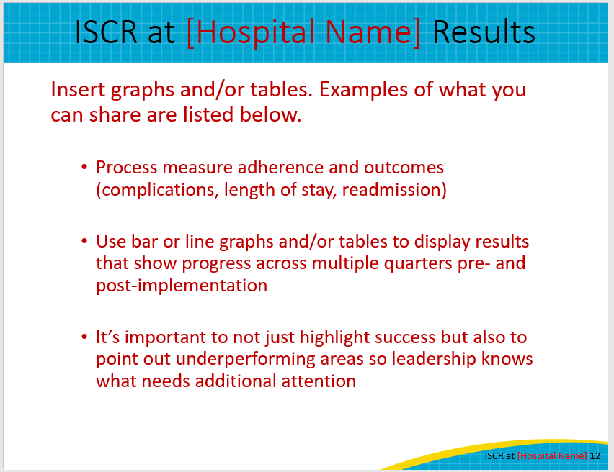
Next Steps  What is next for the ISCR initiative? We have identified [number of next steps identified by the ISCR team] steps we will take in the next [insert timeline for steps (e.g., 6 months)].  Provide an overview of each step and why it is important. An example might be meeting with Information Technology (IT) to develop an ISCR order set in the electronic health record (EHR) system for processes like ambulation or first intake of liquids.  If there are ways the executive’s support will assist with next steps, be sure to highlight how. For example:  To help with our first step, can you introduce me to [a point of contact for EHR order set development]. | Slide 13  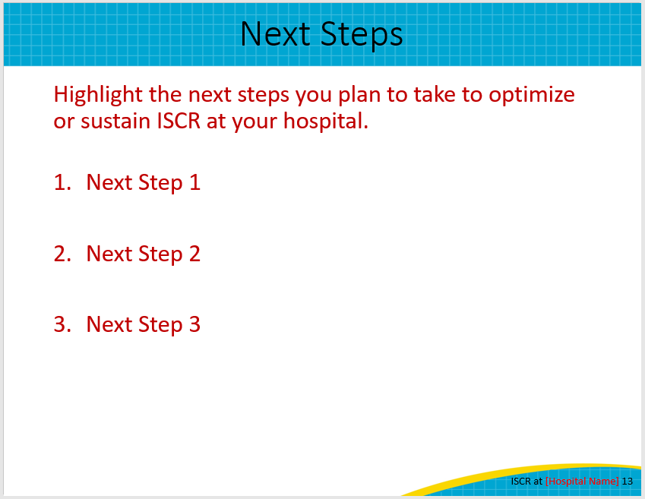
Thank You!  Thank you for your time today. Do you have any questions?  My information is listed on this slide if you have any followup questions about what I’ve shared. Please don’t hesitate to contact me by email or phone. | Slide 14  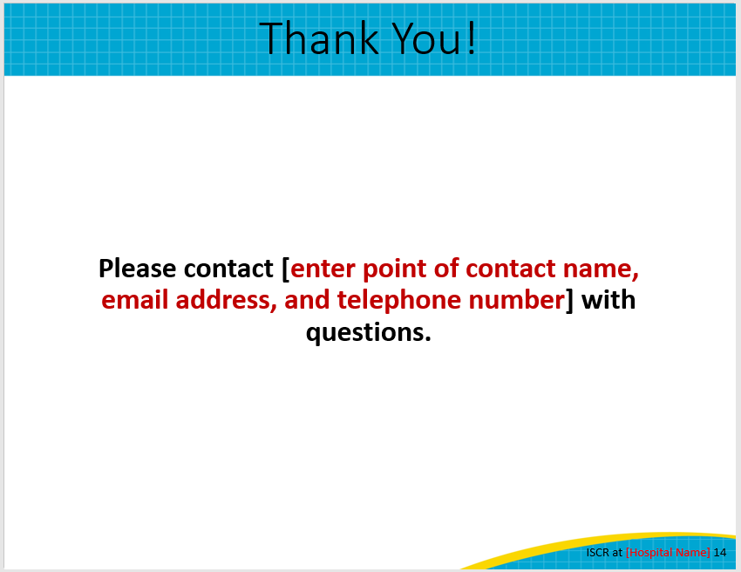
References  References for this presentation are included on this slide. | Slide 15  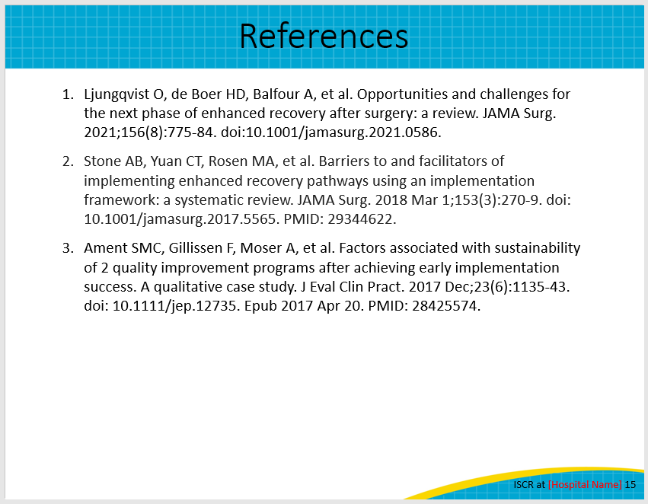
AHRQ Pub. No. 23-0052
June 2023

