Appointment Reminder Letter

This is a reminder that:
[Patient name] has an appointment

For: [purpose]

With: [Clinician name]

Date: [Date]

Time: [Time]

Where: [Name of Practice or Clinic]

Address: [Address]

If you cannot come to this appointment:
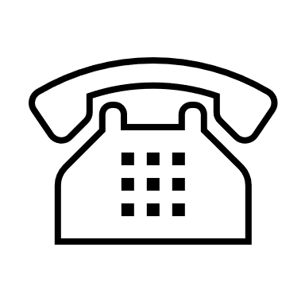
Call [phone number]. When you hear the menu options, press [#] to talk to someone who will help you reschedule the appointment. Or you can reschedule your appointment on the patient portal at: [URL]

What to bring to your appointment:
- Bring your insurance information and a picture I.D.
- Bring a family member or friend if you want.
- Bring all prescription and over-the-counter medicines you take (such as pills, creams, liquids, inhalers, patches, and shots), as well as herbal medicines, vitamins, and supplements.
- Bring a list of the top 3 things you want to talk about.
Special Instructions [if appropriate]:
We will be checking your blood. You can drink water, but do not eat or drink anything else for 12 hours before your visit.

