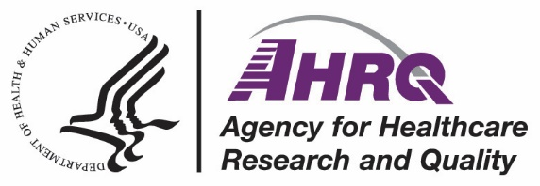 | <Insert facility logo>

Emotional Wellness Resources for
Nursing Home Staff
Stress, fear, and exhaustion from being on the frontlines of the COVID-19 pandemic may leave you feeling anxious and overwhelmed. These feelings are common, and you do not have to face them alone. The following websites offer coping resources, self-care practices, or someone to talk to about how you are feeling.
The Centers for Disease Control and Prevention offers tips to build resilience during the pandemic as well as to cope with stress, compassion fatigue, and burnout.
The Substance Abuse and Mental Health Services Administration (SAMHSA)
Helpline connects you to trained and caring professionals from crisis counseling centers across the nation. Helpline staff offer confidential counseling, referrals, and other support. Contact the crisis text line at 741741.
Dial 211 on your phone or visit the 211 website to connect with support resources or learn about local emotional wellness options. All 211 conversations are confidential and available in many languages
The COVID-19 Frontline Workers Screener from Mental Health America offers ideas to help if you are feeling overwhelmed or facing burnout. This site also offers free and anonymous online screenings to check for symptoms that may affect your emotional well-being. The test for depression, anxiety, and post-traumatic stress disorder, or PTSD, may be the most helpful.
The Emotional PPE Project website can connect you with volunteer licensed mental health professionals within your state. There is no cost or insurance required for these sessions.
Safe Call Now is a confidential 24-hour crisis line and support service for nursing home staff and their family members. Safe Call Now connects you with trained staff who understand the demands of your job.
Our Employee Assistance Program, or EAP, offers confidential support to help with any personal or work-related problems that may impact your job performance, health, and emotional well-being. Contact: [Include your Nursing Home Organization’s EAP Information. Please remove if EAP is not available to employees.]
AHRQ Pub No. 21-0049
March 2022
www.ahrq.gov

