SAY:  The “Apply CUSP” module of the Comprehensive Unit-based Safety Program (or CUSP) Toolkit introduces Just Culture principles, which emphasize shared accountability and attitudes toward risk. This module also summarizes the concepts and activities of the other six modules in the CUSP Toolkit. | Slide 1  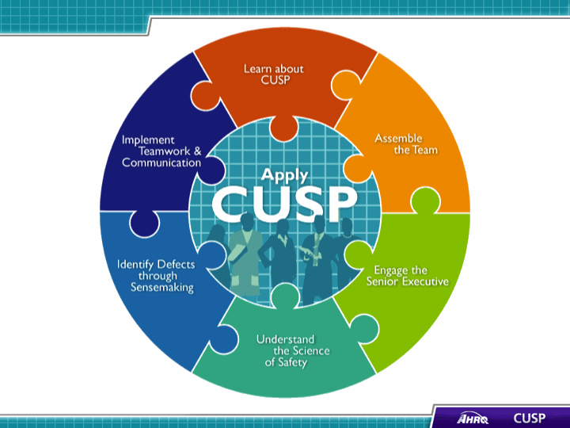
SAY:  In this module, we will:  - Introduce Just Culture principles,  - Show how Just Culture principles can augment CUSP, and  - Review key steps of the CUSP Toolkit. | Slide 2  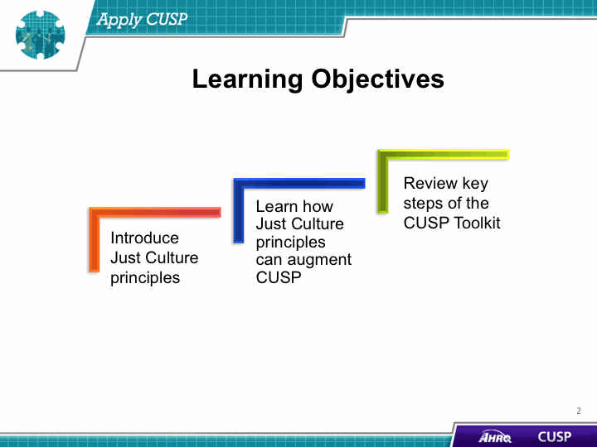
SAY:  The term “Just Culture” refers to a safety-supportive system of shared accountability in which health care institutions are accountable for the practices they have designed and for sustaining the safe choices they have made regarding patients, visitors, and staff. Staff, in turn, are accountable for the quality of the choices they make to ensure their patients receive the highest quality of care possible. | Slide 3  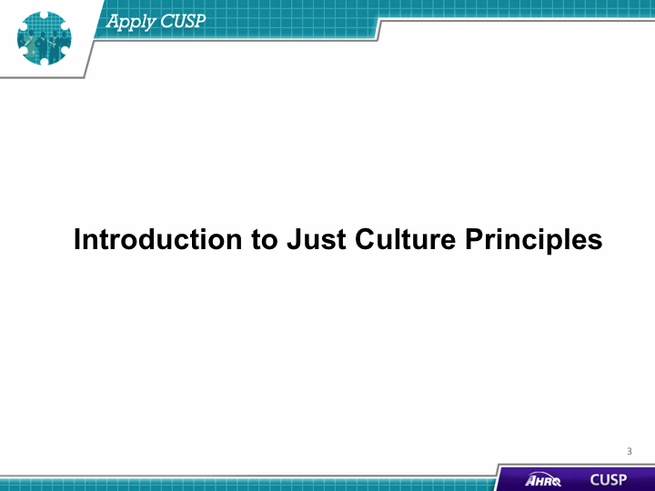

DO:  Play the video.  ASK:  - How would you describe Just Culture to someone?  - Can you identify examples of human error in your unit or hospital? How were these human errors handled? | Slide 4  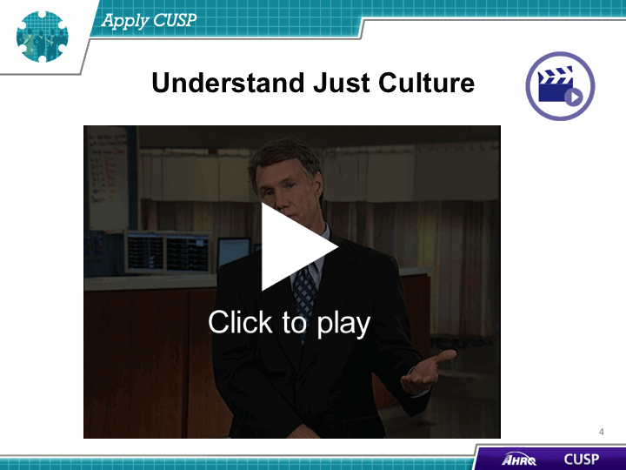
SAY:  A Just Culture environment allows the review of both system design and an employee's choice of behavior in response to assigned duties. A Just Culture provides a comprehensive process to investigate events or patient safety concerns and determine an appropriate course of action with the employees involved.  Just Culture principles are a crucial accompaniment to the CUSP framework and will spark the shared accountability necessary for CUSP implementation to be successful. David Marx developed the Just Culture framework based on risk management concepts from high-reliability industries such as aviation and nuclear energy.  In short, a Just Culture is a system that holds itself accountable, holds staff members accountable, and has staff members who hold themselves accountable. In a Just Culture, shared responsibility is the norm, and a commitment to eliminating the possibility of error is widespread within a Just Culture. | Slide 5  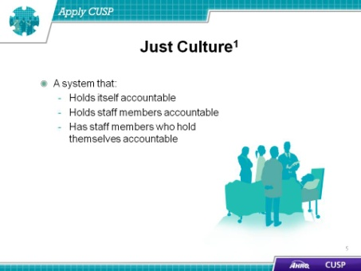

SAY:  The concept of Just Culture gives a framework for understanding risk and human behavior. There is a continuum of possible attitudes and behaviors related to risk, and this continuum is described in three categories:  - Human error—Inadvertently completing the wrong action; a slip, a lapse, or mistake  - At-risk behavior—Choosing to behave in a way that increases risk, where risk is not recognized or is mistakenly believed to be justified  - Reckless behavior—Choosing to consciously disregard a substantial and unjustifiable risk  ASK:  - Can you identify examples of at-risk behavior in your unit or hospital? How were these at-risk behaviors handled?  - Can you identify example of reckless behaviors in your unit or hospital? How were these reckless behaviors handled? | Slide 6  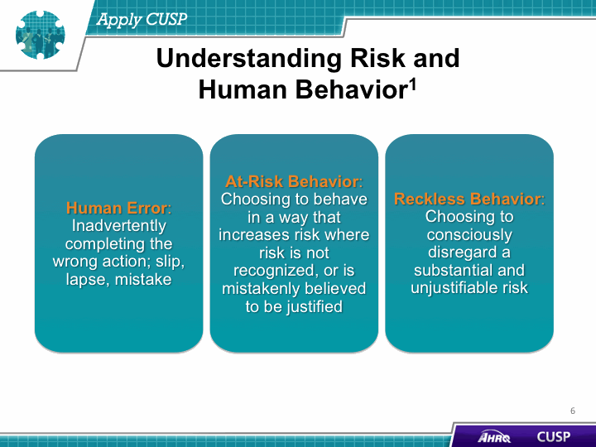
SAY:  To improve outcomes, human error, at-risk behavior, and reckless behavior each should be managed appropriately.  Human error is a product of both system design and behavioral choices. Human error can be managed through changes in processes, procedures, training, system design, or work environment. The proper management approach is to console providers who have committed a human error and to ensure proper systems and procedures are in place to support future appropriate choices.  At-risk behavior is an active choice to engage in risky activity through a belief that the risk was either insignificant or justified for a particular outcome. The best approach to dealing with at-risk behavior is to remove any incentives for engaging in it and to verify the system encourages healthy, risk-reducing behaviors.  Reckless behavior is a conscious disregard of substantial and unjustifiable risk. When reckless behavior has occurred, it must be met with remedial or punitive action to decrease or eliminate the chances the behavior will reoccur. | Slide 7  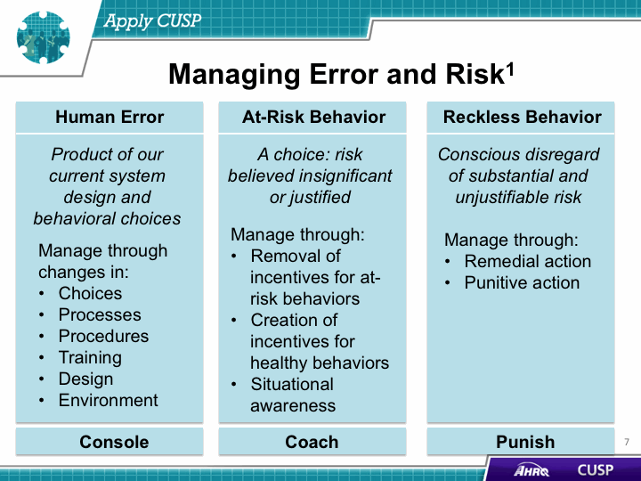
SAY:  Within the Just Culture model, there are five elements that contribute to improved outcomes. These are:  - Mission, values, and expectations;  - System design;  - Behavioral choices;  - Learning systems; and  - Accountability and justice.  Mission, values, and expectations  For an organization to be effective in fulfilling its purpose, it must first define its mission and articulate values and expectations that align with that mission. Perfection is not a productive expectation because it is unattainable. Rather, an organization should set improvement as a goal.  System design  Humans are fallible and occasionally make mistakes, either through inadvertent errors or risky behaviors. To achieve optimal outcomes, organizations must design robust systems that minimize risks. Forcing functions, checks, and redundancies are some features of systems intended to minimize the risk of error.  Behavioral choices  Managing human behavior is essential to refining outcomes. It is critical to reinforce behaviors that will reduce risk and deter behaviors that increase risk.  Learning systems  By establishing learning systems, organizations can manage both systems and human behavior. The Staff Safety Assessment and Learning from Defects Tool in this CUSP Toolkit are two communication tools that can be used to promote learning systems.  Accountability and justice  Accountability in a Just Culture environment is about more than simply blaming a person whenever a patient is harmed. In a Just Culture environment, the quality of behavioral choices should be emphasized more than the outcome of the choices, which may or may not have resulted in harm. | Slide 8  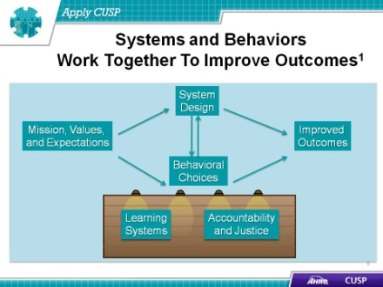
DO:  Play the video.  ASK:  - What are some ways Audrey approaches and coaches Sheri?  - Why does Sheri find it difficult to follow the checklist?  - How does Audrey respond to Sheri’s reasons for not following the checklist? | Slide 9

SAY:  A Just Culture environment is ruled by both transparency and accountability. In a punitive culture that does not strive to understand potential underlying reasons for at-risk behaviors, transparency is impossible. This is especially problematic given that transparency and open communication are necessary for true cooperation, coordination, and teamwork to occur. Transparency is also vital in addressing system factors that may contribute to harm.  At the other extreme, a culture that does not hold team members accountable will never achieve optimal outcomes. In what has been known as a blame-free culture, there is a general failure to uphold standards of care, and staff members are less likely to hold themselves and one another accountable for appropriate behaviors. In contrast, a Just Culture environment will support improved outcomes by emphasizing both robust systems and appropriate behaviors. | Slide 10  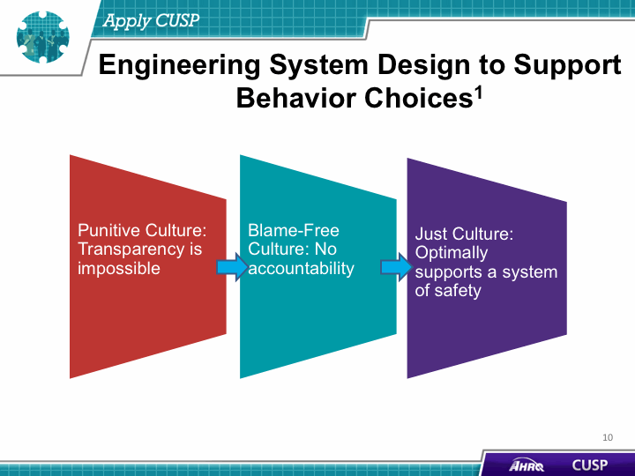
SAY:  There are key ways unit leaders can apply Just Culture principles to enhance culture, accountability, and safety on their unit.  First, unit leaders can have procedures in place for employees to follow. Confirming that protocols are standardized and well-communicated helps employees make the right choices, leading to the best outcomes. When designing procedures, be sure to eliminate reasons for at-risk behavior and reinforce incentives for healthy, risk-reducing choices.  Second, ensure employees are properly trained. Employees should know the correct procedures and grasp the underlying reasons for those procedures so they will be more inclined to engage in appropriate behaviors.  Third, offer positive reinforcement at the monthly Learning from Defects meeting. The Learning from Defects process is an effective way to instill or reinforce learning systems that contribute to improved results. | Slide 11  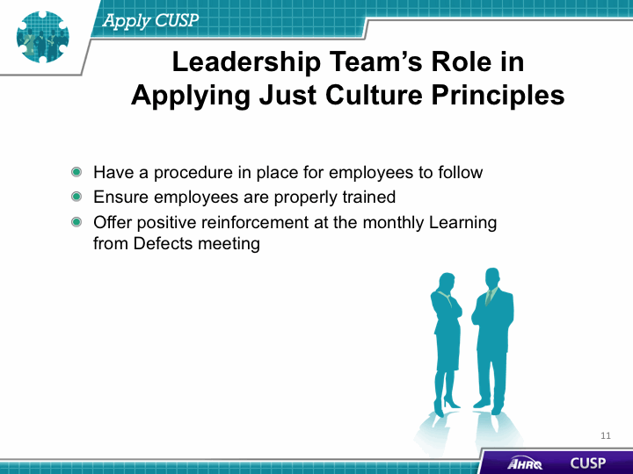
DO:  Play the video. | Slide 12  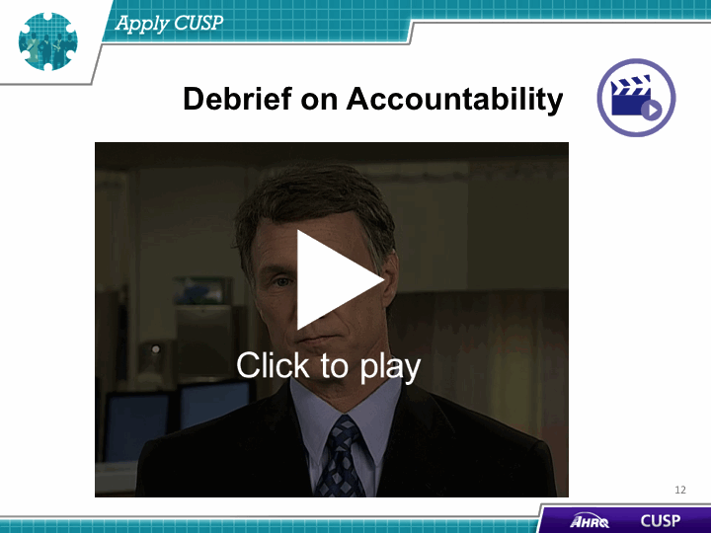
SAY:  The seven modules of the CUSP Toolkit are:  - Learn About CUSP,  - Assemble the Team,  - Engage the Senior Executive,  - Understand the Science of Safety,  - Identify Defects Through Sensemaking,  - Implement Teamwork and Communication, and  - Apply CUSP. | Slide 13  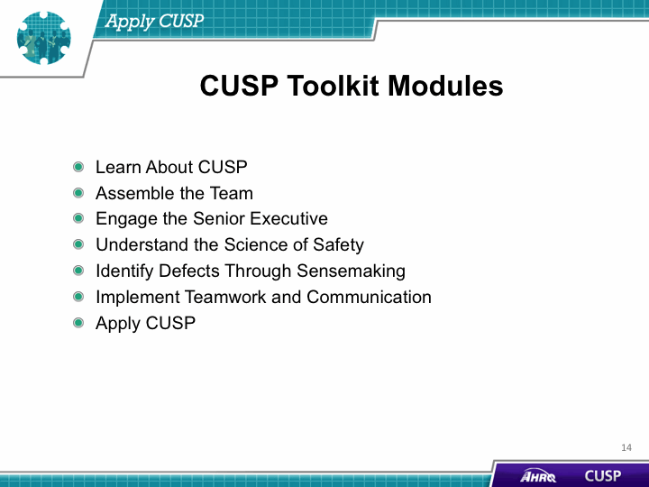

SAY:  Units that are first-time users of the CUSP Toolkit should review both the Learn About CUSP and this module to become familiar with CUSP and then work through the toolkit modules in the following order:  - Understand the Science of Safety  - Assemble the Team  - Engage the Senior Executive  - Identify Defects Through Sensemaking  - Implement Teamwork and Communication  After a unit has gained experience in using the CUSP Toolkit, it can use the modules in any order to meet the needs of the unit. For example, if a unit team has new staff members, reviewing the “Understand the Science of Safety” module will build a foundational knowledge base in systems thinking and the behavioral and environmental factors that affect patient safety. In this situation, the unit team may also want to review the “Assemble the Team” module to consider which staff members to recruit for the CUSP team.  Because different users will need different resources, the toolkit is designed to be modular. Units can present and apply sections, or parts of sections, independently to fit users’ needs. | Slide 14  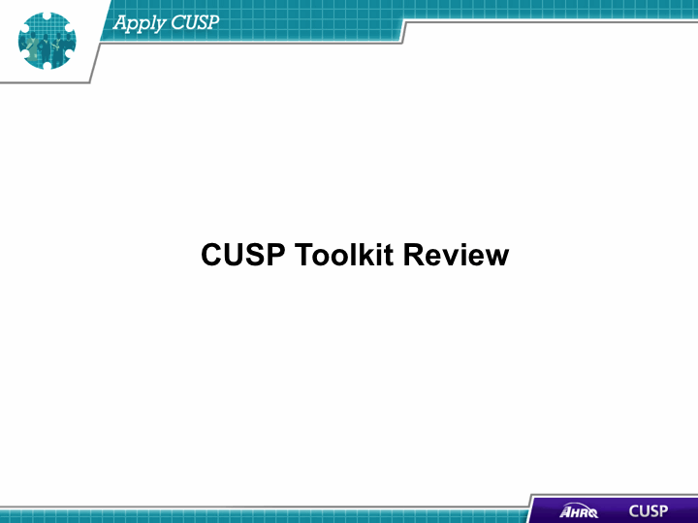

SAY:  We will now review each of the CUSP Toolkit modules to show you how they work to engage unit team members and make system adjustments.  After completing the “Assemble the Team” module, staff will be able to:  - Address the importance of the CUSP team,  - Develop a strategy to build a successful CUSP team,  - Identify the characteristics of effective CUSP teams and the barriers to team performance as identified in TeamSTEPPS, and  - Describe the roles and responsibilities of a CUSP team. | Slide 15  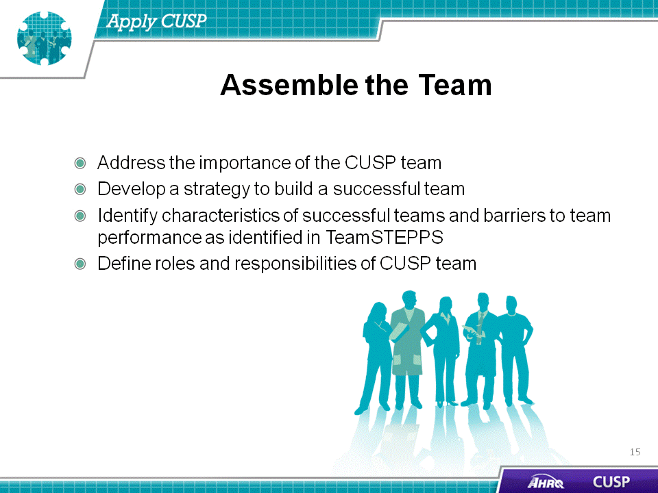
SAY:  The ideal CUSP team has six characteristics. The team:  - Understands patient safety culture is local,  - Comprises engaged frontline providers who hold themselves responsible for patient safety,  - Includes staff members who have different levels of experience,  - Is tailored to include members based on the nature of the clinical intervention they are planning,  - Meets regularly (weekly or at least monthly), and  - Has adequate resources to do its job. | Slide 16  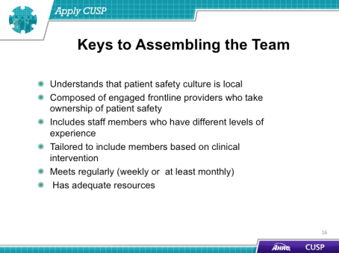

SAY:  After completing the “Engage the Senior Executive” module, staff will be able to:  - Identify characteristics to search for when recruiting the senior executive,  - Describe the responsibilities of the senior executive,  - Explain the role of the senior executive in addressing technical and adaptive work, and  - Describe how to engage a senior executive and develop shared accountability for the work. | Slide 17  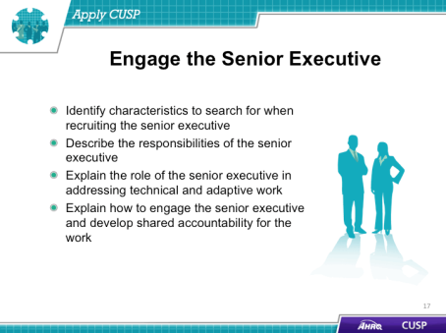
SAY:  Just as it is critical to detail the role and responsibilities of the senior executive, it is equally important for CUSP team leaders to realize how to engage the senior executive while developing shared accountability among the CUSP team. This may be difficult to do. Executives and frontline providers serve different roles within the hospital. As a result, their interests in the program and the skills they will contribute to the CUSP initiative will vary greatly.  To begin, present the senior executive with the benefits of his or her participation in the project. Remember to appeal to the senior executive’s interest in maintaining patient safety, as well as the hospital’s financial gains that will result from participating in the CUSP initiative. Display statistics that show how the initiative reduces both patient harm and the average cost per occurrence for the hospital.  Ensure a senior executive is assigned to a CUSP team. Each CUSP team must have one senior executive team member. This executive should meet with the unit team regularly and be included in any project-related communications. Recruiting senior executives in these initiatives forges bonds and improves communication among hospital staff members, which will ultimately increase patient safety and reduce unnecessary expenses and harm.  Next, increase the visibility of the senior executive. By simply posting a photo and the name of your CUSP team’s senior executive on a bulletin board, you are creating a tool for all staff members to readily identify their senior executive team member. You may ask the executive to participate in a “getting to know you” interview with a staff member, and the responses can be shared with the unit team.  ist identified safety issues. One of the most effective approaches to bridge the gap between senior executives and frontline providers is to conduct executive safety rounds. During these rounds, executive team members interact with staff on the unit while discussing safety issues. The importance of these interactions is two-fold. First, unit-based gatherings offer the senior executive the opportunity to gain a greater understanding of the project and cultivate a sense of the executive’s integral role within the CUSP team. Second, meeting on the unit floor increases the senior executive’s visibility among frontline staff and imparts a strong impression of commitment to the project. The senior executive and other CUSP team members can investigate a staff-identified safety defect identified on the Learning from Defects Tool or the Safety Issues Worksheet for Senior Executive Partnership. This unit-wide interest in patient safety will improve the likelihood of senior executive participation in the initiative and will, in turn, increase the success of the safety initiative. | Slide 18  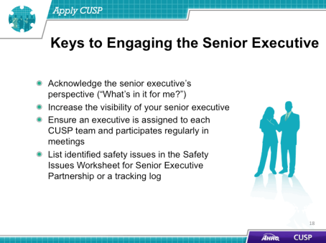

SAY:  After completing the “Understand the Science of Safety” module, staff will be able to:  - Describe the historical and contemporary context of the Science of Safety,  - Explain how system design affects system results,  - List the principles of safe design and identify how they apply to technical work and teamwork, and  - Indicate how teams make wise decisions when there is diverse and independent input. | Slide 19  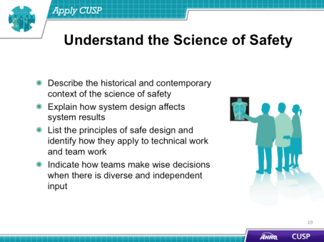
SAY:  The CUSP team and unit staff members should watch the “Science of Safety” video to make sure everyone is familiar with the concepts it presents, especially the three principles of safe design: Standardizing, creating independent checks, and learning from defects. To begin, invite all hospital staff, executives, and providers involved in the CUSP initiative to attend a screening of the video and create a roster of names of individuals who have seen it. | Slide 20  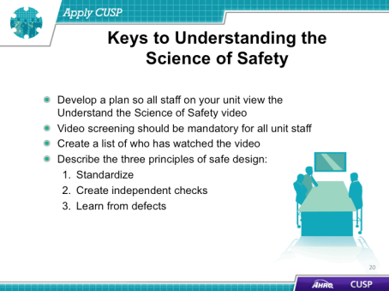
SAY:  After completing the “Identify Defects Through Sensemaking” module, staff will be able to:  - Use CUSP and Sensemaking tools to identify defects or errors,  - Discuss the relationship between CUSP and Sensemaking,  - Show how to apply CUSP and Sensemaking tools, and  - Discuss how to share findings. | Slide 21  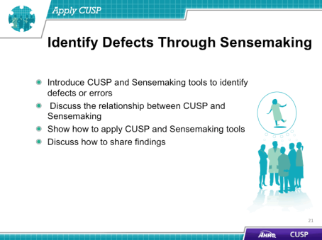
SAY:  Teams should use the CUSP and Sensemaking tools to identify defects and discuss ways to prevent these and other defects from occurring in the future.  Teams should also share summaries of defects with the unit as a whole and engage providers in conversation to enhance their learning from defects skills. | Slide 22  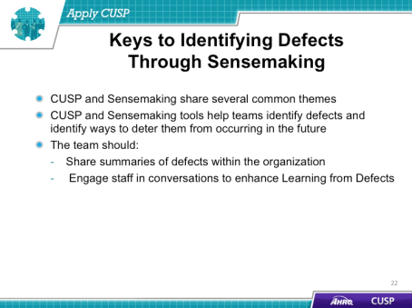
SAY:  After completing the “Teamwork and Communication” module, staff will be able to:  - Recognize the importance of effective communication,  - Identify barriers to communication,  - Describe the connection between communication and medical errors, and  - Identify and apply effective communication strategies from CUSP and TeamSTEPPS. | Slide 23  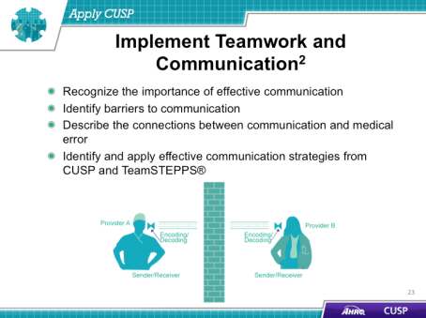
SAY:  Effective communication is complete, clear, brief, and timely.  People who use complete communication provide all relevant information while avoiding unnecessary details that may cause confusion. They plan time for patient and staff questions and answer questions completely.  People who use clear communication convey information that is plainly understood and use layman’s terminology with patients and their families. They use common or standard terminology when communicating with team members.  People who use brief communication are concise.  People who use timely communication are dependable about offering and requesting information. They avoid compromising a patient’s situation by promptly relaying information. They note times of observations and interventions in the patient’s record. They take the time to update patients and families frequently. They also verify their listeners received the intended message. And they validate or acknowledge information they receive. | Slide 24  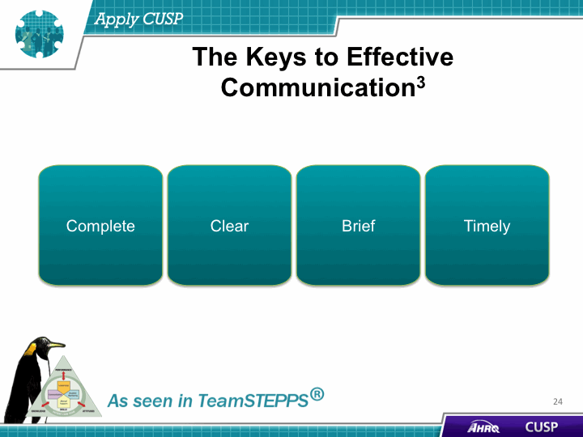
SAY:  A Just Culture is a system that holds itself accountable, holds staff members accountable, and has staff members who hold themselves accountable.  A Just Culture environment is ruled by both transparency and accountability and supports improved outcomes by emphasizing both robust systems and appropriate behaviors.  Use the Just Culture principles along with the CUSP principles involved when assembling the team, engaging the senior executive, identifying defects through Sensemaking, and employing teamwork and communication. | Slide 25  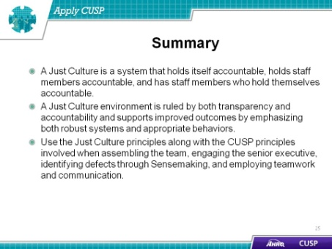
Slide 26
