Facilitator Notes
SLIDE 1  Title: Management Practices for Sustainability, Module 2: Daily Huddles  SAY: This is the second module in the series on frontline management systems to promote sustained safety standard work in ambulatory surgery centers. | 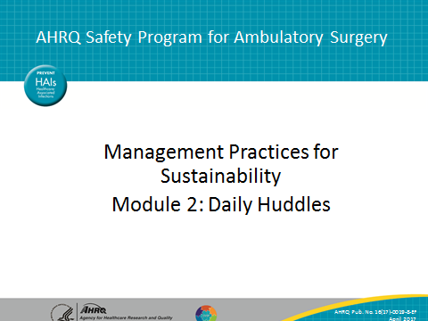
SLIDE 2  Title: A Frontline Management System to Promote Safety Standard Work  SAY: As discussed in the first module, the frontline management system to promote sustained, controlled standard work that ensures patient safety relies on several interlocking parts.  At the center of the system is daily work, including huddles, where problems are identified, anticipated, or otherwise reported on, and visual-management boards that support ongoing performance tracking and help keep tabs on ongoing improvement work.  The system also contains standard work by managers to identify whether frontline standard work is taking place and to monitor problems over time. There are also dedicated methods for problem escalation and problem solving so that staff have the core skills to address issues that can compromise safety.  Finally, the system involves integration, the alignment of staff at all levels around safety goals, and the performance of standard work across organizational levels that supports safety, with these three parts being mutually reinforcing.  This module will focus on the practice of daily safety huddles, which, as you can see, is a core, central element of this system. | 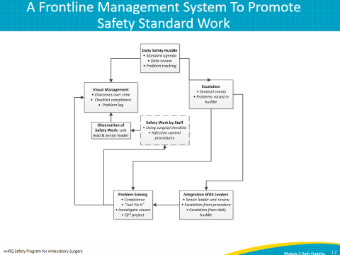
SLIDE 3  Title: What Is a Daily Huddle and Why Is It Important?  SAY: On this slide, we lay out the “what” and “why” for the practice of daily safety huddles. As you talk about daily huddles initially with your staff, you should outline these points with them.  A daily huddle is basically a short, standup meeting, usually once a day at the beginning of the day; it focuses on a specific team, such as an operating room team, or the pre/postoperative team. The huddle should last no more than 10 minutes and ideally, no more than 5 minutes.  Huddles give you an opportunity to recognize problems from yesterday’s work, anticipate problems for today’s work, and check on the status of ongoing improvement work, as well as the status of key performance measures. | 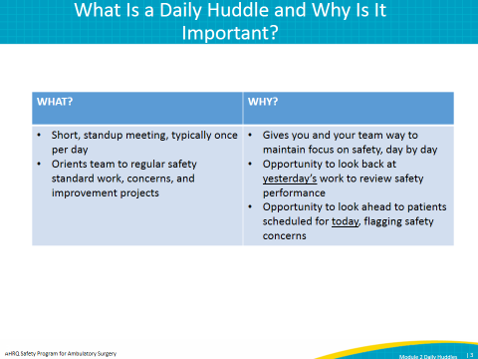
SLIDE 4  Title: Who Is the Huddle For?  SAY: Huddles provide an excellent opportunity to “clear the deck” of any issues.  Different centers structure their huddles in different ways. Some will include separate huddles for each department; from the operating room or OR to sterilization to the business office. Others will try to have a consolidated version of the huddle, incorporating clinical staff, such as the OR, and the pre/post-operative staff together.  How you structure your huddles will depend on how your staff are scheduled and the size of your center. For example, if OR and pre- and postoperative staffs cannot be available at the same time in the same place, either because they are not all onsite at the same time or because many will be treating patients during the best time for a combined huddle, you may consider splitting into smaller department-focused huddles.  You should consider a number of different staff roles to include in the huddle. Your nurses are a good start, along with technicians and frontline managers. Some centers have even been able to get physicians, such as anesthesiologists, to attend huddles. | 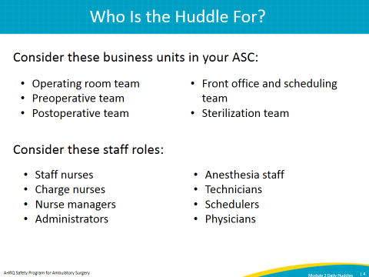
SLIDE 5  Title: A Simple Huddle Agenda  SAY: Once you get the hang of it, the huddle should last no longer than 5 minutes. You should stick to the same agenda each day, and after a few rounds, the agenda should be well understood by staff.  These are five simple points you can adapt for your facility. Start by reviewing any concerns that might touch on safety from the previous day, and consider any safety issues touching not only patients but also staff and physicians. Review any important safety considerations for the cases of the day, such as equipment needs or patients with special needs. Review issues that are actively being tracked, such as quality improvement projects: what is the status, and who is responsible? Consider calling on the staff responsible for these projects. Lastly, ask staff if they have any questions or concerns they’d like to raise, and offer crucial announcements.  Some centers may choose to add additional items, such as updates on important supplies like medication backlogs. These are fine to add. However, it’s crucial to keep the huddles as short as possible and to stick to a clear, consistent agenda. Remember that the huddle is not the time for significant discussion. If issues are raised, record them and follow up with additional exploration or discussion after the huddle, whether individually with particular staff or in management meetings.  If a staff member or physician brings up an issue that feels off topic, politely thank them for raising the issue, ask them to offer more information via email or another appropriate channel, and follow up separately after the huddle. | 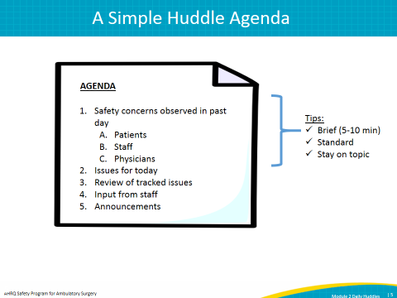
SLIDE 6  Title: Apply the Model for Improvement To Introduce Daily Huddles  SAY: We recommend introducing daily huddles through a structured method called the Model for Improvement.  To use the Model for Improvement, you must first have an aim. Second, you must have measures to see if you have achieved the aim, and third, you must have planned changes to meet the aim. It’s pretty simple, and it probably describes how you already do a lot of your improvement work.  The heart of this model is the “Plan-Do-Study-Act” or “PDSA” cycle, which is another way of basically explaining hypothesis testing. You are testing the hypothesis initially that the daily huddle is feasible in your facility for a given unit, and that you and your staff will find benefit in it as a way to surface and support resolution of safety-related problems.  You will make a plan to test the huddle, such as by running a single huddle; you will do the plan, by actually running one huddle on a given day; you will study the results, by debriefing with staff and management after the huddle to see if you found it helpful or if it needs to be modified; and you will act, by either continuing to run the huddle or modifying its format to meet your needs. | 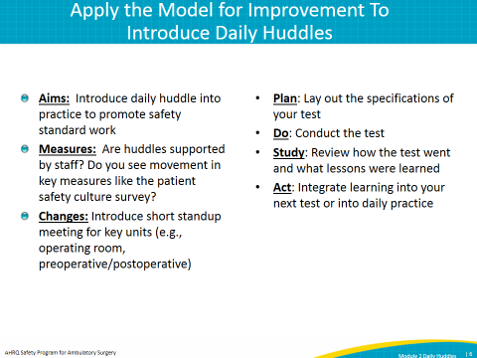
SLIDE 7  Title: Details To Consider for Your First Test  SAY: You will find an example of a deidentified PDSA form for daily huddles on the AHRQ Web site at www.ahrq.gov/HAIambsurgery. You should fill out this form with your team as you plan your introduction of daily huddles.  In planning your PDSA test, make sure you include the elements on this slide:  - Select the appropriate testing unit. Consider the OR and pre/postoperative staffs; identify a nurse manager who is interested in this work.  - Determine who should attend the huddle from your staff. Consider “must-have” or “core” staff versus “nice-to-have” staff who might only attend if available.  - Determine who should lead the huddle. Consider a nurse manager, or a charge nurse initially.  - Determine when and where the test will take place. Consider a location that will not disrupt staff workflow, but that will be private enough to discuss potentially sensitive issues like safety problems.  - Review the template agenda, and adjust to your facility needs.  - Identify someone to write down problems from yesterday and concerns for upcoming cases. He or she may or may not be the same person as the facilitator.  - Plan to give a notification to all relevant parties one day before the test to let them know the huddle will take place, and remind them of the time and location.  - Schedule a 10-minute debrief with the team, after the huddle takes place to review how the test went. | 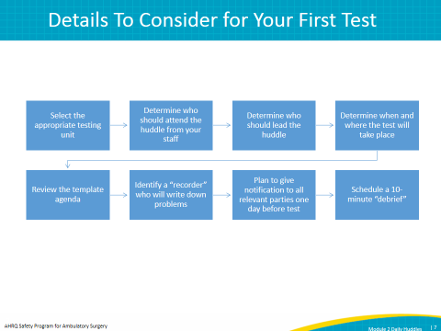
SLIDE 8  Title: Practical Tips to Remember for Your First Test Huddle  SAY: In working with sites to introduce huddles, we’ve identified a few tips that may help you enhance the value of your initial tests.  First, time the initial huddle. It is important to work towards a shorter huddle.  Second, debrief with your staff after the huddle to learn about what they liked and didn’t like.  Third, don’t forget to debrief after the huddle with a smaller leadership team to modify the huddle practice and plan the next small tests of change.  And finally, don’t forget to follow up on issues identified during the huddle, and make sure staff know that you followed up. This will help earn support and engagement as staff will start to see the huddle’s value. | 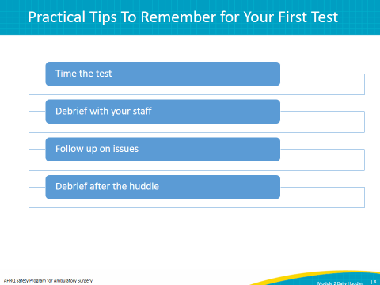
SLIDE 9  Title: Additional Tests To Hardwire Huddles Into Daily Practice  SAY: Once you have completed your first test huddle, you should consider additional PDSA tests that will help you hardwire huddles into daily practice. Consider a test of consecutive daily huddles for 5 days to determine if you can sustain the momentum. This will help you identify problems that may surface in trying to do huddles on consecutive days.  Finally, think about whether or not you can stick with huddles for a month. It is important to note that many sites report that it takes a bit of time for staff to really see the benefit of the huddles and get into the rhythm.  Additional tests to consider may be to alternate staff who lead the huddle or introduce the huddle in more than one department. | 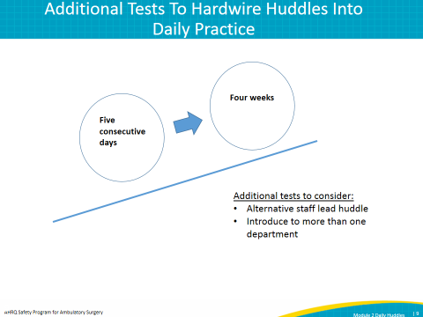
SLIDE 10  Title: Testing and Implementation: Common Problems and Tips  SAY: As you continue with additional tests, you may start to recognize some additional problems.  For example, it is important to cross-train multiple staff to be able to the lead the huddle, in case the usual facilitator is absent. Think about making huddles part of your onboarding for new staff. You can include a description of what the huddle is, why it’s done, and when it’s done, so that new staff begin to see it as part of standard practice.  Again, you should be aware that it may take some time for staff to see the benefits of the huddles. Remember, one of the central benefits is that it is a problem-surfacing mechanism. It may take time to surface problems and to put into place resources and projects to solve them. We’ll have more to say about problem solving in an upcoming module. | 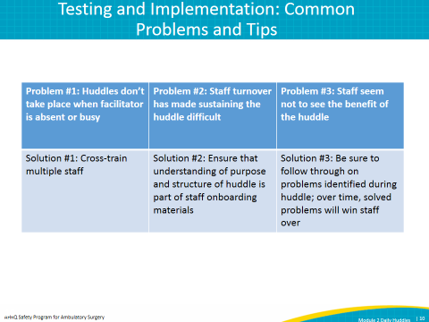
SLIDE 11  Title: Testimonials About the Benefits of Daily Huddles in the ASC Environment  SAY: ASCs that adopted daily huddles provided great feedback. For example, one of the sites that tested the huddle with the Institute for Healthcare Improvement through a dedicated improvement project found a 10 percentage-point increase in its safety culture survey scores, and it cited the huddles as a major driving force in that change. The staff and management also felt that the huddles have improved engagement and the sense of staff empowerment, as you can see in this slide.  If you’d like to learn more about daily huddles, you can view the dedicated component kit we have developed, which is available to you as well through the AHRQ Web site. | 