Daily Huddle Component Kit
Contents
1. Why a Daily Huddle? 2
2. “Know What, Know How, Know Why” for Daily Huddle 4
3. Plan-Do-Study-Act “Ramp”: Learn To Use a Daily Huddle 5
4. Standard Huddle Agenda (Adapt to Your Needs and Experience) 7
5. Learn More 8
Appendix: Plus/Delta Review 9

Why a Daily Huddle?
What is a huddle? It’s a short, standup meeting, 10 minutes or less, that is typically used ONCE at the start of each workday. In inpatient settings using huddles, there is a huddle at the start of each major shift. In ambulatory surgery centers (ASCs), huddles can happen once per day with each unit (e.g., the operating room staff).
The daily huddle gives you and your team a way to maintain a focus on safety, day by day, such as by reviewing the use of the surgical safety checklist. It provides a setting to look back at the previous day’s work to review safety performance and to look ahead to patients scheduled for the day by allowing you to flag safety concerns proactively.
Table 1 summarizes the benefits of the huddle, specifically with a focus on the surgical safety checklist, related communication behaviors and the expected frequency of occurrence.
Table 1. Benefit of Huddle and Expected Frequency
Benefit of Huddle | Expected Frequency
Engage team in thinking and talking about checklist use, communication behaviors, and related safety work | Expected to arise in huddle every day
Recognize issues in checklist use, communication behaviors, and related safety work to address by training, coaching, and revising tools and methods | Expected to arise in huddle one or more times each week
Identify issues that need escalation and resolution beyond the team and supervisor | Expected to arise in huddle typically less than once per week

The huddle also gives the supervisor a chance to update the team about specific safety or quality initiatives that will affect daily work.
Note: While we’re emphasizing safety as the focus of daily huddles, many organizations use daily huddles for general control and information exchange.

Three Levels of Huddle Work Proposed: Work To Reach Level 3
Level 1: Daily huddles in which you regularly discuss the safety performance of your unit.
Level 2: You have a standing written agenda for your huddle that enables you to efficiently review safety performance of previous day and anticipate issues in the current day.
Level 3: Daily huddles happen when the supervisor is not present. Team members see the value and have the skills to run the huddle themselves.

Connections to Other Management System Components
Visual management: Standup huddle takes place in front of the visual display that provides status of current issues and data on safety performance.
Standard work observation: Observation report occurs in huddle.
Escalation: Issues raised in daily huddle that cannot be addressed by manager/supervisor immediately after the huddle may be escalated according to agreed-to procedure.
Problem solving: Unresolved issues become problems to solve.
Integration: Invite senior leaders to participate in your safety huddle to observe your huddle skills and to learn about safety issues.

“Know What, Know How, Know Why” for Daily Huddle
Table 2 lays out how you can introduce huddles into daily practices, and important elements of huddles to keep in mind. The first column, Important Step, lays out key elements of effective huddles. The second column, Key Points, offers additional details that elaborate on the “important steps.” The third column, Reasons, explains the rationale for each important step. This is a format proposed by Training Within Industry experts, cited in Getting to Standard Work in Health Care (2013). A coach uses the sheet to get a person to follow standard work.

Table 2. “Know What, Know How, Know Why” Format
Important Step (“know what”)  A logical segment of the operation when something happens to advance the work | Key Points (“know how”)  For example, information that is critical to the job, may prevent injury, and increases efficiency of the work.  Make the work easier to do--“knack,” “trick,” special timing, bit of special information, etc. | Reasons (“know why”)  Reasons for the key points
- Leader starts at the designated time | - Choose a consistent time to meet (e.g., 15 minutes before first procedure of the day)  - Everyone is standing up | - Consistency helps people plan their work and attend promptly  - Consistency makes the huddle go more quickly
- Leader has the agenda on visual display board | - Point to the agenda; don’t read it | - People practice with visual information
- Leader asks each person to offer one positive safety observation or one issue about safety (e.g., a concern) from previous day; everyone else listens | - Have a method to go through the team (e.g., go clockwise)  - Pass a “talking object” to each person in turn  - Issues are noted by leader for followup; concerns may need to be escalated for resolution | - Don’t fumble for order; you want to move quickly  - If you don’t have the talking object, you should be listening  - Huddles are not for problem solving
- One person previews patients for the day, identifying any safety issues and plans to address | - Identify patients who could have safety issues arise: “issue and plan”  - List of patients and procedures as part of visual-display board can make this step more efficient | - Focus on unusual patients to minimize time in review  - Visual information easier to manage than verbal
- Leader closes huddle with announcements or other message | - Thank the team  - “Huddle is now over” | - Demonstrate courtesy  - Give a clear signal that team should tackle other tasks

Plan-Do-Study-Act “Ramp”: Learn To Use a Daily Huddle
As Figure 1 shows, complex practices like daily huddles often require a series of “PDSA” cycles to introduce into consistent practice. Table 3 outlines the details of PDSAs you can use to introduce huddles. Each PDSA outlined has an increasing level of sophistication.
Figure 1. Improvement Often Requires Multiple PDSA Cycles
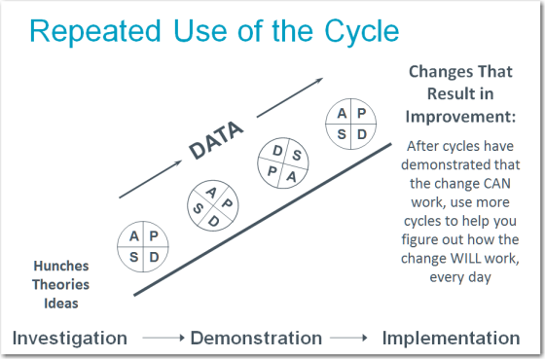

Table 3. Details on a Series of PDSAs To Introduce Daily Huddles
PDSA cycle # | What question(s) are you trying to answer? | Preparation
1 | For one day: Can we huddle for no more than 10 minutes at the start of the day to look back and look ahead to assure safe procedures? | Give heads-up to team about trying a huddle for 1 day (avoid days after weekends or holidays for first test):  “Test of a daily huddle on [date]. Everyone stands up, and it is no more than 10 minutes. Start time is [time].”  Decisions:  - Who attends:  - Operating room staff is first group? Who else?  - With physicians or not?  - Who leads? Default: direct supervisor or manager (subsequently: take turns to build skill among all)  - When: Start of day, what exact time?  - Where: In front of location of visual management board  - Is there a meaningful way to identify safety concerns for the day’s patients? If so, outline the method; default is to work on exception basis. Need also to decide on how any concerns are communicated to pre/postoperative staff and surgeons or proceduralists not in the huddle.  - Team member named to write down concerns from previous day and concerns for today. For supervisor to address and escalate if necessary.  First-cycle agenda: Manager or supervisor leads  - Ask team for safety concerns or successes from previous day  - Identify safety concerns for patient on today’s schedule  - Provide any updates on organization safety or quality projects  - Ask team for reactions on the use of the huddle: Plus/delta (record and reflect). Plus: What worked, and what should we keep doing? Delta: What do we need to change to keep improving?  Measures of the PDSA success: (1) ready to run daily huddle tomorrow and (2) at least one suggestion from team to improve.
2 | For one week: Can we huddle for no more than 10 minutes at the start of the day for 5 consecutive days using a standard agenda? | Adapt the draft agenda to your needs.  Plan to mark a calendar to track the days you succeeded in having the huddle. Leave room for notes of reasons for any missed days.  What can you do to make the huddle happen every day?  What can you do to cover the key points in 5 minutes?
3 | For 1 month: Can we huddle for no more than 10 minutes at the start of the day for 4 weeks using a standard agenda? | Take turns leading the huddle so that when the manager/supervisor is not available, the huddle still takes place.

Standard Huddle Agenda (Adapt to Your Needs and Experience)
This section discusses the most crucial elements of a standard huddle. Sites can adopt this suggested agenda to their own needs and choose the flow that feels most natural.
We suggest a simple 5-item agenda (Figure 2): safety concerns from yesterday, issues flagged for today, review of currently tracked problems or challenges, additional staff input, and announcements.
- Safety Concerns in Past Day

  - Huddle leader invites safety concerns from team from previous day related to patients, staff, or physicians. Everyone else listens. Use the opportunity to report on and reinforce the use of the “Concern-Uncomfortable-Safety Event” (CUS) tool if you are using this approach. We will discuss this approach in further detail in Module 3.
Figure 2. Daily Huddle Agenda
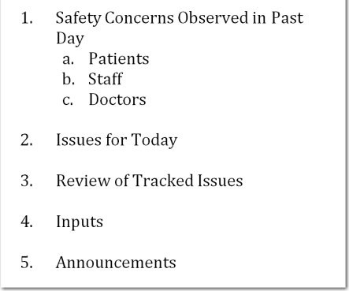
  - Designated recorder notes any concerns that need followup. The visual management board is the default location, and you can strike through items during the day to indicate completion. The board includes any followup with physicians.
  - If the supervisor observed standard work the previous day, supervisor will comment about observation—plus/delta summary. (See Appendix)

- Issues for Today
  - One person previews patients for the day, identifying any safety issues and the plans to address them. Review is faster and easier to reference during the shift if there is a table that lists the patients and safety issues on a visual display board.
  - Note any issues about equipment or room issues that affect safety.

- Review of Tracked Issues
  - Any updates on issues that have been tracked on the visual management board.
- Inputs
  - One more invitation to the team to raise points that affect safety or flow today.

- Announcements
  - Close with critical announcements/schedule changes. You can save time if announcements and schedule changes are written out and posted somewhere for staff reference and the supervisor uses the announcement item to just call out changes and point to the posted locations.

Learn More
CUS Framework
The CUS tool is presented in the Improving Communication and Teamwork in the Surgical Environment section of this Toolkit (slide set and facilitator guide).
You can also find out information about CUS as part of the TeamSTEPPS curriculum, available through AHRQ at the location below. TeamSTEPPS is an evidence-based teamwork system aimed at optimizing patient care by improving communication and teamwork skills among health care professionals, including frontline staff. It includes a comprehensive set of ready-to-use materials and a training curriculum to successfully integrate teamwork principles into a variety of settings.
TeamSTEPPS: Strategies and Tools to Enhance Performance and Patient Safety. Rockville, MD: Agency for Healthcare Research and Quality, May 2016. http://www.ahrq.gov/professionals/education/curriculum-tools/teamstepps/index.html.

Daily Huddles
TeamSTEPPS: Strategies and Tools to Enhance Performance and Patient Safety. Rockville, MD: Agency for Healthcare Research and Quality, May 2016. http://www.ahrq.gov/professionals/education/curriculum-tools/teamstepps/index.html.
The TeamSTEPPS training materials include guidance on conducting huddles.
Harnish V. Mastering the daily and weekly executive meeting. In: Mastering the Rockefeller habits: What you must do to increase the value of your growing firm. New York: SelectBooks; 2002: chapter 8.
This book chapter offers operational guidance on running better huddles (and other regular meetings).

Appendix: Plus/Delta Review
A quick way to evaluate a meeting or test of a work method is to ask the participants two questions:
- Plus: What did we do well that we should continue to keep doing?
Speak up and reinforce ideas to maintain good future performance (e.g., the next meeting, the next time you have to follow the work method).
- Delta: What should we change?
Identify ideas you can try so that the next meeting or next time you follow the work method may yield better results or be more efficient.

For additional information about introducing surgical safety checklists into ambulatory surgical centers, go to www.ahrq.gov/HAIambsurgery for information about the AHRQ Safety Program for Ambulatory Surgery.
Graupp P, Purrier M. Getting to Standard Work in Health Care: Using TWI to Create a Foundation for Quality Care. Boca Raton: CRC Press; 2013.

