Standard Work Observation Component Kit

Contents

1. Why Standard Work Observation? 2

Connections to Other Components 3

2. Tips 3

3. Plan-Do-Study-Act “Ramp”: Observe Checklist Use Regularly 5

4. Example 6

Using the Observations 6

# Why Standard Work Observation?

As you’ve adapted a surgical safety checklist for your site, the AHRQ Safety Program for Ambulatory Surgery has provided a [Checklist Observation Tool](https://www.ahrq.gov/professionals/quality-patient-safety/hais/tools/ambulatory-surgery/sections/implementation/implementation-guide/app-i.html). The program materials on coaching show how to use the Checklist Observation Tool to uncover issues and give useful feedback to your team.

We propose that you regularly observe surgical safety checklist use and apply the coaching recommendations (Figure 1) to maintain good checklist use.

Regular, in-person observation of the checklist in action gives a supervisor or manager—

**This image outlines the coaching algorithm recommended by AHRQ:  First teach, then watch, and then give feedback.**1. Direct evidence of how well people are able to use the surgical safety checklist;

**Figure 1. Coaching Basics1**

2. A basis for coaching;

3. A way to identify training needs;

4. Data to reveal patterns that can help you to change work flow and communication to get the desired performance of each procedure no matter which surgeon or which team is involved;

5. A key way to fight “desensitization” or “just going through the motions”; and

6. Raw data to inform standard work for higher level leaders within the organization (managers, administrators, medical directors), and thus a key element to help promote “integration” of standard work across organizational levels and alignment across organizational levels with strategy and mission. Basics[1]

**Not a chart audit.** Routine electronic health record or paper chart audits can’t capture the look and feel of your team communicating with each other. Go see the use of the checklist in action.

**What counts as regular?** Daily observation of at least one segment of the surgical safety checklist in action (preop, before procedure start, before patient leaves the room) may be feasible in high-volume centers; at least one observation per week is a minimum for maintaining consistency and revealing issues, even in low-volume centers.

**Not just for surgical checklists.** You can apply regular observation, reflection, and feedback to **any** aspect of standardized work in your center.

### Connections to Other Components

Daily Huddle: Sharing checklist observations takes place in daily huddle.

Visual management board: Table of checklist observations shows performance and opportunities.

Problem solving: Patterns in missed checklist items are topics for coaching and problem solving.

Integration: Observation of safety standard work, including the checklist, serves as part of next-level standard work for managers, and helps build a foundation for aligned standard work across levels of the organizational hierarchy.

# Tips

* Make sure you have finished your initial tests of the surgical safety checklist and made initial adaptations to suit your site before putting too much effort into capturing scores.
* Let your team know that you will be testing observation for maintenance, with the aim to make direct observation of checklist use a regular practice to support coaching and improvement. You will share what you learn from the observation for maintenance tests, such as in daily huddles.
* It’s OK to continue to adapt your surgical safety checklist; just make a note of when you make the change so you can match the change to any patterns in observations.
* You can focus your observations on key parts of the checklist, like the Centers for Medicare & Medicaid Services requirements or specific communication elements, such as in the Before Procedure checklist:
  + Even if everyone on the team has worked together multiple times, does each member say “ready” or some other term if there is no need to say name and role?
  + Does the surgeon or charge nurse explicitly ask, “Does anyone have any concerns?”
  + Is there a hard stop, with everyone attentive?
* If you focus on a subset of items, you will track performance on those items on your visual display board.
* Follow the recommended three-step approach (Figure 1) to coaching when you have coaching opportunities in your maintenance observation.
* Keep your maintenance checklist observation forms in a folder or binder, in date order, so you can check your understanding and easily update the performance grid on the visual display board.
* You can select procedures to observe based on management insight; for example, focus on surgeries versus endoscopies. Some procedure types may deserve more coaching and support than others. Further, try to cover different teams and different times of day and days of the week so your observations are well distributed.

# Plan-Do-Study-Act Sequence: Observe Checklist Use Regularly (Table 1)

**Table 1. Plan-Do-Study-Act Sequence**

|  |  |  |
| --- | --- | --- |
| **PDSA Cycle #** | **What question(s) are you trying to answer?** | **Preparation** |
| 1 | Can you use a surgical safety checklist form to summarize three procedure segments? | 1. Draft an observation tool. 2. Make sure you have a regular location to store your sheets for reference. |
| 2 | Can an observer report on an observation in a daily huddle? | 1. Follow the recommendation from the AHRQ Safety Program for Ambulatory Surgery to give feedback to the team observed before bringing to the huddle. Prepare to use the coaching approach. 2. Draft the maintenance record grid for the visual management board. 3. Transfer observation notes onto the maintenance record grid. |
| 3 | Can an observer observe at least two procedures each week for 4 weeks and report to the daily huddle the day following the observation? | 1. Modify the maintenance record grid on the visual management board to match your observation sheet. 2. Decide if there are certain procedures, times of day, and days of the week you want to include in your test. |
| 4 | Can you summarize 10 procedure observations on the visual management board? | 1. Determine a rhythm for observation that fits with your workflow but is not entirely predictable to the teams observed. |
| 5 | Can you use observation data as part of huddles and/or visual management boards in huddles for unit leaders? | 1. Draft a visual management board representing standard work of unit-level leaders tracking observation and other measures. |

# Example

Here is an example of an observation form tested at an ambulatory surgical center in April 2016 (Figure 2).

**Figure 2. Example Observation Form**

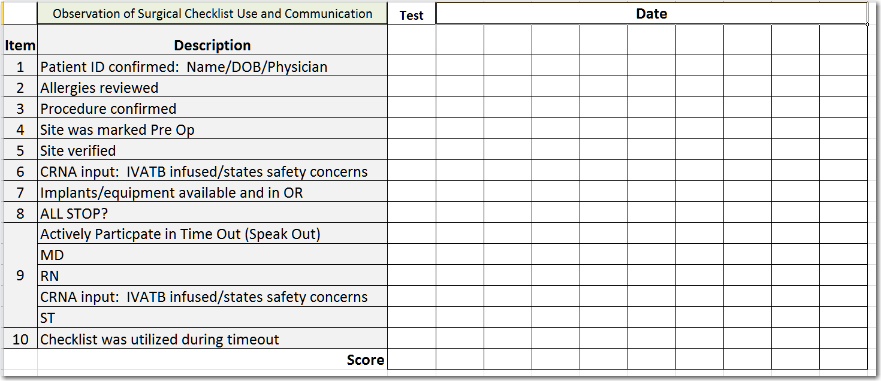

Key:

ID: Identity

DOB: Date of birth

CRNA: Certified registered nurse anesthetist

IVATB: Intravenous antibiotics

MD: Doctor of medicine

RN: Registered nurse

ST: Surgery tech

The observation form helps the observer track the items of standardized work—the use of the surgical safety checklist and communication behavior. Item 9 can be scored as “all or nothing.” To get a point, all four participants need to speak.

Each column represents one observation; use a check mark to indicate if the item happened.

The observation form can be posted on your visual management board.

## Using the Observations

A usual reaction when you see that an item is missed is to point out the missing item to the team and remind people to be more vigilant. Reminders and practice of standard behaviors are important but often not sufficient to get 100 percent performance.

The key step in observation is to understand why an item is not carried out. It may in fact be that surgeons or other team members do not know regulatory or policy requirements. Lack of knowledge of requirements may stem from inconsistent onboarding for new staff. Inconsistent onboarding of new staff may occur because requirements for surgical safety checklist use are not documented and hence not part of standard education, just dependent on who does the orientation for new staff, and the orientation lacks a standard script and packet.

You should ask and follow up the specific circumstances to get at reasons, which often will suggest a change to somebody’s work. Test the change and see if it makes a difference!

You may be familiar with this kind of thinking, which is called “5 Whys”[2]—ask why five times to get beyond the initial (proximate) cause and identify a change that will make a fundamental difference.

1. George E. Coaching with an observation tool. AHRQ Safety Program for Ambulatory Surgery. <http://www.ahrq.gov/HAIambsurgery>. Accessed August 29, 2016.
2. Centers for Medicare and Medicaid Services. Five Whys Tool for Root Cause Analysis. <https://www.cms.gov/medicare/provider-enrollment-and-certification/qapi/downloads/fivewhys.pdf>. Accessed August 25, 2016.