Facilitator Notes
SLIDE 1  Title: Management Practices for Sustainability: Module 4: Observation and Integration  SAY: “The aim of supervision should be to help people and machines and gadgets to do a better job.” This quote comes from W.E. Deming, one of the fathers of the quality improvement and quality management methods and theories espoused by the Institute for Healthcare Improvement, or IHI.  Deming was making a fairly basic point. In order to help people do a better job, a supervisor should know by direct observation how hard or easy it is for his or her team to use the agreed-upon methods.  ASK: For example, do you know how hard or easy it is for an operating room or OR team to use your center’s agreed-upon surgical safety checklist with its associated communication behaviors?  Helping you better address these kinds of questions is the aim of this module.  Deming WE. Out of the Crisis. Cambridge, MA: MIT Press; 1986. | 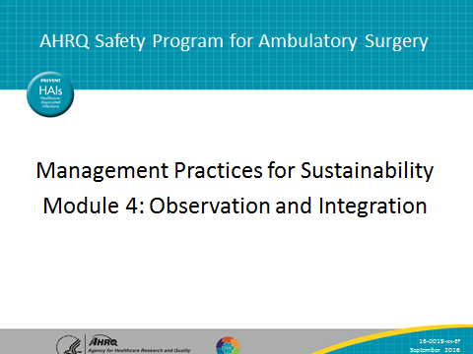
SLIDE 2  Title: A Frontline Management System To Promote Safety Standard Work  SAY: Regular observation of safety standard work forms a key connection in our frontline management system between the other elements, as this figure shows. Visual management boards should ultimately reflect the results of observation. Observation is the firstline linkage between different levels of standard work across the organization—and thus fundamental to the concept of integration, which is one of the pillars of the model. | 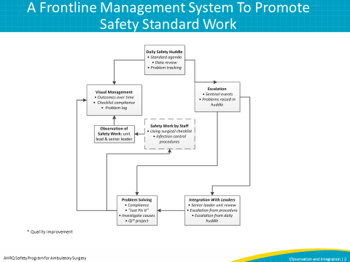

SLIDE 3  Title: Benefits of Direct, Regular Observation: Surgical Safety Checklist Usage  SAY: Observation, at the most basic level, entails collecting direct evidence for how well people are able to use your center’s surgical safety checklist. It has many benefits, including that it helps provide important data to inform coaching, it helps identify needs for further training, and it provides data to help you track fidelity to standard work and patterns in performance.  You might wonder, what counts as regular observation? Our experience has taught us that daily observation of at least one segment of the checklist in action (preop, before procedure start, before patient leaves the room) may be feasible in high-volume centers. At least one observation per week is a minimum for maintaining consistency and revealing issues, even in low-volume centers.  We also want to make some prefatory comments to help give you some practical tips about surgical safety checklist observation.  First—a note about audits versus observation. By observation, we do not mean chart audits of surgical safety checklist use. Routine electronic health record or paper chart audits can’t capture the look and feel of your team members communicating with each other. It is important to see the use of the surgical safety checklist in action.  Second—a note about tone. It’s important that you take the perspective of a coach trying to help your team do a better job, rather than that of a traffic cop giving a speeding ticket. This is true of nearly all improvement work of course.  Finally, you might wonder if this is just about surgical safety checklists. It’s not. We use the surgical safety checklist as an example. You can apply regular observation, reflection, and feedback to any aspect of standardized work | 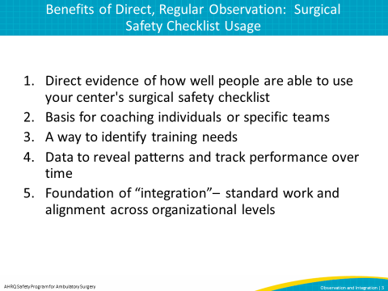
SLIDE 4  Title: Example of a Data Sheet used to Guide an Observation  SAY: An observation form like this one can help the observer track the items of standardized work—the use of the surgical safety checklist and communication behavior. Item 9 can be scored as “all or nothing.” To get a point, all four participants need to speak.  Each column represents one observation. Use a check mark to indicate if the item happened.  The observation form can be posted on your visual management board and prompt comments from the supervisor in the daily huddle. | 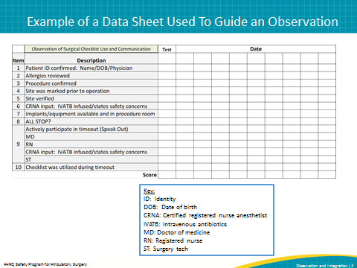
SLIDE 5  Title: Example of a Data Sheet Used To Guide an Observation-2  SAY: This is a form used by a quality improvement coordinator at one of the facilities that IHI worked with in prototype testing work, to track the use of daily huddles.  The slide shows daily observation of multiple huddles. It looks like the huddle topics are discussed regularly, so observation frequency can be reduced to one observation per day so each unit is observed once a week. | 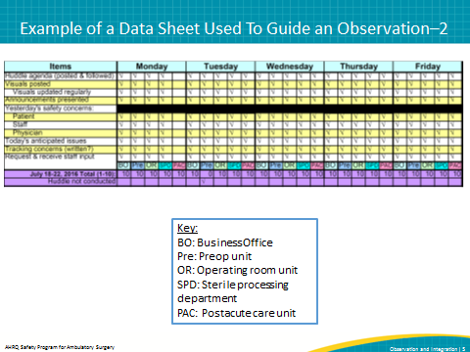
SLIDE 6  Title: Apply the Model for Improvement to Observation  SAY: As with the other elements in the frontline management system, you can apply the Model for Improvement to introduce daily observation. To apply the Model for Improvement, you need to define three things: (1) clarify what you are trying to accomplish, (2) define how you’ll know that a change is an improvement, and (3) define changes to meet your aim.  Think about how to apply this framework to daily observation:  What are you trying to accomplish? We are trying to accomplish reliable use of agreed-upon work methods, such as the surgical safety checklist and communications behaviors.  How will we know that a change is improvement? We should eventually see better alignment between agreement and actual practice shown in checklist record.  What can we change to make an improvement? We can introduce regular, direct observation by the unit supervisor. | 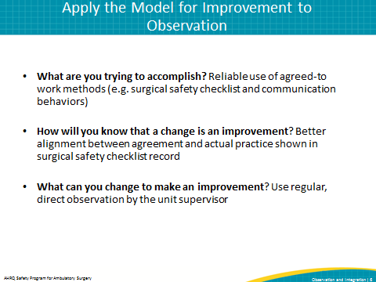
SLIDE 7  Title: Apply the Model for Improvement to Observation–2  SAY: As we’ve said in previous modules, the “engine” we use to apply the Model for Improvement is the Plan-Do-Study-Act, or PDSA, cycle. As for huddles and visual management boards, you’ll want to design a carefully detailed test to help you advance your observation work. | 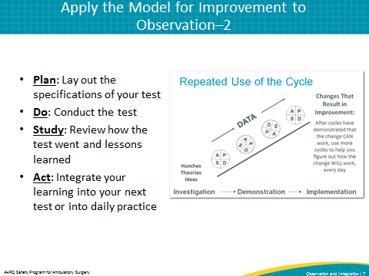
SLIDE 8  Title: Apply the Model for Improvement to Observation–3  SAY: This slide lays out a short sequence of PDSA cycles you can introduce to improve your observation of safety standard work. Applied in the context of the surgical safety checklist consider the cycles this way:  - First— Can you capture fidelity to the surgical safety checklist through observation the OR? Can you apply an observation tool?  - Second— Can an observer report on an observation in a daily huddle? In the surgical safety checklist context, can the observer report on the results of surgical safety checklist observation in a daily huddle with the OR staff, for example?  - Third— Can you introduce observation on a more consistent basis? Can an observer observe at least two procedures each week for four weeks and report the results in daily huddles following observation?  - Fourth— Can you summarize 10 procedure observations, with records of observations on the visual management board? | 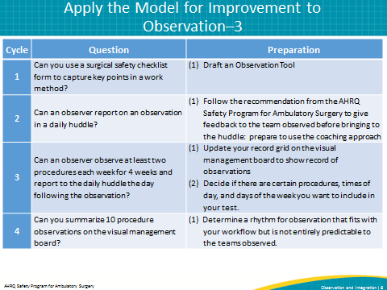
SLIDE 9  Title: Tips  SAY: Here is a summary of some practical tips to help you in your testing of observation.  First, use direct observation to start noticing differences in fidelity to standard work among physicians and teams. Target improvement discussions and projects accordingly.  Second, think of direct observation as a helpful tool for supervisors and managers to focus their efforts and understand where additional coaching may be necessary.  Points three and four— remember to integrate observation with the other management tools you are introducing, such as the daily huddles and visual management boards. Discuss the results of observation in the huddles, and add measures to the visual management boards reflecting the results of observation.  Fifth, remember that you have a great repository of resources from the AHRQ Safety Program for Ambulatory Surgery on coaching and observation, including a checklist observation tool. | 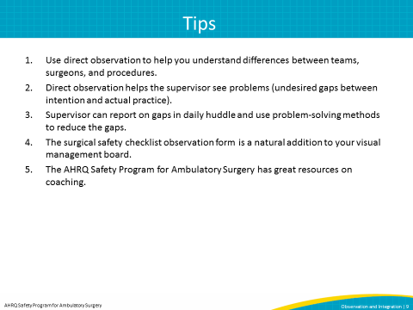
SLIDE 10  Title: Observation and Integration  SAY: Observation of standard work has a natural linkage to another element of our system—the idea of integration. Integration refers to alignment of standard work across levels of the organization, and alignment of standard work and management practices with organizational strategy and goals.  Observation of standard work, including the surgical safety checklist, can be thought of as a major part of the standard work of the frontline manager. As you make progress in introducing the management practices we have discussed, consider opportunities to scale them across not only departments, but also hierarchical levels of the organization. Can you introduce daily huddles for the unit-level managers? Can you introduce visual management for top leadership in your facility like the medical directors and senior administrators?  Observation of key standard work, like the surgical safety checklist and timeout, can serve as a crucial data point to inform standard work at higher management levels of the organization—thus providing you with an important resource to move to achieving integration.  You can report the results of observations of standard work to members of the leadership team as a way to spur discussion about consistency of your performance with organizational goals and mission overall. | 