Facilitator Notes
SLIDE 1  Title: Management Practices for Sustainability, Module 1: Overview  SAY: This module was created by the Institute for Healthcare Improvement, a not-for-profit global organization based in Cambridge, MA, dedicated to advancing the triple aim of better health, better health care, and lower per-capita health care costs. IHI was part of the National Program Team on the Agency for Healthcare Research and Quality Safety Program for Ambulatory Surgery. Throughout this module, the Agency for Healthcare Research and Quality will be referred to as AHRQ and ambulatory surgery centers as ASCs.  This module serves as an introduction to a number of management practices that we have found to promote the sustainability of safety standard work. To better understand safety standard work, like surgery checklists and sterilization practices, be sure to view the resources available to ambulatory surgery centers on AHRQ’s Web site. These management-focused modules can be thought of as a companion to those resources. | 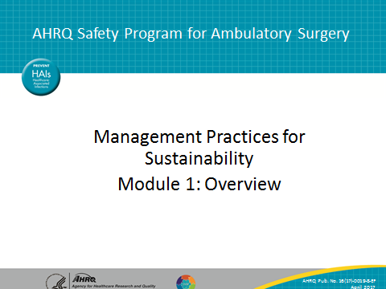
SLIDE 2  Title: Ensuring Safety in Ambulatory Surgery  SAY: We know that surgery has increasingly been moving to the outpatient arena, including to ambulatory surgery centers. At the same time, the diversity and complexity of procedures continues to increase.  ASCs have an excellent safety record, but events do happen. Surgical safety checklists and other examples of safety standard work can help you avoid both near misses and serious safety events. In fact, the Centers for Medicare & Medicaid Services now mandates checklist use for ASCs.  Because standard work fatigue can reduce the impact of such practices, the introduction of management-focused standard work into frontline clinical care is essential. | 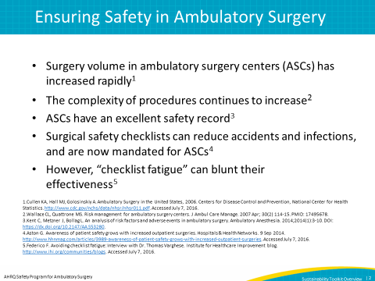

SLIDE 3  Title: AHRQ Safety Program for Ambulatory Surgery  SAY: These sustainability resources are part of a larger project AHRQ funded as part of the National Action Plan to Prevent Healthcare-Associated Infections. This project has included 665 ASCs participating in eight project cohorts over several years. The two main program goals were to reduce surgical infection and complication rates and to improve safety culture through improved teamwork and communication.  Key interventions have included shared reporting on key safety indicators; collaborative learning and coaching on quality improvement methods and safety practices; and support for specific safety interventions such as checklists, safety escalation protocols, and communication practices like TeamSTEPPS.  Many participating ASCs have demonstrated improvements in safety practices. Many though are now wondering: How can they maintain the effectiveness of this work over time? What is the key to sustainability for safety standard work? | 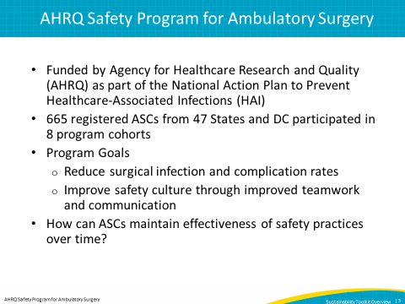
SLIDE 4  Title: Sustaining Change Is Not Easy!  SAY: Many change efforts fail to result in sustained improvements. Researchers have wondered about this problem. Studies of sustainability have tended to focus on resources, contextual factors, and program content, as well as the ever-vague category of “cultural change.” But few studies provide practical guidance or specific methods for sustaining changes.  The IHI team studied 10 leading health care organizations that have made headway in solving this problem—leaders like Intermountain Healthcare in Utah and Virginia Mason in Seattle. They have used Lean and other management frameworks to help them move toward changes that stick. | 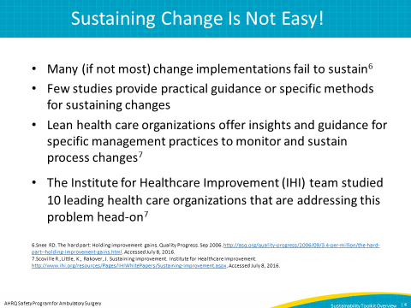

SLIDE 5  Title: What Does it Take To Sustain Improvement?  SAY: Through its research, the IHI team developed a model for sustainability focused on daily work for frontline managers and staff. IHI found that standard work for frontline managers is essential to the “stickiness” of changes.  Key elements of the model include many elements that may already be familiar to you; practices like daily huddles, the use of visual boards to present data at the front line, having well-understood problem solving and escalation protocols, and clear alignment around organizational aims and priorities across levels of the organization in an integrated way. These practices and others will be the focus of the modules in this series. | 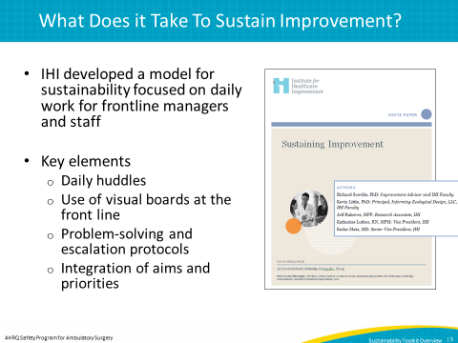
SLIDE 6  Title: A Model for Sustainability in ASCs  SAY: This slide lays out in greater detail the elements of the system. As you can see, we have conceived of an interlocking set of practices that together promote sustainability of standard safety practices. The whole is greater than the sum of the parts.  At the center of the system is standard work for all levels of the organization relating to safety. Examples include safe surgery checklists, infection control procedures, and role-based standard work like communication and handoff protocols.  Moving across this diagram: frontline leaders observe and track standard work at the front lines, often recording the results using visual management boards. The boards also track key safety indicators.  At the top center: Daily safety huddles, which are a form of leader and staff standard work, as well as a mechanism to support accountability for standard work, serve as a linchpin or anchor for the system. Huddles provide a venue to identify problems and review improvement projects, as well as to monitor performance measures. They also improve team cohesion and engagement by offering all team members a voice.  Moving down: well-understood escalation protocols support staff in understanding which problems they can solve themselves, and which require additional support from leaders, or dedicated improvement projects.  Moving to the bottom right: Integration refers to support for the practices at each level of the organization as well as engagement in huddles and visual management by leaders at each level. Integration also implies alignment of goals across organizational levels, which also supports sustained momentum for the system overall.  Moving to the bottom center: Problem solving methods are key for identifying and addressing problems at the front line. Without skill in problem solving methods, the huddles and visual management boards end up seeming pointless, given that while staff may recognize problems, solutions may never arrive. | 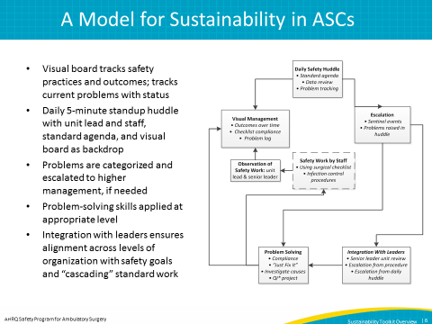
SLIDE 7  Title: Testing the Model  SAY: After developing this theory of change, the Institute for Healthcare Improvement team tested the theory with several ambulatory surgical centers. The testing was focused on one large center with a foundation of quality improvement, and one smaller center with less training around quality improvement methods.  The testing included prework calls and activities, as well as two-day site visits and followup calls to monitor progress.  The testing included introduction of the management practices described earlier; daily huddles focused on safety standard work, the construction and use of visual management boards, the development of clearer escalation protocols, and the like.  The IHI team found an enthusiastic response to these practices. Staff had taken to the huddles enthusiastically. Managers noticed improved staff engagement, as staff had a consistent voice in operations. The larger center visited by IHI, had expanded the huddle practice to the point where each of their five departments has its own huddle and visual board. That particular center saw a 10 percentage-point increase in their patient safety culture survey, which they credit to the introduction of these practices. | 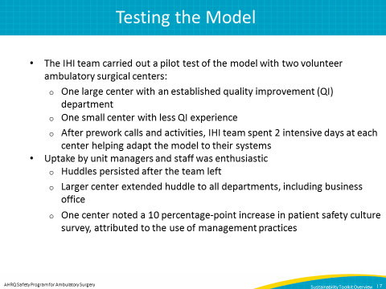

SLIDE 8  Title: Key Findings from IHI’s Pilot Testing  SAY: The IHI team uncovered a number of insights and practical tips on what it means to introduce this management system in the ASC environment. You’ll find these tips throughout the modules in this series.  This slide offers you a snapshot of the key findings. There was an initial focus on the core practices of daily huddles and visual management which is typical as this is the foundation for the system.  Daily huddles can be short, ideally 5 minutes, and should focus on reviewing safety-related issues from the previous day and any concerns for upcoming patients today.  Visual management can focus on a few simple metrics, at least initially, such as days since last harm event, days since last near miss, and surgical timeout compliance.  Overall, the IHI team learned that this model builds on the skills of frontline managers, and that it’s crucial to consider these management practices with fundamental skill building in improvement methods like the Model for Improvement, which the Institute for Healthcare Improvement has been teaching to health care providers across the globe for the past 30 years.  The goal here has been to give you a flavor for the kinds of management practices studied in ASCs. The next module will offer you a deeper dive into the practice of daily huddles which once again is really a foundational element for the system overall. You can find more information about the system in a set of “component kits” which offer you practical tips and guidance on running small tests of change. You can also find other helpful materials on the AHRQ Web site, like examples of forms to help plan small pilot tests and other documents to help you outline work on these management practices at your center. | 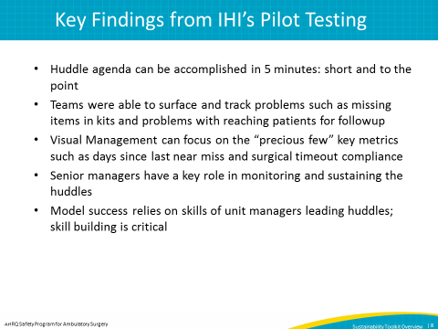
SLIDE 9  Title: References | 