Facilitator Notes

SLIDE 1  Title: Management Practices for Sustainability, Module 3: Problem Solving and Escalation  SAY:  In this module, we will focus on two elements in the frontline management system that we have outlined—having well-understood problem-solving and problem-escalation methods available to and routinely used by staff and leaders. | 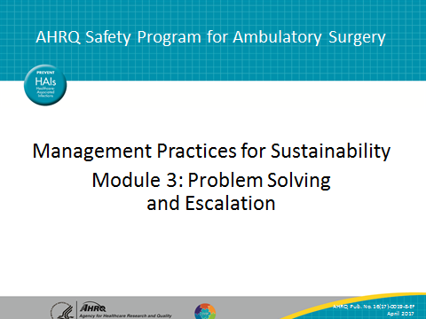
SLIDE 2  Title: A Frontline Management System To Promote Safety Standard Work  SAY:  As the figure here shows, the frontline management system rests on the ability of staff and supervisors to recognize problems and either solve them directly or get assistance to solve them.  There are many ways to solve problems. Does your organization have a preferred method? What agreements do you have about when and how to escalate problems and issues in order to get attention and help from senior managers? | 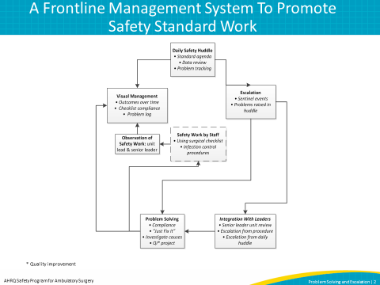
SLIDE 3  Title: What Is a Problem? What Is a Solution?  SAY: You can have problems that involve results such as harm events or near-misses. Ambulatory surgery centers typically have formal methods to investigate and resolve such problems, documenting root cause analysis and countermeasures to prevent recurrence.  You can also have problems that involve methods, such as a gap between the standard way to conduct timeouts in the operating room and a direct observation of the timeout. For example, in an observation of 190 hours of nursing work in four hospitals, researchers saw 120 problems. Of those 120 problems, 110 were tackled and solved as type 1 solutions, which close the immediate gap without necessarily preventing recurrence in the future. Type 2 solutions prevent recurrence, often getting at deeper causes. Do these numbers match your experience?  Often, it is appropriate to apply type 2 problem solving to understand why the problem occurred and then try to prevent recurrence. To prevent recurrence, sometimes the fix is obvious, and other times you have to try different ideas.  Tucker AL, Edmondson AC, Spear S. When problem solving prevents organizational learning. Journal of Organizational Change Management 2002 15(2): 122-37. | 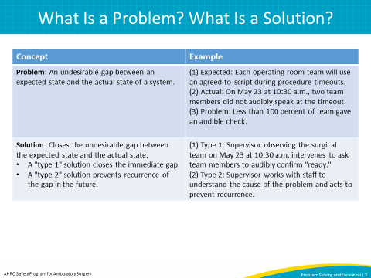
SLIDE 4  Title: How Do Problems Get Flagged?  SAY: Most problems are identified by staff or are observed by supervisors.  The daily huddle gives you a place and time every day to speak up about problems observed by team members. Weekly observation of procedures and work methods by the supervisor, as actually performed, is another primary source. The supervisor can bring observations to the daily huddle, too. | 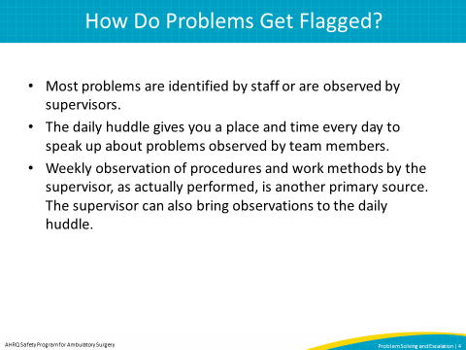
SLIDE 5  Title: Four Problem Boxes  SAY: Some problems and issues require immediate management attention, such as urgent and important issues like a harm event. In these cases, you may design an “SBAR,” laying out the Situation, Background, your Assessment of the situation, and a Recommendation. This is problem solving and escalation in action.  Many issues, though, will not require such immediate attention. We divide the nonurgent issues into four categories.  Let’s look at box 1: If a nonurgent issue is related to individuals not following the agreed-upon methods or established protocol, then reminders and information may be enough to correct the problem. Sometimes, the method needs to be redesigned and the way forward is not clear, so you jump down to box 3.  In box 2 we describe another approach called “just do it.” “Just do it” is appropriate if you have a clear understanding of how to prevent the problem from recurring and there is no risk of unintended consequences. The change to work method or work environment can be done immediately. If your understanding is a little fuzzy or you’re concerned about unintended consequences, jump to box 3.  Box 3 is applicable if you are not sure what to do, and you need to spend time and effort to prevent recurrence. Analysis is one way to move forward. You can use root cause analysis tools like “is/is not” tables or cause-and-effect diagrams to develop change ideas that you can test which may lead to improved performance.  If the problem appears bigger than what the team and supervisor can handle within the unit within a week, then the problem is a candidate for escalation to a more formal quality improvement project.  Box 4 refers to process redesign problems or problems with flow between departments that need additional attention and can be larger, cross-functional quality improvement projects.  Think about the applicability of this categorization to your current problem-solving process. | 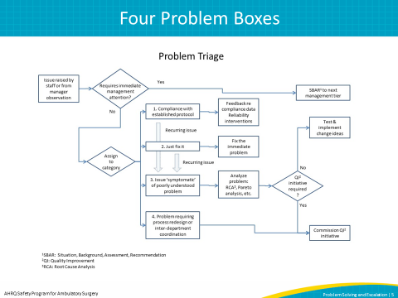
Slide 6  Title: Apply the Model for Improvement To Improve Your Problem Solving  SAY: To introduce more systematic problem solving into your organization, you can use the Model for Improvement, just as we have been doing for the other management practices we’ve discussed.  The Model for Improvement starts with three questions:  ASK: First, what is your aim? In other words, what are you trying to accomplish?  Second, what are your measures? In other words, how will you know that a change is an improvement?  Finally, what are your changes that you are going to test? What, specifically, will you do differently to make an improvement?  SAY: Let’s go through an example. The manager of the center has noticed that the same problem is recurring and wants to delve deeper into how to make the improvement. So, what she is trying accomplish is the reduction in the number of recurring problems. She will know that it is successful when fewer similar problems occur. To determine the right course of action, the manager will use the problem triage algorithm.  Using these questions as a guide will help with clearly identifying the problem and intended end result. | 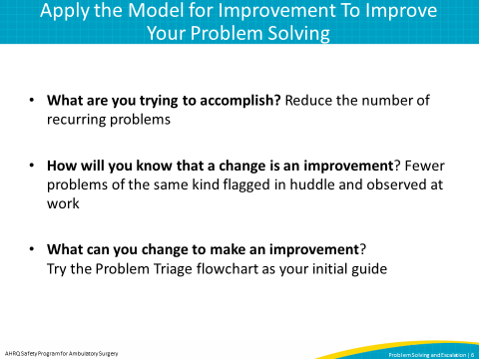
Slide 7  Title: Apply the Model for Improvement To Improve Your Problem Solving–2  SAY: The main avenue we use to apply the Model for Improvement is the “Plan-Do-Study-Act,” or “PDSA” cycle, as described in previous modules.  Here is a refresher on PDSAs. When you “plan,” you lay out the specifications or the details of your test. Who, when, where, how, why. When you “do,” you actually run the test. When you “study,” you review how the test went and what you learned, as well as reflect on what you might do differently. When you “act,” you use those reflections and insights to inform your next tests, or your newly agreed-upon way of doing the work.  Turning to problem solving:  - A first test—can you assign a problem to one of the four boxes and follow it through to resolution?  - A second test—can you assign each of five problems to a box and follow through to resolution?  These tests should reveal opportunities to develop guidelines for your staff to follow. | 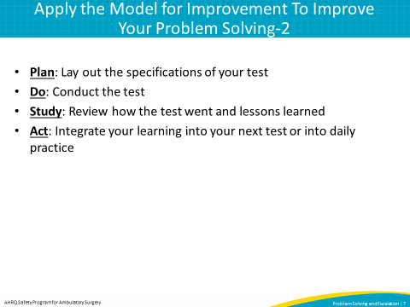
Slide 8  Title: Escalation for Frontline Clinical Issues  SAY: Much of the discussion thus far has been on problem solving and escalation in general.  We also want to remind you that there are resources to facilitate escalation of critical, safety-related issues that may occur at the front lines of clinical care. You can find resources on the AHRQ Web site related to how to use the one tool in particular that can help flag safety concerns, CUS. In verbal communication, CUS can be a signal phrase to all team members that an issue is serious and requires attention.  To use CUS, first, state your concern, then state why you are uncomfortable. If the conflict is not resolved, state that there is a safety issue and discuss in what way the concern is related to safety. If the safety issue is not acknowledged, a supervisor should be notified.  If an event occurs during care provision that a staff member is concerned about, this simple protocol makes it an expectation that the staff member express that concern. If the concern is not addressed, then the staff person declares that they are uncomfortable.  If the statement of discomfort is still not addressed, then the staff person declares that there is a safety issue that requires action—for example, to call for additional clinical staff or to stop the procedure.  In the component kit accompanying this module that is available through the AHRQ Web site, you can find more information about CUS, as well as a template policy that you can adapt to your facility to help hardwire the use of the CUS tool in your center. | 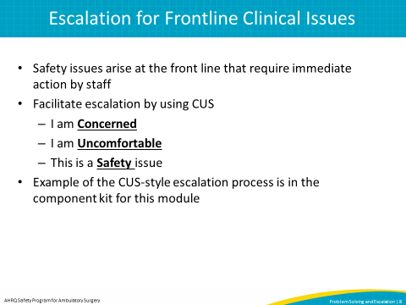
Slide 9  Title: Tips  SAY: As with the other practices we’ve discussed in the prior modules, we want to leave you with some practical tips to help you with the introduction of enhanced problem solving and escalation in your organization. Problem solving as we've described aims to achieve and maintain reliable performance  First, if your organization has a standard problem-solving method, learn to use it. Second, understand the tools for root cause analysis that your center applies to investigate and document harm events. Third, incorporate use of the CUS communication protocol into routine use at your facility. It is important to ensure broad staff understanding and comfort with its use.  For more information about problem solving and escalation, see the component kits also available on the AHRQ Web site that accompany these presentations.  Thank you for reviewing this module on problem solving and escalation. Remember to review the modules and component kits on the other elements of the frontline management system to promote sustained safety standard work in ambulatory surgery centers, also available via the AHRQ Web site: www.ahrq.gov/HAIambsurgery. | 