Slide Title and Commentary | Slide Number and Slide
Title Slide  Forming a Comprehensive Unit-based Safety Program Team  SAY:  Today, we will briefly revisit the key concepts of the Comprehensive Unit-based Safety Program or CUSP. Then, we will dive into a focused discussion on forming a CUSP team. We will also cover strategies to help your team successfully implement the AHRQ Safety Program for Mechanically Ventilated Patients. | Slide 1  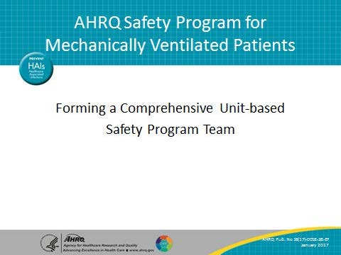
Learning Objectives  SAY:  This overview of the safety program features the adaptive work of CUSP at the heart of all technical interventions.  Adaptive change describes the changes in unit and organizational culture that lasting improvement requires. CUSP helps teams achieve those changes in culture. CUSP is a powerful process that teams employ to recover from mistakes, but also to learn from them and prevent similar mistakes from happening again. CUSP reinforces the power of the frontline wisdom and taps into that wisdom. Through CUSP, frontline providers find a voice and are empowered to engage in quality improvement and patient safety initiatives. Evidence shows that CUSP implementation and the resulting changes lead to improvements in clinical outcomes and can even reduce staff turnover. Barriers between frontline staff and hospital administration begin to break down through adaptive change efforts. | Slide 2  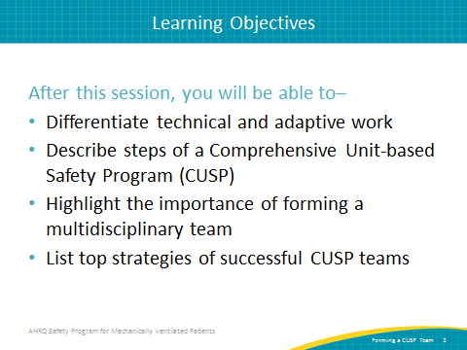
AHRQ Pub. No. 16(17)-0018-28-EF
January 2017

Slide Title and Commentary | Slide Number and Slide
Key Concepts—Technical and Adaptive Work  SAY:  Technical and adaptive work are key to successful change efforts, so it is useful to review both concepts.  Technical work refers to the procedural tasks providers perform when caring for patients. Because of the procedural nature, technical work lends itself to standardization through checklists, protocols, and order sets.  Of course, it is one thing to introduce a new protocol and quite another for providers to effectively and consistently implement that protocol. That is where adaptive work or the people side of change comes in. Adaptive work represents the change in values, attitudes, and beliefs that are required to put the technical work in place. Sustainable progress requires successful implementation of both the technical and adaptive aspects of any change initiative. You must balance both technical and adaptive aspects for a successful and sustainable change effort. | Slide 3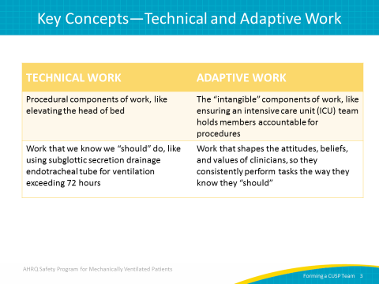
Steps of CUSP  SAY:  CUSP is a continuous process that features five steps. While CUSP seems quite simple at first glance, teams often face great challenges integrating diverse team members in complex organizations. Briefly, teams should first educate all staff members on the science of patient safety. Science of Safety teaches clinical providers and support personnel to see problems due to poor system design. Through system lenses, staff can focus on how workflow allows defects in care rather than blaming and shaming providers.  Second, as staff members begin to evaluate the system of care delivery, they are asked to identify defects with three powerful questions. Simply put, a defect is anything that happens, either clinically or operationally, that you don't want to happen again.  ASK:  How do you think your next patient will be harmed?  What do you think we can do to prevent that harm?  How can we get your patient off the ventilator faster?  SAY:  We first spoke about these questions in Module 3, the Comprehensive Unit-based Safety Program, Staff Safety Assessment, and Premortem Exercise module. These questions are part of the staff safety assessment or SSA. These questions tap into the wisdom and knowledge the frontline providers have about the risks in the patient care area.  Third, partner with a senior executive. An effective partnership opens lines of communication between the clinical area and the hospital administration. It supports team efforts to collaborate with multiple downstream and upstream departments, and can even help teams gain access to constrained resources.  (continued on next page) | Slide 4  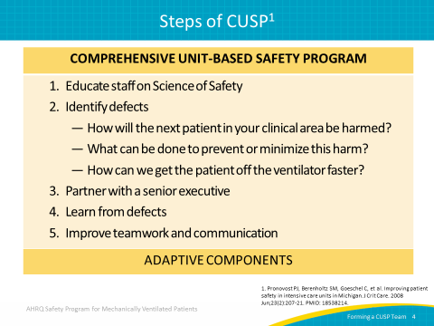
Steps of CUSP (continued)  SAY:  Fourth, teams learn from their local defects through a four-step process that guides an investigation into the root causes of the defect. Through this process, CUSP teams can isolate contributing factors, develop interventions, and proactively prevent defects.  Finally, through the application of focused tools, teamwork and communication improve. Examples of tools include daily briefings, daily goals, and safety walking rounds. | Slide 4 (continued)
Successful CUSP Teams  SAY:  We have learned a great deal about forming and leading successful teams. Unfortunately, we also have learned a great deal about ineffective teams. Implementing and sustaining change in health care is a challenging endeavor. It demands engaged clinicians willing to take ownership of patient safety and quality. Focusing on what our patients need requires a variety of informed perspectives. Team members should be diverse, representing varying levels of experience and disciplines. Seek out team members from multiple disciplines and backgrounds. Actively solicit input from each team member for all team decisions. | Slide 5  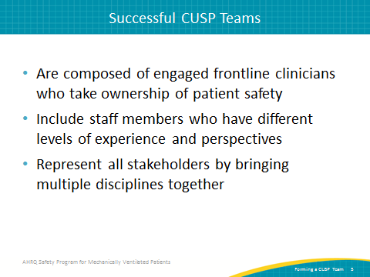
Why Engage Across Disciplines  SAY:  We know that successful efforts are informed by science, led by clinicians, guided by measures, and informed by a systems view. This requires input from across various disciplines. | Slide 6  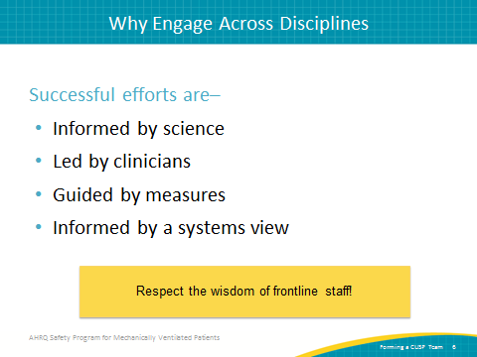
Safety Program CUSP Team Members  SAY:  The AHRQ Safety Program for Mechanically Ventilated Patients will require several roles, labeled essential team members. Depending on where you are within the program, you may also need several enhancing roles. All roles represent key stakeholders and will impact your improvement initiatives. In an ideal world, each of these clinical areas would be fully represented on an ongoing basis. In the reality of overextended acute-care settings, we offer suggestions to help prioritize needs. This program requires a variety of disciplines for successful implementation. The essential team members must be represented; the enhancing team members will augment your team as it evolves through the program based on availability and relevance. | Slide 7  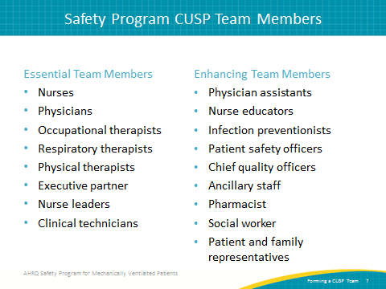
Core CUSP Team Roles  SAY:  Teams perform better when we clearly delineate the responsibilities associated with each role. Team members cannot perform to their maximum potential if they don't know what is expected of them. You can find detailed information on each core team role on the AHRQ Web site in the CUSP Toolkit. | Slide 8  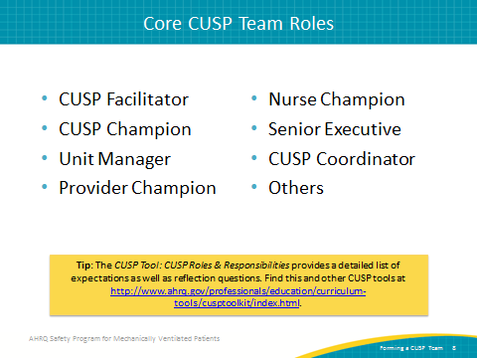
Team Roles—CUSP Facilitator  SAY:  The CUSP facilitator supports others as they achieve exceptional performance. They help with CUSP processes and enable productive communications. CUSP facilitators serve as subject matter experts on CUSP and share lessons learned. This role provides safety culture survey support for teams and gathers trends from local data. The facilitator also coordinates and leverages senior leadership, patient safety initiatives, and external resources. | Slide 9  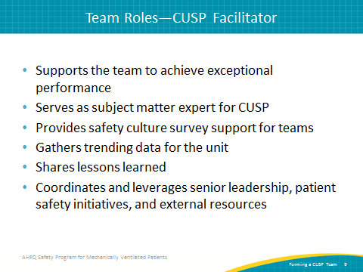
Team Roles—CUSP Champion  SAY:  A CUSP champion works to ensure that the vision of CUSP is translated into action and that all staff members are engaged. This role educates staff on CUSP and implements a staff training plan on the Science of Safety. The champion sets the agenda for safety meetings and reviews project status updates, including needed resources and the barriers encountered throughout implementation. The CUSP champion serves as a contact for questions and gathers staff feedback. | Slide 10  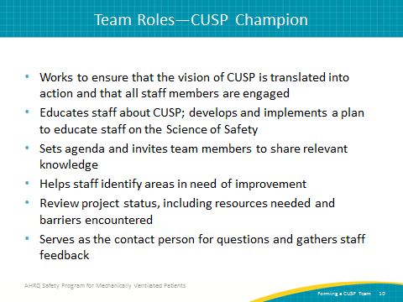
Team Roles—Unit Manager  SAY:  The unit manager is often either a nurse manager or unit manager. The support of local management is essential to the success of any change process. This role works with staff to initiate new policies and procedures and sustain patient safety efforts. The unit manager listens to staff concerns and represents the staff in communications with hospital administration and departmental management. This role actively supports patient safety and quality improvement projects. The unit manager mentors the team to speak up and identify defects. | Slide 11  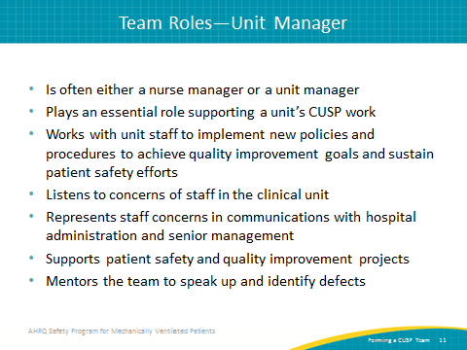
Team Roles—Provider Champion  SAY:  The provider champion is usually a physician, but could also represent other specialties or nursing. You may need a champion from several disciplines representing the key stakeholders impacted by this safety program. The organization of your intensive care unit and department will likely drive some of these decisions. Many teams find success with a provider and nurse champion partnership. Other teams augment physician or nurse champions with champions for physical therapists and respiratory therapists.  Regardless of what you chose for your safety team, keep the following tasks in mind for your provider champions. Provider champions learn about CUSP and systems thinking models, develop the lenses to view the care delivery system as a whole, and lead change efforts. They galvanize other providers to actively participate in safety initiatives and represent these providers on the CUSP team. They respect the contributions made by their peers and have a deep understanding of the workflow. Provider champions participate in defect investigation, articulate these workflow processes, and provide input to the team regarding patient-level factors. | Slide 12  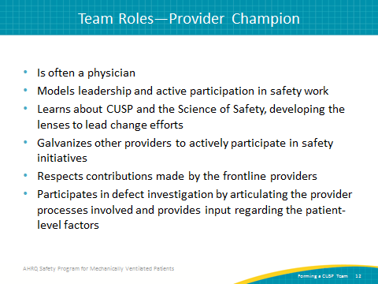
Who To Engage—Provider and Nurse Champions  SAY:  Provider champion positions are generally filled by people other clinicians look up to and respect. Select champions who model solid leadership skills and exemplify the values of your organization. Effective champions are approachable and inclusive of input from diverse team members. Diverse team members will have varying levels of experience, represent multiple fields of study, and embody demographic differences.  Some teams elect to form a compact between their champions. A compact is an agreement that clearly identifies what is expected of a champion or champion partnership and allows teams to regularly review the performance of those champions. | Slide 13  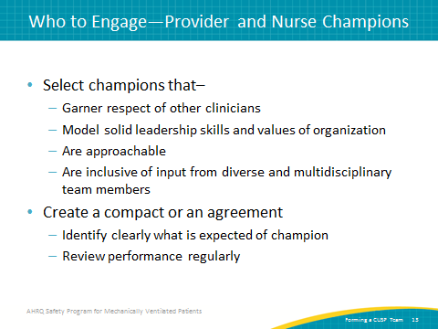
Team Roles—Senior Executive  SAY:  Engaging a senior executive is so fundamental to the success of change initiatives that it is a dedicated step of the CUSP process. The senior executive meets monthly with your team and engages with frontline staff. This role helps prioritize safety initiatives, identify resources, and reduce barriers that could hinder CUSP work. With access to resources beyond the reach of your other team members, their influence is essential to successful implementation. This role also shares the organization’s strategic goals and aligns local quality improvement work with those priorities. They are also an important liaison between the change initiative and the hospital administration. Senior executives mentor the team in problem solving and decision making skills. This person opens up communication channels throughout the organization. | Slide 14  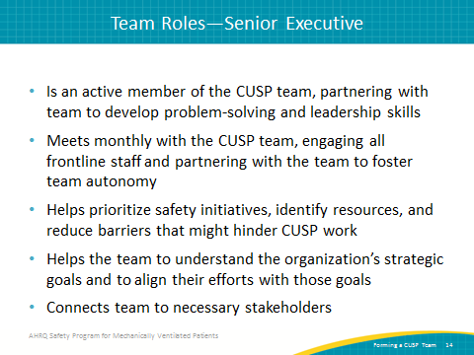
Engage the Senior Executive  SAY:  This short video called "Engaging the Senior Executive" is available on the AHRQ Web site and can be watched now by pressing the “play” button in presentation mode. | Slide 15
Team Roles—CUSP Coordinator  SAY:  The CUSP coordinator is not essential for the success of your first CUSP team. But should your hospital decide to form additional CUSP teams across the organization, a CUSP coordinator is the hub to spread and manage CUSP throughout your organization. As your organization matures with CUSP, a coordinator serves as a tremendous resource to support existing teams in several units, form new teams, develop CUSP processes, and use CUSP tools. | Slide 16  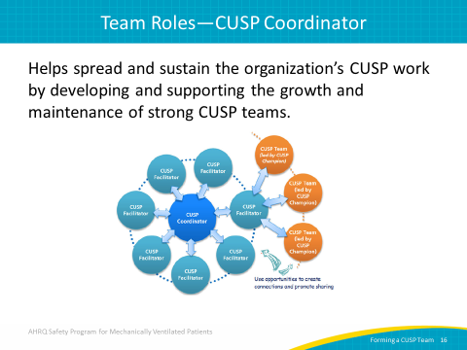
STRATEGIES FOR SUCCESS  SAY:  Now let’s talk about some strategies for successful CUSP work. | Slide 17  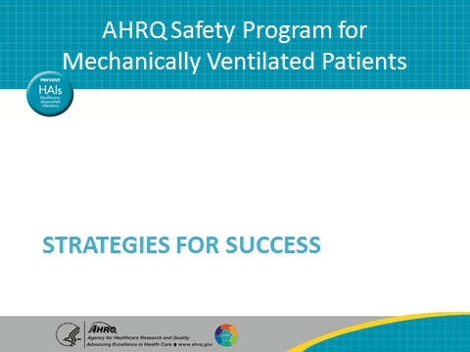
Mission Statement for CUSP Team  ASK:  How will you share the goal of CUSP work on your unit?  SAY:  Your core CUSP team can develop a mission statement to guide your improvement efforts. Here are some guiding questions to support this task.  ASK:  Could you share it with a team member in less than 30 seconds?  SAY:  As you develop your statement, reflect on an elevator pitch of your guiding principles. An elevator pitch is a concise statement that includes all essential information and can be shared in less than 30 seconds.  ASK:  Can it be easily understood?  Does it reflect how you will measure success?  Does it align with your organization's strategic safety and quality improvement goals?  Are your first projects salient to your entire care team?  Does it reflect patient- and family-centered care values?  And finally, is it motivating?  SAY:  Many teams overlook a key element in their first draft of their new mission statement. Anticipate this likelihood as you develop your mission statement and re-ask the questions listed. | Slide 18  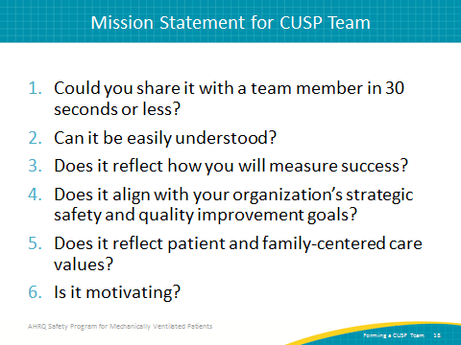
Top 10 Strategies for Success  SAY:  We have identified the top 10 strategies for successful CUSP teams.  First, set a goal to exceed 80 percent response rate on your local patient safety culture surveys. Valid safety culture scores require participation from the majority of the frontline staff.  Second, strive to exceed 80 percent on all safety climate domain scores.  Third, use unit-level data and staff inputs to drive improvement efforts. Your frontline staff must own their patient safety initiatives.  Fourth, use CUSP tools to learn from defects. | Slide 19  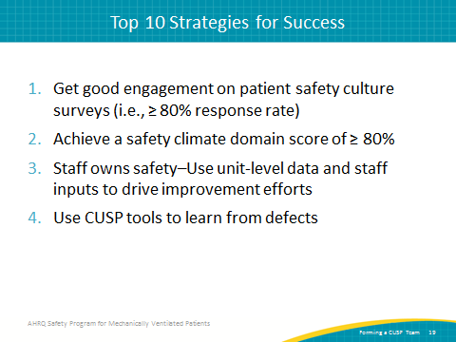
Top 10 Strategies for Success  SAY:  Fifth, protect that time! Hospital teams consistently report lack of time to dedicate to data collection, data analysis, quality improvement, and patient safety initiatives. Invest in the time required to solve complicated problems.  Sixth, the champion, unit manager, and provider champions can seek additional exposure to CUSP tools or training on CUSP processes. Resources are available on the AHRQ Web site.  Seventh, all frontline staff receive science of safety training on systems-thinking. Incorporate science of safety into new employee onboarding programs. Retrain at regular intervals, such as annually. | Slide 20  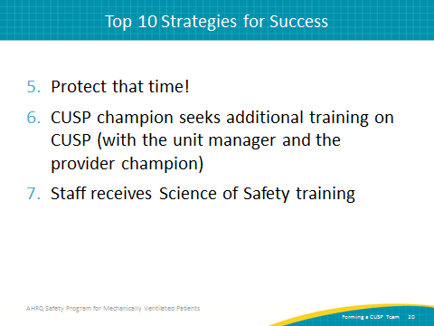
Top 10 Strategies for Success  SAY:  Eighth, the provider champions must be engaged and regularly contribute to CUSP work. Leadership from clinician and nurse champions is imperative to set priorities and serve as an advocate for this challenging work.  Ninth, successful CUSP teams partner with an engaged senior executive that contributes to CUSP work and participates in safety walking rounds.  Tenth, successful CUSP teams meet on a consistent basis. Subgroups may meet between monthly meetings and team members are accountable for progress. | Slide 21  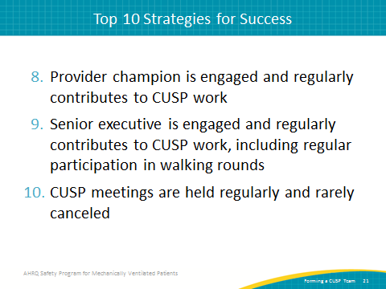
Strong CUSP Teams…  SAY:  Across intensive care units to pediatric units, strong CUSP teams share many characteristics. They share a strong team orientation and believe they have additional strength when they work together. They share a mental model of the team’s mission and work together to achieve the mission. Strong CUSP teams build frameworks for team behaviors and norms. | Slide 22  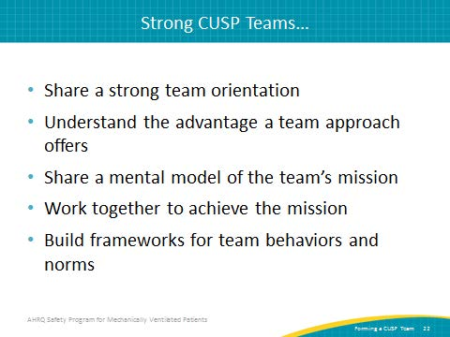
Assembling a CUSP Team  SAY:  Additional CUSP tools are available on the AHRQ Web site. Take the time to establish a guiding framework that covers meeting logistics, communication methods, decisionmaking hierarchy, participation, and expectations.  ASK:  Will you meet every fourth Thursday of the month or every other Tuesday morning?  Can you alternate morning and evening times to accommodate various shifts?  Will conference phone lines be available or do you have to attend in person?  How will decisions be made? | Slide 23  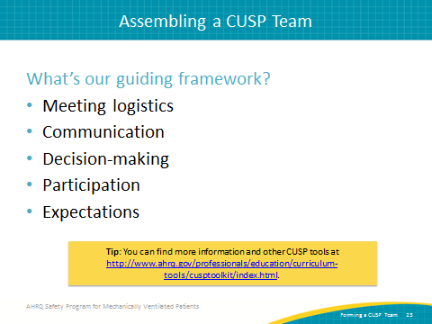
Meeting Resistance?  SAY:  When we meet resistance, tune into what’s in it for your audience. First, recognize that people resist loss, not change. So as your team makes changes, think about the real and perhaps perceived losses behind that resistance.  ASK:  Is he afraid of having enough time to complete what is expected of him?  Is she worried about a perceived loss of autonomy in doing her job?  Is he afraid he doesn’t know what he needs to do the task?  SAY:  Sometimes perceived losses seem larger than real losses. When the perception of loss is high, implementation becomes exceedingly difficult. To mitigate those fears, provide opportunities for dialogue. Give your entire team the chance to ask questions; it will help you identify their concerns and address them. Prepare a strong communication plan to share information with entire frontline staff. Act on their concerns. | Slide 24  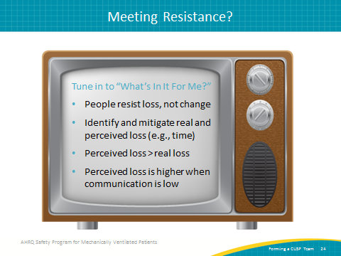
Communication Tips  SAY:  CUSP provides a framework for quality improvement and patient safety conversations to begin. A communication plan is key. We must communicate expectations with others and provide role clarity. Set expectations about how the team will communicate and keep the group updated on progress. This will avoid misconceptions and surprises. People perform better when they know what is expected–so tell them. Create accepted mechanisms to provide feedback to team members and clinicians. Underestimate what your staff knows about the CUSP improvement efforts.  Next, seek out and listen to staff members that resist your improvement plans. It is important that we value the dissenter. As you initiate any change, some people will object. Listen to those who resist your proposed change, because there is probably truth hidden within their objections. By addressing those objections early in the process, you build a stronger and more reliable intervention that anticipates obstacles and barriers. | Slide 25  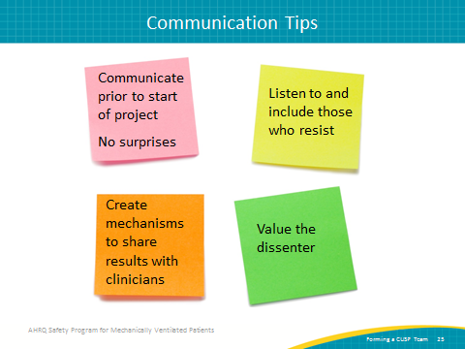
Don’t Ignore the Elephants in the Room  SAY:  Do not ignore the reality on your unit. Most units will face barriers to successful interventions. The reality exists that you may be understaffed or lack required equipment. Ignoring the issue will not improve the delivery of care for your patients. As you build your team, leverage the champions and the senior executive partner to directly address those issues.  If you do not have enough resources, it is vital that your executive partner know so you can get the resources you need. And, we suggest that as you start this process that you might want to go for the proverbial low-hanging fruit. Use early wins to help build support and momentum for the project. Handle things that can be easily dealt with and be a success first. This way, they won’t get in your way as they linger unaddressed and the successes can motivate your team. | Slide 26  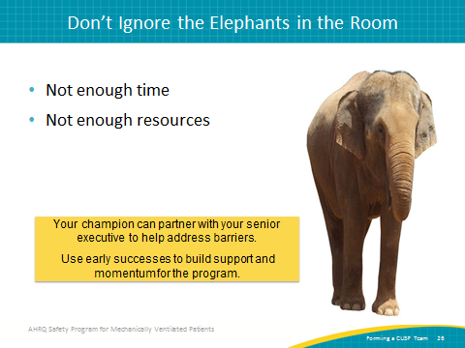
Discussion  SAY:  Here are some discussion questions to pose to your CUSP team.  ASK:  What strategies have you used that have led to an engaged team?  What other disciplines have you successfully engaged?  Did your approach vary by discipline? How?  Did you leave someone out you later regretted not having on the team?  SAY:  The dialogue these questions generate can help your team replicate previous successes and avoid previous setbacks. They can also help establish shared group norms and expectations. Good luck forming your CUSP team in support of the AHRQ Safety Program for Mechanically Ventilated Patients. | Slide 27  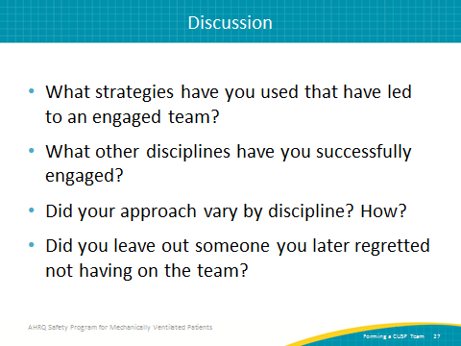
Questions | Slide 28  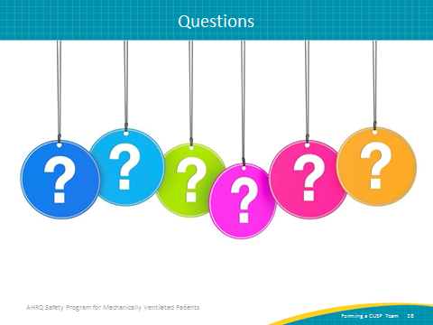
References | Slide 29  