Daily Low Tidal Volume Ventilation Data Collection Tool
Hospital___________ Unit___________ Date ___________
Fill out for all beds |  | Fill out if patient is mechanically ventilated |  |  |  |  |  | Fill out if Vent Mode = 1 or 2 |  |  |  |  |  | Fill out if Vent Mode = 1, 2, or 3
Bed # | Intub/  Trach & Mech Vent | Vent Mode –  1, 2, or 3 |  | Height – enter centimeters or inches |  |  | Gender –  M or F |  | Target Tidal Volume (mL) (based on PBW) – Enter value | Actual Tidal Volume (mL)  – Enter value | Plateau Pressure  (cm H2O) –  Enter value or NK | PEEP  (cm H2O) – Enter Value or NK | Does patient have a risk factor for ARDS? |  | Does the patient  have ARDS?
 |  |  |  | cm |  | in
 | Y N E | 1 2 3 |  |  |  |  | M F |  |  |  |  |  | Y N |  | Y N
 | Y N E | 1 2 3 |  |  |  |  | M F |  |  |  |  |  | Y N |  | Y N
 | Y N E | 1 2 3 |  |  |  |  | M F |  |  |  |  |  | Y N |  | Y N
 | Y N E | 1 2 3 |  |  |  |  | M F |  |  |  |  |  | Y N |  | Y N
 | Y N E | 1 2 3 |  |  |  |  | M F |  |  |  |  |  | Y N |  | Y N
 | Y N E | 1 2 3 |  |  |  |  | M F |  |  |  |  |  | Y N |  | Y N
 | Y N E | 1 2 3 |  |  |  |  | M F |  |  |  |  |  | Y N |  | Y N
 | Y N E | 1 2 3 |  |  |  |  | M F |  |  |  |  |  | Y N |  | Y N
 | Y N E | 1 2 3 |  |  |  |  | M F |  |  |  |  |  | Y N |  | Y N
 | Y N E | 1 2 3 |  |  |  |  | M F |  |  |  |  |  | Y N |  | Y N
 | Y N E | 1 2 3 |  |  |  |  | M F |  |  |  |  |  | Y N |  | Y N
 |  |  | ARDS = Acute respiratory distress syndrome; E = Empty; Intub = Intubation; Mech Vent = Mechanically Ventilation; N = No; NK = Not known; PEEP = Positive-end expiratory pressure; Trach = Tracheostomy; Vent Mode = Ventilator Mode; Y = Yes

Ventilator Modes
Select the patient’s ventilator mode from the table below. Enter the heading number in the Vent Mode column.

Enter 1  Volume-Cycled Modes | Enter 2  Pressure-Cycled Modes | Enter 3  Other Modes
Continuous Mandatory Ventilation (CMV)  Assist Control (AC)  Synchronized Intermittent Mandatory Ventilation (SIMV)  Volume Support (VS)  Pressure Regulated Volume Controlled (PRVC) | Pressure Support (PS)  Continuous Positive Airway Pressure (CPAP)  Pressure Control (PC)  Airway Pressure Release Ventilation (APRV)  Bilevel Ventilation | Proportional Assist Ventilation (PAV)  Adaptive Support Ventilation (ASV)  Inverse Ratio Ventilation (IRV)  High Frequency Oscillatory Ventilation (HFOV)  Extracorporeal Membrane Oxygenation (ECMO)  Other

Instructions
Please complete this tool once a day, every day. If possible, complete it around the same time each day, ideally during patient rounds.
Patients are considered mechanically ventilated on a specific day if they are mechanically ventilated at the time of observation.
All of the vent modes are listed on the back of the data collection sheet for your reference. Please print this data collection tool with the vent modes on page 2 of this document for easier data collection.

DATA FIELD | DIRECTIONS
Hospital | Enter the name of your hospital.
ICU | Enter the name of your unit.
Date | Enter today’s date as MM/DD/YYYY format (e.g. 01/31/2014).
Bed # | Enter all the bed numbers on the tool, whether the patient is on mechanical ventilation or not. Include empty beds.
Intub/Trach & Mech Vent:  Is the patient currently receiving mechanical ventilation? | Enter for all patients. Mechanical ventilation is defined as receiving ventilator support via a subglottic secretion drainage endotracheal tube or tracheostomy tube.  - Patients treated with noninvasive ventilation are counted as “N.”  - Enter “Y” if the patient is currently intubated/trached and mechanically ventilated.  - Enter “N” if the patient is NOT currently intubated/trached and mechanically ventilated.  - Enter “E” if there is no patient in the bed.  For any specific patient, if the patient is not currently intubated/trached AND on mechanical ventilation, STOP. Do not enter any more information regarding that bed for this date.

DATA FIELD | DIRECTIONS
Vent Mode:  What mode of ventilation is being used at the time of observation? | Enter for all patients receiving mechanical ventilation.  Enter 1, 2, or 3 on the data collection tool depending on which type of vent mode is present at the time of observation.  Enter 1 – if the patient’s ventilator is set to one of the following Volume-Cycled Modes:  - Continuous Mandatory Ventilation (CMV)  - Assist Control (AC)  - Synchronized Intermittent Mandatory Ventilation (SIMV)  - Volume Support (VS)  - Pressure Regulated Volume Controlled (PRVC)  Enter 2 – if the patient’s ventilator is set to one of the following Pressure-Cycled Modes:  - Pressure Support (PS)  - Continuous Positive Airway Pressure (CPAP)  - Pressure Control (PC)  - Airway Pressure Release Ventilation (APRV)  - Bilevel Ventilation  Enter 3 – if the patient’s ventilator is set to one of the following Other Modes:  - Proportional Assist Ventilation (PAV)  - Adaptive Support Ventilation (ASV)  - Inverse Ratio Ventilation (IRV)  - High Frequency Oscillatory Ventilation (HFOV)  - Extracorporeal Membrane Oxygenation (ECMO)  - Other  If “1” or “2” for any specific patient, continue to next column.  If “3” for any specific patient, skip ahead to the last two columns:  “Does patient have a risk factor for ARDS?” AND “Does the patient have ARDS?”

DATA FIELD | DIRECTIONS
Height:  How tall is the patient? | Evaluate daily for patients receiving mechanical ventilation and whose vent mode equals 1 or 2.  Depending of which measurement your unit uses, enter EITHER centimeters OR inches.  Pick one.  - Enter the patient’s height in centimeters in the “cm” column if your unit uses centimeters.  - Enter the patient’s height in inches in the “in” column if your unit uses inches.
Gender | Evaluate daily for patients receiving mechanical ventilation and whose vent mode equals 1 or 2.  - Enter “M” if the patient is male.  - Enter “F” if the patient is female.
Target Tidal Volume:  What is the target tidal volume based on PBW? | Quick reference tables are available on the last page of this document to calculate predicted body weight for tidal volume.  Evaluate daily for patients receiving mechanical ventilation and whose vent mode equals 1 or 2.  Enter the target tidal volume in milliliters (mL). If you entered “3” for the ventilator, you should NOT be collecting this data. (Please refer to instructions for Vent Mode on page 4.)

DATA FIELD | DIRECTIONS
Actual Tidal Volume:  What is the tidal volume at the time of observation? | Quick reference tables are available on the last page of this document to calculate predicted body weight for tidal volume.  Evaluate daily for patients receiving mechanical ventilation and whose vent mode equals 1 or 2.  Enter the actual tidal volume in milliliters (mL). Use the preset tidal (prescribed) volume if the mode is one of the volume cycled modes (from Vent Mode question above).  If the mode is one of the pressure cycled moves (from Vent Mode question above), enter the approximate expired tidal volume.  If you entered “3” for the ventilator, you should NOT be collecting this data. (Please refer to instructions for Vent Mode on page 4.)
Plateau Pressure:  What is the plateau pressure at or nearest to the time of observation? | Evaluate daily for patients receiving mechanical ventilation and whose ventilator mode equals 1 or 2.  Enter the plateau pressure at or nearest to the time of observation.  If it is not available or not known, please enter “NK.”  For APRV/bilevel modes, this is the P_{high} value.  If you entered “3” for the ventilator, you should NOT be collecting this data. (Please refer to instructions for Vent Mode on page 4.)
PEEP:  What is the PEEP (Positive End-Expiratory Pressure) at or nearest to the time of observation? | Evaluate daily for patients receiving mechanical ventilation and whose vent mode equals 1 or 2.  Enter the PEEP value at or nearest to the time of observation.  If it is not available or not known, please enter “NK.”  For APRV/bilevel modes, this is the P_{low} value.  If you entered “3” for the vent, you should NOT be collecting this data. (Please refer to instructions for Vent Mode on page 4.)
Risk Factors for ARDS:  Does the patient have a risk factor for ARDS? | Evaluate daily for patients receiving mechanical ventilation and whose ventilator mode equals 1, 2, AND 3.  If the patient has one or more of the following, enter “Y,” otherwise enter “N.”  - Pneumonia  - Sepsis, severe sepsis, or septic shock, not secondary to pneumonia  - Aspiration  - Trauma  - Other risk factor (i.e., massive transfusion, acute pancreatitis, etc.)  ALL ventilator modes (1, 2, and 3) should respond to this question.
ARDS:  Does the patient have the diagnosis of ARDS at the time of the observation? | Evaluate daily for patients receiving mechanical ventilation and whose ventilator mode equals 1, 2, AND 3.  If the patient has a diagnosis of ARDS at the time of observation, enter “Y,” otherwise enter “N.”  ALL ventilator modes (1, 2, and 3) should respond to this question.

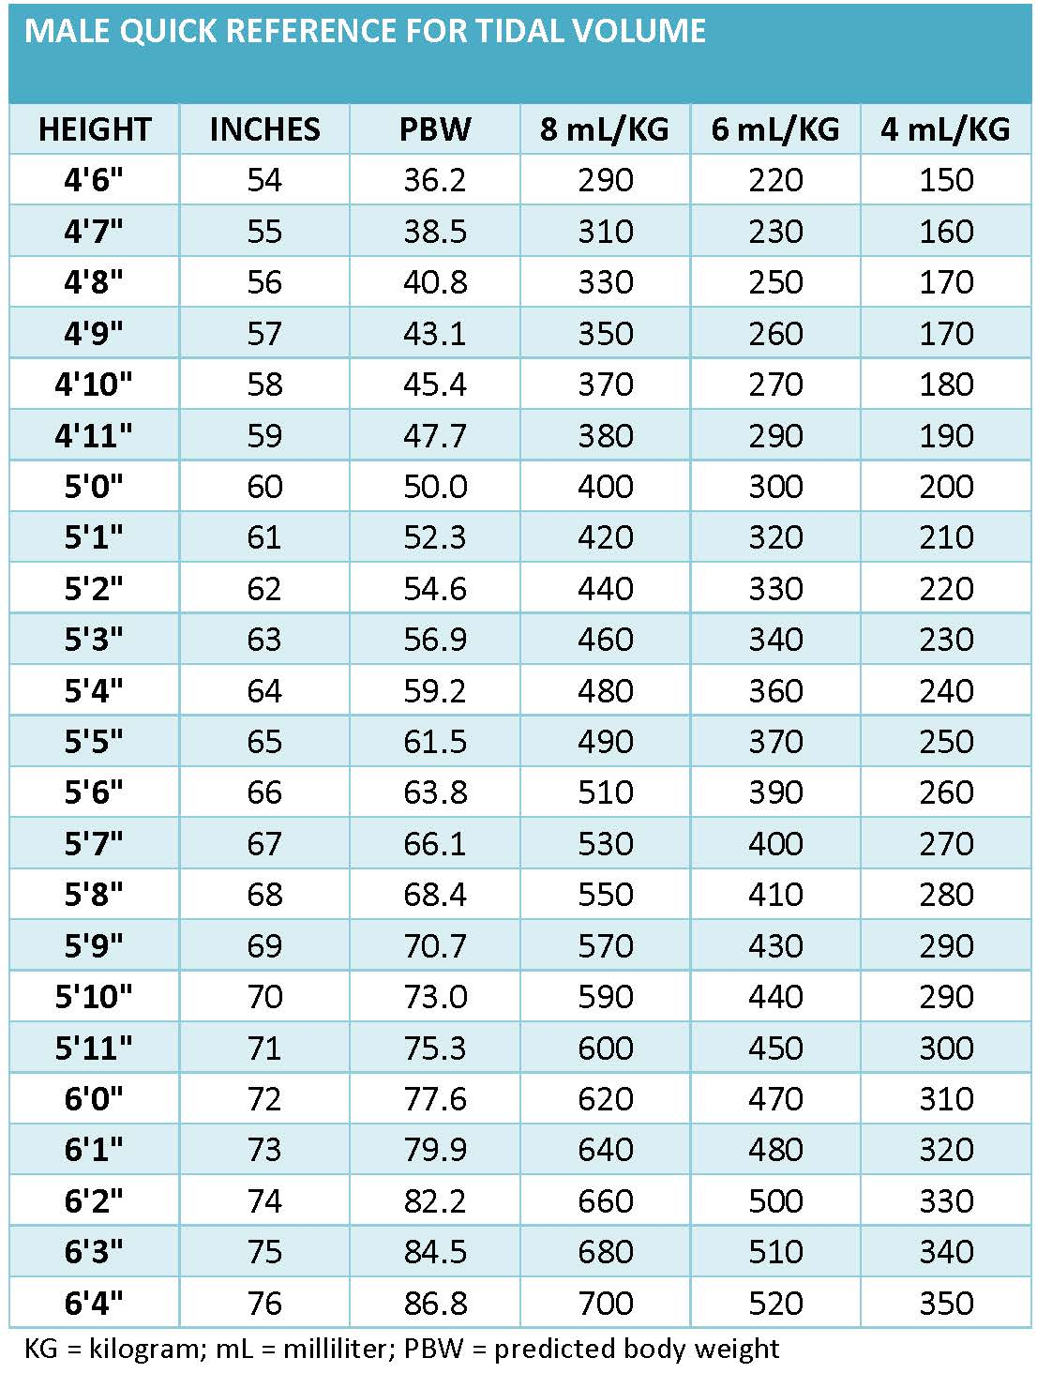
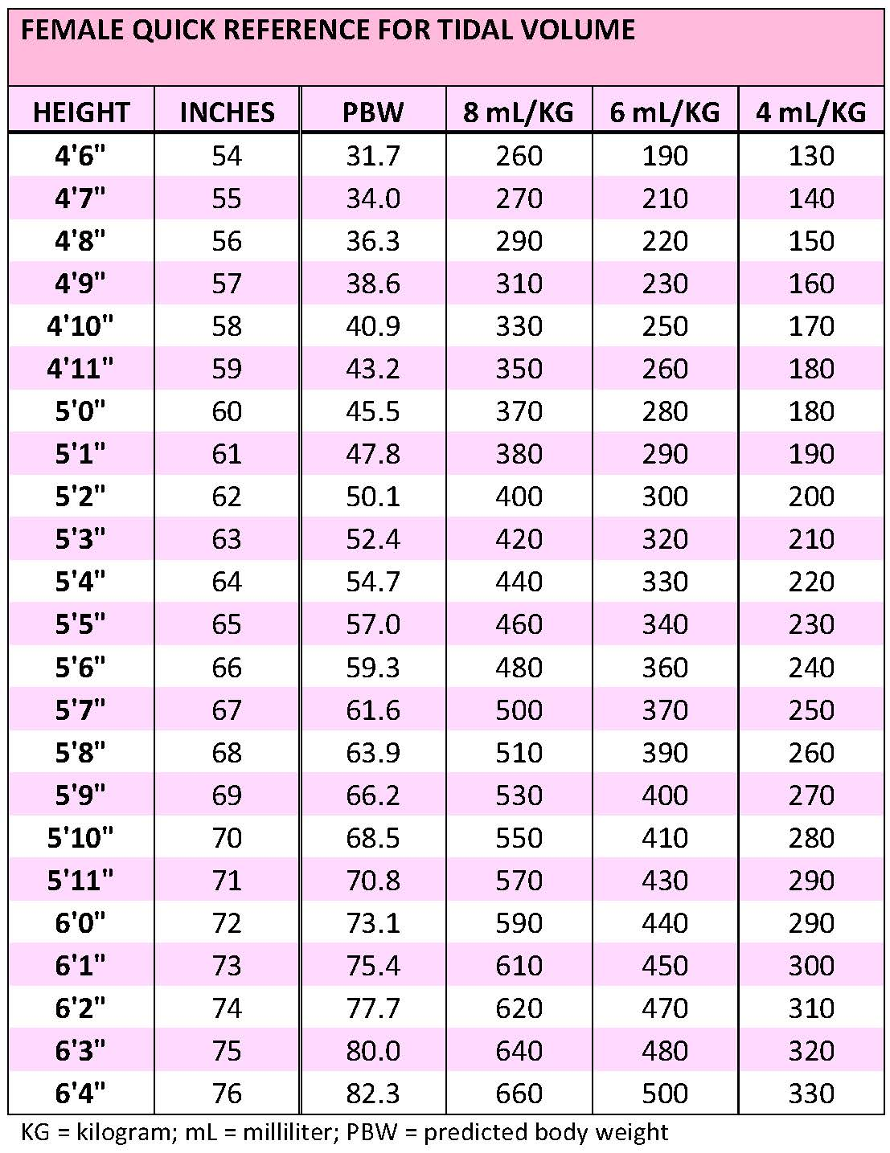

AHRQ Pub. No. 16(17)-0018-11-EF
January 2017

