Medical Screening Algorithm
Medical screening algorithm to evaluate patient appropriateness for rehabilitation.
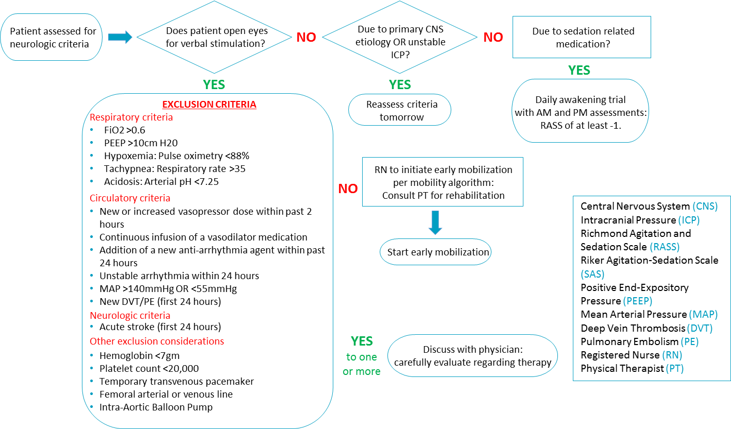
AHRQ Pub. No. 16(17)-0018-4-EF
January 2017

