Facilitator Notes

SAY:  The Comprehensive LTC Safety Modules assist users with how to apply safety principles. This overview module explains the purpose of the toolkit and how it can be used in your facility’s quality improvement initiatives. | SLIDE 1 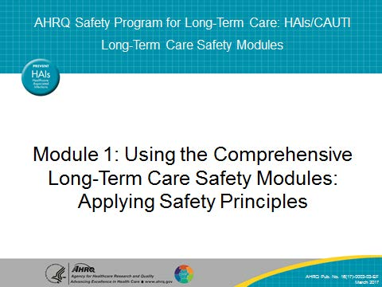
SAY:  The objectives of this module are to—  - Describe the purpose of the LTC Safety Modules  - Explain how the LTC Safety Modules supports other quality and safety tools  - Demonstrate how to apply the LTC Safety Modules in your facility | SLIDE 2  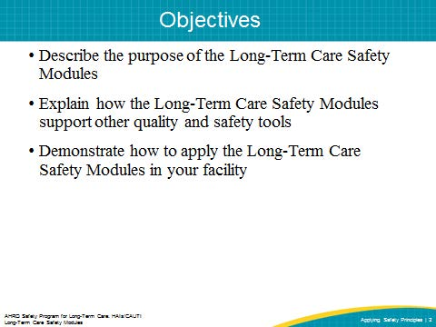
SAY:  The purpose of this toolkit is to support learning and implementation efforts to improve safety culture in long-term care or LTC facilities. Safety concepts including senior leadership engagement, staff empowerment, teamwork and communication, resident and family engagement, and sustainability are addressed. These tools are used in combination with clinical or operational efforts to minimize harms such as falls, medication errors, and healthcare-associated infections, such as catheter-associated urinary tract infections. The toolkit provides tools that are not meant to be an additional program or effort done at your facility. These tools supplement other quality and performance improvement initiatives, all of which aim to change the way facilities do their work and provide care, allowing for better outcomes and higher quality of care for residents. | SLIDE 3  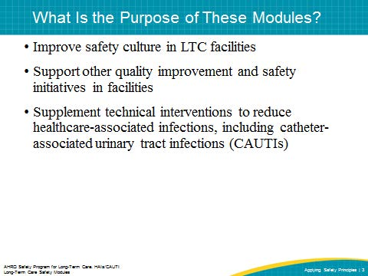
SAY:  Why is infection prevention and quality improvement important? Think about why they are important in your own facility as you watch this video.  PLAY VIDEO:  Video 2.1: Importance of Infection Prevention  ASK:  Why is infection prevention important? Why are we doing another quality improvement project? | SLIDE 4  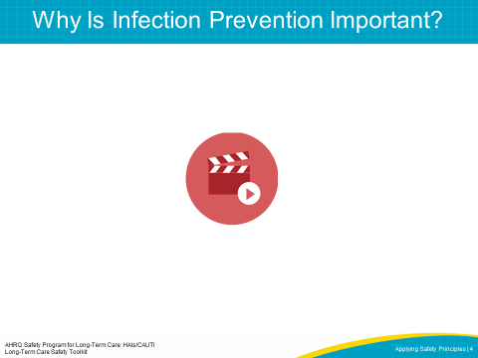
SAY:  Why is this work important? There are a few questions that put the issue of resident safety in real terms. Think about the facility where you work.  - Would you want a loved one to be a resident there? Would you want to be a resident there? Does your facility do everything it can to protect residents?  - How do you think the next resident could be harmed in your facility?  - Do you feel comfortable talking about resident safety in your facility? Why or why not?  - When a safety issue occurs in your facility, how does your facility address it?  - Is there a formal process to track safety-related improvements? Do you believe this process is effective?  DO:  Debrief with the group and encourage people to share their reflections. After some sharing by three or four members of the group, ask the group whether any of what was shared was surprising. | SLIDE 5  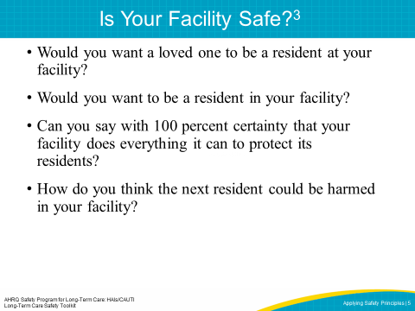
SAY:  The LTC Safety Modules present the cultural interventions that supplement the technical interventions needed to reduce healthcare-associated infections. These cultural interventions can be summarized with the T.E.A.M.S. Bundle:  Team formation to plan and implement the program  Excellent communication skills learned  Assess what’s working and plan to expand  Meet monthly to learn together  Sustain efforts and celebrate success  These five concepts will be covered in the six LTC Safety Modules. | SLIDE 6  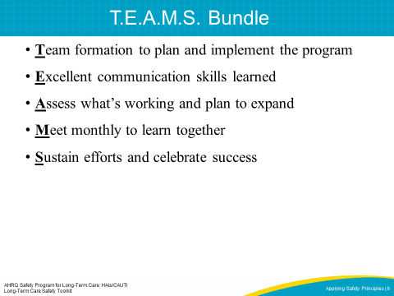

SAY:  The six modules are:  - Using the Comprehensive LTC Safety Modules  - Senior Leader Engagement  - Staff Empowerment  - Teamwork & Communication  - Resident & Family Engagement  - Sustainability  After a facility’s first implementation of the LTC Safety Modules, modules can be used in any order, depending on the needs of the facility. They are intended to be stand-alone educational sessions, and can be used in conjunction with other quality improvement tools your facility is using. | SLIDE 7  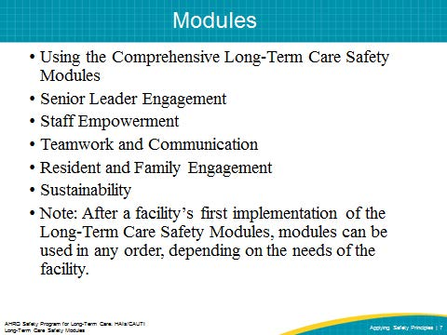
SAY:  The Toolkit provides educational support for staff interested in improving safety and quality. The PowerPoint presentations, facilitator notes, and videos are ready-to-use content. Each module can be shown in its entirety, or they can be broken into smaller portions depending on the length of the educational opportunity and the needs of the facility. The materials are aimed at both senior leaders and frontline caregivers in the LTC setting. These frontline caregivers include, but are not limited to: certified nursing aides, licensed practical nurses, registered nurses, nurse managers, and infection preventionists. | SLIDE 8  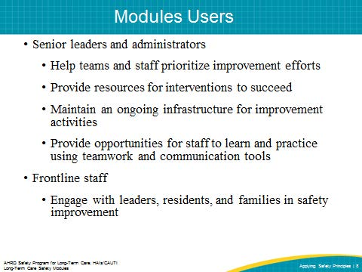
SAY:  In the Senior Leader Engagement module, we will—  - Identify characteristics of successful quality improvement or safety leaders  - List five practices of effective leaders  - Describe the responsibilities of senior leaders  - Explain the role of the senior leader in addressing clinical, operational, or safety efforts  - Describe how to engage senior leadership in the facility’s initiatives and develop shared accountability for the work needed to achieve the facility’s safety goals | SLIDE 9  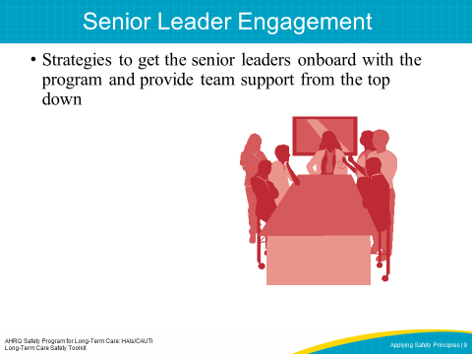
SAY:  In the Staff Empowerment module, we will—  - Understand staff empowerment concepts  - Discuss the importance of staff empowerment to create a culture of safety, which leads to improved outcomes and quality of life for residents  - Learn three ways to increase staff empowerment  - Learn how to remove roadblocks to staff empowerment. | SLIDE 10  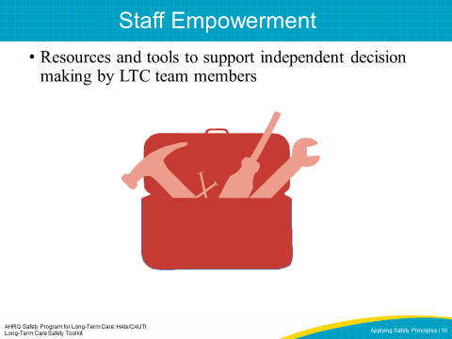
SAY:  In the Teamwork and Communication module, we will—  - Describe why practicing communication skills optimizes resident safety  - Describe effective communication and teamwork, both among team members, and between staff, residents and family members  - List barriers to effective teamwork and communication  - Explain solutions to the barriers using communication tools | SLIDE 11  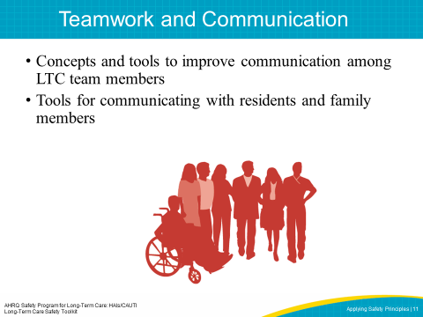
SAY:  In the Resident and Family Engagement module, we will—  - Define resident-centered care  - Explain the importance of engaging residents and family members  - Distinguish between different methods of engaging residents and family members  - Discuss how to work with resident advisers, advocates, and long-term care ombudsman programs | SLIDE 12  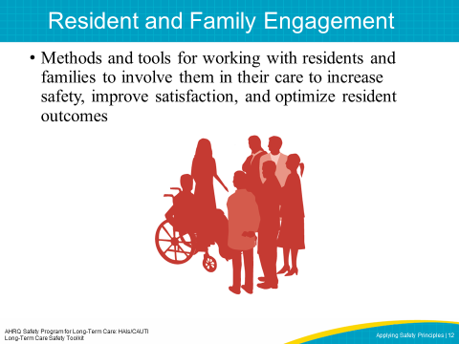
SAY:  Finally, in the Sustainability module, we will—  - Define sustainability and understand the importance of maintaining positive change  - Understand the link between sustainability and spread  - Learn how to create and implement a plan for sustainability. This includes identifying barriers to sustainability, developing solutions, and measuring it.  - Learn from examples of sustainability success across multiple settings | SLIDE 13  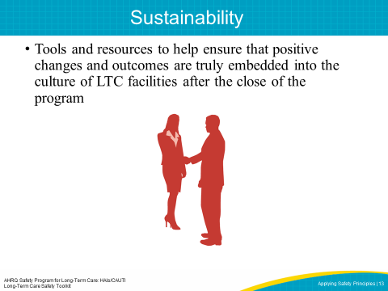
SAY:  There are many ways to use the LTC Safety Modules. Users can—  - Share videos with teams to spark engagement and learning  - Provide templates and discussion guides to project leads  - Educate teams on T.E.A.M.S.  - Orient new staff  - Train teams to use teamwork and communication tools  - Engage senior leaders and project champions  Each module in the LTC Safety Modules includes short videos, which can be powerful ways to spark the engagement of frontline providers. In addition, the toolkit can enable teams to address root causes of adverse events more effectively.  The Teamwork and Communication module also contains useful, structured communication tools, including resources from TeamSTEPPS. These resources will help teams prevent misunderstandings and improve communication, the most significant contributing factor to prevent harm or errors in care. Tools such as the Staff Safety Assessment can be particularly effective in engaging senior leaders by demonstrating the need for their involvement in safety improvements. | SLIDE 14  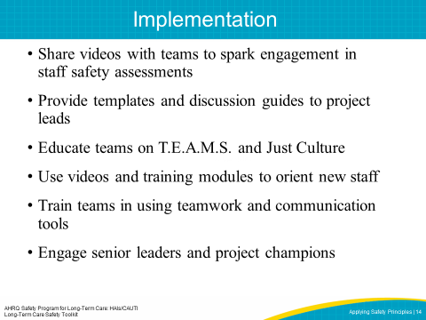
SAY:  Users may encounter challenges when making use of the toolkit, such as—  - Engaging the interest and participation of senior leaders  - Contending with high staff turnover  - Ensuring staff empowerment  The toolkit will help you and your facility work through these challenges, allowing for change and resident safety initiatives. | SLIDE 15  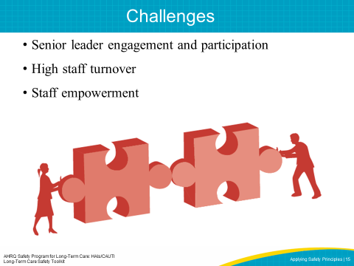
SAY:  If teams experience fatigue with improvement projects, team leaders should remember to streamline those initiatives and discuss them as managing change. For example, Kotter’s Eight Steps of Change describes what happens to get change to occur.  - Step 1: Create a sense of urgency  - Step 2: Create a guiding coalition  - Step 3: Develop a shared vision  - Step 4: Communicate the vision  - Step 5: Empower others to act  - Step 6: Generate short-term wins  - Step 7: Consolidate gains and produce more change  - Step 8: Anchor new approaches in culture  Each of these steps is crucial to the success of culture improvement efforts, but real, lasting change happens one facility at a time. Improving culture requires an understanding that culture is different from facility to facility. Each facility must work to reform their own culture and it must be owned by everyone. Another key element to create a culture of safety is explained in the principles of Just Culture. | SLIDE 16  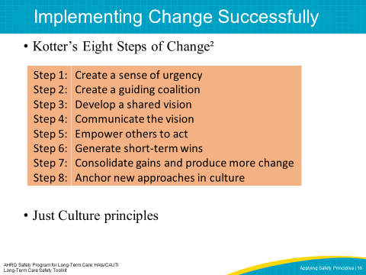
SAY:  The term “Just Culture” refers to a system of shared accountability in which health care organizations are accountable for the practices they’ve designed and for sustaining the safe choices they’ve made. Staff, in turn, are accountable for the quality of the choices they make to ensure their residents receive the highest quality of care possible.  A Just Culture environment reviews both the way the system is designed and an employee's choice of behavior in response to their assigned duties. It investigates events or safety concerns, and determines an appropriate course of action with the employees involved. Just Culture principles are crucial to the shared accountability necessary for resident safety and quality improvement programs to be successful.  David Marx developed the Just Culture framework based on risk management concepts from high-reliability industries such as aviation and nuclear energy. A Just Culture system holds itself accountable, holds staff members accountable, and has staff members who hold themselves accountable. In a Just Culture, shared responsibility is the norm, and a commitment to eliminating the possibility of error is widespread. We’re now going to watch a brief video from K. Scott Griffiths, who introduces Just Culture and how it relates to our work.  PLAY VIDEO http://www.ahrq.gov/professionals/education/curriculum-tools/cusptoolkit/videos/07a_just_culture/index.html  ASK:  How would you describe Just Culture to someone?  Can you identify examples of human error in your unit or facility? How were these human errors handled? | SLIDE 17  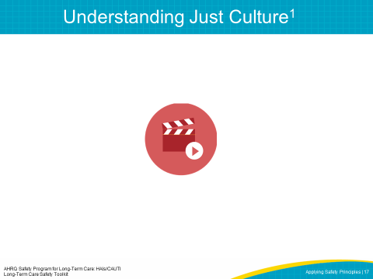
SAY:  Just Culture helps us understand risk and human behavior. There is a range of possible attitudes and behaviors related to risk, and they can be described in three categories:  - Human error—Inadvertently completing the wrong action; a slip, a lapse, or mistake  - At-risk behavior—Choosing to behave in a way that increases risk, where risk is not recognized or is mistakenly believed to be justified  - Reckless behavior—Choosing to consciously disregard a substantial and unjustifiable risk  ASK:  Can you identify examples of at-risk behavior in your facility? How were these at-risk behaviors handled? | SLIDE 18  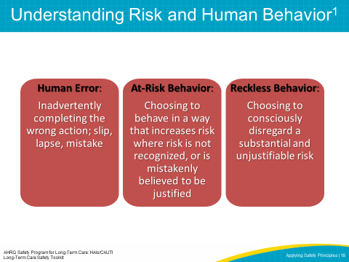
SAY:  To improve outcomes, human error, at-risk behavior, and reckless behavior should each be managed differently.  - Human error is a product of both system design and behavioral choices. Human error can be managed through changes in processes, procedures, training, system design, or work environment. The proper management approach is to console team members who have committed a human error and to ensure proper systems and procedures are in place to support future appropriate choices.  - At-risk behavior is an active choice to engage in risky activity through a belief that the risk was either insignificant or justified for a particular outcome. The best approach to deal with at-risk behavior is to remove any incentives for engaging in it, confirm that the system encourages healthy, risk-reducing behaviors, and coach team members to know what is going on around them.  - Reckless behavior is a conscious disregard of substantial and unjustifiable risk. When reckless behavior has occurred, it must be met with remedial or punitive action to decrease or eliminate the chances the behavior will reoccur.  A Just Culture environment is ruled by both transparency and accountability. In a punitive culture that does not strive to understand underlying reasons for at-risk behaviors, transparency is impossible. This is especially difficult given that transparency and open communication are necessary for true cooperation, coordination, and teamwork to occur. Transparency is also important in addressing system factors that may contribute to harm. At the other extreme, a culture that does not hold team members accountable will never achieve optimal outcomes. In what has been known as a blame-free culture, there is a general failure to uphold standards of care, and staff members are less likely to hold themselves and one another accountable for appropriate behaviors. Overall, a Just Culture environment will support improved outcomes by emphasizing both robust systems and appropriate behaviors. | SLIDE 19  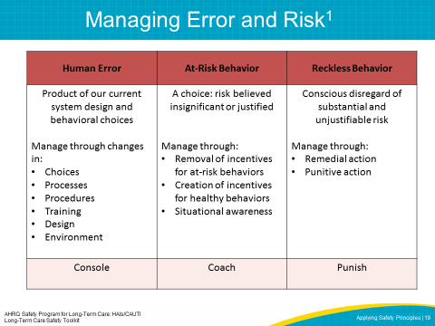
SAY:  There are key ways leaders can apply Just Culture principles to enhance culture, accountability, and safety in their facility.  First, facility leaders can have procedures in place for employees to follow. Confirming that protocols are standardized and well communicated helps employees make the right choices, leading to the best outcomes. When designing procedures, be sure to eliminate reasons for at-risk behavior and reinforce incentives for healthy, risk-reducing choices.  Second, ensure employees are properly trained. Employees should know the correct procedures and understand the reasoning behind those procedures so they will be more inclined to engage in appropriate behaviors.  Third, offer positive reinforcement at monthly meetings. These meetings are an opportunity to reinforce learning systems that contribute to improved results. | SLIDE 20 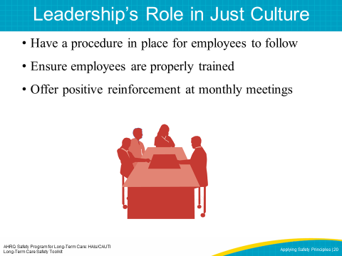

SAY:  We’ve covered Just Culture, which has to do with creating a safe environment for staff to share their safety concerns. Together, staff and leadership must work towards building safety and quality into the system. That is how and why we do this work.  PLAY VIDEO:  Video 2.4: Building Safety and Quality into the System  ASK:  Why do you do this work? | SLIDE 21  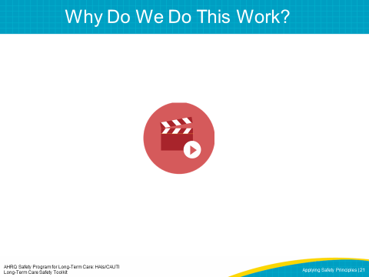

SAY:  Kotter’s Eight Steps of Change and Just Culture are only two components for implementing change in your facility. The LTC Safety Modules incorporate these principles, as well as a number of other quality and safety tools, including—  - TeamSTEPPS®  - Six Sigma  - Institute for Healthcare Improvement’s Model for Improvement  - Plan-Do-Study-Act  - Root Cause Analysis  - Failure Mode Effect Analysis  In addition to these tools, a number of LTC-specific resources offer excellent examples and support for improving resident safety at your facility. The Advancing Excellence in America’s Nursing Homes campaign and the Centers for Disease Control and Prevention’s infection prevention website for long-term care facilities are just two of these examples.  ASK:  Do you know which quality improvement initiatives are being implemented in your facility? Do you see common themes across your safety initiatives? How can you integrate across projects to improve resident safety? | SLIDE 22  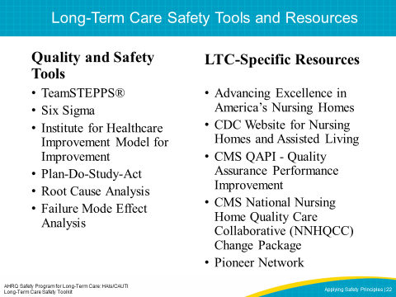
SLIDE 23
