Facilitator Notes

SAY:  The Sustainability module of this toolkit helps an organization maintain and sustain a process that has worked well. | SLIDE 1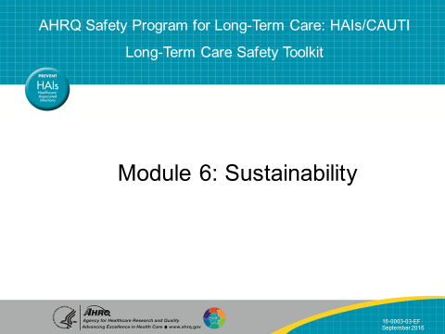
SAY:  In this module we will—  - Define sustainability and understand the importance of maintaining positive change  - Describe the link between sustainability and spread  - Develop a plan for sustainability  - Discuss the steps needed to sustain efforts  - Describe lessons learned from examples of success across multiple settings | SLIDE 2  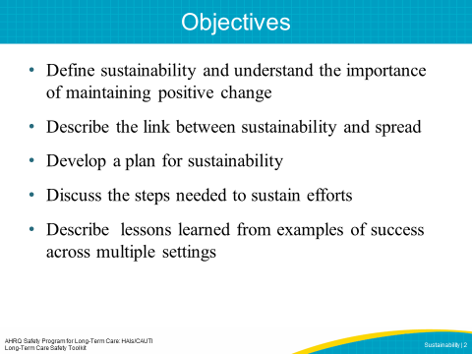
SAY:  What is sustainability in the patient safety context and within an organization?  There are many definitions of sustainability. To summarize, sustainability occurs when processes or improved outcomes last within an organization after implementation has occurred. An improvement that has become part of the organizational culture and has been maintained regardless of workforce turnover is an example of a sustained improvement.  Sustainability is also related to successful culture change within an organization. Maintaining the ideas, beliefs, principles, or values underlying an initiative and having the new ways of working become the norm show that the change has positively influenced the culture. | SLIDE 3  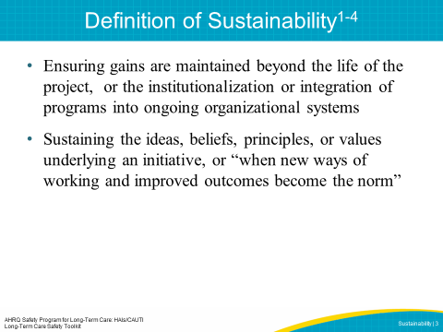

SAY:  Without sustainability, valuable time and resources are wasted investing in organizational improvement. Due to the high level of variability in health care, quality improvement must be continuously integrated into an organization’s culture in order to provide high-quality care and reliable safe practices. Project fatigue can be prevented by making new processes routine. Organizations that monitor outcomes are able to evaluate themselves and take control of their own improvement. Continued senior leader engagement will also improve as leaders see the return on investment and routinely prioritize safety and quality improvement efforts. Lastly, sustainability engages staff to create a safety culture that lasts beyond the life of the project. | SLIDE 4  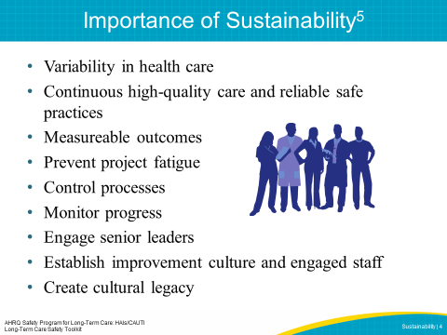
SAY:  This graph shows how effective processes help ensure that after the project ends, the desired improved performance trend continues upward. The goal of sustainability should be both the continuation of the implemented changes and continued effectiveness or improvement. Therefore, the goal is to embed safe practices within your organization rather than allow for backsliding of performance or individual behavior. Backsliding can occur as a result of factors such as staffing conditions, administrators’ loss of interest, or changes in organizational goals.  DO: During the presentation, draw attention to the following points on the graph: the dotted line illustrating project end, the upward trending line illustrating a sustained project, and the downward trending line illustrating backsliding.  ASK: Can anyone give an example of a quality improvement project you participated in that followed either of these trend lines? | SLIDE 5  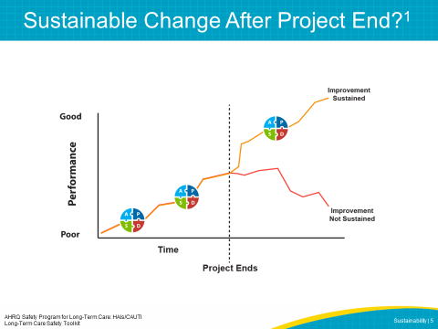
SAY:  What does sustainability mean for your facility?  DO: Ask the audience to discuss these questions in small groups. Have them discuss what sustainability means in their facilities right now. Have at least one member from each group report out on the discussion.  ASK:  - How do you see other projects sustained in your facility?  - Are values, beliefs and practices incorporated into the mission of your organization and/or are they incorporated into existing processes?  - Are other quality assurance and performance improvement (QAPI) initiatives aligned? | SLIDE 6 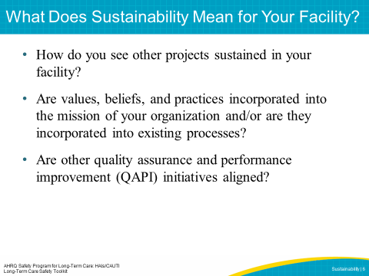
SAY:  There are many models that describe the steps that lead to sustainable change. One of the more recognized models is John Kotter’s 8 Steps of Change. Kotter defines 8 steps to creating change, with the last two steps, steps 7 and 8, focusing on sustainability.  Step 1: Create Sense of Urgency  If others see the need for change, they will be convinced of the importance of acting immediately.  Step 2: Building the Guiding Team  Assemble a group with the characteristics to lead the change effort and work together as a team.  Step 3: Develop a Change Vision and Strategy  Create a vision to help direct the change effort and develop strategies for achieving that vision.  Step 4: Understanding and Buy-In  Make sure others understand and support the vision and strategy.  Step 5: Empower Others  Encourage risk taking, nontraditional ideas, activities, and actions that will empower others to achieve the change.  Step 6: Short-Term Wins  Focus on change that is possible and easily achieved to motivate the team.  Step 7: Don’t Let Up – Be Relentless  Use the knowledge and momentum from short-term wins to align policies with the vision and train staff to fulfill the vision. Develop strategies to address obstacles and remove barriers that may threaten the change.  Step 8: Create a New Culture  Institutionalize the change by making it routine and a part of daily life in the facility. | SLIDE 7  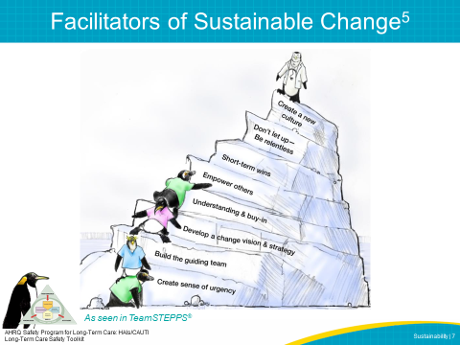
SAY:  Let’s briefly discuss the link between sustainability and spread. Both are necessary for successful safety culture change throughout an organization.  Sustainability should not to be confused with spread, which is discussed in another AHRQ toolkit on CUSP.  Sustainability aims to maintain a process within an organizational culture, while spread aims to disseminate the process to other units, facilities or organizations.  Spread takes a successful process that originated at the unit level to a broader population in the organization. Initially, the organization should adapt and spread the new process to similar resident populations, shifts, units, procedures, or diagnoses. After facilities put the new process in place, staff should review and tailor it, if necessary, to meet the needs of the new population or area. | SLIDE 8  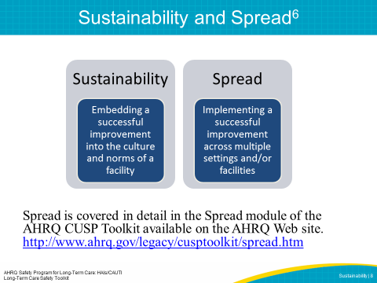
SAY:  The following section discusses the importance of planning early for sustainability and the essential steps to create a sustainability plan. | SLIDE 9  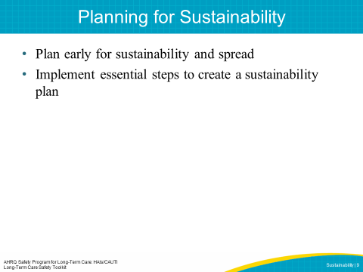
SAY:  Sustainability should be considered as part of the beginning stages of a project. By planning early, your facility can develop a plan that considers not only the resources needed to implement a project but also ways to sustain the project in case there are challenges such as discontinued funding or staff departures. Planning early helps the team think about how it will sustain its goal despite changes such as resource shortages in the future.  Planning early also allows your facility to identify key leaders and to engage senior leaders and administration to rally behind the improvement goals. Planning ahead gives you time to learn how to create a sustainable plan and to create educational materials and trainings for staff on the work ahead.  Most importantly, planning early for sustainability allows your facility time to decide how you will measure success and how you will make adjustments as needed along the way. | SLIDE 10  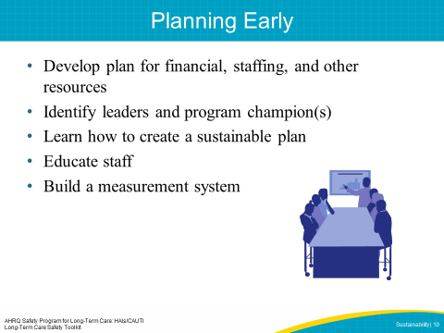
SAY:  There are several essential steps to creating a sustainability plan.  We will begin with the first step, which is identifying and developing your program champions. Then, we will discuss how to build the implementation team and empower frontline staff. Next, we will describe how to establish a sustainability measurement plan and managing barriers such as skepticism and resistance. Finally, we will discuss how engaging staff with stories and recognizing and celebrating success can support sustainment of project interventions. | SLIDE 11  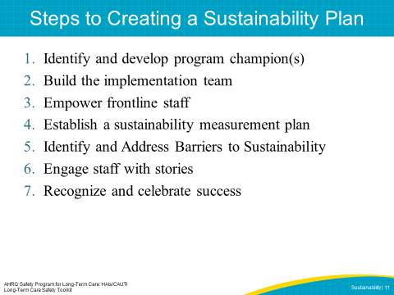

SAY:  Identify and Develop Program Champion(s)  The first step in developing a sustainability plan is to identify and partner with administrative and clinical champions who will communicate and continually reinforce that resident safety is a priority for the organization. Champions should have support from physicians, nursing, and administration. Champions often serve in higher roles in the organization, such as a director, but can be anyone who is passionate and committed to the program goals and can effectively communicate the vision for the work. The champion should be assigned at the beginning of the planning process and be able to motivate and coach others. | SLIDE 12  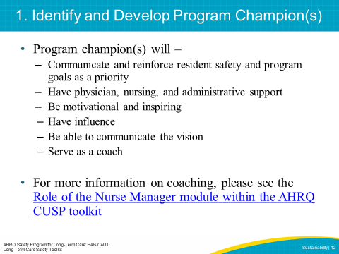
SAY:  Build the Implementation Team  An implementation team will drive the project. Building a team of enthusiastic members is a key step to creating a successful program. This team will ideally include—  - Facility team lead  - Administrator  - Data coordinator  - Survey coordinator  The team lead will be responsible for addressing team member concerns throughout the project. This individual should be chosen based on their ability to influence, as well as their motivation and time commitment for the role. Include the program champions to help persuade and motivate the team. Everyone on the implementation team should commit to understanding the program goals and components. | SLIDE 13  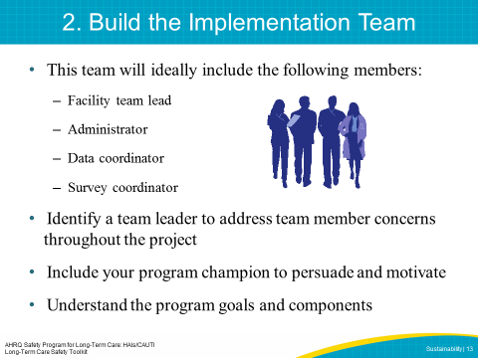
SAY:  Empower Frontline Staff  Frontline staff should feel comfortable bringing up safety concerns to other team members or team leaders, and leadership should encourage this behavior by ensuring that staff members who speak up are commended, and not punished, for doing so. | SLIDE 14  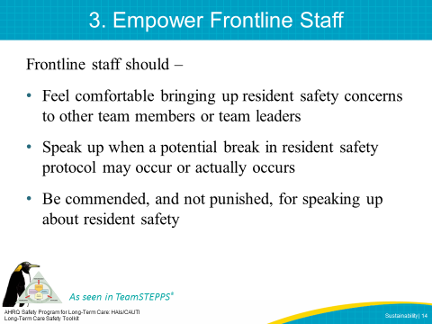
PLAY VIDEO:  Video 2.3: A Collaborative Effort  ASK:  Can you identify the first three steps of sustainability planning in this video? | SLIDE 15  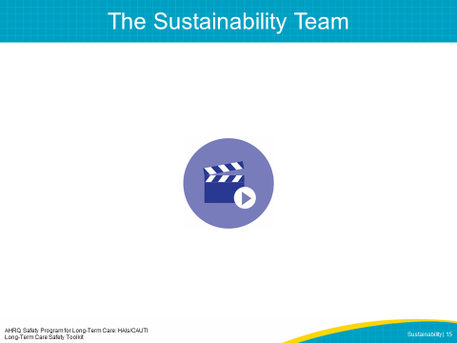
SAY:  Establish a Sustainability Measurement Plan  Establishing a sustainability measurement plan is a key step in evaluating over time whether the improvement is actually being sustained. Before your facility can determine if it is sustaining an improvement, you must first define what sustainability means for your facility. Sustainability will look different in different facilities depending on resources and goals.  Assessing readiness for sustainability will help clarify for the team what performance improvements are most important to sustain.  Team leaders may need to be coached on how to build a measurement system to collect process, outcome, and quality improvement data, and on how to use the data system.  Once you have developed the measurement system, you will need to determine what, when, and how to measure performance and who will collect the data. According to what measurements are being tracked, the data may look very different from project to project. Process measures, or measures that describe how the project is implemented, will yield data on the actual intervention or improvement action. Outcomes measures, or measures that describe the effect of the intervention, will allow you to see the intervention’s effects within the organization. For instance, an example of a process measure could be tracking how often hand hygiene education is provided to staff or how frequently alcohol-based hand rub is refilled in a facility’s dispenser. An outcome measure for proper hand hygiene could be how often staff perform proper hand hygiene as measured by observations or audits. Choosing how often and how to track these measurements is very important.  A robust and transparent feedback loop will help your facility use the performance data to continuously improve performance. Provide regular feedback to senior leadership and the team on progress in reaching goals and implementing improvement processes across various units. This step supports data transparency throughout the facility and provides opportunities to troubleshoot if any issues arise or if the team is behind target on goals. It is also helpful for the team to provide feedback on their experience with the project, which can be used to refine the plan. | SLIDE 16  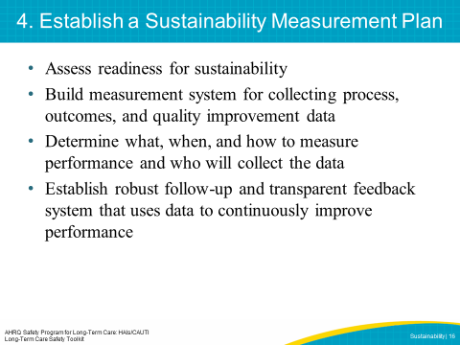
SAY:  Identify and Address Barriers to Sustainability  It’s important to identify and address barriers to sustainability. One of the most common barriers may be skepticism and resistance to change. Active involvement of the administrative and clinical champions will help encourage and motivate staff to support the program interventions. As staff experience positive outcomes from new ways of doing things, the champions can highlight these changes to encourage new procedures as the norm. Also, champions and administration can dedicate time and resources to help carry out the interventions, which can go a long way to overcoming resistance. | SLIDE 17  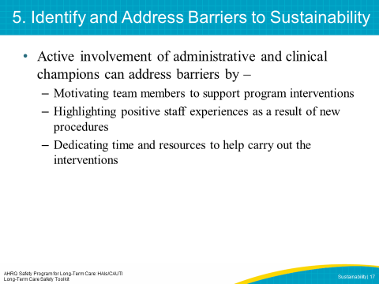
SAY:  Engage Staff With Stories  Data collection and measuring progress are important performance improvement activities. However, putting a human face on each harm event or near miss can engage staff in a powerful way that numbers cannot. Encourage team leaders to discuss actual resident stories to drive home important lessons. | SLIDE 18  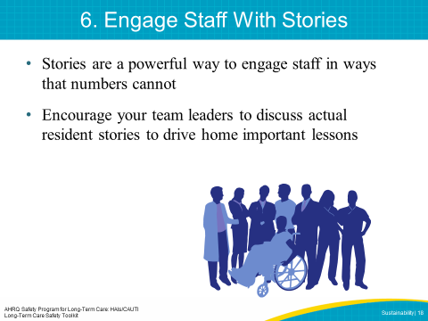
SAY:  Recognize and Celebrate Success  Recognizing success—large and small and both early on and long-term—is important to sustainability. Communicating success will help front-line staff gain courage to speak up, as well as reinforce the importance of program interventions. Celebrations do not need to be elaborate or formal to help sustain project gains. | SLIDE 19  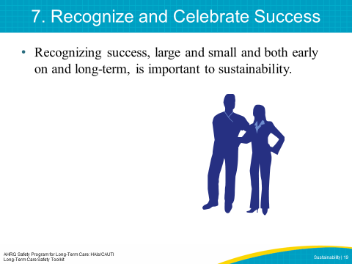

SAY:  To review, the following steps are critical for sustaining change in your facility.  - Collect, review and share data with administration and frontline staff  - Communicate and engage all staff  - How is staff reminded of the project on an ongoing basis? Posters with CAUTI rates? Announcements such as “100 days since the last CAUTI”?  - Align with other QAPI efforts  - Celebrate successes  - Incorporate changes into staff orientation and training  - Address barriers to sustainability with workable solutions | SLIDE 20  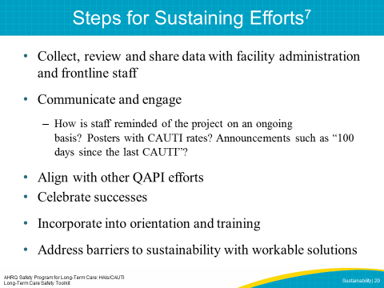
SAY:  There are other reasons programs or improvements may not be sustained, including—  Lack of Organizational Infrastructure and Resources  Programs are often discontinued when resources are reduced or no longer available. This can include financial resources such as funding and supplies, external organizational support, and staff. Failure to plan for and provide the necessary organizational infrastructure and resources can be a barrier to sustaining change.  Staff Turnover  As people leave an organization, they take with them hours of training and knowledge about organizational processes and norms. Hiring new employees means spending time and resources training and developing skills within the organization to support improvement processes. Staff turnover can interrupt the sustainability process by draining human resources.  Organizational Skepticism and Resistance  Resistance may be present within the organization itself. If leadership is not supportive or if the facility has experienced several failures in performance improvement, there may be skepticism that any new changes will be successful.  Individual Resistance to Change  Everyone responds to change differently, and some staff may not be convinced of the value of quality improvement within their facility. If staff do not accept the change as important to them, they may prevent the team from implementing and sustaining the change within the organization. | SLIDE 21  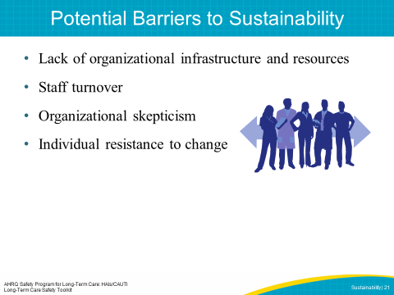

SAY:  There are ways to overcome these barriers. If the barrier is related to lack of resources, then the facility could plan for gaps in organizational resources and develop strategies to adjust as needed to fluctuations in resources. Anticipating financial resources needed to maintain improvements after the project ends allows you to be better prepared if changes occur.  To account for the possibility of staff turnover, consider incorporating project changes into new staff orientation and organizational policies. In addition, plan for continuous staff training and consider having experienced staff mentor newer staff. Finally, develop volunteer networks to provide project support in the event there is a resource shortage. | SLIDE 22  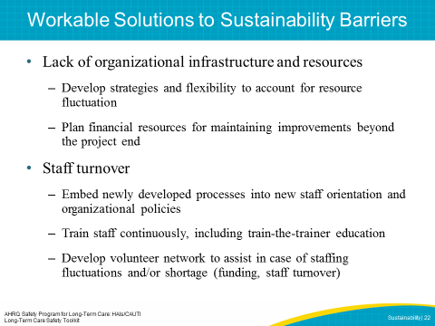
SAY:  In order to manage skepticism, leaders and champions could present ongoing evidence that the new process is better than previous processes. Show relevant data and share project experiences and stories with staff that illustrate improvements. Also, allow staff time away from normal duties to work on project improvements. Consider measuring how frequently senior leaders and administrators review data in order to check how engaged they are with the project. | SLIDE 23  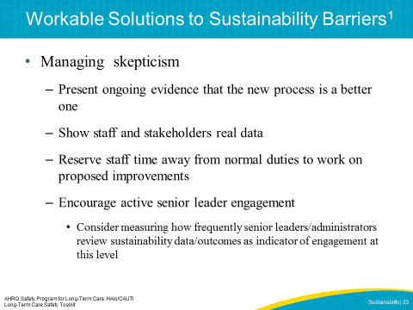
ASK:  To review, assess your sustainability measurement plan by asking—  - What data will be acceptable?  - How often will it be reviewed?  How will you make the new changes part of everyday operations?  - Will it be included in new staff orientation and in competency assessments for existing staff?  - How will you make sure excitement will be the same in a year or two as it is today? | SLIDE 24  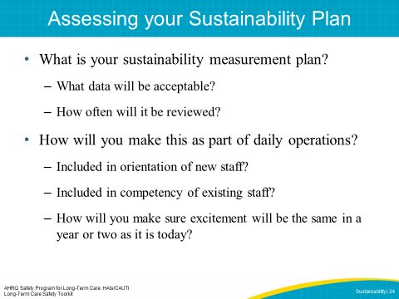
SAY:  One example of project sustainment in a health care setting focuses on data and feedback.  Baptist Memorial Health Care System in Memphis. This system created a measurement system, appointed a facilitator for the process, designed the process for collecting, reporting, and inputting data into a database, developed graphics to show performance trends and feedback, and communicated results to senior leadership and medical staff. Most importantly, Baptist uses this data to refine its improvement plan.  Another example of using data to sustain improvements is at Minnesota Children’s Hospitals and Clinics. They use a screensaver slide show on all computer terminals to display up-to-date intervention results. This encourages participation and communication about improvement projects while motivating staff.  ASK:  In what ways does your facility sustain improvements? What strategies could your facility use to sustain improvements moving forward? | SLIDE 25  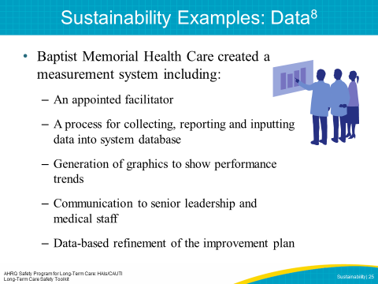
SAY:  Partners in Care, a New York City-based home health agency, identified communication among staff and supervisors as a priority area. To address this concern, all home health aides were trained in the PHI Coaching Approach to Communication, which teaches core communication skills. To roll out the program, the trainers not only taught coaching skills to supervisors and home health aides but also provided a train-the-trainer component to include in the regular in-service training of all staff. Incorporating information into in-service trainings and orientations for staff helps ensure that employees have consistent information and expectations. Leaders and staff at Partners in Care identified modeling the change, ongoing training, and incorporating the change into daily practice as the keys to sustainability of their new communication training.  ASK:  In what ways does your facility provide ongoing training and orientation for staff? What strategies could your facility use to sustain education and training moving forward? | SLIDE 26  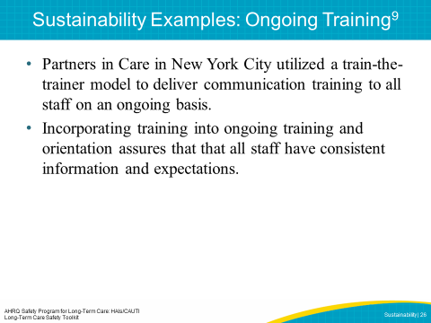
SAY:  In summary, sustainability can help organizations embed processes into their culture, making improvement the norm. Organizations need to address external and internal factors that can benefit or obstruct sustainability. An effective sustainability plan involves planning early, choosing easy-to-reach goals, identifying strong program champions to rally around the improvement, choosing a focus that fits with the organizational mission, and continually evaluating process and outcome measures. | SLIDE 27  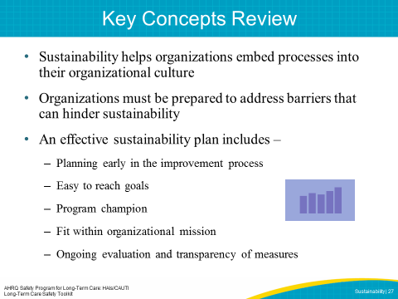
SLIDE 28
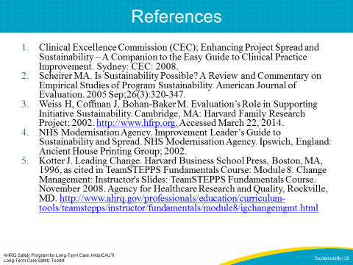
SLIDE 29
