3A: Master Clinical Pathway for Inpatient Falls
Background: The purpose of this tool is to provide an overview of how fall prevention care processes could occur at your hospital or hospital unit.
Reference: Developed by Falls Toolkit Research Team.
How to use this tool: Compare the master clinical pathway to your current activities and adapt your activities or the master clinical pathway as needed to suit your specific circumstances.
This tool can be used by the quality improvement manager, staff nurses, and nursing assistants as an aid in designing a new system, as a training tool, or as an ongoing clinical reference tool. This tool can be modified or a new one created to meet the needs of your particular setting. If you prepared a process map describing your current practices, you can compare that with desired practices outlined on the clinical pathway.

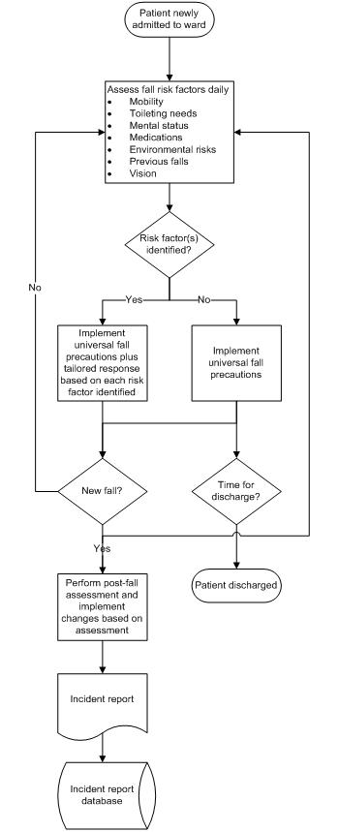
Inpatient Falls Clinical Pathway

