Pressure Ulcer Prevention Toolkit

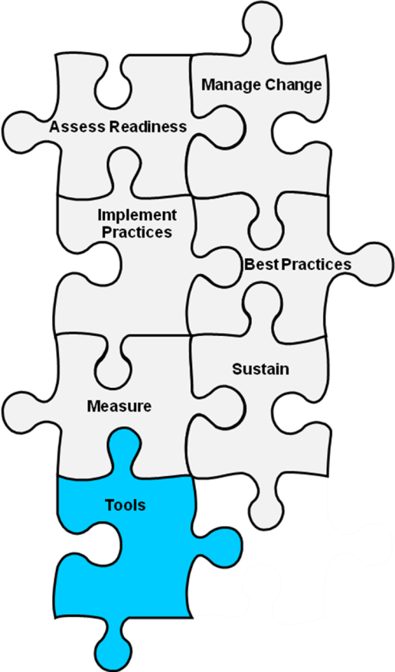
Module 1 Tools
1E: Resource Needs Assessment (Revised)

Sullivan N. Chapter 21. Preventing in-facility pressure ulcers. In: Making Health Care Safer II: An Updated Critical Analysis of the Evidence for Patient Safety Practices. March 2013. Agency for Healthcare Research and Quality, Rockville, MD.

1E: Resource Needs Assessment (revised 2/15)

Background: The purpose of this tool is to identify resources that are available for a quality improvement initiative.
Reference: Developed by Boston University Research Team.
Instructions: Complete this checklist to assess the resources that are available and the resources that are still needed.
Use: Ensure that all resources needed for launching a pressure ulcer prevention initiative are available.
Pressure Ulcer Prevention Program Resource | Needed:  Yes/No | Notes on what is needed
Monetary Resources
Funds
Facility/Staff Resources
Staff education programs
Quality improvement experts
Physical/occupational therapy consultation on work practices
Information technology support
Facilities and supplies (e.g., meeting rooms)
Printing/copying
Graphics/design
Nonclinical time for team meetings and activities
Other
Specific products - floor stock or formulary items
PH balanced skin cleanser
Skin creams (for dry skin)
Moisture barrier creams
Skin protectant wipes
Briefs
Dressings
Other products
Specific Tools – available or ability to rent
Pressure Redistribution bed surface (mattresses)
Pressure Redistribution chair surface (chair cushions)
Heel Suspension Devices
Patient transfer devices
Other tools

