Module 3: Best Practices in Pressure Injury Prevention

Module Aim
The aim of this module is to support your efforts to use best practices as outlined in the Preventing Pressure Ulcers in Hospitals Toolkit in this hospital’s Pressure Injury Prevention Program.

Module Goals
The goals of Module 3 are to have the Implementation Team identify opportunities for prevention improvement related to pressure injury practices:
  - Which pressure injury prevention practices to use
  - How to perform a comprehensive skin assessment
  - How to conduct a standardized assessment of pressure injury risk factors
  - How to incorporate risk factors into individualized care planning

Timing
This module will take 80 minutes to present.
Below is the estimated time needed to present each topic:
Slide numbers | Topic | Time in minutes
1–4 | Introduction | 5
5–14 | Comprehensive Skin Assessment and Video | 15
15–23 | Pressure Injury Risk Assessment and Case Study | 20
24–31 | Pressure Injury Care Planning | 15
32–38 | Identifying Bundle of Best Practices | 15
39–40 | Action Plan and Summary | 10

Learning Methodology Checklist
- Large group discussion
- PowerPoint slide presentation
- Video
- Case study

Additional Related Training Resources
- Conducting a Comprehensive Skin Assessment — AHRQ Pressure Injury Prevention Program Training Webinar
- Using Pressure Ulcer Risk Assessment Tools in Care Planning — AHRQ Pressure Injury Prevention Program Training Webinar
- Risk Factors for Pressure Injuries: Going Beyond Validated Instruments — AHRQ Pressure Injury Prevention Program Implementation Sharing Webinar
- Device-Related Pressure Injury — AHRQ Pressure Injury Prevention Program Implementation Sharing Webinar
- The Power of Nutrition for Pressure Ulcer Prevention — AHRQ Pressure Injury Prevention Program Implementation Sharing Webinar
- Putting the Nutrition Guidelines into Practice for Pressure Injury Prevention — AHRQ Pressure Injury Prevention Program Implementation Sharing Webinar
- National Pressure Ulcer Advisory Panel’s (NPUAP’s) best practices for preventing device-related pressure injuries http://www.npuap.org/resources/educational-and-clinical-resources/best-practices-for-prevention-of-medical-device-related-pressure-injuries/

Materials Checklist
- LCD projector and laptop
- “Parking Lot” flip chart page (with tape or sticky band) and markers
- Flip chart page with the following chart on it:

BEST PRACTICES DECISIONS
Practice | Decision
Comprehensive skin assessment | When? How often?
Risk factor assessment | Which assessment tool? How often?
Care planning | Develop or modify existing?

Instructor Preparation
- Add the specific hospital name to the first slide.
- Have the PowerPoint file Module 3 cued on the computer and minimized.
- Participants should have Tool 2I: Action Plan available, as they will continually add to it in each module.
- Ask the Team Leader which pressure injury risk assessment tool the hospital uses. If the hospital is using an assessment scale other than the Braden or Norton Scale, ask the Team Leader(s) to be prepared to review the subscales of the risk assessment tool they use or plan to use. Then, consider deleting the next 5 slides on the Braden Scale and ask the Team Leader(s) to discuss how the assessment scale they are using is scored. Ask them to include an example of how to score using their risk assessment scale.
- Have a copy of the following materials for all participants:
  - Module 3 PowerPoint slide presentation handout, 3 slides to a page
  - Tool 3A: Pressure Ulcer Prevention Pathway for Acute Care
  - Tool 3B: Elements of a Comprehensive Skin Assessment
  - Tool 3C: Pressure Ulcer Identification Pocket Pad
  - Tool 3D: The Braden Scale for Predicting Pressure Sore Risk
  - Mr. K Case Study
  - Tool 3E: Norton Scale
  - Tool 3F: Care Plan
  - Tool 3G: Patient and Family Education Booklet
  - Tool 2I: Action Plan

Module 3: Best Practices in Pressure Injury Prevention
Slide | Script
Slide 1  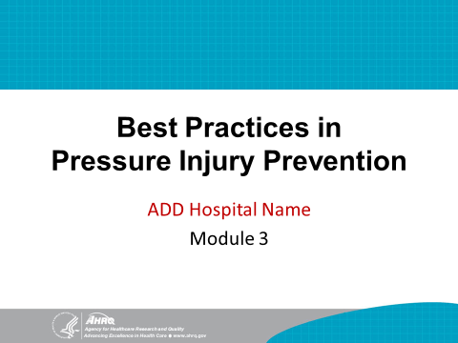 | SAY: Module 3 introduces best practices and how to determine which pressure injury prevention practices you want to use in this hospital.
Slide 2  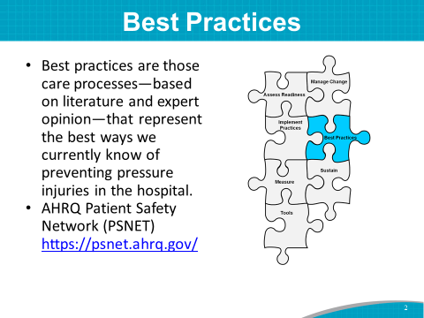 | SAY: For the purposes of this training, we define best practices as those care processes that, based on literature and expert opinion, represent the best ways we currently know of preventing pressure injuries in the hospital.  Instructor’s Note: Please see reference below.  The AHRQ Patient Safety Network (PSNET) is a national Web-based resource for staying current on tested strategies and best practices for patient safety. Find current information on https://psnet.ahrq.gov/.
Slide 3  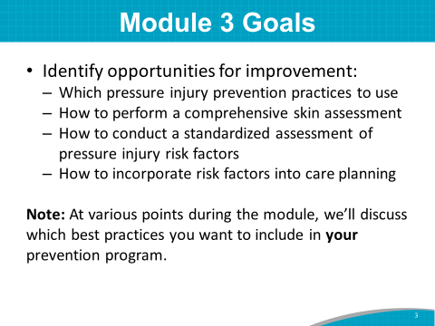 | SAY: The goals of the Module 3 training are to have the Implementation Team identify opportunities for prevention improvement related to pressure injury prevention practices. These include:  - Which pressure injury prevention best practices to use at this hospital.  - How to perform a comprehensive skin assessment.  - How to conduct a standardized assessment of pressure injury risk factors.  - How to incorporate risk factors into care planning.
Slide 4  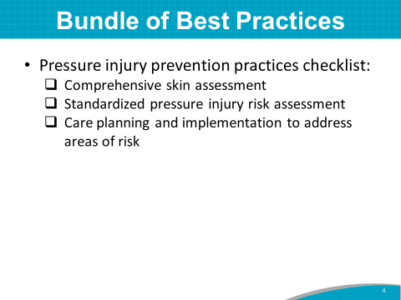 | SAY: Let’s take a few minutes to reflect. Your current prevention program may include these best practices. We talked about your current practices in the last module. Most hospitals include skin assessments, risk assessments, and care planning to address areas of risk.  In this module, we will address best practices and opportunities for improvement in more detail.
Slide 5  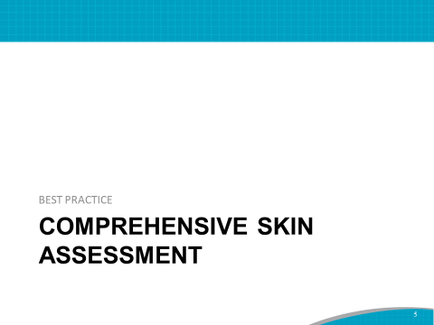 | SAY: The first step in a clinical pathway to prevent pressure injuries is performing a comprehensive skin assessment.  As we go through each section, please continue to jot down notes on opportunities for improvement that can later be considered for your organization’s Action Plan.  For example, think about the way skin and risk assessments are currently done. Is there room for improvement?
Slide 6  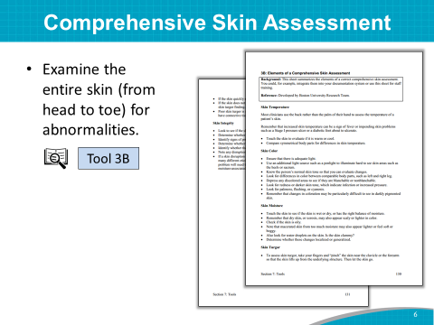 | SAY: As you know, a comprehensive skin assessment is a process by which the entire skin of an individual is examined for abnormalities.  It requires looking at and touching the skin from head to toe, with an emphasis on bony prominences.  A comprehensive skin assessment (Tool 3B) is done to:  - Identify any pressure injuries that may be present. Any patient with an existing pressure injury is at risk for additional injuries.  - Determine whether there are other lesions and skin-related factors that predispose the patient to pressure injury development, such as excessively dry skin or moisture-associated skin damage.  - Identify other important skin conditions.  - Provide the data necessary for calculating pressure injury incidence and prevalence.
Slide 7  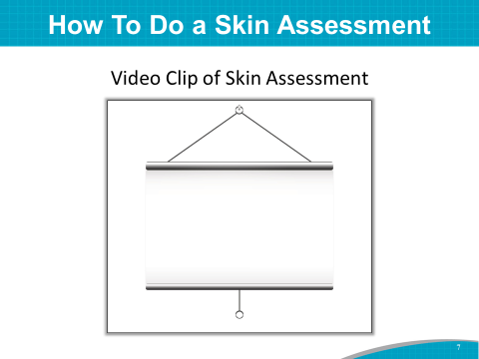 | SAY: Let’s watch a short video clip of an expert skin assessment. You might also consider using this short video clip as a tool to teach staff, and it could also be shared with frontline staff before implementing changes.  DO: Play video clip.  ASK: How did this skin assessment compare with those you have done?  Do you think the skin assessment methods used in the video could be instituted in this hospital?
Slide 8  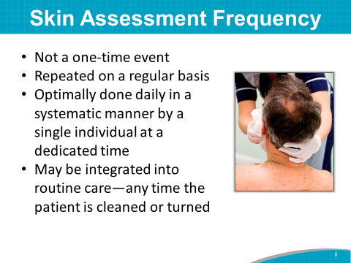 | SAY: A comprehensive skin assessment is not a one-time event limited to your patient’s admission.  It should be repeated on a regular basis to determine whether any changes in skin condition have occurred.  In some settings, such as in a critical care unit, it may be done frequently.  Optimally, the daily comprehensive skin assessment will be performed in a standardized manner by a single individual at a dedicated time.  It may also be possible to integrate it into routine care, such as any time a patient is cleaned or turned.  ASK: What would work best for your pilot units?  SAY: Whatever you decide works best—in terms of skin assessment frequency—should be standardized for care planning.
Slide 9  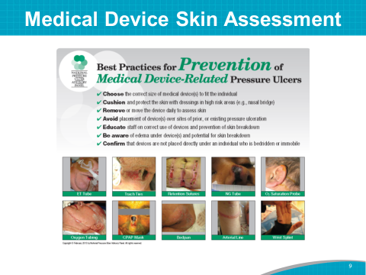 | SAY: When performing a skin assessment or reassessment, pay careful attention to the skin beneath a medical device.  In adults, 34.5 percent of facility-acquired pressure injuries were identified as medical device related in one study.  Medical device-related pressure injuries result from the use of devices designed and applied for diagnostic or therapeutic purposes, such as face masks, nasal cannulas, feeding tubes, catheters, neck braces, and trach tubes.  This slide shows best practices for preventing medical device-related pressure injuries. The best practices begin with a comprehensive assessment of the skin beneath the medical device.  ASK: Does your facility have standardized prevention procedures and documentation for medical devices?  Instructor’s Note: Recommend that the Team Leaders consider viewing Device-Related Pressure Injury — AHRQ Pressure Injury Prevention Program Implementation Sharing Webinar and NPUAP’s best practices for preventing device-related pressure injuries http://www.npuap.org/resources/educational-and-clinical-resources/best-practices-for-prevention-of-medical-device-related-pressure-injuries/.  Instructor’s Note: Please see reference below.  Black JM, Cuddigan JE, Walko MA, et al. Medical device related pressure ulcers in hospitalized patients. Int Wound J 2010;7:358-65. PMID:20561094.
Slide 10 | SAY: To make the skin assessment most useful to the patient and staff treating the patient, document the results, including skin under a medical device, in your patient’s medical record. Also, be sure to communicate the results among staff.  ASK: How do you review or audit documentation now?
Slide 11  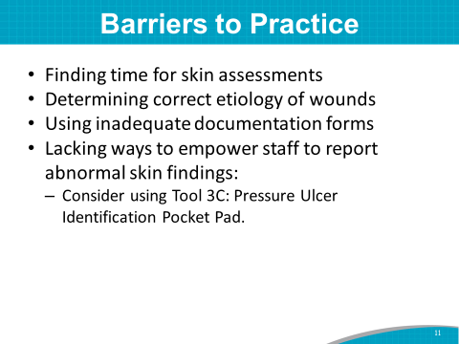 | SAY: There are many challenges to performing skin assessments.  It may be difficult to:  - Find the time for an adequate skin assessment. As much as possible, integrate the skin exam into the normal workflow.  - Determine the correct etiology of wounds. Many lesions may occur on the skin. If unsure, check with the Wound Care Team or other staff member who may be more knowledgeable.  - Develop forms that will facilitate the recording of the skin assessment.  - Empower staff—both nurses and nursing assistants—to report abnormal skin findings. Communication among nursing assistants, nurses, and managers is critical to success. Consider using Tool 3C: Pressure Ulcer Identification Pocket Pad (shown on the next slide) for communication among unit staff.
Slide 12  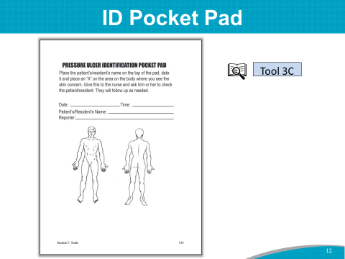 | SAY: Here is Tool 3C. To use it, a nursing assistant or other discipline, such as a respiratory therapist, places an X on any suspicious lesion and gives the note to a nurse for followup.
Slide 13  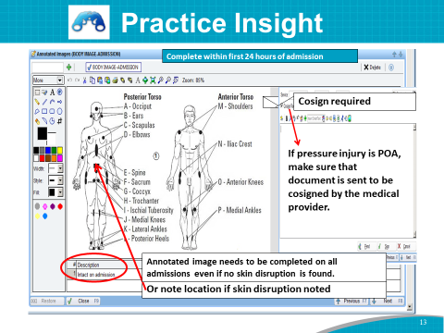 | Practice Insight  SAY: A large acute care hospital incorporated an annotated pocket pad image into its electronic health record (EHR) to aid in documenting pressure injuries upon admission.  A problem was identified with inconsistent or absent documentation of present on admission (POA) skin integrity issues.  With the implementation of the EHR, the Team identified inconsistencies in documenting skin integrity issues POA and describing the location of these POA skin issues. The failure to have clear admission documentation led to an increase in the documentation of hospital-acquired skin integrity issues.  The hospital IT Team ensured the annotated image would automatically pop up for the nurse during the admission assessment.  They also developed a process to transfer the image to the medical provider note for co-signature.  The Implementation Team and IT educator provided housewide education to nursing staff.  The wound nurses, Quality Department, and nurse managers audited the use of the annotated image.
Slide 14  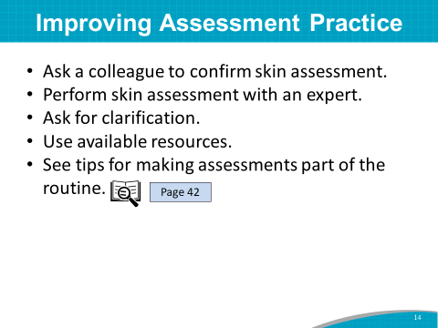 | SAY: Skin assessments require considerable skill, and ongoing efforts are needed to enhance skills. Take advantage of available resources. For instance:  - Ask a colleague to confirm a skin assessment. Having a colleague evaluate the assessment provides immediate feedback and lowers documentation errors. How often does that occur?  - Consider having a wound care expert or nurse from another unit with wound expertise round with unit staff quarterly to confirm findings from the skin assessments. Is this something that might be possible?  - Clarify when unsure of a lesion. Ask the Wound Care Team to weigh in on certain lesions.  - Use available resources to practice the ability to differentiate etiology of skin and wound problems.  - See tips for making assessments part of routine care on page 42 of the Toolkit.
Slide 15  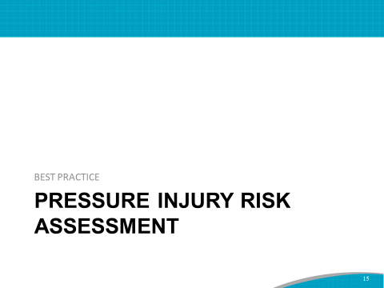 | SAY: The skin assessment helps to identify visible changes in the skin that indicate increased risk for pressure injuries.  Let’s move on to other factors that must be assessed to identify patients at risk for pressure injuries.  Step 2 in the clinical pathway of pressure injury prevention is completing a standardized pressure injury assessment. Again, continue to jot down notes on areas that might be opportunities for improvement.
Slide 16  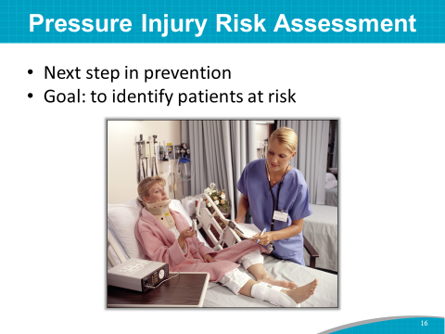 | SAY: The goal of a pressure injury risk assessment is to identify patients at risk so that plans for preventive care can be implemented.  Risk assessment is essential for many reasons:  - It aids in clinical decision making. Use of a standardized risk assessment tool helps to direct the process by which clinicians identify those at risk and quantify the level of this risk.  - It allows the selective targeting of preventive interventions. Prevention is resource intensive. Resources should be targeted toward those at greatest risk who would benefit most.  - It facilitates care planning. Care plans focus on the specific dimensions that place patients at greatest risk.  - It facilitates communication between health care workers and care settings. Workers have a common language by which they describe risk.
Slide 17  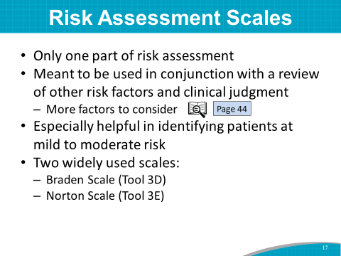 | SAY: It is important to realize that risk assessment scales are only part of a risk assessment.  They are meant to be used in conjunction with a review of other risk factors and clinical judgment. See page 44 of the Toolkit for several additional factors to consider as part of the risk assessment process.  The scales are especially helpful in identifying patients at mild to moderate risk.  The two scales that are used most often and have established reliability and validity are:  - The Braden Scale (Tool 3D).  - The Norton Scale (Tool 3E).  DO: Ask the Team Leader(s) to address the following questions:  - Which pressure injury risk assessment tool does this hospital use?  - When and how is the initial risk assessment completed?  - When is a reassessment of risk completed?  Instructor’s Note: If the hospital is using an assessment scale other than the Braden or Norton Scale, ask the Team Leader(s) to review the subscales of the risk assessment tool they use or plan to use. Consider deleting the next 5 slides and ask the Team Leader(s) to discuss how the assessment scale they are using is scored. Include an example of how to score using their scale.
Slide 18  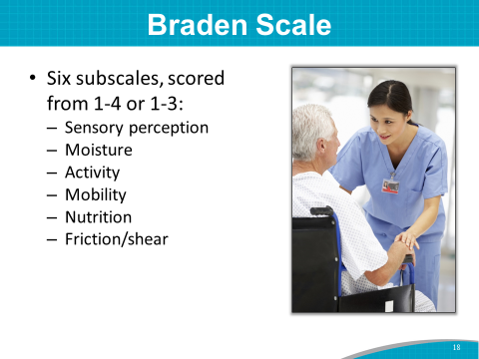 | SAY: The Braden Scale is made up of six subscales, scored from 1 to 4, or 1 to 3. The subscales are:  - Sensory perception.  - Moisture.  - Activity.  - Mobility.  - Nutrition.  - Friction/shear.  Add the subscales together for a total score that ranges from 6 to 23.  A lower score indicates higher levels of risk for pressure injury development.  A score of 18 or less generally indicates at-risk status.
Slide 19  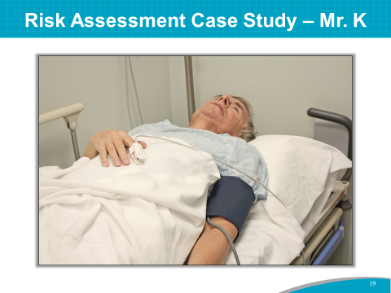 | SAY: Let’s assess pressure injury risk via a short case study using the Braden Scale.  DO: Pass out the Pressure Injury Risk Assessment Case Study – Mr. K (included at the end of this document).  Read the case study aloud, and ask participants to pair up and use the Braden Scale to score this patient.  Have two or three participant pairs say what risk assessment score they would give this patient upon admission.  Instructor’s Note: The answers may vary somewhat. There may need to be additional probing questions, such as, “What did you eat this morning?” to help determine appetite and if intake is adequate.
Slide 20  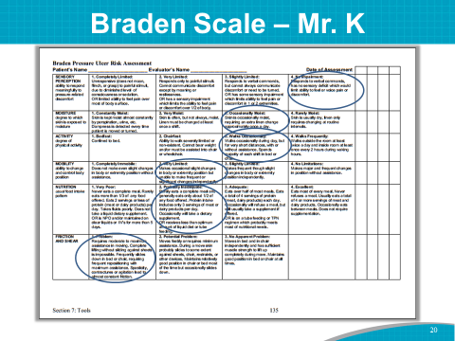 | Mr. K’s risk score: 15 (a score of 18 or less indicates at-risk status)  ASK: How long did it take to come up with a risk assessment score?  What element in the case study requires additional clinical judgment?  SAY: The answer is the wound or ostomy nurse consult revealed a slightly pink coccyx. This clinical issue heightens the risk to a much higher level. It doesn’t affect the actual risk score, but a professional’s clinical judgment would reveal that this patient needs a comprehensive care plan that involves:  - Frequent skin assessment.  - Frequent repositioning.  - Special equipment (such as a pressure-relieving mattress).  - Skin hygiene (and so on).  This patient is at high risk for a pressure injury. You might even assess this patient as having a Stage 1 pressure injury. Staging of pressure injuries is discussed in Module 5.  ASK: What current hospital policy or procedure would this assessment trigger?
Slide 21  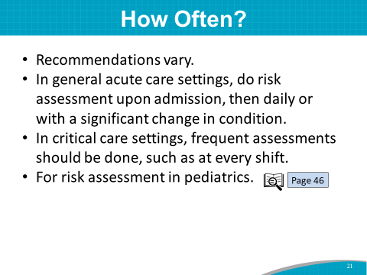 | SAY: How often is a risk assessment done?  Recommendations vary for frequency of risk assessment.  In general, acute care settings consider performing a risk assessment on admission and daily or with a significant change in condition.  In critical care settings, the assessment should be done frequently, such as at every shift.  See page 46 of the Toolkit for risk assessment recommendations for special populations, such as pediatric patients.  ASK: How often do you currently conduct a skin assessment on a patient?
Slide 22  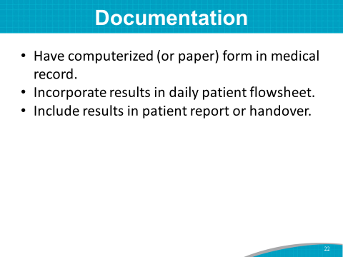 | SAY: Documenting pressure injury risk is essential to ensure that staff know a patient’s risk status.  In addition to documentation in the medical record, here are some other ways to ensure that staff know the level of risk:  - Have a dedicated (computerized or paper) form in the medical record.  - Incorporate results into the daily patient flowsheet.  - Include results as part of shift change.  Remember that in documenting pressure injury risk, you want to incorporate not only the score and subscale scores of the risk assessment tool, but also other factors placing the patient at risk.  Communicate risk status orally at shift change or by review of written notes.  ASK: How do you indicate your patients’ risk status? How is risk identified at shift handoff?
Slide 23  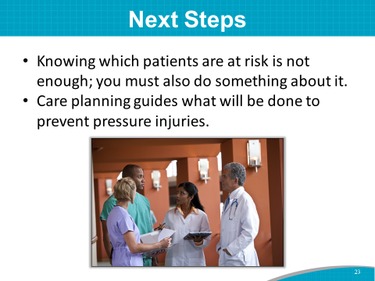 | SAY: Knowing which patients are at risk for a pressure injury is not enough; you must also do something about it.  Care planning provides the guide for what you will do to prevent pressure injuries.  Once risk assessment has helped identify patient risk factors, it is important to match care planning to those needs.
Slide 24  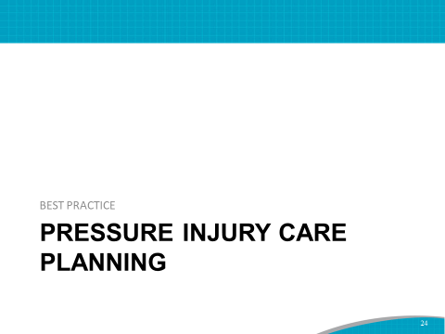 | SAY: The third step in the clinical pathway to prevent pressure injuries is to create a care plan that is responsive to the patient’s pressure injury risks.
Slide 25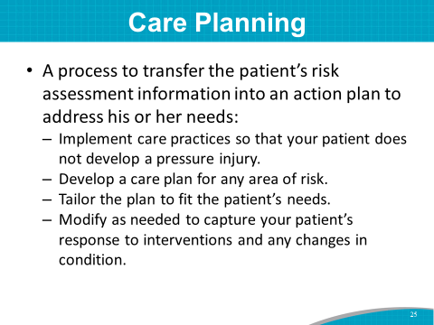 | SAY: Pressure injury care planning is the process by which the patient’s risk assessment information is translated into an Action Plan to address the identified patient needs.  Its specific purpose, in this case, is to implement care practices so that the patient does not develop a pressure injury during hospitalization.  All care planning needs to be individualized to fit the patient’s needs.  Any area of risk should have a corresponding care plan regardless of the overall risk assessment scale score.  The care plan is an active document. It incorporates the patient’s response to the interventions and any changes in his or her condition.
Slide 26  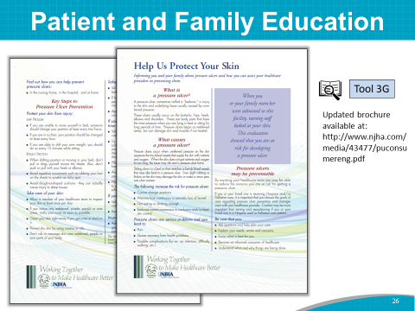 | SAY: Each patient should understand his or her pressure injury risk and how a care plan addresses this risk. The patient’s family should know, too.  Identify some aspects of the care plan that patients and families can help implement. Use an educational resource, such as Tool 3G: Help Us Protect Your Skin, to augment instruction.  Instructor’s Note: An updated version of this tool is available at: http://www.njha.com/media/43477/puconsumereng.pdf.
Slide 27  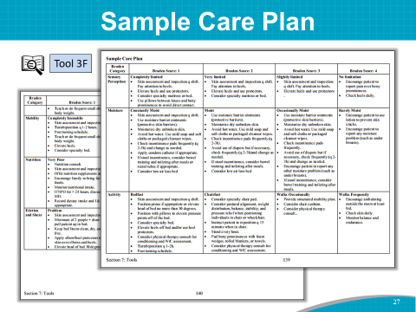 | SAY: Tool 3F is a sample care plan based on the Braden Scale assessment. It can be modified for a specific patient.
Slide 28  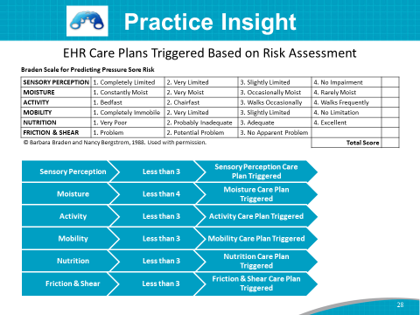 | Practice Insight  SAY: After the in-person training, the implementation group in an acute care hospital began to work with their IT Department to integrate care plans into the EHR. Previously, the Braden Scale categories for patients were assessed only at the following levels of risk: very high, high, moderate, low, and very low.  This type of risk communication did not adequately tell staff about the most at-risk areas of the Braden Scale for the patient. The Core Implementation Team decided on the specific interventions for each Braden subscale area.  The EHR was modified so that when a patient is scored less than a certain number in the Braden subscale (that is, sensory perception, moisture, activity, mobility, nutrition, and friction and shear), a pop-up appears and asks the nurse whether a care plan should be started to address the low Braden subscale score; after the nurse begins the care plan, the EHR provides various recommendations for the patient.  These care plans are also added to the nurse’s action list, which will remind the nurse to complete the care plan. Previously, care plans could be created, but there would be no reminders that they needed to be completed. The nurse can complete the care plan items after they have been added to the action list.  A documentation screen appears when the nurse completes the action list items that provides a date and time stamp.
Slide 29  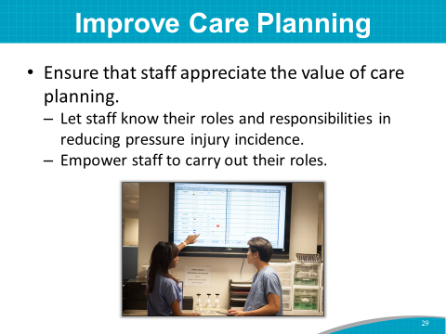 | SAY: Planning care is essential to quality. Here are some ways to ensure that staff appreciate the value of care planning:  - Make sure all staff understand what portion of the care they are responsible for and the value they bring to the overall care of the patient.  - Empower all levels of staff to carry out their roles.
Slide 30  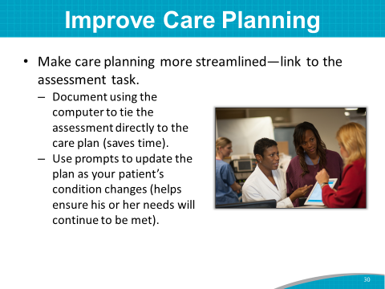 | SAY: Make care planning more streamlined by linking it to the assessment task.  - Computer documentation that ties assessment directly to the care plan saves time.  - Having prompts to update the plan as the patient’s condition changes helps ensure the patient’s needs will continue to be met.  ASK: Do you currently electronically link the assessment risk factors to the care plan in the health record? How does that work?
Slide 31  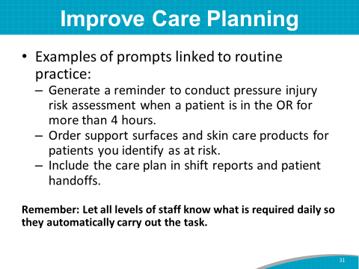 | SAY: Here are some examples of prompts:  - A patient who is in the OR for more than 4 hours generates a reminder to the staff to do a pressure injury risk assessment.  ASK: Does the OR use the same EHR as the rest of the hospital? If not, how does the information transfer into the hospital EHR?  SAY:  - Patients who are identified as at risk generate an automatic order for support surfaces and skin care products.  - Link the care plan to routine practice. The care plan should be routinely included in shift reports and patient handoffs.  All levels of staff should know what is required daily and automatically do it.
Slide 32  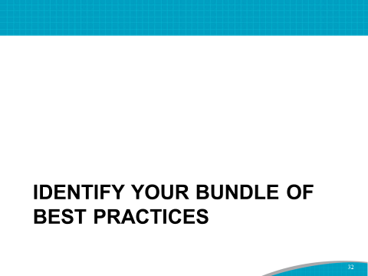 | SAY: Now it is time to decide how to enhance the comprehensiveness and completeness of your specific bundle of best practices for this hospital.
Slide 33  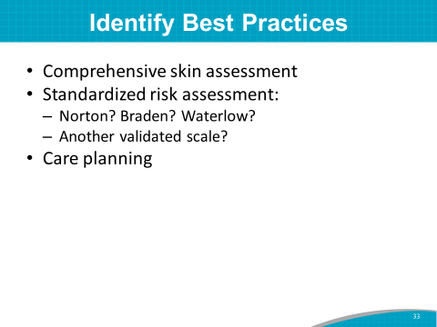 | SAY: The three best practices that are advocated for a Pressure Injury Prevention Program are:  - A comprehensive skin assessment.  - A standardized pressure injury risk assessment.  While the Braden Scale is widely used and has established reliability and validity, you may decide to use other valid scales, such as the Norton or Waterlow pressure injury risk assessment tools. Validity means that research studies showed the tool accurately identified patients at increased risk.  - Care planning based on identified risk.
Slide 34  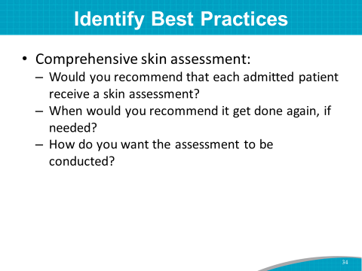 | DO: Show the slide, then move to the flip chart.  ASK: Let’s start with a comprehensive skin assessment.  Would you recommend that each admitted patient receive a skin assessment?  When would you recommend the assessment be done again, if needed?  How do you want the assessment done?  DO: Write the Team’s responses on the flip chart page.
Slide 35  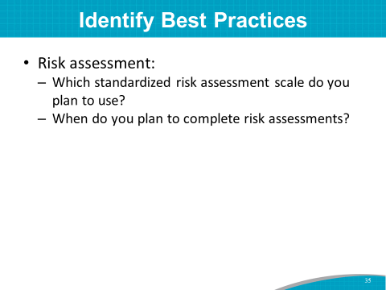 | ASK: Which standardized risk assessment scale do you plan to use?  When do you plan to complete risk assessments?  DO: Write the Team’s responses on the flip chart page.
Slide 36  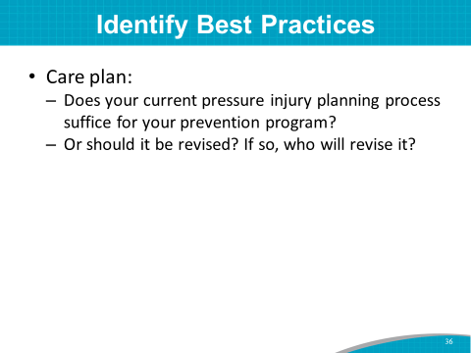 | ASK: Does your current pressure injury prevention care planning process suffice for your prevention program?  Should it be revised? If so, who will revise it?  DO: Write the Team’s responses on the flip chart page.  SAY: We now have an idea of what revisions and upgrades should be done to your bundle of best practices for this hospital’s prevention program. Good job on your decisions!
Slide 37  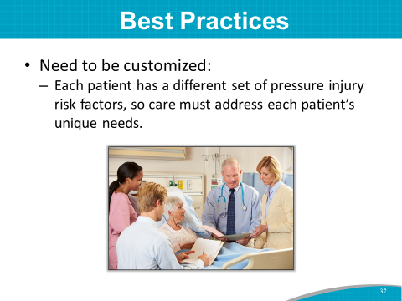 | SAY: These best practices also need to be customized for individual patients. You will want to address these issues during your staff training.
Slide 38  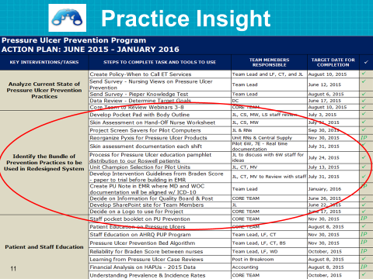 | Practice Insight  SAY: This slide shows an example of an action plan that was developed by the same hospital Prevention Team we looked at in Module 2.  Let’s look at Key Intervention 2, which is to identify the bundle of prevention practices to be used in your redesigned system.  This hospital Team identified many best practices they wanted to institute or improve in their hospital.  Look at the tasks they are working on. Note that they have a person or persons responsible to make each task happen by a certain date.  DO: Read the key intervention tasks from the slide.
Slide 39  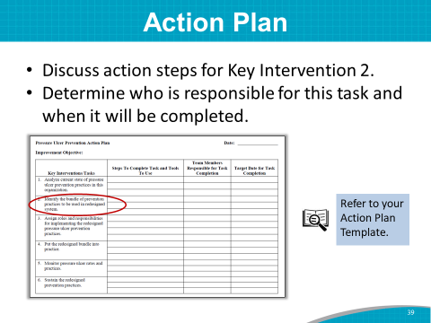 | DO: Start a discussion of prioritized opportunities for change for Key Intervention 2.  SAY: Please take out partially completed Tool 2I.  We discussed the opportunities for change for Key Intervention 1. Now we can move on to Key Intervention 2: identify the bundle of prevention practices to be used in your redesigned system. Look at the example for steps to complete this task.  ASK: What are the steps to complete Key Intervention 2?  DO: Write the steps as participants present them.  SAY: Who is responsible for these tasks? What is a draft target date for completion of these tasks?  DO: Write the Team member responsible and the target date for completion on the form.  SAY: Keep Tool 2I available in your packet of information, as we will fill out Key Interventions 3 to 5 in the upcoming modules.  Instructor’s Note: If the group can’t complete Key Intervention 2 during this training, continue this task at later meetings, and complete Action Plan Step 2 within the next couple of weeks with the Team.
Slide 40  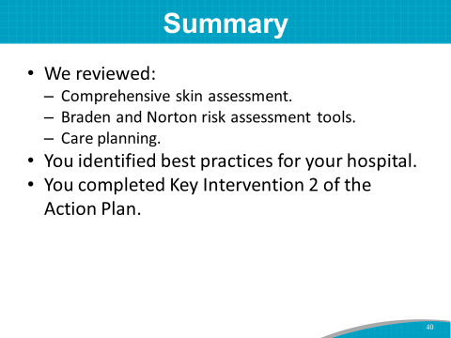 | SAY: In summary, we reviewed skin assessment practices, looked at the Braden risk assessment tool, and reviewed optimal care planning practices for pressure injury prevention.  Then you identified areas in this hospital’s bundle of best practices that should be revised and updated for this hospital’s prevention program.  And you began the process of identifying opportunities for change in the Key Intervention 2 area of your Action Plan.  This was a very productive training workshop session. Determining where the opportunities for change are in this hospital’s bundle of best practices is a major step in implementing a Pressure Injury Prevention Program.

PRESSURE INJURY RISK ASSESSMENT CASE STUDY – Mr. K
Mr. K was admitted to the hospital for ongoing complex medical care and a need for management of advanced Parkinson’s disease, dysphagia, and failure to thrive. He developed difficulty swallowing after his usual Parkinson’s medication schedule was inadvertently altered at rehab 1 month ago. He is now designated as nothing by mouth (NPO) and has trouble with secretions. Mr. K is alert and oriented, but speech and sensory motor function are not smooth and symmetric.
Currently he is being fed Ensure Plus via a feeding tube. A nutrition consult has been ordered. He is usually unable to walk and has difficulty talking. He requires total care for bathing, toileting, dressing, and feeding. At least two nurses or nurse aides are required to move him. He is occasionally incontinent.
A wound or ostomy nurse consult revealed he has a slightly pink coccyx (the base of his spinal column).

