Module 4: How To Implement the Pressure Injury Prevention Program in Your Organization

Module Aim
The aim of this module is to support your efforts to implement the new prevention practices at the patient care level.

Module Goals
The goals of the Module 4 training are to have the Implementation Team determine how to successfully implement changes to its program by answering the following questions:
- What roles and responsibilities will staff have in preventing pressure injuries?
- What role will the Wound Care Team play? What if the hospital has no formal Wound Care Team?
- What role will the Unit-Based Team play?
- What role will the Unit Champions play?
- How will you put the new practices into operation?
- How can you help staff learn new practices?

Timing
This module will take 75 minutes to present.
Allow approximately 45 minutes to present slides 1–33. That leaves approximately 30 minutes for assessment of current staff education and training (Slide 34) and the conclusion of this module.

Learning Methodology Checklist
- Large group discussion
- PowerPoint slide presentation

Additional Related Training Resources
- Staff Roles and Training for Your Pressure Ulcer Prevention Program – AHRQ Pressure Injury Prevention Program Training Webinar

Materials Checklist
- LCD projector and laptop
- “Parking Lot” flip chart page (with tape or sticky band) and markers

Instructor Preparation
- Add the specific hospital name to the first slide.
- Have the PowerPoint file Module 4 cued on the computer and minimized.
- Participants should have Tool 2I: Action Plan available, as they will add to it in this module.
- Ask the Implementation Team Leader to work with the manager of the pilot unit(s) prior to this training to identify Unit Champions for each shift on each pilot unit. (Refer to page 62 in the Toolkit for characteristics of a good Unit Champion.)
- Ask the Implementation Team Leader to assign a Task Force Leader to think about which staff roles will be responsible for performing the best practices tasks using Tool 4B: Staff Roles. (See Slide 12, where the Implementation Team Leader is asked to assign a Task Force Leader and then ask for volunteers to be on the small Task Force.)
- Alert the Implementation Team Leader or designee to be ready to present findings from Tool 4C: Assessing Staff Education and Training and to lead a group planning discussion of developing an Action Plan for this education.
- Alert the Education Department representative to be present and ready to discuss Tool 2G: Pieper Pressure Ulcer Knowledge Test and staff training needs.
- Alert the information technology (IT) representative on the Implementation Team to be ready to talk about the following topics during this module:
  - The electronic health record (EHR) and the possibility of building pressure injury prevention into the electronic documentation system
  - How to use electronic communication modalities to communicate the program’s progress and success to the rest of the hospital staff

- Have a copy of the following materials for all participants:
  - Module 4 PowerPoint slide presentation handout, 3 slides to a page
  - Tool 4A: Assigning Responsibilities for Using Best Practice Bundle (with the left column completed by the Implementation Team Leader/co-leaders and best practices decided upon earlier by the team)
  - Tool 4B: Staff Roles
  - Tool 4C: Assessing Staff Education and Training (completed by the Implementation Team Leader or designee)
  - Tool 2G: Pieper Pressure Ulcer Knowledge Test

Module 4: How To Implement the Pressure Injury Prevention Program in Your Organization
Slide | Script
Slide 1  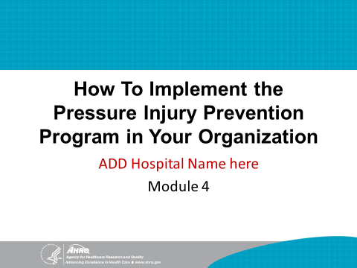 | SAY: In this module, we will begin planning for implementation of this hospital’s Pressure Injury Prevention Plan and updated best practices.
Slide 2  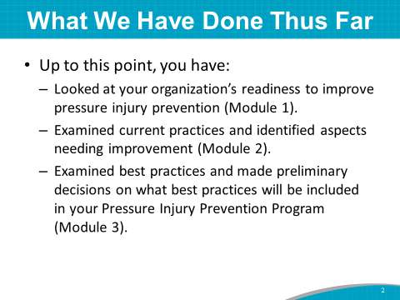 | SAY: Up to this point, you have:  - Addressed this hospital’s readiness to improve pressure injury prevention (Module 1).  - Examined this hospital’s current practices and identified aspects needing improvement (Module 2).  - Examined best practices and made preliminary decisions on how current best practices will be updated and included in your Pressure Injury Prevention Program (Module 3).
Slide 3  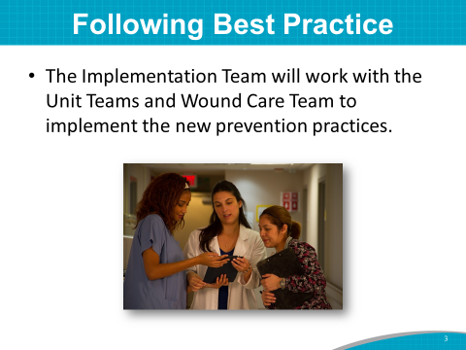 | SAY: In Module 4, we will focus on the Implementation Team interacting with the Unit Teams and Wound Care Team to implement your new prevention practices at the patient care level.  This is where the rubber meets the road. For any prevention program to succeed, staff must use the updated best practices you have decided to implement.
Slide 4  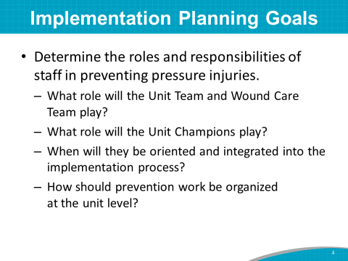 | SAY: There are many goals for planning implementation, such as determining the roles and responsibilities of staff in preventing pressure injuries.  Even though we can’t answer everything today, you’ll want to start thinking about the following questions.  - What role will the Unit Team and Wound Care Team play?  - What role will the Unit Champions play?  - When will they be oriented and integrated into the implementation process?  - How should prevention work be organized at the unit level?
Slide 5  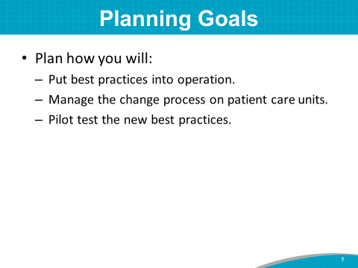 | SAY: Another implementation planning goal is to put new evidence-based practices into operation. The questions to ask your Team are:  - How will you put updated best practices into operation?  - How will you manage the change process at the patient care level?  - How will you pilot test the new practices?  As suggested in Module 2, the change process of rolling out new practices tends to be most successful when teams follow a systematic approach to analysis and implementation, such as in the Plan, Do, Study, Act improvement process (described on page 27 of the Toolkit).  Consider implementing small tests of change, whereby one staff nurse tries out the new practice for 1 day, and then two or more nurses implement the new practice for 1 or 2 days. This systematic approach helps to work out any problems before rolling out the new practice to the whole unit and helps to perfect a practice.
Slide 6  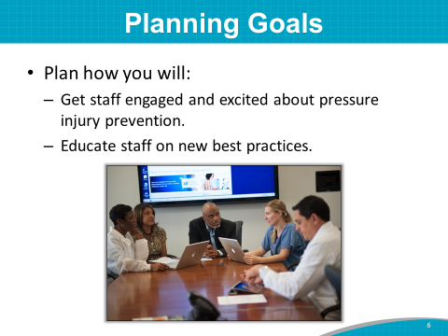 | SAY: You should also think about these questions:  - How do you get staff engaged and excited about pressure injury prevention?  - How can you help staff learn new practices?  Not everything will change. You may already have elements of the best practices that are functioning well.  Again, the questions we just went over are points to ponder as you plan your prevention program.
Slide 7  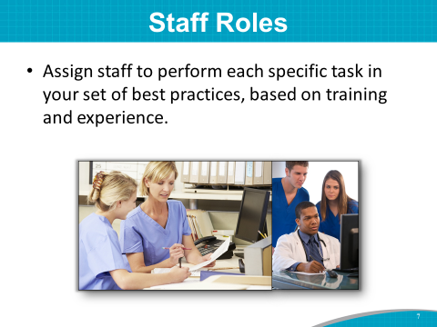 | SAY: Think about who will perform each specific task identified for your set of best practices.  Assign responsibilities based on the formal training and informal work experience of each individual.
Slide 8  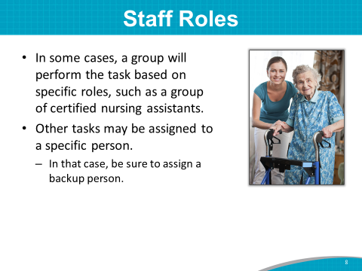 | SAY: In some cases, a group will perform a task based on its specific role or title, such as certified nursing assistants (CNAs).  Other tasks may be assigned to a specific individual. In that case, always ensure you have a backup and that everyone knows who the backup is.
Slide 9  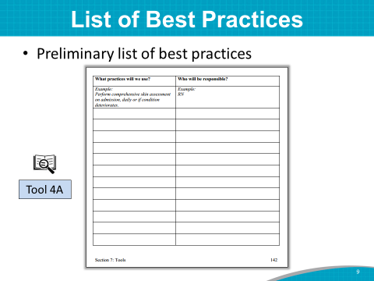 | DO: Ask participants to take out Tool 4A: Assigning Responsibilities for Using Best Practice Bundle.  SAY: The Implementation Team decided on a preliminary list of best practice opportunities for change earlier in Module 3.  Here are the opportunities for best practices or redesigned best practices to be incorporated at this hospital.  DO: Show the flip chart “Best Practices Decisions” page completed by the Implementation Team during Module 3. Read the best practices listed on the flip chart page, and ask participants to write the preliminary list of best practices on Tool 4A.
Slide 10  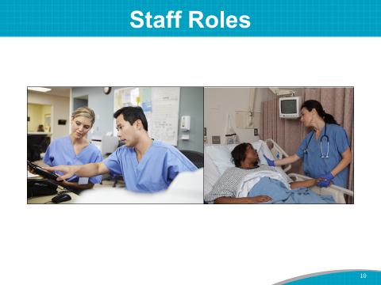 | SAY: The next step is to decide who will be responsible for carrying out the tasks necessary to implement best practices at the unit level.  DO: Ask participants to take out Tool 4B: Staff Roles.
Slide 11  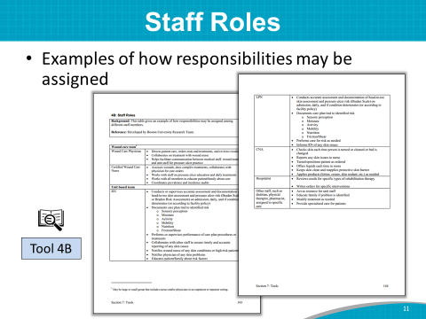 | SAY: Use Tool 4B to help you think through who will be responsible for performing the best practices tasks.
Slide 12  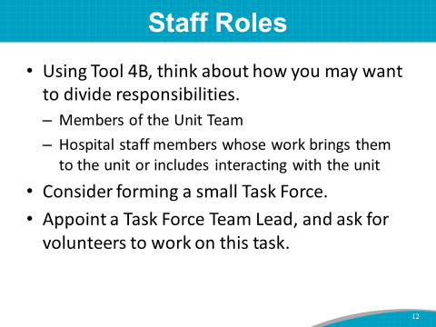 | SAY: Tool 4B includes examples of how responsibilities may be assigned among:  - Members of the Unit Team whose roles will be defined in the next few slides.  - Hospital personnel whose work brings them to the unit or includes interactions with the unit.  Assign staff roles for performing the identified best practices using Tool 4B. In this case, it is best to assign this task to a small Task Force of the Implementation Team.  Because of time constraints today, we will not be able to complete this activity in person. I suggest you ask for volunteers or assign staff members to be on this Task Force.  You may decide to make this topic an agenda item for one of your first Team meetings.  DO: Ask the Implementation Team Leader to appoint the Task Force Lead and then ask for volunteers.  ASK: What would be a reasonable timeline for this Task Force to complete this task?
Slide 13  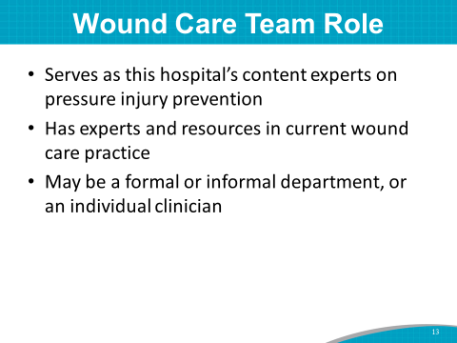 | SAY: What role will the Wound Care Team play?  This hospital (has/doesn’t have)* a team that directs wound care and assists in preventive practices. A Wound Care Team usually:  - Serves as the hospital’s content experts on pressure injury prevention.  - Has experts and resources in current wound care practices.  The Wound Care Team may be a formal or informal department, or you may have an individual clinician.  Regardless of the Team’s size or composition, the Team members are the hospital experts in current wound care practice. They are a resource when others have questions.  *Instructor’s Note: You asked in Module 2 if the hospital has a Wound Care Team or Nurse. Modify this statement based on its answer.  ASK: How does your Wound Care Team/Nurse operate in this hospital?
Slide 14  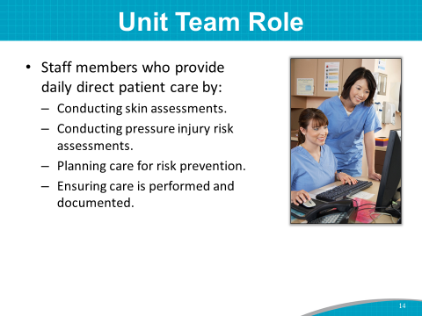 | SAY: The staff members who will be assigned to carry out best practices are often considered the Unit Team. The Team does not have to be large, and it may include some of the same people who are on the Wound Care Team. The Unit or Skin Champion of the care unit is often the person who represents the Unit Team.  The Unit Team is made up of the staff members who provide daily direct patient care by:  - Conducting comprehensive skin assessments.  - Conducting pressure injury risk assessments.  - Planning care for pressure injury prevention.  - Ensuring care is performed and documented.  In other words, they are responsible for the performance of your bundle of best practices.
Slide 15  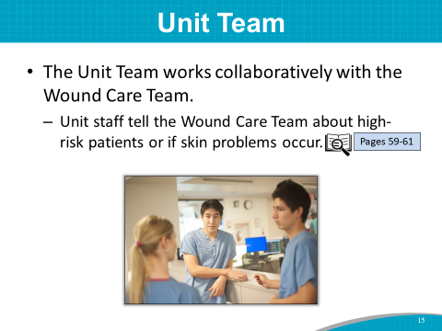 | SAY: The Unit Team works collaboratively with the Wound Care Team. Unit staff notify the Wound Care Team if skin problems arise or if high-risk patients are identified.  See pages 60–61 of the Toolkit for more information on the Unit Team.
Slide 16  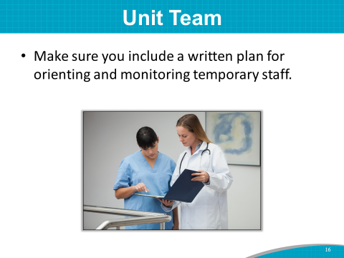 | SAY: Develop a plan for orienting and monitoring temporary staff, including travelers.  As you know, each day brings the possibility of a different temporary staff member being pulled onto the unit. Share a written plan to communicate pressure injury risk procedures with the new member. This keeps temporary staff in the loop.  You will want to include training for temporary staff in your pressure injury prevention staff education plan. We’ll be working on this plan later in the module.  ASK: How will you make sure temporary staff are trained in pressure risk procedures?  SAY: I recommend that the pilot study units assign the same temporary staff for the pilot study duration and train them along with pilot study staff.
Slide 17  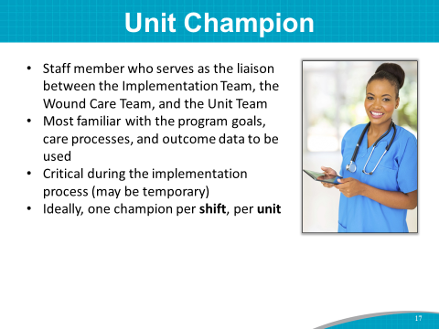 | DO: If Unit Champions have been identified prior to training, introduce them to the group if they are in the room. Otherwise, read the list of Unit Champion names.  SAY: Many successful improvement efforts rely on Unit Champions, especially during the implementation process.  A Unit Champion is a staff member who serves as the liaison between the Implementation Team, the Wound Care Team, and the Unit Team.  The Unit Champion is familiar with the program goals, care processes, and outcome data that will be used.  The Unit Champion will need to be oriented to the Pressure Injury Prevention Program prior to implementation.  The Unit Champion is the go-to person when staff have questions.  The Unit Champion is critical during the implementation period and may be temporary.  Ideally, there should be one Unit Champion per shift to provide guidance to other staff.
Slide 18  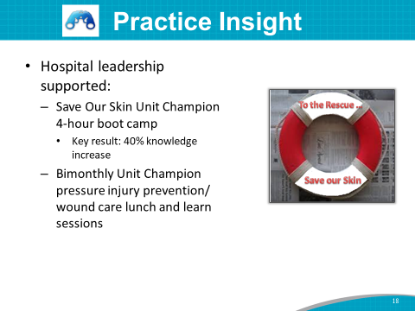 | Practice Insight  SAY: The leadership of an acute care hospital supported additional training for their Unit Skin Champions so they could serve as mentors and educators for coworkers.  The hospital had a known staff pressure injury knowledge deficit as demonstrated by pretest data. Hospital administration supported implementation of a 4-hour Unit Champion program called Save Our Skin boot camp, with lunch provided. Post-test results of the boot camp showed a 38 percent increase in knowledge.  In addition, the hospital administration committed to provide training with free lunch every other month in recognition of the additional responsibilities as the unit leader for skin care.  Because of the positive feedback on the Save Our Skin program, the plan is to continue to offer the boot camp twice a year and continue bimonthly pressure injury prevention and wound care-related educational lunch-and-learn sessions.
Slide 19  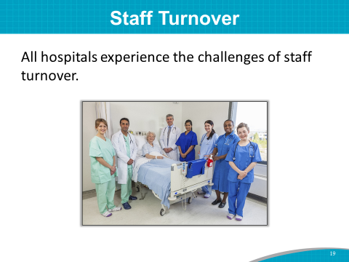 | SAY: All hospitals experience staff turnover.  Staff turnover tends to make it difficult to keep staff adequately trained and up to speed on prevention efforts. Make sure that pressure injury prevention is included in new staff or travel staff training.  It is especially difficult when someone on the Pressure Injury Prevention Implementation Team takes another position. It is helpful to have a plan or process in place to identify a replacement for each role on your Implementation Team, including the Unit Champions. This plan for turnover on the Team should include specific training for each role.  ASK: What are the challenges of staff turnover at this hospital?
Slide 20 | Practice Insight  SAY: Here’s how one hospital has addressed nursing turnover. It instituted a 1-year residency program for new-graduate registered nurses (RNs) to provide support and training in an effort to retain them. The goal is to provide specific orientation and on-the-job training to empower new RNs to learn and be confident in their skills. The new-graduate nurse program is usually a class of 30 RNs.  The program includes:  - A 3-week orientation to the hospital and its prevention programs.  - A 9-week preceptorship with floor nurses to build skills.  - Nine months of support, which includes a monthly forum to talk about their work and to provide an emotionally supportive atmosphere.  - A graduation ceremony.  - A pay raise upon graduation.  The outcome of this residency program is an 85 to 95 percent 2-year retention rate of new-graduate RNs. Recently, the main reasons for losing new-graduate RNs early is the travel nurse allure or wanting a nurse specialty that this hospital doesn’t have.  While there are no simple solutions for addressing staff turnover, it will be critical for you to plan for it as you move forward with your Pressure Ulcer Prevention Program.
Slide 21  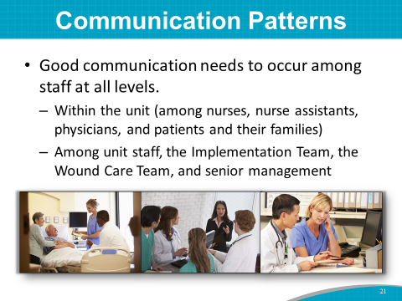 | SAY: Now let’s look at another challenge: communication. Good communication needs to occur among staff at all levels:  - Within the unit (among nurses, nurse assistants, physicians, and patients and their families)  - Among unit staff, the Implementation Team, the Wound Care Team, and senior management
Slide 22  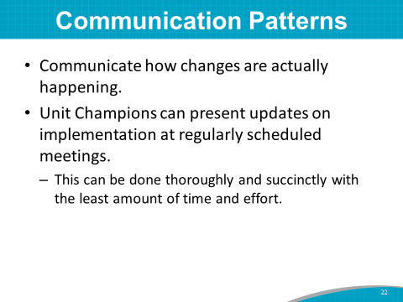 | SAY: There is a need to communicate about how implemented changes are working.  The Unit Champions can present updates on new changes at regularly scheduled meetings of the Implementation Team.  This will help the communication process continue regularly and thoroughly with the least amount of time and effort.  ASK: What steps would you like to take to ensure staff remain updated (such as hourly rounding or huddles)?
Slide 23  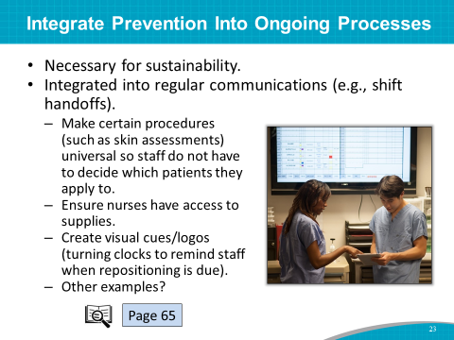 | SAY: Building new pressure injury prevention practices into ongoing work processes is necessary for sustainability.  Here are some strategies for building prevention into ongoing processes:  - Make some procedures (such as skin assessments) universal so staff do not have to decide which patients they apply to.  - Integrate communication regarding pressure injury risk into regular communication, such as during shift handoffs.  - Give nurses access to dressings when wound staff are unavailable.  - Create visual cues or reminders, such as logos indicating elements of the pressure injury risk care plan or turning clocks to remind staff when repositioning is due.  ASK: Does anyone have any ideas about who in this hospital might be able to help create visual cues? Perhaps a public relations or communications professional?  For examples of how change can be incorporated into routine care, see page 65 of the Toolkit.  SAY: The next slide addresses ways to use electronic health records.
Slide 24  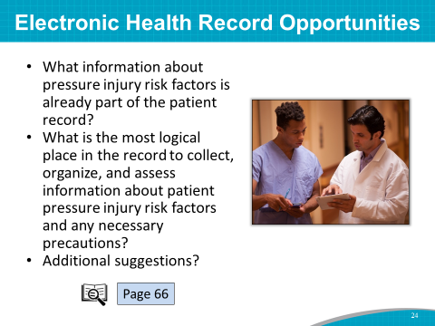 | SAY: Electronic health records provide additional opportunities to integrate best practices into the daily routine.  For hospitals that have electronic records, questions to consider include:  - What information about pressure injury risk factors is already part of the patient record?  - What is the most logical place in the record to collect, organize, and assess information about patient pressure injury risk factors and any necessary precautions?  Additional suggestions for building pressure injury prevention into electronic documentation systems can be found on page 66 of the Toolkit.  If a member of the IT Department is on the Implementation Team, he or she can discuss changes to the system that are possible.  ASK: Can (name of IT representative) speak to the possibility of building pressure injury prevention into the electronic documentation system?  Instructor’s Note: In general, IT can be an issue. Some facilities may be able to modify theirs, while others cannot.
Slide 25  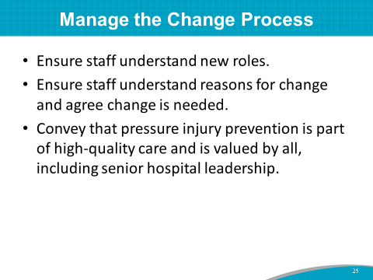 | SAY: Incorporating a new set of practices involves changes in the way people do their work. To manage the change process more efficiently, consider doing the following:  - Ensure staff members understand their new roles, know why the new roles are important, and have the knowledge and tools to carry out their roles.  - Help reduce resistance to change by ensuring that staff understand the reasons for change and agree that change is needed.  - To help staff accept the new set of practices fully, ensure they understand that those practices offer promising strategies for providing high-quality care to patients. With senior leadership encouraging these new practices, staff should feel empowered to carry out their roles and responsibilities.
Slide 26  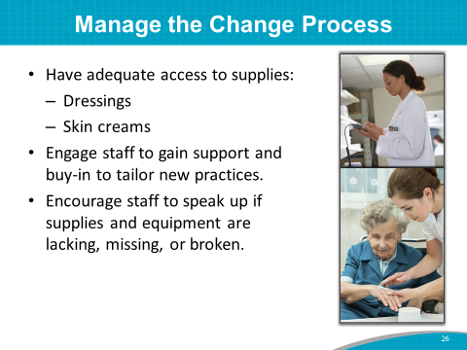 | SAY: Identify and minimize practical barriers to using the new practices, such as inadequate access to supplies and equipment. For example, supplies such as dressings and creams should be stored on or near the unit for easy availability.  Engage staff at all levels to gain their support and buy-in to the improvement effort and help tailor the practices to pressure injury prevention.  Encourage staff to speak up if supplies and equipment are lacking, missing, or broken.
Slide 27  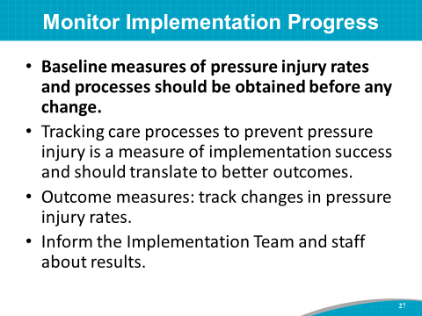 | SAY: The Implementation Team, Wound Care Team, and Unit Champions should develop a process for ongoing monitoring of implementation progress.  It’s very important to collect baseline measurements of pressure injury rates and current practices before implementing any changes.  The monitoring process should include outcome measures, such as tracking changes in pressure injury rates.  Tracking process and outcome measures can help determine if the changes you have made are leading to a reduction in pressure injuries. We will discuss what measures to track in Module 5.  You will need to communicate the tracking results to staff, the Wound Care Team, senior administration, and the Implementation Team.
Slide 28  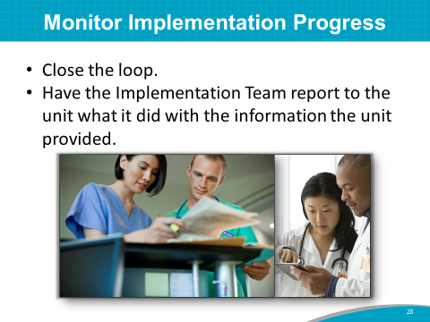 | SAY: Close the information loop by having the Implementation Team report back to the Unit Team on how it communicated the unit’s process and outcome data to hospital managers and leadership.  This communication may result in continuous quality improvement by providing additional staff training or obtaining needed supplies for pressure injury prevention; or simply letting the entire hospital know the successes of the prevention program.
Slide 29  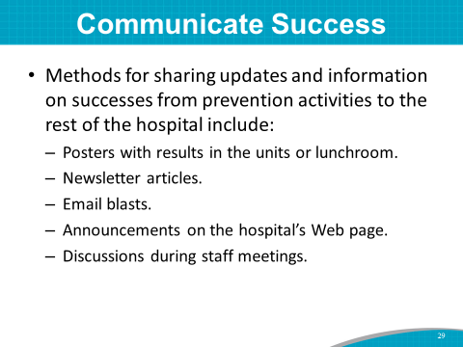 | SAY: Tips for how to convey updates and information on successes from the prevention activities include using:  - Posters with results in the units or lunchroom.  - Newsletter articles.  - Email blasts.  - Announcements on the hospital’s homepage.  - Discussions during staff meetings.  ASK: Does anyone have suggestions for how to convey updates and program successes to the hospital at large?  How can IT professionals help with communicating about the program?
Slide 30  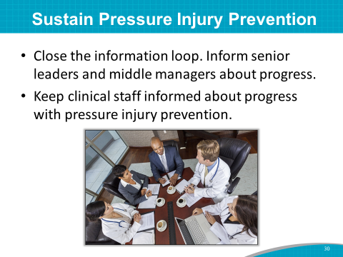 | SAY: To help sustain the prevention program, make sure senior leaders and middle managers know about the tracking results. Share this information on a regular basis.  Keeping senior administrative leadership in the know and involved in the prevention program is key to sustaining the program over the long term.  Engaging the buy-in and ongoing participation of staff members who are involved in hands-on care is crucial to achieving the improvement objectives.  Communicate with clinical staff about the progress that has been made in pressure injury prevention.  SAY: Let’s quickly brainstorm how to keep senior administration leadership and staff involved.  ASK: What creative ideas would you suggest to best share tracking results or brief vignettes of success stories about the program?  Is there a hospital staff member here who does this kind of work?
Slide 31  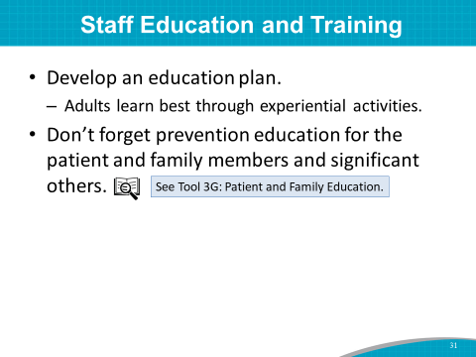 | SAY: Let’s turn now to staff education and training. How can you help staff learn new practices? You may want to craft an education plan to enhance staff knowledge on pressure injury prevention.  First, adult learning theory suggests that adults learn best through methods that build on their own experiences.  We also want to remember that we should provide prevention education to the patient and his or her family members and significant others. Tool 3G is an example of patient and family education about pressure injury prevention.
Slide 32  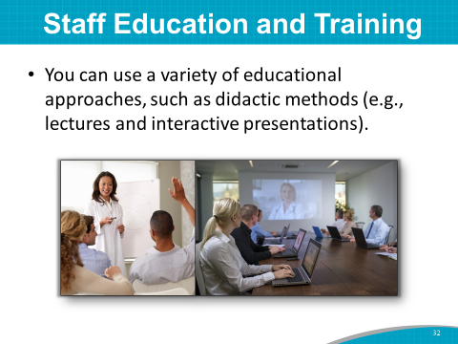 | SAY: Because individuals have different learning styles and are at different levels of practice proficiency, a variety of educational approaches is best. Options include didactic methods, such as lectures, interactive presentations, online lessons, case study analysis, and grand rounds talks.
Slide 33  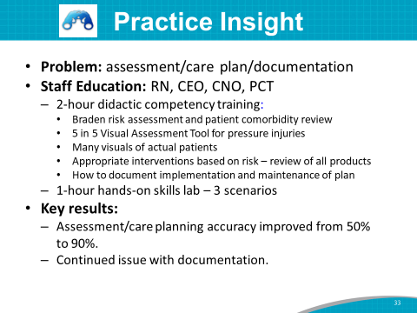 | Practice Insight  SAY: A Pressure Injury Prevention Team in a large acute care hospital conducted a review of same-day RN assessment scores and intervention vs. Wound, Ostomy, and Continence (WOC) Nurse assessment. They found a 50 percent variance in scoring and inappropriate intervention selection and only 20 percent documentation completion. They also found that preceptor staff were teaching what they knew, not what was correct, which perpetuated inaccuracies.  To improve competency of assessment scoring, care plan intervention selection, and documentation, a comprehensive skills lab was developed and implemented.  RNs were required to attend a mandatory 3-hour training: a 2-hour didactic training and a 1-hour hands-on skills lab.  The 2-hour didactic portion included:  - Braden risk assessment and patient comorbidity review.  - 5 in 5 Visual Assessment Tool for pressure injuries.  - Several visuals of actual patients.  - Appropriate interventions based on risk, and a review of all products.  - How to document implementation and maintenance of the plan.  The 1-hour hands-on portion included:  - Mockups.  - Three scenarios.  Patient Care Technicians attended a 1.5-hour mandatory session that covered the same information but focused on their scope of practice.  The hospital CEO and CNO also went through the training.  One month after the skills lab, a second assessment was completed comparing RN scores and care planning interventions to WOC RN scores and care planning interventions. The accuracy of assessment and care planning interventions improved to 90 percent. However, there continued to be documentation issues that needed to be addressed.
Slide 34  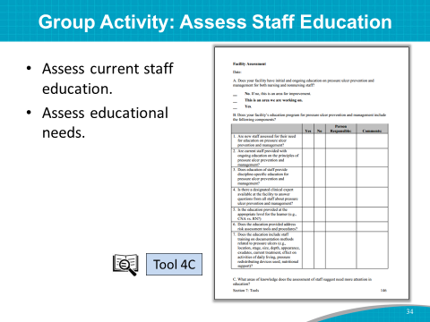 | SAY: (Name of Implementation Team Leader or designee), in collaboration with other Team members, assessed the current staff education practices on pressure injury prevention using Tool 4C.  Keep in mind: The purpose of assessing staff education is to identify where there may be room for improvement.  DO: Distribute Tool 4C, or ask participants to take out their copy.  SAY: I’d like to ask (name of Implementation Team Leader or designee) to review Tool 4C with you and lead a discussion about staff training needs.  DO: Have the Implementation Team Leader or designee review the completed Tool 4C and lead a discussion about staff training needs.
Slide 35 | SAY: To assess staff understanding of pressure injury prevention, Tool 2G: Pieper Pressure Ulcer Knowledge Test is administered to staff to help determine their educational needs.  DO: Ask the Implementation Team Leader or designee to ensure that this test is included in the Action Plan for Staff Education and Training. The test should be administered to staff at baseline and after staff training on pressure injury prevention.  Instructor’s Note: Tool 2H: Pressure Ulcer Baseline Assessment, which is a shorter knowledge test, is also available in the Toolkit to assess knowledge of nurses and nurse assistants.
Slide 36  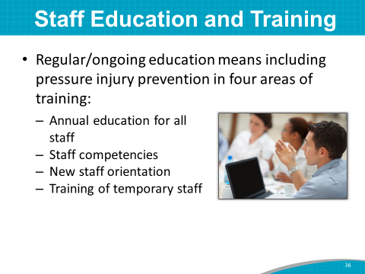 | SAY: You will want to ensure staff members follow this hospital’s Pressure Injury Prevention Plan, so it is a good idea to have ongoing training to help remind staff of pressure injury prevention strategies.  Pressure injury prevention should be included in four areas of training:  - Annual education for all staff  - Staff competencies  - New staff orientation  - Training of temporary staff prior to patient care duties
Slide 37  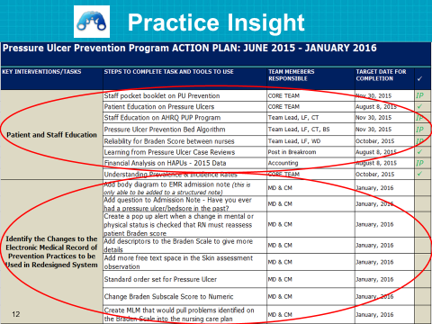 | Practice Insight  SAY: Here’s an example of how an acute care hospital included staff education on new prevention practices in its action plan.  For the key intervention on patient and staff education, the team plans to do the following.  DO: Read aloud the steps on the slide.  SAY: This plan also tells how staff will implement best practices in daily clinical care.  For the key intervention to identify changes in the EHR, the team plans to do the following.  DO: Read aloud the steps on the slide. Note those responsible for completing each step and the date for completion.
Slide 38  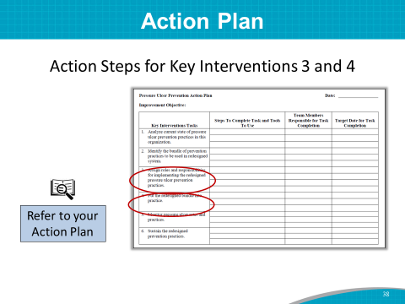 | SAY: Throughout the day, you have identified best practices to include in your prevention program and opportunities for change.  Let’s try to brainstorm some steps to complete the key interventions on this slide.  DO: Ask the Implementation Team Leader or designee to lead or help with this activity. Write down the steps on the flip chart as the group says them.  Instructor’s Note: Here are some examples of Key Intervention 3 (assign roles and responsibilities for implementing the redesigned pressure ulcer prevention practices):  - Decide how and when skin assessments and risk assessments will be completed.  - Provide education on pressure injury knowledge and prevention.  Here are some examples of Key Intervention 4 (put the redesigned bundle into practice):  - Identify needed changes in the EHR.  - Plan for pilot testing new strategies.  - Plan for educational needs on new practices.  - Plan for incorporating all pressure injury risk into a plan of care.  SAY: The responses from this short brainstorming session can be further finalized in the next 2 weeks or so at our meetings. This task may be fine tuned as you begin planning for implementation, but this is a great start.  Your staff roles Task Force will be coming up with the final plan for assigning roles and responsibilities for staff. This plan will be used for Key Intervention 3.
Slide 39  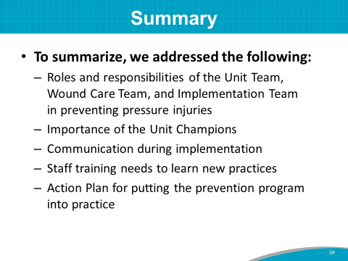 | SAY: To summarize, in this training module, we walked through the process of building a dynamic Unit Team to implement the Pressure Injury Prevention Program, including:  - Roles and responsibilities of unit staff working with the Implementation Team and Wound Care Team to prevent pressure injuries in patients.  - The importance of the Unit Champions.  - Communication of successes and areas that need more attention during implementation.  - Staff training needs to learn new practices.  In addition, we began determining how to complete a draft Action Plan for Key Interventions 3 and 4. This is a working document that can be revised as the Team works through its planning processes.  You have accomplished a great deal in planning to implement your Pressure Injury Prevention Program.  Now let’s take a break, and then move on to planning for measuring and tracking pressure injury rates and practices of your quality improvement program.

