Module 5: How To Measure Pressure Injury Rates and Prevention Practices

Module Aim
The aim of this module is to support your efforts to measure and monitor pressure injury rates and pressure injury prevention practices.

Module Goals
The goals of Module 5 are to have the Implementation Team agree on and develop a plan for measures to track pressure injury rates, pressure injury prevention practices, and communication of trends by addressing the following questions:
- How do you measure pressure injury rates?
- How do you measure pressure injury prevention practices?
- How will you communicate trends in pressure injury rates to key stakeholders?

Timing
This module will take 90 minutes to present.
Below is the estimated time needed to present each topic:
Slide numbers | Topic | Time in minutes
1–14 | Introduction | 15
15–33 | Measuring Pressure Injury Rates | 25
34–42 | Measuring Key Processes of Care | 15
43–46 | Action Plan Activity | 30
47–48 | Summary and Next Steps | 5

Learning Methodology Checklist
- Large group discussion
- PowerPoint slide presentation

Additional Related Training Resources
- Wound Classification — AHRQ Pressure Injury Prevention Program Training Webinar.
- Measuring Pressure Ulcer Rates and Prevention Practices — AHRQ Pressure Injury Prevention Program Training Webinar.
- Measurement — AHRQ Pressure Injury Prevention Program Implementation Sharing Webinar.
- Edsberg LE, Black JM, Goldberg M, et al. Revised National Pressure Ulcer Advisory Panel Pressure Injury Staging System: Revised Pressure Injury Staging System. Journal of Wound, Ostomy, and Continence Nursing 2016 Nov/Dec;43(6):585-97.
- Berlowitz D. Incidence and prevalence of pressure ulcers. In: Thomas D, Compton M, eds. Pressure ulcers in the aging population: a guide for clinicians. New York: Springer Science & Media; 2014. p. 19–26. http://media.axon.es/pdf/101060_1.pdf.
- Clark M. Skin assessment in dark pigmented skin: a challenge in pressure ulcer prevention. Nursing Times 2010; 106: 30. http://www.nursingtimes.net/nursing-practice/clinical-specialisms/dermatology/skin-assessment-in-dark-pigmented-skin-a-challenge-in-pressure-ulcer-prevention/5017918.article.

Materials Checklist
- LCD projector and laptop
- “Parking Lot” flip chart page (with tape or sticky band) and markers

Instructor Preparation
- Add the specific hospital name to the first slide.
- Have the PowerPoint file Module 5 cued on the computer and minimized.
- Alert the Implementation Team Leader or designee (as well as the QI Team, if appropriate) that he/she will be leading or helping to lead a group activity to complete the Action Plan Tool To Measure Pressure Injury Rates and Pressure Injury Prevention Practices.

- Have a copy of the following materials for all participants:
  - Module 5 PowerPoint slide presentation handout, 3 slides to a page
  - The hospital’s Incident Report, if available
  - Tool 5C: Assessing Comprehensive Skin Assessment
  - Tool 5D: Assessing Standardized Risk Assessment
  - Tool 5E: Assessing Care Planning
  - Action Plan Tool To Measure Pressure Injury Rates and Pressure Injury Prevention Practices

Module 5: How To Measure Pressure Injury Rates and Prevention Practices
Slide | Script
Slide 1  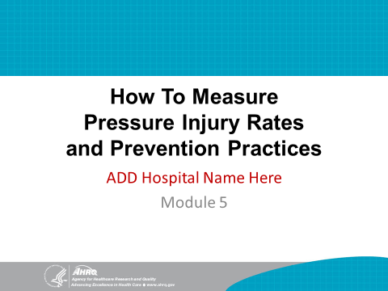 | SAY: In this final module, we will discuss how to measure pressure injury rates and pressure injury prevention practices. This tracking of key indicators is critical to improving prevention practices in this hospital.
Slide 2  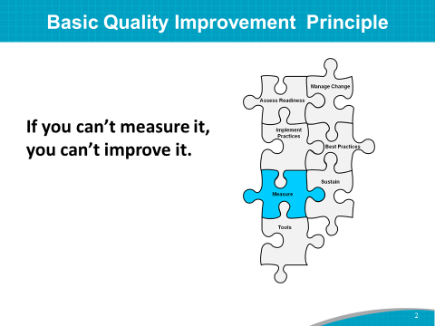 | SAY: A basic principle of quality improvement is:  If you can’t measure it, you can’t improve it.  By tracking performance, you will know whether care is improving, staying the same, or getting worse in response to efforts to change practice.  Continued monitoring will help you understand where you are starting from, and whether your improvement gains are being sustained.
Slide 3  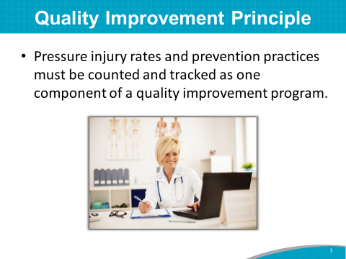 | SAY: Pressure injury rates and pressure injury prevention practices must be counted and tracked as one component of a quality improvement program.  Use of the National Database of Nursing Quality Indicators (NDNQI) is recommended when measuring pressure injury rates and practices.  NDNQI is used by many hospitals, but there are various options to measure pressure injuries.
Slide 4  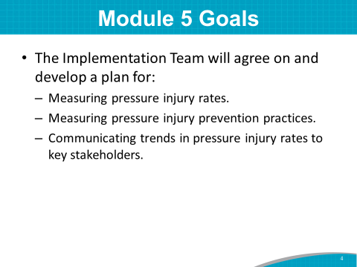 | SAY: The goals of the Module 5 training are to have the Implementation Team agree on and develop a plan for:  - Measuring pressure injury rates.  - Measuring pressure injury prevention practices.  - Communicating trends in pressure injury rates to key stakeholders.
Slide 5  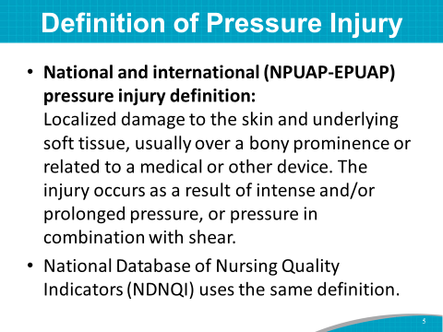 | SAY: As of 2016, the National Pressure Ulcer Advisory Panel (NPUAP) and the European Pressure Ulcer Advisory Panel (EPUAP) define a pressure injury as:  - Localized damage to the skin and underlying soft tissue, usually over a bony prominence or related to a medical or other device. The injury occurs as a result of intense and/or prolonged pressure, or pressure in combination with shear.  - NDNQI uses the same definition.
Slide 6  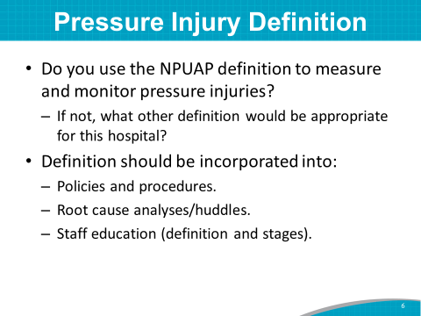 | ASK: Is this the definition you use?  Is there another definition you would like to consider?  DO: If the group agrees to use the NDUAP- EPUAP definition, write it on the flip chart.  If the group comes up with another definition, write it on the flip chart.  SAY: The agreed-upon definition of pressure injury should be incorporated into:  - Policies and procedures.  - Root cause analysis.  - Staff education.
Slide 7  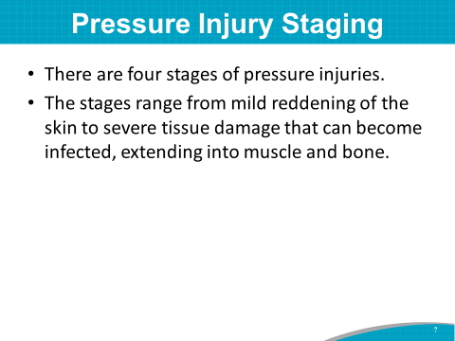 | SAY: Now that we have agreed on how to define a pressure injury, let’s review the stages of pressure injuries.  As you know, pressure injuries are described in four stages.  Pressure injuries range from mild reddening of the skin to severe tissue damage that can become infected, extending into muscle and bone.
Slide 8  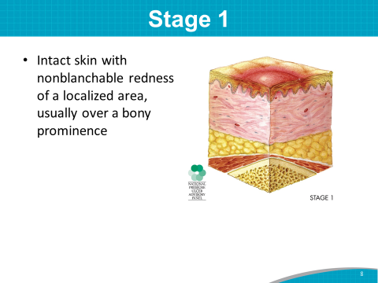 | SAY: Let’s briefly go over the stages now.  A Stage 1 pressure injury is characterized by intact skin with a localized area of nonblanchable erythema, usually over a bony prominence.  Stage 1 may be difficult to detect in individuals with dark skin tones.  A copy of a recent Nursing Times article on skin assessment in dark skin tones is included in your packet.  With Stage 1:  - Presence of blanchable erythema or changes in sensation, temperature, or firmness may precede visual changes.  - Color changes do not include purple or maroon discoloration; these may indicate a deep tissue pressure injury.  - Stage 1 may indicate at-risk people.
Slide 9 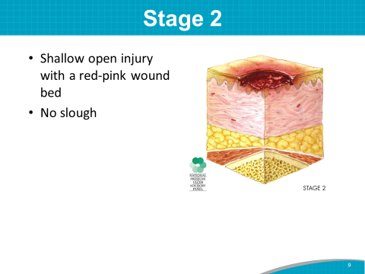 | SAY: A Stage 2 injury is a partial-thickness skin loss with exposed dermis.  With Stage 2:  - The wound bed is viable, pink or red, and moist. It may also present as an intact or ruptured serum-filled blister.  - Adipose (fat) is not visible, and deeper tissues are not visible.  - Granulation tissue, slough, and eschar are not present.
Slide 10  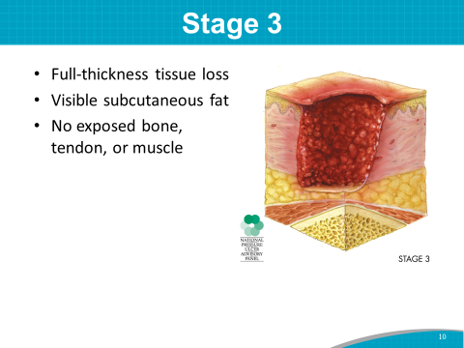 | SAY: Stage 3 presents as a full-thickness tissue loss. Adipose (fat) is visible in the injury, and granulation tissue and epibole (rolled wound edges) are often present. Subcutaneous fat may be visible, but no bone, tendon, or muscle is exposed.  Stage 3 may include undermining and tunneling.  Slough and/or eschar may be visible.
Slide 11  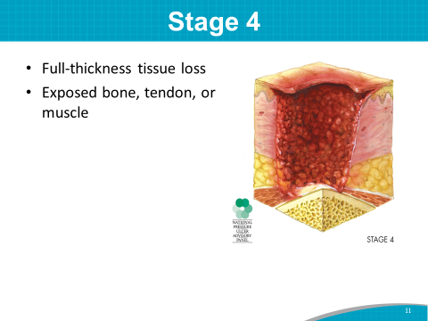 | SAY: A Stage 4 injury has a full-thickness skin and tissue loss with exposed or directly palpable fascia, muscle, tendon, ligament, cartilage, or bone in the injury.  Slough and/or eschar may be visible. Epibole (rolled edges), undermining, and/or tunneling often occur.
Slide 12  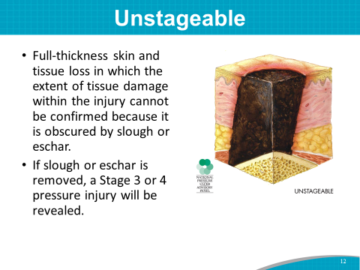 | SAY: An unstageable injury is a full-thickness skin and tissue loss in which the extent of tissue damage within the injury cannot be confirmed because it is obscured by slough or eschar. An injury that cannot be staged is a full-thickness tissue loss.  If slough or eschar is removed, a Stage 3 or Stage 4 pressure injury will be revealed.
Slide 13  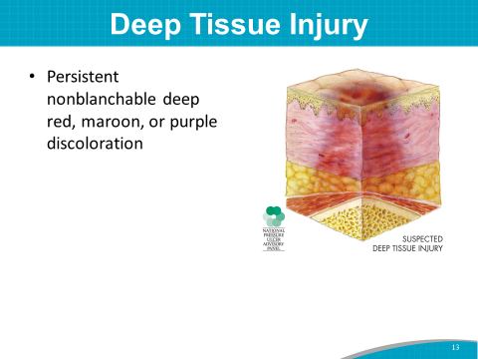 | SAY: A suspected deep tissue injury is an intact or nonintact skin injury with a localized area of persistent nonblanchable deep red, maroon, or purple discoloration or epidermal separation revealing a dark wound bed or blood-filled blister.  This injury results from intense and/or prolonged pressure and shear forces at the bone-muscle interface. The wound may evolve rapidly to reveal the actual extent of tissue injury or may resolve without tissue loss.
Slide 14  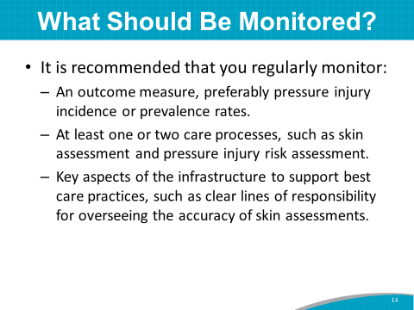 | SAY: It is recommended in the Toolkit that you regularly monitor:  - An outcome measure, preferably pressure injury incidence or prevalence rates.  - At least one or two care processes, such as skin assessment and pressure injury risk assessment.  - Key aspects of the infrastructure to support best care practices, such as clear lines of responsibility for overseeing the accuracy of skin assessments.
Slide 15  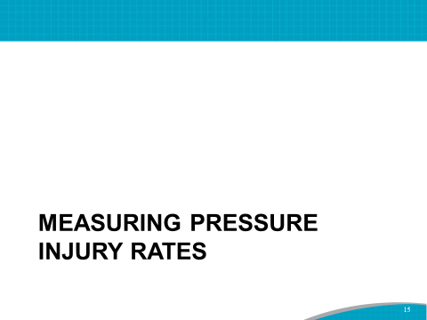 | SAY: Pressure injury rates are the most direct measure of how well you are succeeding in preventing pressure injuries.
Slide 16 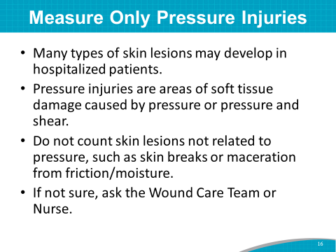 | SAY: Measure only pressure injuries—not other types of skin lesions that may develop in hospitalized patients.  A pressure injury is localized injury to the skin and/or underlying tissue, usually over a bony prominence, as a result of pressure, or pressure in combination with shear. Do not count skin lesions not related to pressure, such as skin breaks or maceration from friction or moisture, even when found over a bony prominence.  If you are not sure a skin lesion is a pressure injury, ask the Wound Care Team or Wound Care Nurse.  ASK: What do you regularly do if you are unsure of the etiology of a skin lesion?
Slide 17  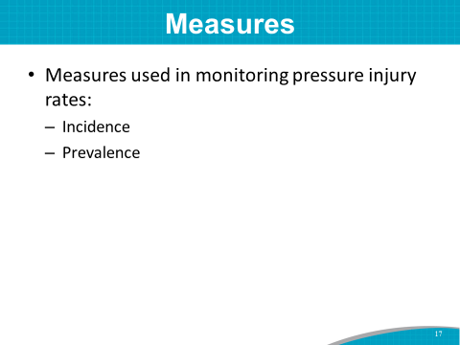 | SAY: Incidence and prevalence measures are used in monitoring pressure injury rates.
Slide 18  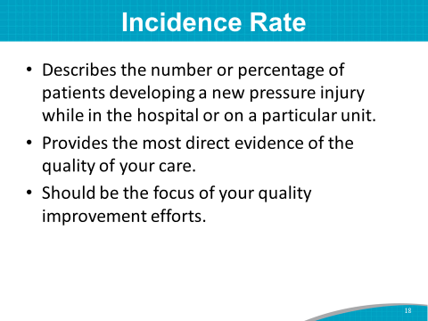 | SAY: An incidence rate describes the number or percentage of patients developing a new injury while in the hospital or on your unit. Incidence measures hospital-acquired pressure injuries (HAPIs).  Incidence rates provide the most direct evidence of the quality of your care.  Therefore, your quality improvement efforts should focus on incidence rates.
Slide 19  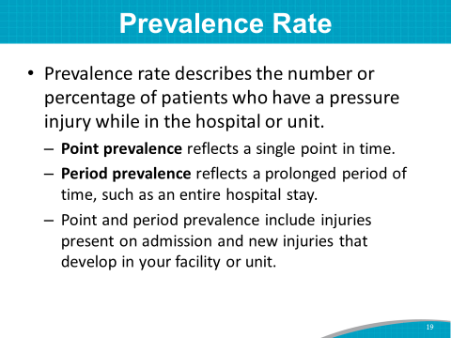 | SAY: The prevalence rate describes the number or percentage of patients who have a pressure injury while on your unit.  It may reflect a single point in time, such as the first day of each month. This is known as point prevalence.  It can also reflect a prolonged period, such as an entire hospital stay. This is known as period prevalence.  Point and period prevalence rates include injuries present on admission and new injuries that develop in your facility or unit.
Slide 20  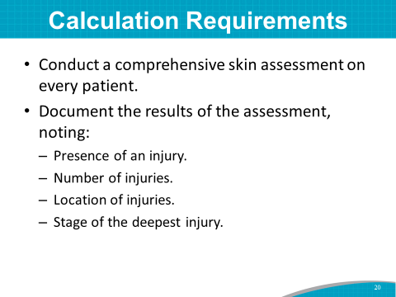 | SAY: To calculate pressure injury incidence or prevalence rates, you need to:  - Conduct a comprehensive skin assessment on every patient.  - Document the results of the skin assessment on every patient with a standard form, noting the following:  - Presence of an injury,  - Number of injuries,  - Location of injuries, and  - Stage of the deepest injury.
Slide 21  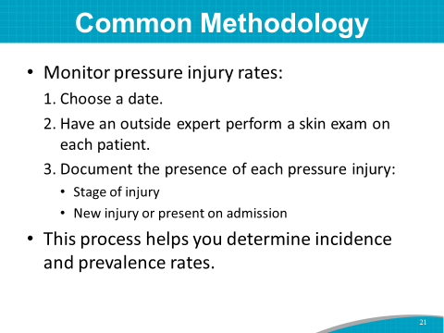 | SAY: One common way to monitor injury rates is the following:  - Pick a date, such as the first of the month.  - Perform a detailed skin exam on each patient. This can be done by an outside expert, such as the wound nurse or nurse manager from another unit.  - For each pressure injury present, describe the stage and determine whether the injury was present on admission.  This approach allows the determination of both incidence and prevalence rates.
Slide 22  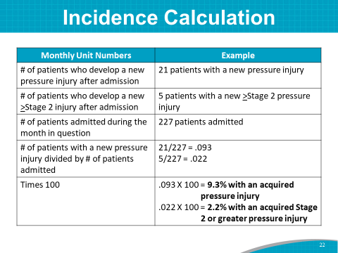 | SAY: Incidence is the number of patients who develop new pressure injuries after being admitted. When calculating incidence rates for a given period, use the following method:  - Count the number of patients who developed a pressure injury (of any stage) after being admitted to your unit.  - Count the number of patients who developed a Stage 2 or greater pressure injury after being admitted to your unit.  - Count the number of patients who were admitted to your unit during that period.  - Divide the number of patients with a new pressure injury (of any stage) by the total number of patients admitted.  - Divide the number of patients with a new Stage 2 or greater pressure injury by the total number of patients admitted.  - Multiply by 100 to get the percentage of both total patients with pressure injuries and those with Stage 2 or greater.
Slide 23  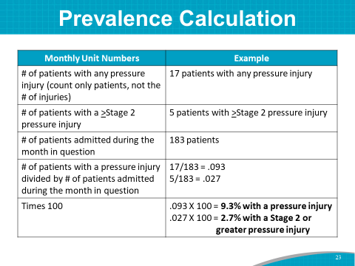 | SAY: Prevalence is the number of patients with pressure injuries. When calculating prevalence rates at a certain point or period of time, use the following method:  - Count the number of patients with a pressure injury (of any stage) on your unit.  - Count the number of patients with a Stage 2 or greater pressure injury on your unit.  - Count the number of patients on your unit.  - Divide the number of patients with a pressure injury (of any stage) by the total number of patients on your unit.  - Divide the number of patients with a Stage 2 or greater pressure injury by the total number of patients on your unit.  - Multiply by 100 to get the percentage of both total patients with pressure injuries and those with Stage 2 or greater.
Slide 24  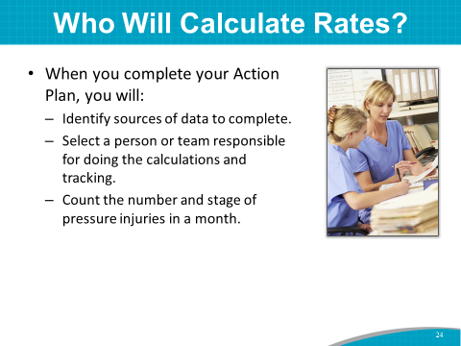 | SAY: When we address the Measurement Action Plan at the end of this module, you will identify a person or a team to be responsible for identifying sources of data to collect, as well as doing these calculations and tracking them over time.  The person or team responsible for putting together a plan for tracking pressure injuries in the hospital will also want to document Stage 2 and greater pressure injuries.  ASK: Who do you think would be the most logical person or team to calculate pressure injury incidence and prevalence rates in this hospital?  DO: Write the Team’s responses on the flip chart.
Slide 25  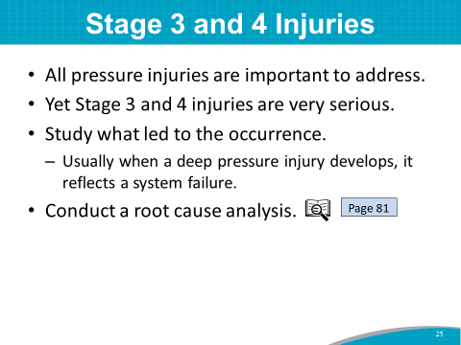 | SAY: All pressure injuries are important to address, but hospital-acquired Stage 3 and 4 injuries are very serious.  Most importantly, a hospital should study in detail what led to the occurrence of each Stage 2 or greater pressure injury.  When a deep pressure injury develops, it usually reflects a system failure—meaning the pressure injury prevention plan was not implemented or followed—and not so much the failure of an individual health professional.  Conducting a root cause analysis is a useful technique for understanding reasons for a failure in the system.  ASK: Has anyone here ever used root cause analysis to study why something happened and determine possible ways to improve care?
Slide 26  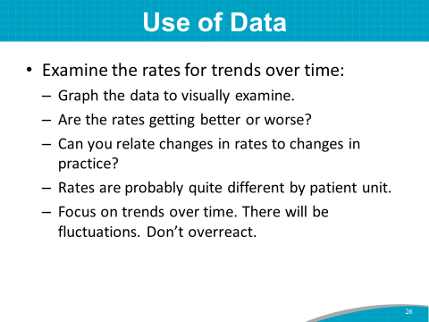 | SAY: Obtaining monthly data on pressure injuries can be very useful.  First, examine your rates every month and look at the trends over time. How are they changing? Are they improving or getting worse?  Can you relate changes in pressure injury rates, including the rates of types of pressure injuries, to changes in practice?  Pressure injury rates may change based on the season or month of the year. For example, winter months may have more pressure injuries. Rates may also vary by unit. For example, a Geriatric Psychiatry Unit may have more than an Intensive Care Unit (ICU).  Focus on the underlying trend of the data over time. There will be fluctuations. Don’t overreact to any individual month’s data.  The purpose of measurement is to show what needs to be improved. Measurement is critical in today’s health climate.
Slide 27  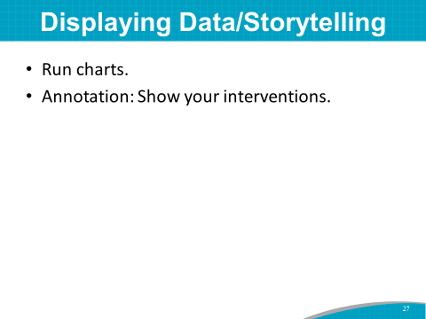 | SAY: Data are more than just numbers. For instance, they can show you if your program is improving.  One way to display data in a way that tells a story is using run charts and annotated run charts.  A run chart is a line graph of data plotted over time.  By collecting and charting data over time, you can find trends or patterns in the process.  The next 3 slides show examples of how data can be displayed as an annotated run chart to show the impact of prevention strategies during the QI change process.
Slide 28  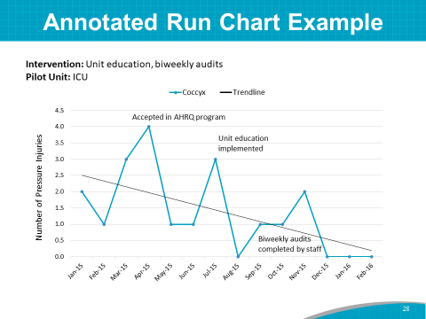 | SAY: This is a simple annotated run chart tracking the actual number of hospital-acquired pressure injuries (red line) in an ICU pilot unit over a 13-month timeframe.  The hospital launched a Pressure Injury Prevention Program using the AHRQ Toolkit in April 2015. A pressure injury educational program began in July. In November, staff began a biweekly audit of intervention performance measures.  This run chart shows that the actual number of HAPIs decreased in response to the implementation of prevention strategies.  Annotated run charts can help you:  - Look for trends and variation.  - See if a process is changing, as in response to a QI initiative.  - See if results are sustained over time.  - Track the implementation of an intervention.  An annotated run chart shows your interventions in relation to the data.
Slide 29  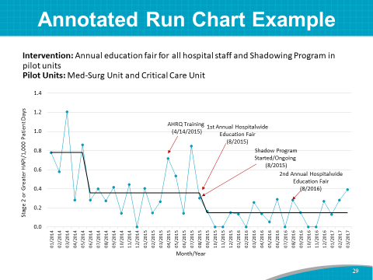 | SAY: This is another example of a simple annotated run chart tracking the HAPIs (blue line) in two pilot units—Medical-Surgical and Critical Care.  The hospital implemented a hospitalwide education fair and a shadowing program. The shadowing intervention included requiring two RNs to sign off on skin assessments and staging of wounds.  As shown here, hospitalwide HAPIs fell approximately 60 percent. On the pilot units (not shown here), HAPIs went down 90 percent.
Slide 30  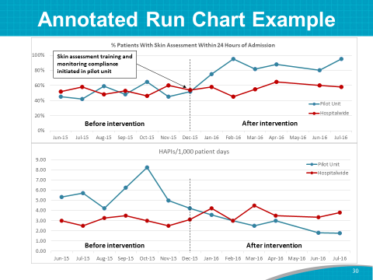 | SAY: This is a more sophisticated example of an annotated run chart.  The top portion of the chart depicts the percentage of patients with a skin assessment within 24 hours of admission on the pilot unit—before and after the intervention. The percentage of patients with a skin assessment within 24 hours of admission increased on the intervention pilot unit and stayed flat hospitalwide.  The bottom portion of the chart shows a decrease in HAPIs per 1,000 patient days in the intervention pilot unit and a slight increase hospitalwide in the same timeframe. Note that the pilot unit started out with a higher HAPI rate than the rest of the hospital.  This run chart helps us understand the impact of the intervention by providing data before and after the intervention.  In this case, the prevention strategy is making an impact on pressure injury rates.
Slide 31  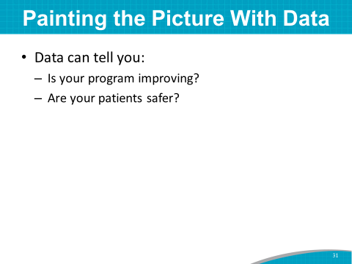 | SAY: Use data to paint a picture. Is your program improving because of your QI initiative? Are your patients safer?  When you plot your pressure injury data over time, especially in an annotated run chart, you can see how the pressure injury rates change in response to implementing prevention strategies.  The staff who are doing the data collection and analysis may want to view the following webinar for more information:  Measurement — AHRQ Pressure Injury Prevention Program Implementation Sharing Webinar
Slide 32  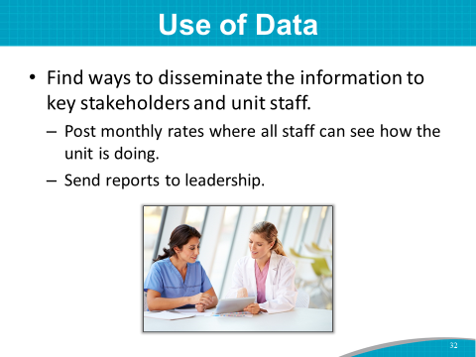 | SAY: You will want to disseminate your data on HAPIs to key stakeholders and unit staff. Use run charts and annotated run charts to visually tell the story of your prevention program efforts.  Post monthly rates in places where all staff can see how the unit is doing.  Send reports to leadership.  Sharing information on performance is critical to your quality improvement effort.  ASK: How do you currently share your pressure injury data? Are you reaching everyone who should know about your rates?
Slide 33  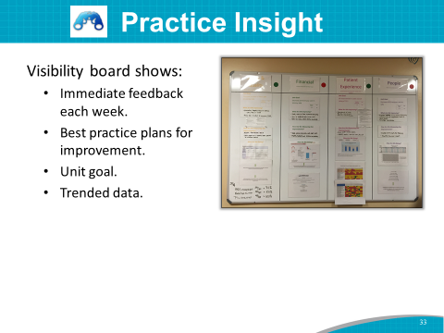 | Practice Insight  SAY: One data-driven hospital used the Lean model for quality improvement.  Unit staff complained that they were not getting data in a timely manner, and therefore would lose interest. They also were not aware of what the interventions were and what actions were being worked on. They heard about the interventions at huddles, but there was nothing they could see or hold on to as a reminder. This led to a lot of inconsistency and noncompliance.  The Implementation Team developed a visual management board—or visibility board—that targets four key themes:  - People  - Patient experience  - Financial information  - Safety and quality  Pressure injuries fall under safety and quality, in the far left column.  The visibility board requires specific information, such as what the unit goal is, what the unit is trying to improve, how to do it, how to measure it, and what the results have been. The staff now receive immediate feedback each week on how well they are doing with prevention.  A visibility board is posted on each nursing unit. It shows trended data specific to the unit for the quality indicators measured and monitored. Executive leaders visit the units and discuss results with staff.
Slide 34  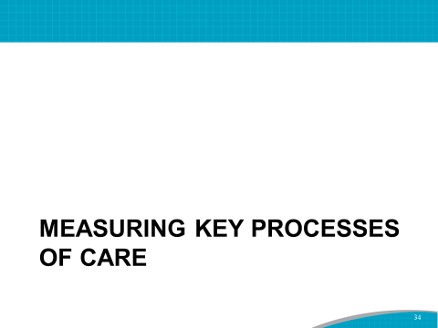 | SAY: Measuring key processes of care aims to find out if the prevention practices you put in place are being done.
Slide 35  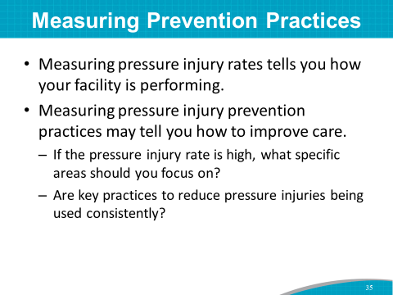 | SAY: Why measure pressure injury prevention practices?  Measuring pressure injury rates is the test of how this hospital or unit is performing, but pressure injury rates are limited in that they do not tell you how to improve care.  For example, if your pressure injury rate is high, what specific areas should you focus your energies on?  To know where to focus improvement efforts, it is important to measure whether key practices to reduce pressure injuries are being done consistently.
Slide 36  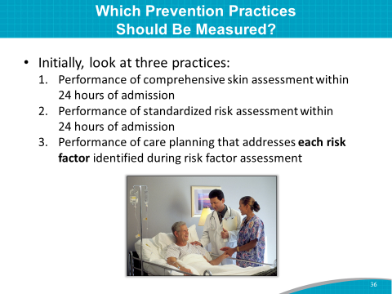 | SAY: There are many pressure injury prevention practices you can measure.  Here are three practices to look at initially:  - Accurate performance of comprehensive skin assessment within 24 hours of admission  - Accurate performance of standardized risk assessment within 24 hours of admission  - Performance of care planning that addresses each risk factor identified during risk factor assessment
Slide 37  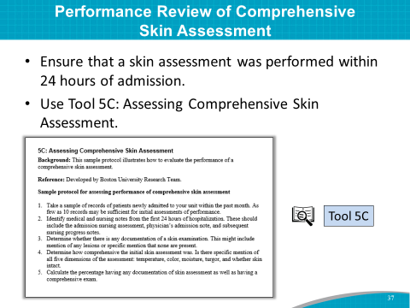 | SAY: As the first step in prevention, it is essential to ensure that a comprehensive skin assessment is performed within 24 hours of admission.  While you can also use data from your EHR to assess what percentage of patients had a skin assessment completed within the first 24 hours, a review of a sample of records will allow an assessment of the quality and completeness of the skin assessment.  Consider using Tool 5C: Assessing Comprehensive Skin Assessment.
Slide 38  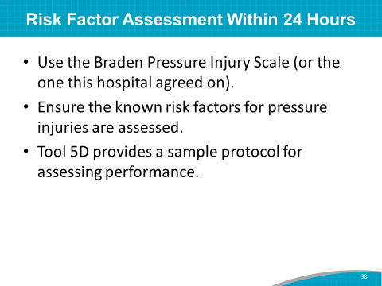 | SAY: Risk assessment is the cornerstone of prevention. It identifies whether patients are at risk and what specific interventions need to be implemented. Ensure that a standardized risk assessment was performed within 24 hours of admission.  You will use the (name of scale the hospital will use, such as Braden) scale.  Look at the sample protocol for evaluating the performance of pressure injury risk factor assessment in Tool 5D.
Slide 39  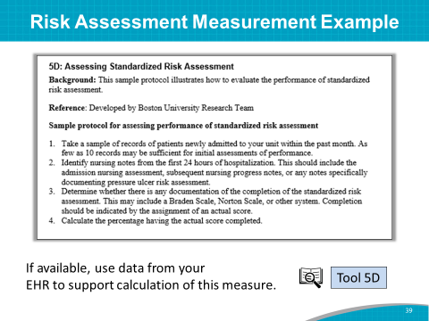 | SAY: This sample protocol illustrates how to evaluate the performance of standardized risk assessment.  To use this protocol:  - Review the records of a random sample of newly-admitted patients.  - Identify the records that show a standardized risk assessment was completed.  - Calculate the percentage of patients who have a completed risk score.  You may be able to pull these data from your EHR. Nearly all patients should have a risk assessment conducted within the first 24 hours; if you find it’s less than that (e.g., 93%), there is opportunity for improvement.
Slide 40  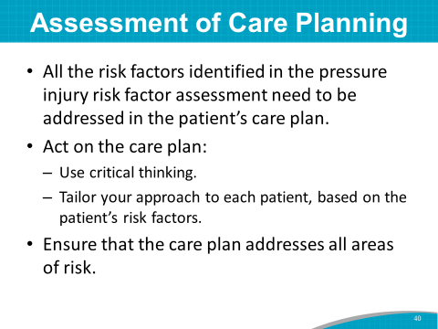 | SAY: For a risk factor assessment to make a difference, all the risk factors identified in the assessment need to be addressed in the patient’s care plan.  And the care plan needs to be acted on. This requires critical thinking on the part of staff and a tailored approach to each patient based on the individual patient’s risk factors.  Ensure that the care plan addresses all areas of risk.
Slide 41  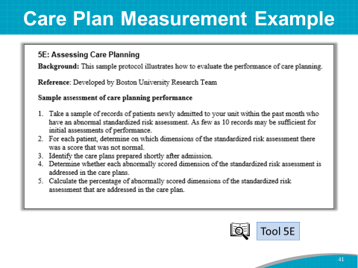 | SAY: This sample protocol illustrates how to evaluate the performance of care planning.  To use this protocol:  - Take a sample of patients newly admitted within the past month who have an abnormal standardized risk assessment.  - Identify the care plans prepared shortly after admission.  - Determine whether each abnormally scored dimension of the standardized risk assessment is addressed in the care plans.  - Calculate the percentage of care plans that address all areas of risk.
Slide 42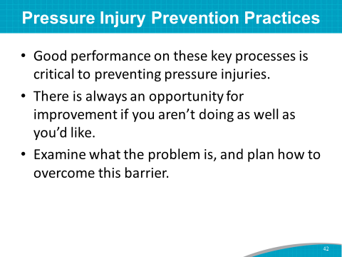 | SAY: What if you are not doing well on your measures of pressure injury prevention practices?  Good performance on these key processes of care is critical to preventing pressure injuries.  If you are not doing well in one of these key areas, there is an opportunity for improvement.  Examine what the problem is, and plan how to overcome this barrier.
Slide 43  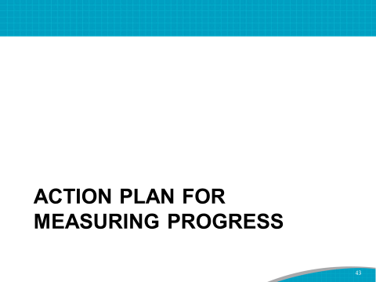 | SAY: Let’s pull it all together with an Action Plan for measuring progress.
Slide 44  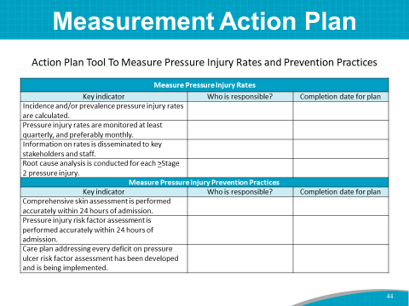 | SAY: Please take out the Action Plan Tool To Measure Pressure Injury Rates and Prevention Practices.  DO: Ask the Implementation Team Leader or designee to lead this activity. Have him/her go through each of the key indicators on the tool. With the help of the Team, he/she should fill in the responsible person or group, and the expected date of completion.
Slide 45  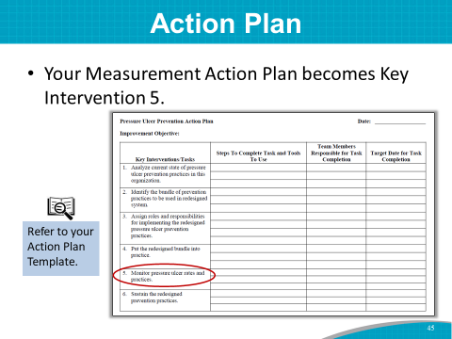 | SAY: Now that we have a preliminary Pressure Injury Measurement Action Plan, let’s end this module by folding this information into Key Intervention 5 for the overall Pressure Injury Prevention Program Action Plan.
Slide 46  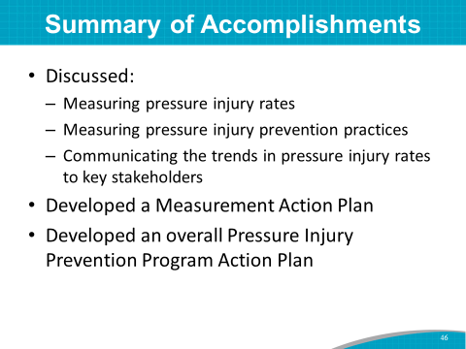 | SAY: To summarize, in this module, we discussed the following:  - How to measure and track pressure injury rates  - How to measure and track pressure injury prevention practices  - How to communicate the trends in pressure injury rates to key stakeholders  In addition:  - You developed an Action Plan to collect and measure pressure injury rates and prevention practices.  - You added to the overall Pressure Injury Prevention Program Action Plan.
Slide 47  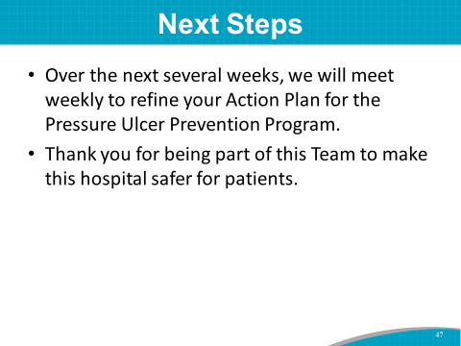 | SAY: Today, you made great progress in beginning to develop an implementation plan for pressure injury prevention in this hospital.  Your draft Action Plan covers the key interventions you plan to use, who is responsible for the plans, and when they will be completed. This is your launching pad for your program.  Over the next several weeks, we will meet weekly for focused discussions on:  - Compiling opportunities for improvement identified throughout the training.  - Prioritizing these opportunities for improvement.  - Developing and refining an Action Plan.  Thank you for your participation on the Pressure Injury Prevention Implementation Team and your efforts to make this hospital safer for patients.

Action Plan Tool To Measure Pressure Injury Rates and Prevention Practices
Measure Pressure Injury Rates
Key indicator | Who is responsible? | Completion date for plan
Incidence and/or prevalence pressure injury rates are calculated.
Pressure injury rates are monitored at least quarterly, preferably monthly.
Information on rates is disseminated to key stakeholders and staff.
Root cause analysis is conducted for each >Stage 2 pressure injury.
Measure Pressure Injury Prevention Practices
Key indicator | Who is responsible? | Completion date for plan
Comprehensive skin assessment is performed accurately within 24 hours of admission.
Pressure injury risk factor assessment is performed accurately within 24 hours of admission.
Care plan addressing every deficit on pressure injury risk factor assessment has been developed and is being implemented.

