AHRQ’s Safety Program for Nursing Homes: On-Time Pressure Ulcer Healing

Facilitator Training Instructor Guide

Slide 1: Introduction to Pressure Ulcer Healing Reports
SAY:

In this session we will introduce you to the pressure ulcer healing electronic reports.

Slide 2: Pressure Ulcer Healing Electronic Reports
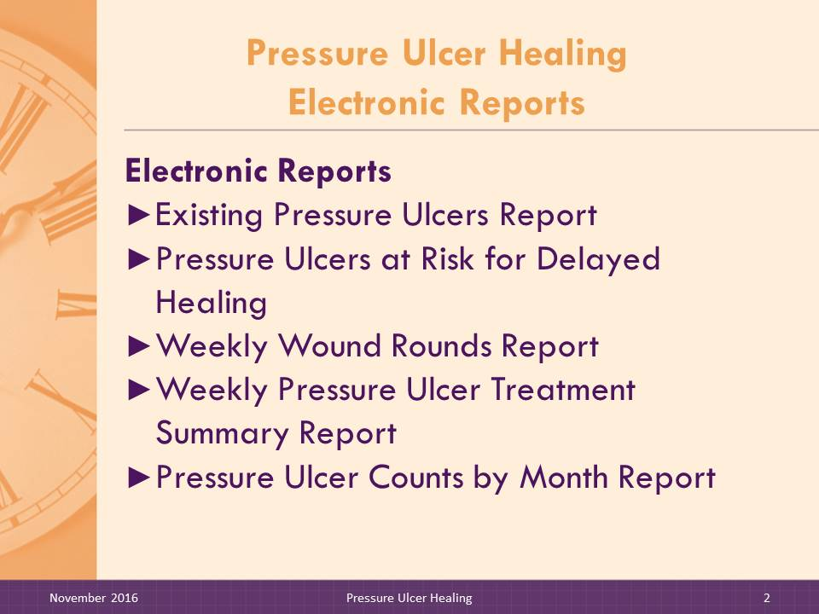
SAY:

This section will cover each component of Pressure Ulcer Healing, which includes the following electronic reports. The electronic reports are:
- Existing Pressure Ulcers Report
- Pressure Ulcers at Risk for Delayed Healing
- Weekly Wound Rounds Report
- Weekly Pressure Ulcer Treatment Summary Report
- Pressure Ulcer Counts by Month Report

Slide 3: Teaching the Pressure Ulcer Healing Electronic Reports
This training will provide you with the information you need to teach the reports to the nursing home change team. The training will follow a similar approach to how you should present the reports to the nursing home team. We will:
- Step 1: Review the purpose of the report.
- Step 2: Describe the content of the report.
- Step 3: Discuss the calculation details.
The Facilitator needs to understand the sources of the data in each report, criteria for inclusion of residents in each report, and calculations that create the elements in the report: the column headings and cell content. With this knowledge, the Facilitator can answer questions that may arise about the content and accuracy of the reports.
Nursing home staff need to master enough details about the report to see the value of the reports, judge the accuracy of the reports, and use them to help make care plan decisions.
- Step 4: Use quizzes and exercises that are provided for each report to test participants’ understanding.

DO:

Use additional quiz questions and exercises provided as a handout to further test understanding of calculation details, if needed.

Slide 4: Pressure Ulcer Assessment title slide

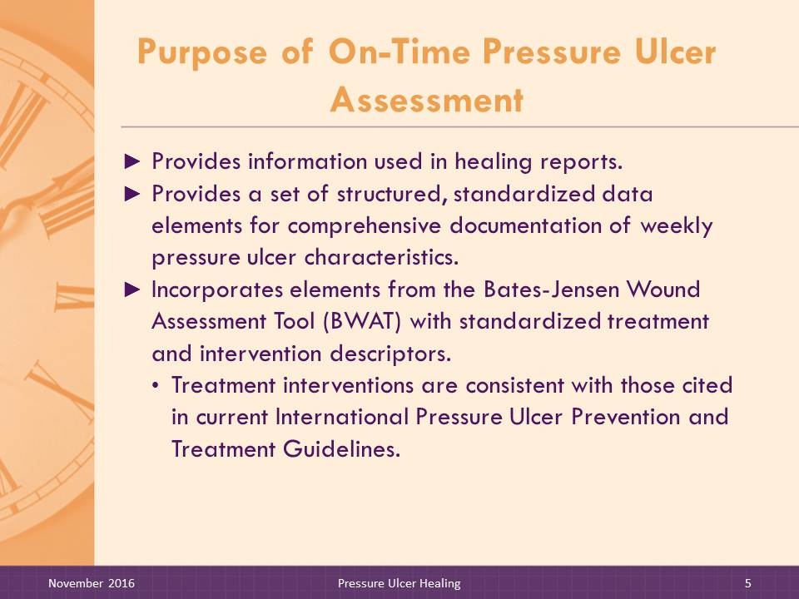
Slide 5: Purpose of On-Time Pressure Ulcer Assessment
SAY:

The On-Time Pressure Healing Reports use information recorded in the On-Time Pressure Ulcer Assessment. The assessment provides a set of structured, standardized data elements for comprehensive documentation of weekly pressure ulcer characteristics. The assessment also includes treatment and intervention information. It incorporates elements from the Bates-Jensen Wound Assessment Tool (BWAT) with additional standardized treatment and intervention descriptors. A copy of the On-Time Pressure Ulcer Assessment is included in the packet of handouts that accompany this training.
The On-Time Pressure Ulcer Assessment was developed by a multistate multidisciplinary design team that consisted of wound nurses, nurse leaders, and consultants from standalone nursing homes, large nursing home chains, and wound centers. The data elements contained on the On-Time Pressure Ulcer Assessment populate the reports. Thus, to take advantage of the full benefit of the On-Time reports, including rules to determine risk for slow healing, staff must record all data elements.

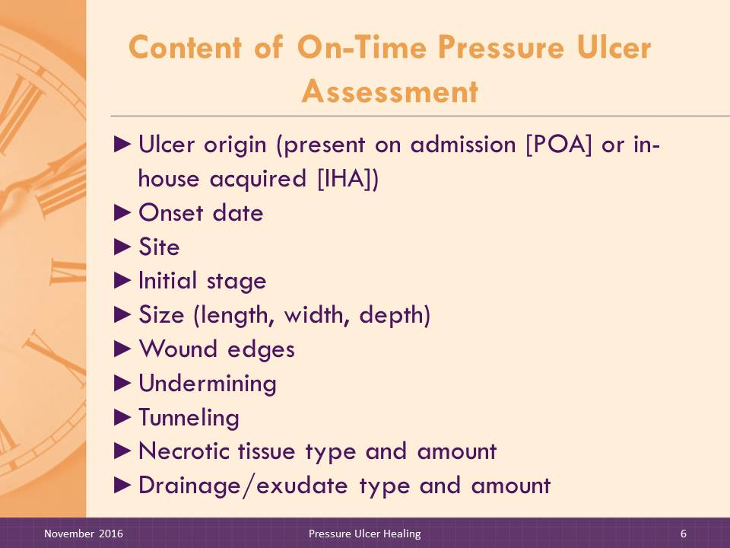
Slides 6–12: Content of On-Time Pressure Ulcer Assessment
SAY:
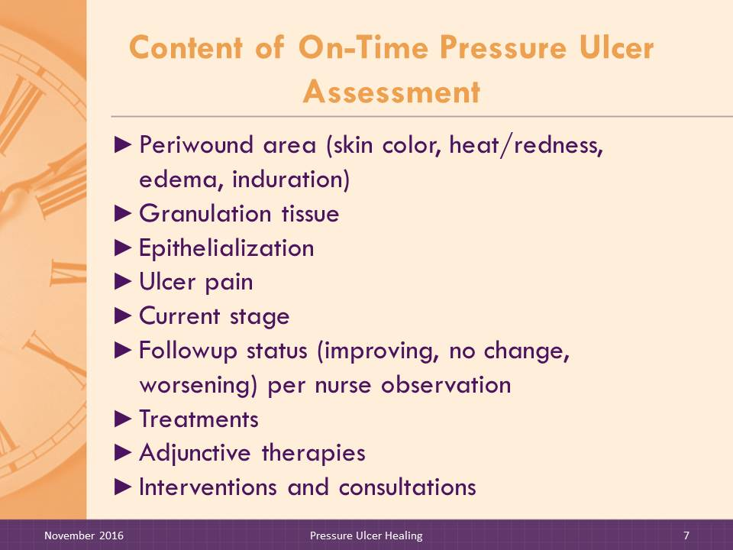
The On-Time Pressure Ulcer Assessment includes information on the following:
- Origin (in-house acquired [IHA], present on admission [POA])
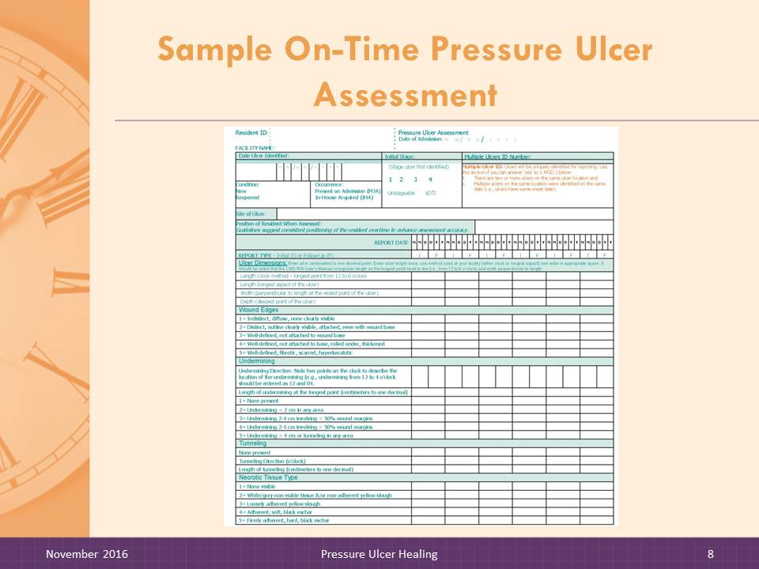
- Onset date
- Site
- Initial stage
- Size (length, width, and depth)
- Wound edges
- Undermining
- Tunneling
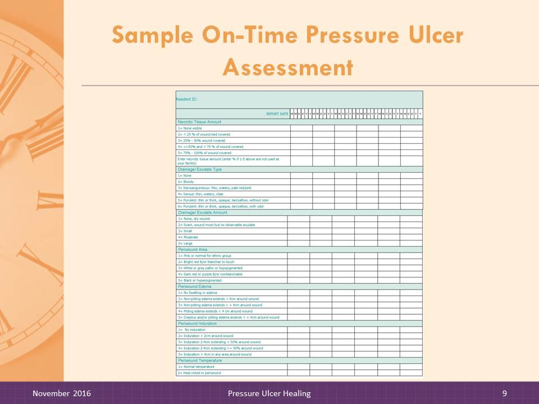
- Necrotic tissue type and amount
- Drainage/exudate type and amount
- Periwound area (skin color, heat/redness, edema, and induration)
- Granulation tissue
- Epithelialization
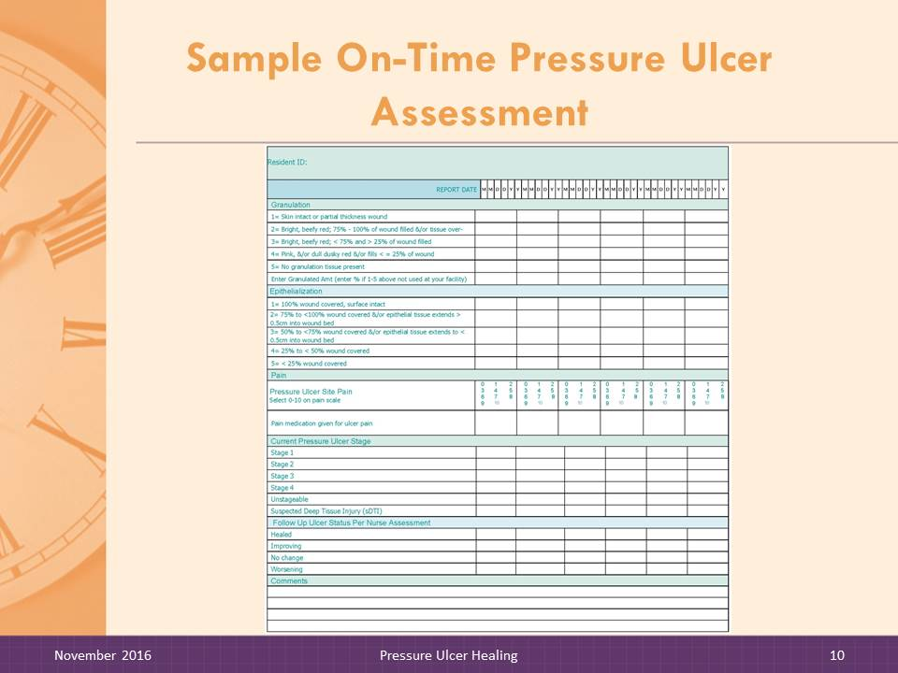
- Ulcer pain
- Current stage
- Followup ulcer status (improving, no change, worsening) per nurse observation
- Treatments
- Adjunctive therapies
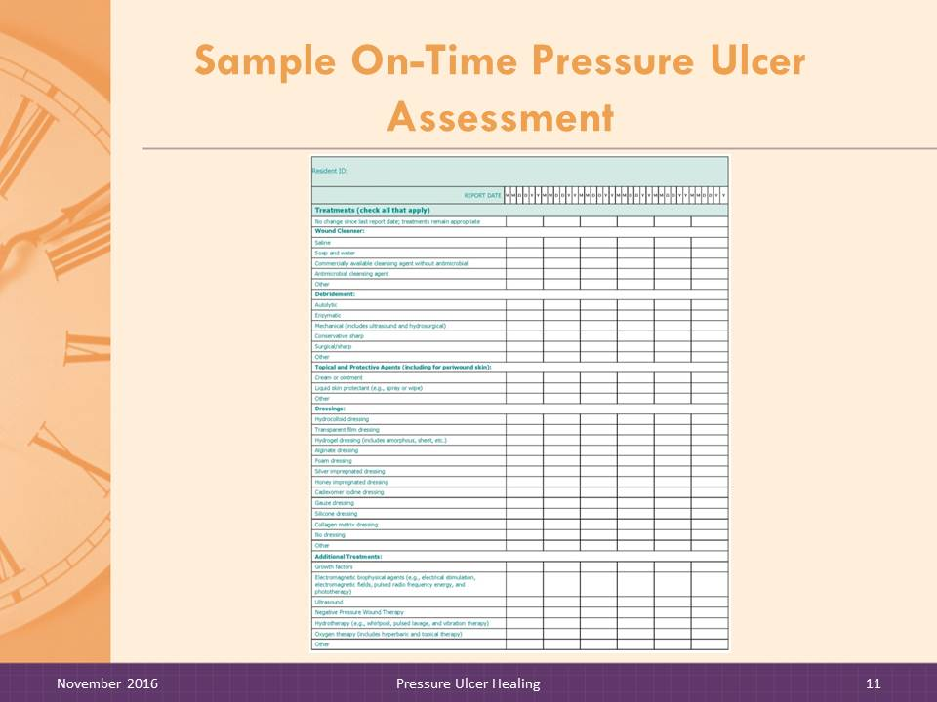
- Interventions and consultations

DO:

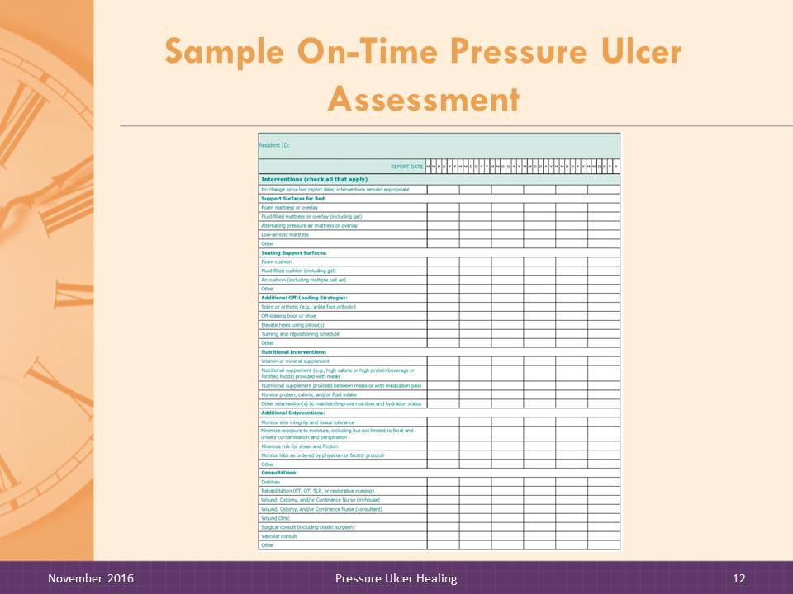
Instruct trainees to look at the Pressure Ulcer Assessment handout. Review the assessment contents and point out special features.

Slide 13: Existing Pressure Ulcers Report title slide
SAY:

Now let’s begin going over each report.

Slide 14: Existing Pressure Ulcers Report
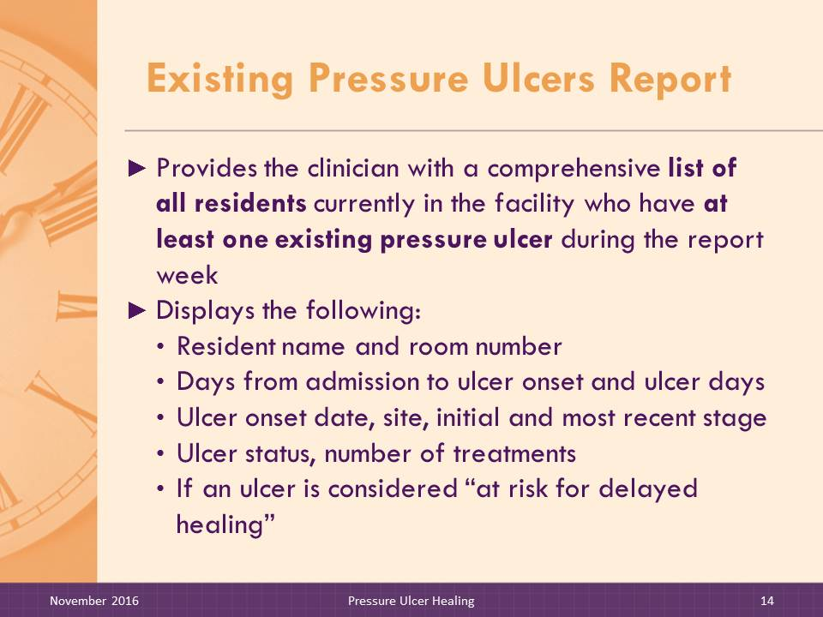
SAY:

The Existing Pressure Ulcers Report provides the clinician with a comprehensive list of all residents currently in the facility with at least one existing pressure ulcer during the report week. All ulcers being treated when the report is generated will display. For residents with more than one pressure ulcer, each pressure ulcer will be displayed separately.
Clinicians can use this report to track all residents in the facility with pressure ulcers. This report is also useful for administrators and other management staff who want at-a-glance information about the number of residents with pressure ulcers on specific nursing units or the facility at large and a limited set of ulcer details, such as ulcer age and whether the ulcer is improving or at risk for delayed healing.
The report is not intended to be used as a standalone report to support clinical decisionmaking and care planning regarding pressure ulcer treatment options and interventions and therefore does not display a wide array of ulcer details.
The Existing Pressure Ulcers Report displays weekly resident-level information. For each ulcer, the following information is displayed:
- Days from admission to ulcer onset;
- Ulcer onset date;
- Ulcer site;
- Ulcer days;
- Initial ulcer stage;
- Ulcer origin (POA, IHA);
- Most recent ulcer stage;
- Ulcer status (no change, improving, worsening);
- Number of treatment changes; and
- At risk for delayed healing.

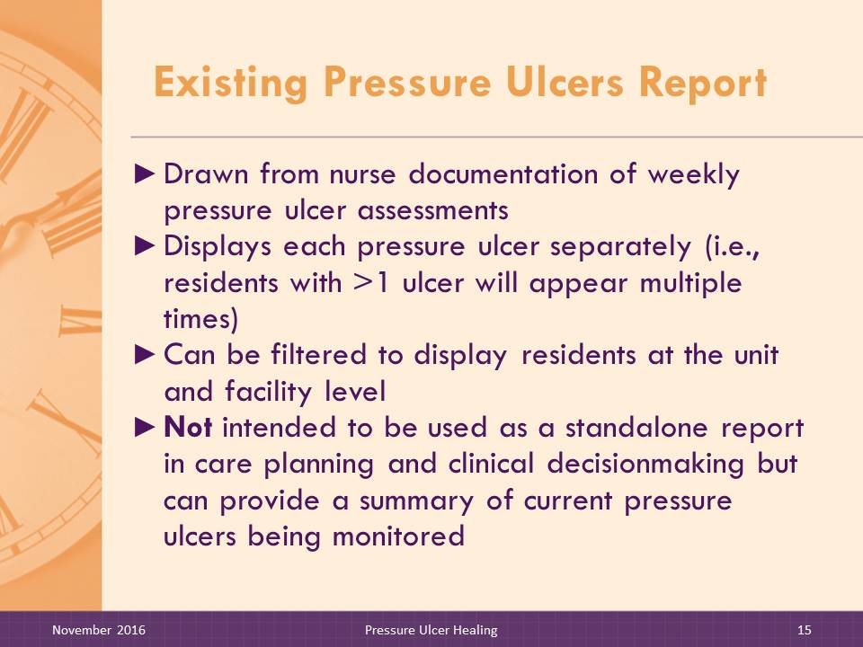
Slide 15–16: Existing Pressure Ulcers Report
SAY:

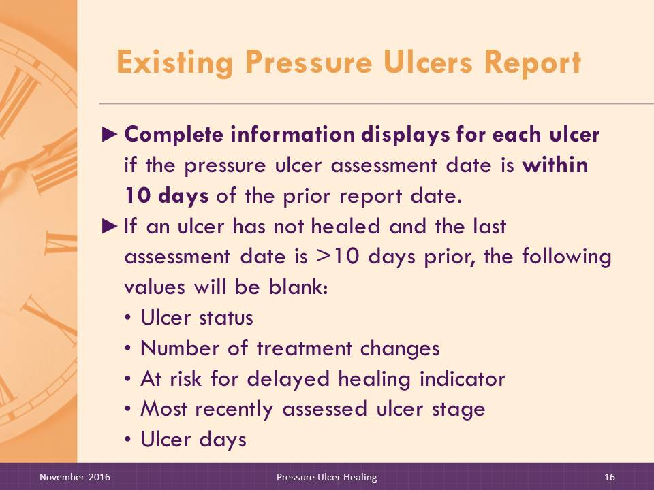
This report can be filtered to display a single nursing unit or all residents in the facility with pressure ulcers. Pressure ulcer information that displays is captured from the most recent On-Time Pressure Ulcer Assessment.
Criteria for identifying pressure ulcers at risk for delayed healing were derived from a review of current pressure ulcer treatment guidelines and discussions with clinical experts. The criteria are explained in detail in the following section, which describes the On-Time Pressure Ulcers At-Risk for Delayed Healing Report.
Complete information will display for each ulcer if the pressure ulcer assessment date is within 9 days and prior to the report date. If an ulcer is not healed and the assessment date is beyond the 9-day assessment window, the following cells will be blank: ulcer status, number of treatment changes, risk for delayed healing indicator, most recent assessed ulcer stage, and ulcer days.

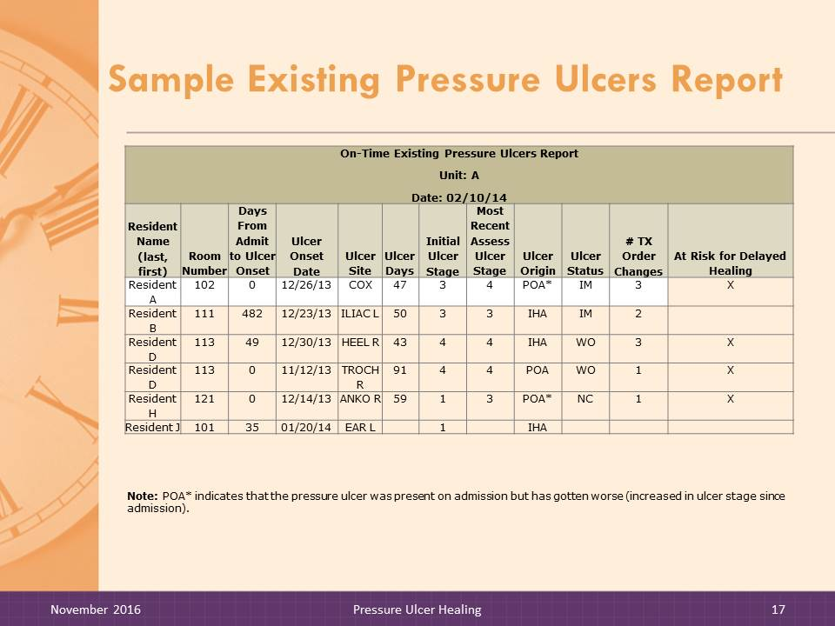
Slide 17: Sample Existing Pressure Ulcers Report
DO:

Instruct trainees to look at Existing Pressure Ulcers Report handout. Review the report contents and point out special features.
On-Time Existing Pressure Ulcers Report
Unit: A
Date: 02/10/14
Resident Name  (last, first) | Room Number | Days From Admit to Ulcer Onset | Ulcer Onset Date | Ulcer  Site | Ulcer Days | Initial Ulcer Stage | Most Recent Assess Ulcer Stage | Ulcer Origin | Ulcer Status | # TX Order Changes | At Risk for Delayed Healing
Resident A | 102 | 0 | 12/26/13 | COX | 47 | 3 | 4 | POA* | IM | 3 | X
Resident B | 111 | 482 | 12/23/13 | ILIAC L | 50 | 3 | 3 | IHA | IM | 2
Resident D | 113 | 49 | 12/30/13 | HEEL R | 43 | 4 | 4 | IHA | WO | 3 | X
Resident D | 113 | 0 | 11/12/13 | TROCH R | 91 | 4 | 4 | POA | WO | 1 | X
Resident H | 121 | 0 | 12/14/13 | ANKO R | 59 | 1 | 3 | POA* | NC | 1 | X
Resident J | 101 | 35 | 01/20/14 | EAR L |  | 1 |  | IHA
Note: POA* indicates that the pressure ulcer was present on admission but has gotten worse (increased in ulcer stage since admission).

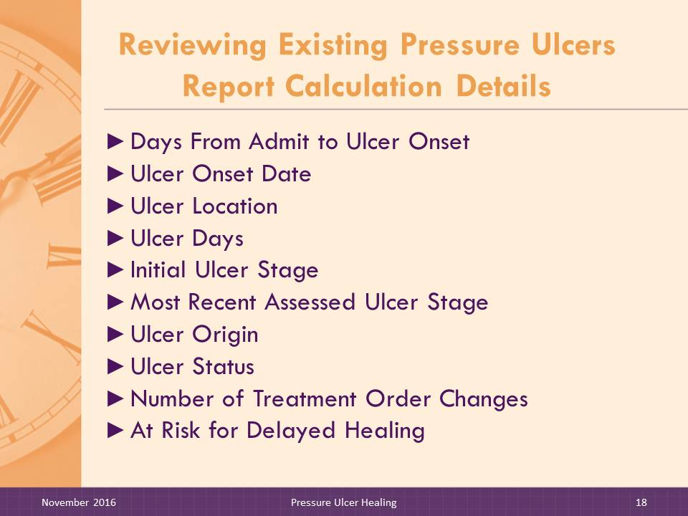
Slide 18: Reviewing Existing Pressure Ulcers Report Calculation Details
DO:

Review the calculation details with facilitator trainees.
SAY:

The On-Time software performs various calculations to display the relevant information. We will review how the different fields are determined.
Days From Admit to Ulcer Onset. This the number of days from the admission date to the date the pressure ulcer was first observed.
Ulcer Onset Date. This is the date that the pressure ulcer was first observed.
Ulcer Site. This is a code to indicate the location of the pressure ulcer on the resident’s body.
Ulcer Location Code | Ulcer Location Description
HEAD | Back of head
EAR | Ear: R/L
SCAP | Scapula: R/L
ELB | Elbow: R/L
VERTU | Vertebrae upper
VERTM | Vertebrae mid
SACR | Sacrum
COX | Coccyx
ILIAC | Iliac Crest: R/L
TROCH | Trochanter: R/L
ISCHIA | Ischial Tuberosity: R/L
THIGH | Thigh: R/L
KNEE | Knee: R/L
LLEG | Lower Leg: R/L
ANKI | Ankle, Inner: R/L
ANKO | Ankle, Outer: R/L
HEEL | Heel: R/L
TOE | Toes: R/L
OTH | Other

Ulcer Days. This is the number of days from the date of onset to the most recent pressure ulcer assessment date.
Initial Ulcer Stage. This is the stage of the pressure ulcer when it was first observed and recorded on the original pressure ulcer assessment.
Most Recent Assessed Ulcer Stage. This is the stage recorded on the most recent pressure ulcer assessment, if the assessment date is ≤9 days before the report date. If the pressure ulcer assessment date is 10 or more days before the report date, no information will display for this item. Pressure ulcers are not “reverse staged.” Thus, unless the pressure ulcer has increased in stage, the original pressure ulcer stage when first observed will be displayed.
Ulcer Origin. This is the pressure ulcer origin as recorded on the initial pressure ulcer assessment. There are two possible origins:
- POA
- IHA
Pressure ulcers that are present on admission but stage increased after the admit date are flagged as POA*.
Ulcer Status. This is the subjective overall assessment of the current status of the pressure ulcer as observed by nursing. Ulcer status will only be reported if the assessment date is ≤9 days from the report date. If the pressure ulcer assessment date is 10 or more days before the report date, no information will display for this item. Pressure ulcers may improve (IM), worsen (WO), or show no change (NC).
Number of Treatment Changes. This is the number of times the treatment orders have been changed since the pressure ulcer was first observed. Treatment changes include treatment orders and adjunctive therapies as recorded from physician orders or as recorded on the pressure ulcer assessment. This item does not include orders to discontinue a treatment or adjunctive therapy. The pressure ulcer assessment date must be ≤9 days before the report date. If the pressure ulcer assessment date is 10 or more days before the report date, no information will display for this item.
At Risk for Delayed Healing. This is a flag for pressure ulcers at risk for delayed healing due to factors that indicate a lack of expected progress toward healing. Details on criteria are provided in the discussion that follows on the Pressure Ulcers at Risk of Delayed Healing Report.

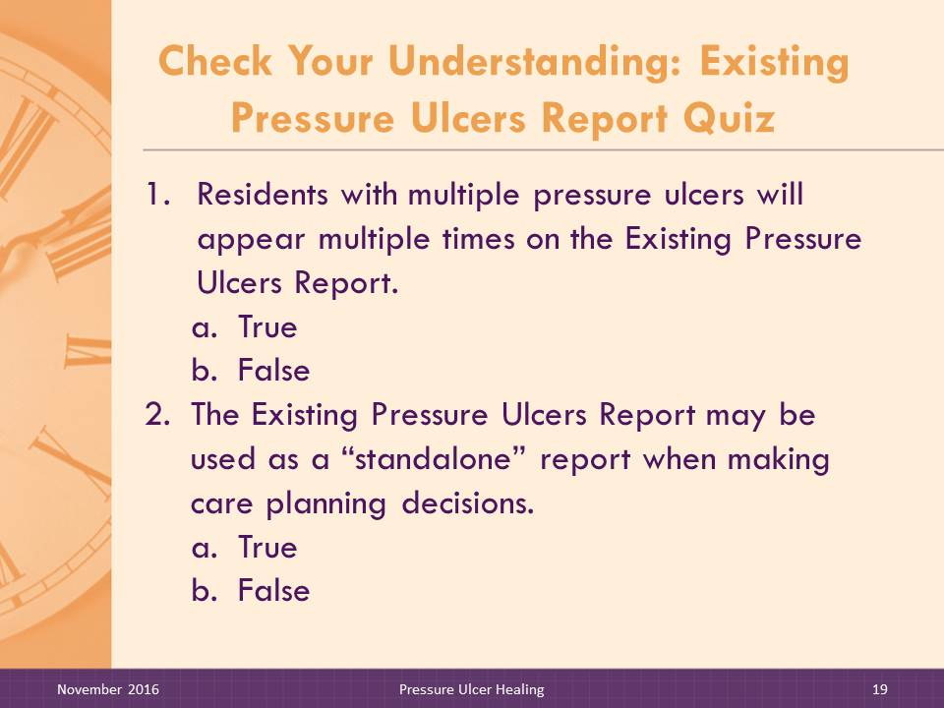
Slide 19-20: Check Your Understanding: Existing Pressure Ulcers Report Quiz
DO:

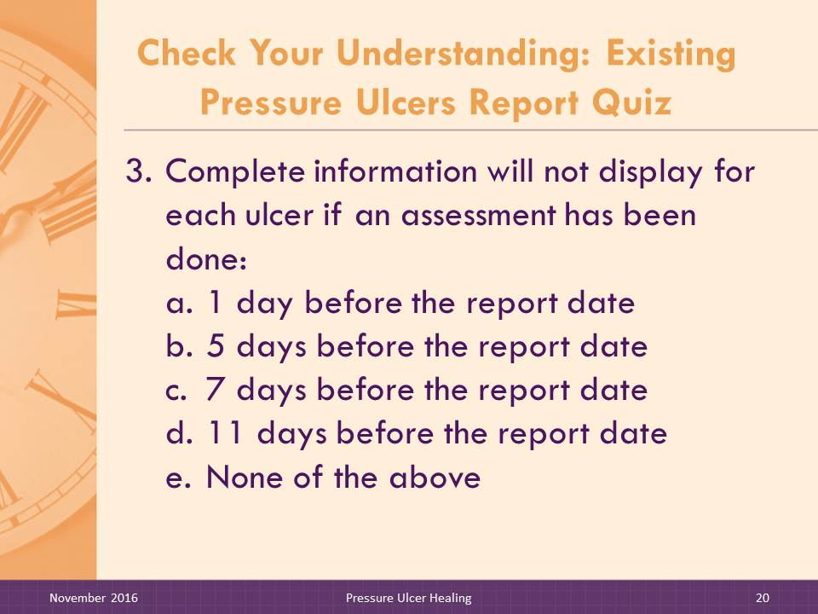
Ask participants to answer the quiz questions independently and then discuss as a group.
- Residents with multiple pressure ulcers will appear multiple times on the On-Time Existing Pressure Ulcers Report.
- True
- False
ANSWER: a
- The On-Time Existing Pressure Ulcers Report may be used as a “standalone” report when making care planning decisions.
- True
- False
ANSWER: b
- Complete information will not display for each ulcer if an assessment has been done:
- 1 day before the report date
- 5 days before the report date
- 7 days before the report date
- 11 days before the report date
- None of the above
ANSWER: d

Slide 21: Pressure Ulcers at Risk for Delayed Healing Report title slide
SAY:

Now let’s look at the next report.

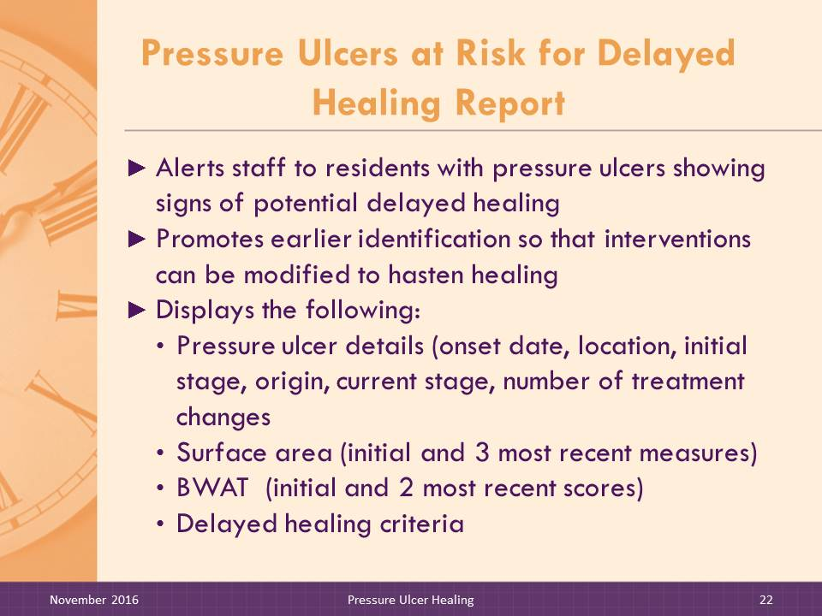
Slide 22–25: Pressure Ulcers at Risk for Delayed Healing Report
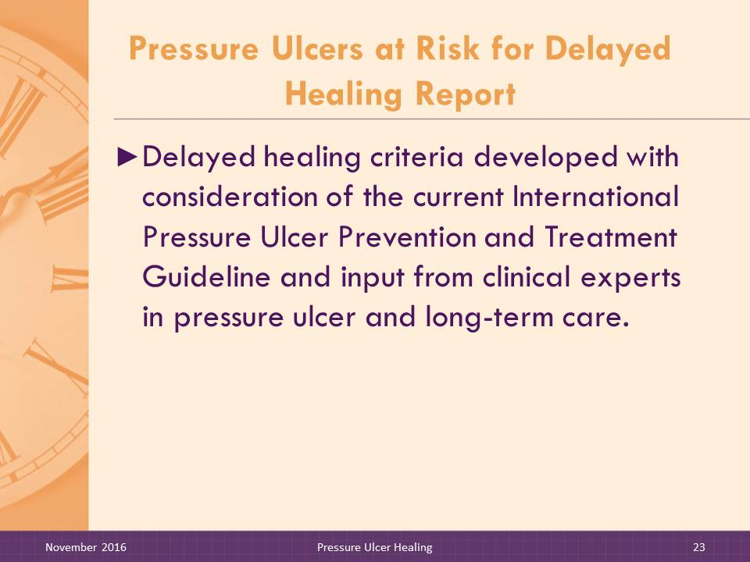
The Pressure Ulcers at Risk for Delayed Healing Report is intended to alert staff to residents with pressure ulcers showing signs of potential delayed healing. This report is helpful for nursing staff and wound care nurses to promote earlier identification of pressure ulcers not healing in a timely manner so that interventions can be modified to hasten healing. The report brings multiple data elements together in one location to enable monitoring of pressure ulcer healing progress.
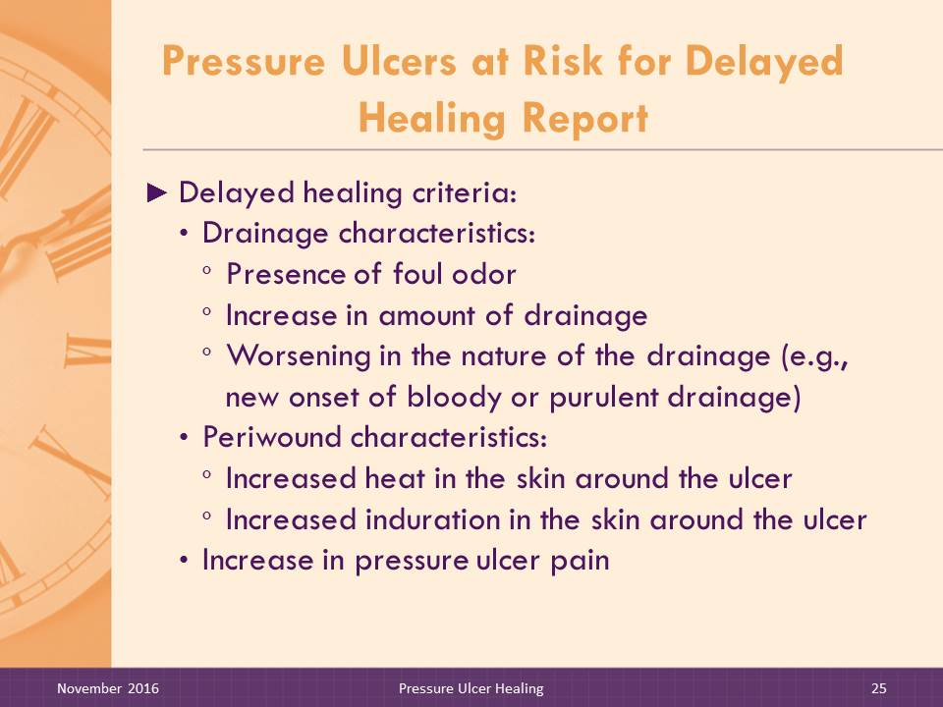
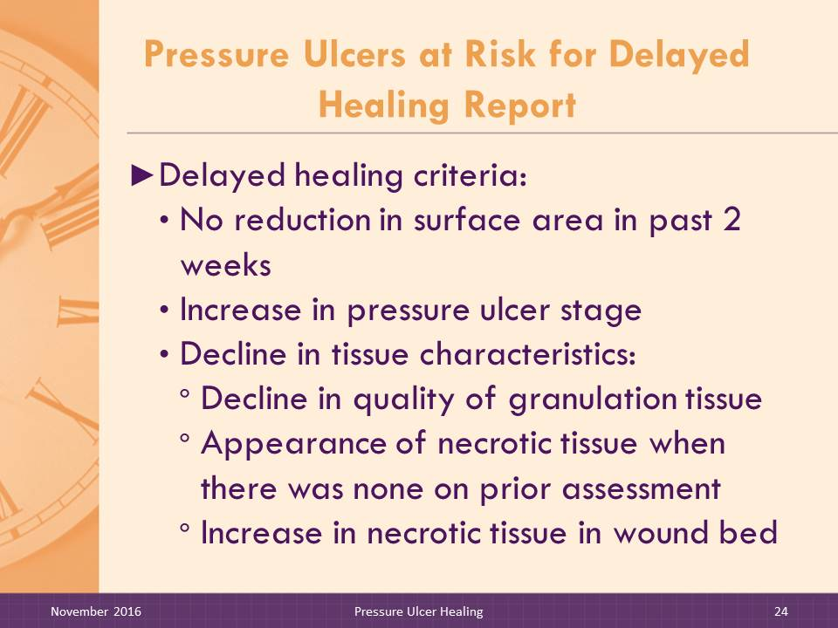
The report displays details from the On-Time Pressure Ulcer Assessment as well as the reasons the resident is at risk for delayed healing. Surface area is displayed to facilitate a standardized comparison of pressure ulcer measurements across time. The initial surface area is shown as well as the three most recent weeks’ measures. The BWAT total assessment score is included as it provides an alert to subtle changes that may be occurring, with a higher score reflecting pressure ulcers that may be worsening.
The criteria for delayed healing were derived from the 2014 International Pressure Ulcer Prevention and Treatment Guidelines and discussions with clinical experts. The criteria capture indicators of possible infection as well as delayed healing, as any sign of infection in the pressure ulcer may affect healing. Any pressure ulcer with any of the following characteristics will display on the At Risk for Delayed Healing Report.
- No reduction in surface area in the past 2 weeks
- Increase in pressure ulcer stage
- Decline in tissue characteristics, as evidenced by:
- Decline in the quality of granulation tissue
- Appearance of necrotic tissue when there was none on prior assessment
- Increase in necrotic tissue in the wound bed

- Drainage characteristics, as evidenced by
- Presence of foul odor
- Increase in the amount of drainage from the pressure ulcer
- Worsening in the nature of the drainage (e.g., new onset of bloody drainage or purulent drainage)
- Periwound characteristics, as evidenced by:
- Increased heat in the skin around the ulcer
- Increased induration in the skin around the ulcer
- Increase in pressure ulcer pain

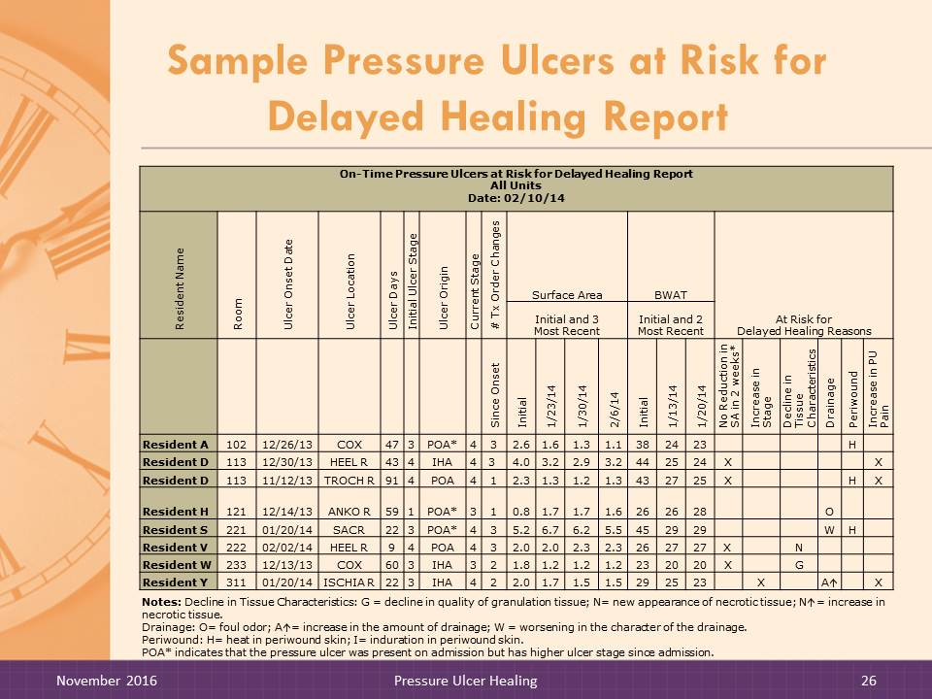
Slide 26: Sample Pressure Ulcers at Risk for Delayed Healing Report
DO:

Instruct trainees to look at Pressure Ulcers at Risk for Delayed Healing Report handout. Review the report contents and point out special features.

On-Time Pressure Ulcers at Risk for Delayed Healing Report
All Units
Date: 02/10/14
Resident Name | Room | Ulcer Onset Date | Ulcer Location | Ulcer Days | Initial Ulcer Stage | Ulcer Origin | Current Stage | # Tx Order Changes | Surface Area |  |  |  | BWAT |  |  | At Risk for  Delayed Healing Reasons
 |  |  |  |  |  |  |  |  | Initial and 3  Most Recent |  |  |  | Initial and 2  Most Recent
 |  |  |  |  |  |  |  | Since Onset | Initial | 1/23/14 | 1/30/14 | 2/6/14 | Initial | 1/13/14 | 1/20/14 | No Reduction in SA in 2 weeks* | Increase in Stage | Decline in Tissue Characteristics | Drainage | Periwound | Increase in PU Pain
Resident A | 102 | 12/26/13 | COX | 47 | 3 | POA* | 4 | 3 | 2.6 | 1.6 | 1.3 | 1.1 | 38 | 24 | 23 |  |  |  |  | H
Resident D | 113 | 12/30/13 | HEEL R | 43 | 4 | IHA | 4 | 3 | 4.0 | 3.2 | 2.9 | 3.2 | 44 | 25 | 24 | X |  |  |  |  | X
Resident D | 113 | 11/12/13 | TROCH R | 91 | 4 | POA | 4 | 1 | 2.3 | 1.3 | 1.2 | 1.3 | 43 | 27 | 25 | X |  |  |  | H | X
Resident H | 121 | 12/14/13 | ANKO R | 59 | 1 | POA* | 3 | 1 | 0.8 | 1.7 | 1.7 | 1.6 | 26 | 26 | 28 |  |  |  | O
Resident S | 221 | 01/20/14 | SACR | 22 | 3 | POA* | 4 | 3 | 5.2 | 6.7 | 6.2 | 5.5 | 45 | 29 | 29 |  |  |  | W | H
Resident V | 222 | 02/02/14 | HEEL R | 9 | 4 | POA | 4 | 3 | 2.0 | 2.0 | 2.3 | 2.3 | 26 | 27 | 27 | X |  | N
Resident W | 233 | 12/13/13 | COX | 60 | 3 | IHA | 3 | 2 | 1.8 | 1.2 | 1.2 | 1.2 | 23 | 20 | 20 | X |  | G
Resident Y | 311 | 01/20/14 | ISCHIA R | 22 | 3 | IHA | 4 | 2 | 2.0 | 1.7 | 1.5 | 1.5 | 29 | 25 | 23 |  | X |  | A |  | X
Notes: Decline in Tissue Characteristics: G = decline in quality of granulation tissue; N= new appearance of necrotic tissue; N= increase in necrotic tissue.
Drainage: O= foul odor; A= increase in the amount of drainage; W = worsening in the character of the drainage.
Periwound: H= heat in periwound skin; I= induration in periwound skin.
POA* indicates that the pressure ulcer was present on admission but has higher ulcer stage since admission.

Slide 27: Reviewing Pressure Ulcers at Risk for Delayed Healing Report Calculation Details
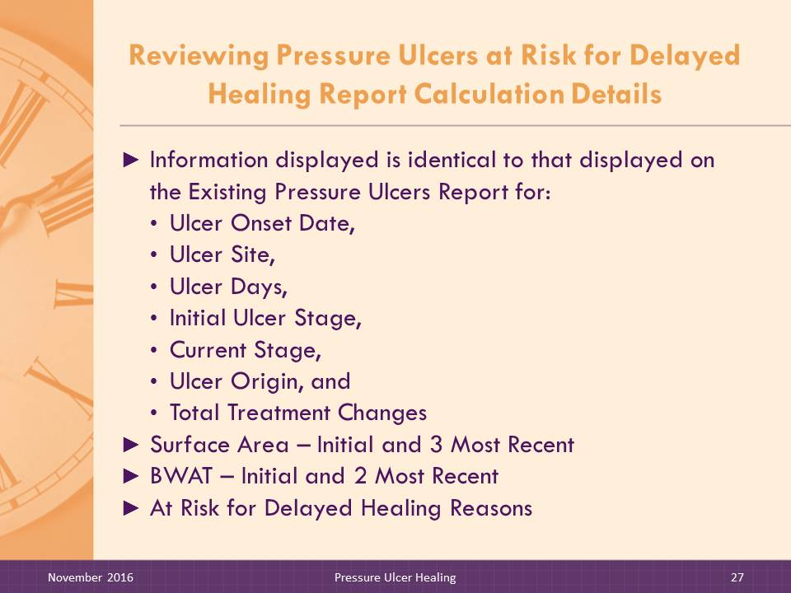
DO:

Review the calculation details with facilitator trainees.
SAY:

The On-Time software performs various calculations to display the relevant information. We will review how the different fields are determined.
Information displayed for Ulcer Onset Date, Ulcer Site, Ulcer Days, Initial Ulcer Stage, Current Stage, Ulcer Origin, and Total Treatment Changes/Last is identical to the information displayed on the Existing Pressure Ulcers Report.
Surface Area – Initial. This is the measure of the pressure ulcer’s surface area (length x width) as recorded when first observed.
Surface Area – 3 Most Recent. These are the measures of surface area in the 3 most recent weeks.
BWAT – Initial. This is the BWAT total assessment score as recorded when the pressure ulcer was first observed. If there is no BWAT score recorded in the weekly pressure ulcer assessment when the ulcer was first observed, or if the BWAT documentation is incomplete, this item will be blank.
BWAT – 2 Most Recent. This is the BWAT total assessment score as recorded for the 2 most recent weeks. If there is no BWAT score recorded in the 2 most recent weekly pressure ulcer assessments, or the BWAT documentation is incomplete, this item will be blank.

At Risk for Delayed Healing Reasons. Reasons for residents being at risk for delayed healing of pressure ulcers are grouped in five categories, which are:
- No Reduction in Surface Area in Last 2 Weeks. The surface area recorded on the most recent pressure ulcer assessment is compared to the assessment performed 2 weeks earlier. If the measures are the same or no reduction is noted, an “X” will display in this column.
- Increase in Stage. The stage of the pressure ulcer as recorded on the most recent assessment is compared to the stage as recorded on the prior assessment. If there has been an increase in the stage, an “X” will display in this column.
- Decline in Tissue Characteristics. A decline in tissue characteristics will be flagged if any of the following are noted on the most recent pressure ulcer assessment when compared to the prior assessment. Multiple symbols will display if applicable.
- If there is a decline in the quality of granulation tissue, a “G” will display;
- If there is new necrotic tissue, an “N” will display; and
- If there is an increase in the amount of necrotic tissue, an “N↑” will display.
- Drainage. The presence of or change in the characteristics of drainage from the pressure ulcer are flagged when the most recent pressure ulcer assessment is compared to the prior assessment. Multiple symbols will display, if applicable.
- If the drainage has a foul odor, an “O” will display;
- If there is an increase in the amount of drainage, an “A↑” will display; and
- If there is a worsening in the characteristics of the drainage, a “W” will display.
- Pain. If there is an increase in pressure ulcer pain as recorded on the most recent pressure ulcer assessment compared to the one prior, an “X” will display.

Slide 28–29: Check Your Understanding: Pressure Ulcers at Risk for Delayed Healing Quiz
DO:
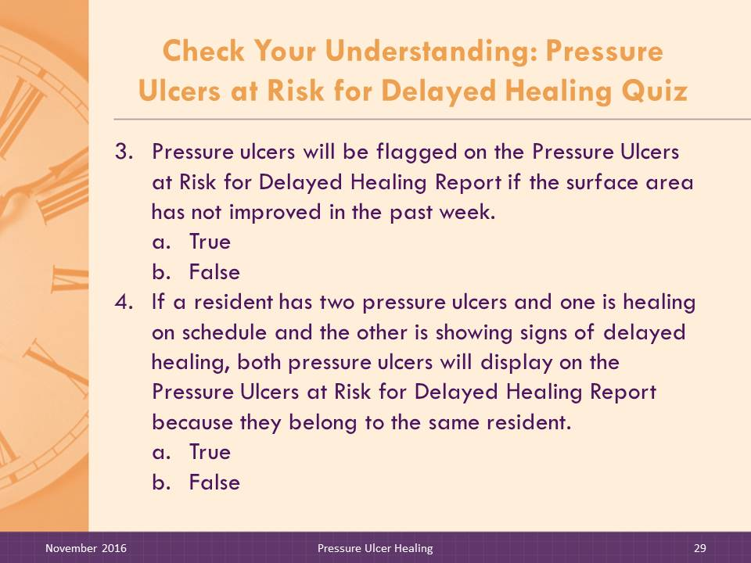
Ask participants to answer the quiz questions independently and then discuss as a group.
- Signs of delayed healing include possible infection.
- True
- False
ANSWER: a
- Most Recent Ulcer Stage, as displayed on the Existing Pressure Ulcers Report and the Pressure Ulcers at Risk for Delayed Healing Report, shows the highest stage ever recorded for a pressure ulcer.
- True
- False
ANSWER: a
- Pressure ulcers will be flagged on the Pressure Ulcers at Risk for Delayed Healing Report if the surface area has not improved in the past week.
- True
- False
ANSWER: b
- If a resident has two pressure ulcers and one is healing on schedule and the other is showing signs of delayed healing, both pressure ulcers will display on the Pressure Ulcers at Risk for Delayed Healing Report because they belong to the same resident.
- True
- False
ANSWER: b

Slide 30: Weekly Wound Rounds Report title slide
SAY:

Now let’s look at the Weekly Wound Rounds Report Self-Assessment Worksheet.

Slide 31–32: Weekly Wound Rounds Report
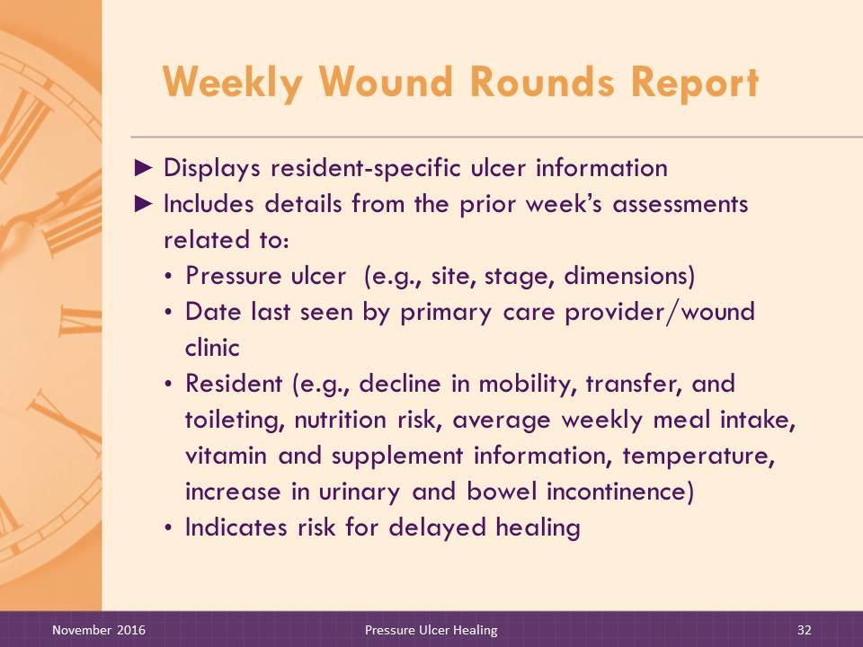
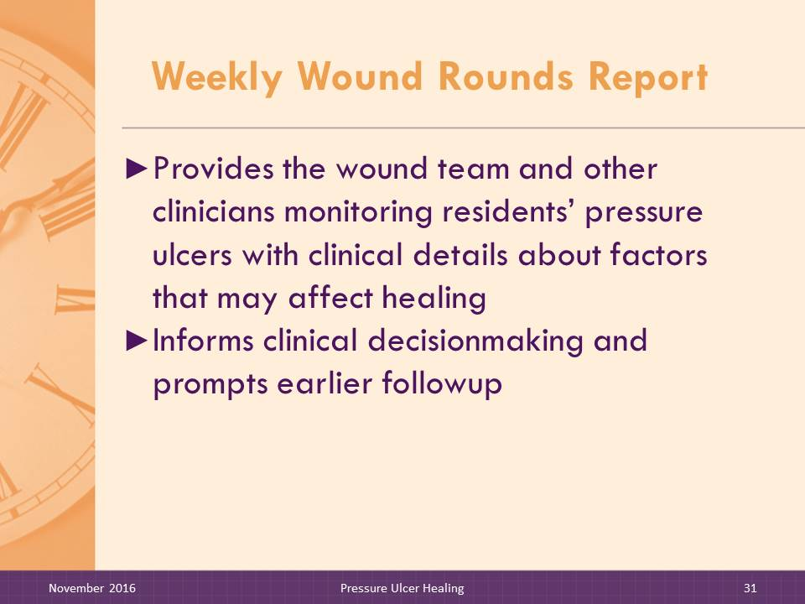
The Weekly Wound Rounds Report provides clinical details that alert staff to factors that may affect the pressure ulcer healing process. For instance, if a resident has a pressure ulcer that is not improving, as evidenced by surface area unimproved from the prior week, the clinician or wound team may note that average meal intake is low and therefore consider dietary consultation. If the report is used during wound rounds and the dietitian attends, the team can discuss this issue immediately and promptly update care plan interventions. If an ulcer appears to be worsening and an increase in urinary or bowel incontinence or a decline in functional status is noted, the team can promptly alert appropriate care teams.
Such details are available when the pressure ulcer is being assessed during wound rounds or during weekly wound review meetings with the larger multidisciplinary team. Report information aids decisionmaking and facilitates earlier followup.
The Weekly Wound Rounds Report displays resident-specific ulcer information, similar to the Existing Pressure Ulcer and Pressure Ulcers at Risk for Delayed Healing Reports. It includes details on the characteristics of the pressure ulcer (e.g., ulcer site, initial and most recent stage, length, width, and depth dimensions, change in surface area, total treatment changes, and days from admission to ulcer onset).
Additional clinical details that may affect pressure ulcer healing are also included, such as date last seen by physician, last wound clinic date, nutrition details (e.g., vitamin and supplement information with date ordered, average weekly meal intake for the report week), indicators for increase in urinary and bowel incontinence, and most recent temperature. Indicators of a decline in activities of daily living (ADLs), such as bed mobility, transfer, or toileting, captured from daily nursing assistant charting, also display. Lastly, the report provides an alert to indicate the ulcer is at risk for delayed healing.

Slide 33: Sample Weekly Wound Rounds Report
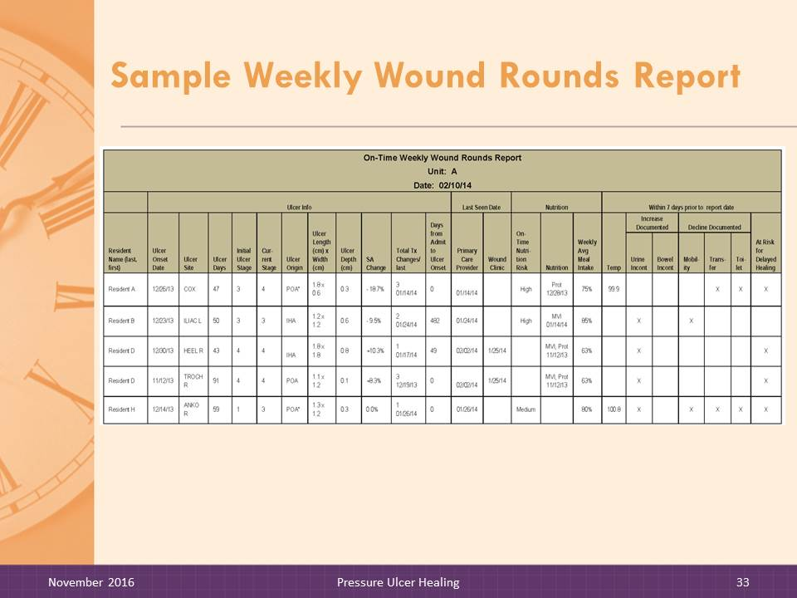
DO:

Instruct trainees to look at the Weekly Wound Rounds Report handout. Review the report contents and point out special features.

On-Time Weekly Wound Rounds Report
Unit: A
Date: 02/10/14
 | Ulcer Info |  |  |  |  |  |  |  |  |  |  | Last Seen Date |  | Nutrition |  |  | Within 7 Days Prior to Report Date
Resident Name | Ulcer Onset Date | Ulcer Site | Ulcer Days | Initial Ulcer Stage | Current Stage | Ulcer Origin | Ulcer Length (cm) x Width (cm) | Ulcer Depth (cm) | SA Change | Total Tx Changes/ Last | Days From Admit to Ulcer Onset | Primary Care Provider | Wound Clinic | On-Time Nutrition Risk | Nutrition | Weekly Avg Meal Intake | Temp | Increase Documented |  | Decline Documented |  |  | At Risk for Delayed Healing
 |  |  |  |  |  |  |  |  |  |  |  |  |  |  |  |  |  | Urine Incont | Bowel Incont | Mobility | Transfer | Toilet
Resident A | 12/26/13 | COX | 47 | 3 | 4 | POA* | 1.8 x 0.6 | 0.3 | -18.7% | 3  01/14/14 | 0 | 01/14/14 |  | High | Prot 12/28/13 | 75% | 99.9 |  |  |  | X | X | X
Resident B | 12/23/13 | ILIAC L | 50 | 3 | 3 | IHA | 1.2 x 1.2 | 0.6 | -9.5% | 2  01/24/14 | 482 | 01/24/14 |  | High | MVI 01/14/14 | 85% |  | X |  | X
Resident D | 12/30/13 | HEEL R | 43 | 4 | 4 | IHA | 1.8 x 1.8 | 0.8 | +10.3% | 3  01/17/14 | 49 | 02/02/14 | 1/25/14 |  | MVI, Prot  11/12/13 | 63% |  | X |  |  |  |  | X
Resident D | 11/12/13 | TROCH R | 91 | 4 | 4 | POA | 1.1 x 1.2 | 0.1 | +8.3% | 1  12/19/13 | 0 | 02/02/14 | 1/25/14 |  | MVI, Prot  11/12/13 | 63% |  | X |  |  |  |  | X
Resident H | 12/14/13 | ANKO R | 59 | 1 | 3 | POA* | 1.3 x 1.2 | 0.3 | 0.0% | 1  1/26/14 | 0 | 01/26/14 |  | Medium |  | 80% | 100.8 | X |  | X | X | X | X
Key: SA = surface area; MVI = multivitamin; Prot = protein.
POA* indicates that the pressure ulcer was present on admission but has gotten worse in ulcer stage since admission.

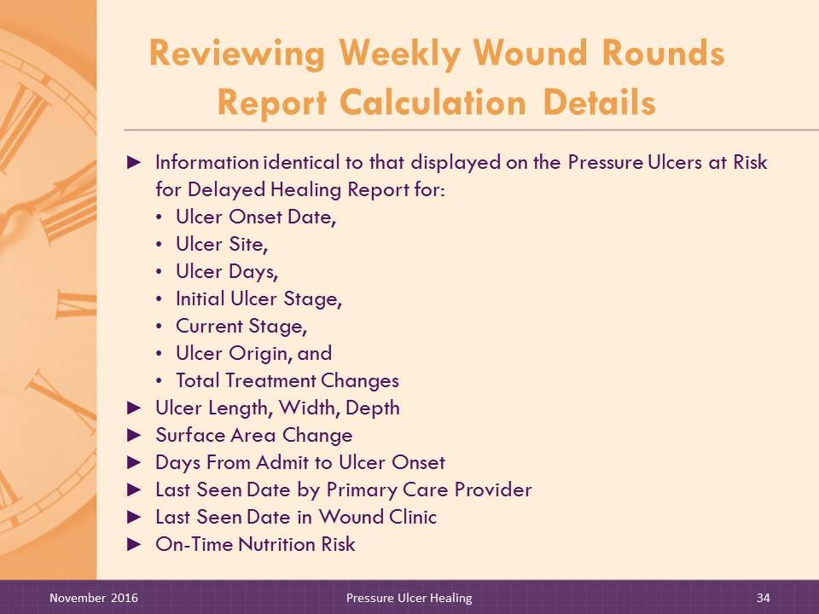
Slide 34–35: Reviewing Weekly Wound Rounds Report Calculation Details
DO:
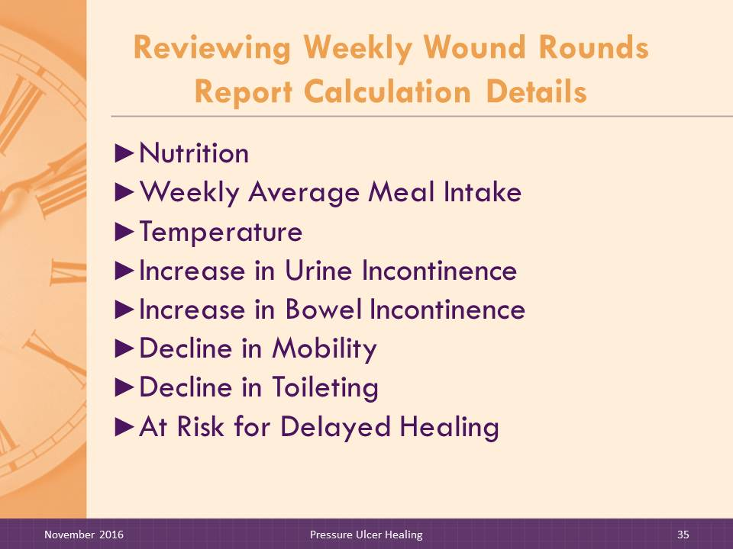
Review the calculation details with facilitator trainees.
SAY:

The On-Time software performs various calculations to display the relevant information. We will review how the different fields are determined
Information displayed for Ulcer Onset Date, Ulcer Site, Ulcer Days, Initial Ulcer Stage, Current Stage, Ulcer Origin, and Total Treatment Changes/Last is identical to the information displayed on the Pressure Ulcers at Risk for Delayed Healing Report.
Ulcer Length (cm) x Width (cm). This is the measurement of the ulcer length recorded using the facility’s method (i.e., either at longest aspect or per clock method [12 to 6 o’clock]) as recorded in centimeters. Width is the widest point of the ulcer perpendicular to the length as recorded in centimeters.
Ulcer Depth (cm). The depth of ulcer measured at the deepest point in centimeters.
SA Change. The current surface area is computed using the length x width dimensions and compared to the prior SA. The difference between the current SA and prior SA is reported as a percentage. If the current SA is greater than the prior SA, a plus (+) sign is displayed in front of the number; if the current SA is less than the prior SA, a negative (-) sign is displayed next to the number.
Days From Admit to Ulcer Onset. The number of days from the admission date to the ulcer onset date.

Last Seen Date by Primary Care Provider. The date of the most recent primary care provider (M.D., D.O., NP, or PA) visit to see the resident.
Last Seen Date in Wound Clinic. The most recent date that the resident was seen in the wound clinic. If the resident has not been seen in the wound clinic, this field will be blank.
On-Time Nutrition Risk. This column displays whether the resident is at high or medium nutrition risk according to the rules set forth in the On-Time Pressure Ulcer Prevention Nutrition Risk Report. Two criteria are used to determine level of nutrition risk:
- If meal consumption is 50 percent or less for two meals in one day at least one time during the report week.
- If there is any weight loss during the report week, determined by subtracting the current week’s weight from the most recent weight.
Residents meeting either one of the criteria will display as medium risk; residents meeting both criteria will display as high risk.
Nutrition. Physician orders for vitamin or mineral supplement, nutritional supplement (e.g., high-calorie or high-protein beverage or fortified foods) provided with meals, nutritional supplement provided between meals or with medication pass, monitoring of protein, calorie, and fluid intake or other interventions to maintain/improve nutrition and hydration status display with the order date. The facility will determine which physician orders to use for report displays; it will depend on what the electronic medical record (EMR) vendor has available for display.
Weekly Average Meal Intake. This item displays average meal intake according to the rules set forth in the On-Time Pressure Ulcer Prevention Nutrition Risk Report. This is the average percentage of meals consumed for one full week, including breakfast, lunch, and dinner. It takes into account missed meals, refusals, and NPO (nothing through the mouth) status.
- The numerator is the sum of meal intake percentages (includes breakfast, lunch, and dinner) for all meals during the week ending prior to report ending date. The denominator is the total possible meals in one week. If a resident is available for each meal, then the denominator is 21; NPO does not affect the denominator. Total possible meals may vary for new admissions or readmissions.

- NPO and missed meals affect the average meal intake value (count as 0 percent intake).
- Missing documentation or unavailable for meal (out of the building) are not included in the denominator.
- If the report is run for the current week, the denominator adjusts to the day of the week that the report is generated. For example, a report generated on Thursday would have a total of nine possible meals (Monday, Tuesday, and Wednesday).
Temp. This is the most recent temperature (within 7 days of the report date) recorded in the system displayed in Fahrenheit or Celsius. If there are multiple temperatures within the 7 days, the highest temperature will be displayed.
Increase in Urine Incontinence. This item is calculated according to the rules for the Pressure Ulcer Prevention Risk Change Report. The criteria are an increase in the number of shifts or the number of times the resident was incontinent from the previous week. Urinary incontinence may be documented or calculated in two ways:
- To calculate an increase in urinary incontinence by shift:
- For the current week, count the number of shifts a resident had at least one episode of urinary incontinence documented by the nursing assistant.
- For the prior week, count the number of shifts a resident had at least one episode of urinary incontinence documented by the nursing assistant.
- If the number of shifts of urinary incontinence increased by three or more (Current minus Previous ≥3), then an X is displayed.
- To calculate an increase in urinary incontinence by the number of episodes per week:
- For the current week, sum the number of urinary incontinence episodes documented by the nursing assistant.
- For the prior week, sum the number of urinary incontinence episodes documented by the nursing assistant.
- If the number of urinary incontinence episodes increased by 12 or more (Current minus Previous ≥12), then an X is displayed.

Increase in Bowel Incontinence. This item is calculated according to the rules for the Pressure Ulcer Prevention Risk Change Report. If the resident had an increase in the number of shifts or number of episodes of bowel incontinence, an X is displayed. Bowel incontinence may be documented or calculated in two ways:
- To calculate an increase in bowel incontinence by shift:
- For the current week, count the number of shifts a resident had at least one episode of bowel incontinence documented by the nursing assistant.
- For the prior week, count the number of shifts a resident had at least one episode of bowel incontinence documented by the nursing assistant.
- If the number of shifts of bowel incontinence increased by 1 or more (Current minus Previous ≥1), the report displays an X.
- To calculate an increase in bowel incontinence by the number of episodes per week:
- For the current week, sum the number of bowel incontinence episodes documented by the nursing assistant.
- For the prior week, sum the number of bowel incontinence episodes documented by the nursing assistant.
- If the number of bowel incontinence episodes increased by 2 or more (Current minus Previous ≥2), the report displays an X.
Decline in Mobility. This item is calculated according to the rules for the Pressure Ulcer Prevention Risk Change Report. An X is displayed if there has been a decline in the resident’s self-performance level from the prior week to the current week for Bed Mobility.
- Self-performance is rated as Independent, Supervision, Limited Assistance, Extensive Assistance, Total Dependence, or Activity Did Not Occur.
- The highest (or most dependent) value for Bed Mobility recorded during the current week is compared to the highest value (or most dependent) value for Bed Mobility recorded for the prior week.
- If the level of self-performance has declined, than an X is displayed.
- If either current week value or prior week value is Activity Did Not Occur, calculation is not done and cell is blank.
- Example: If Bed Mobility self-performance is documented as Total Dependent in current week and Extensive Assistance in prior week, Bed Mobility ADL has declined and an X is displayed.
- Example: If Bed Mobility self-performance is documented as Extensive Assistance in current week and Total Dependence in prior week, Bed Mobility ADL has not declined and cell is blank.
Decline in Transfer. This item is calculated according to the rules for the Pressure Ulcer Prevention Risk Change Report. An X is displayed if there has been a decline in the resident’s self-performance level from the prior week to the current week for Transfer; rules are the same as described above for Bed Mobility.
Decline in Toileting. This item is calculated according to the rules for the Pressure Ulcer Prevention Risk Change Report. An X is displayed if there has been a decline in the resident’s self-performance level from the prior week to the current week for Toileting; rules are the same as described above for Bed Mobility.
At Risk for Delayed Healing. Reasons for residents being at risk for delayed healing of pressure ulcers as described for the Pressure Ulcers at Risk for Delayed Healing Report.

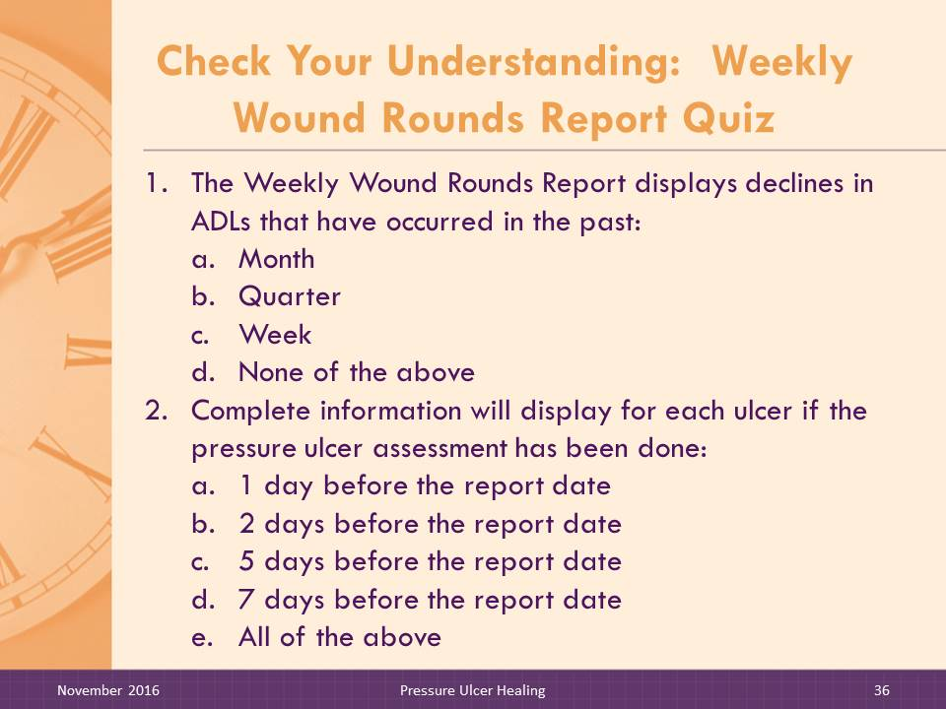
Slide 36–37: Check Your Understanding: Weekly Wound Rounds Report Quiz
DO:

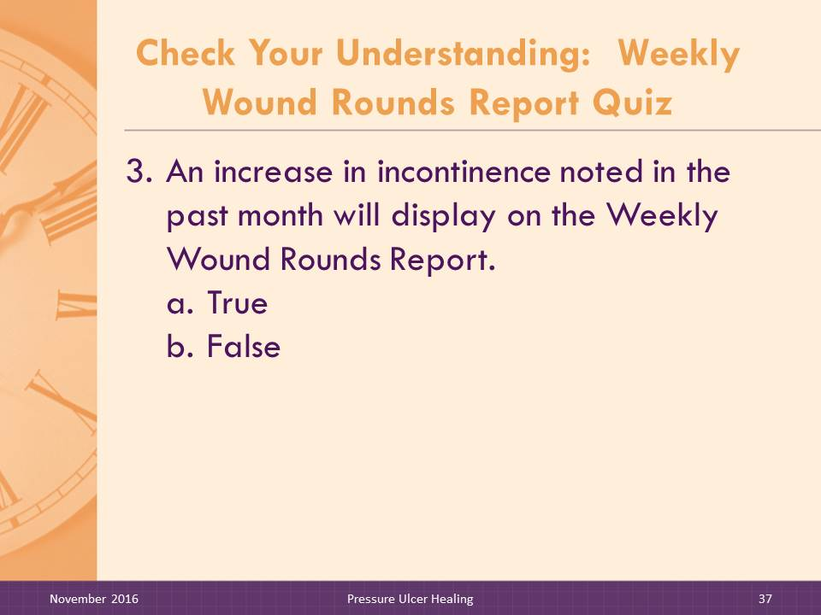
Ask participants to answer the quiz questions independently and then discuss as a group.
- The Weekly Wound Rounds Report displays declines in ADLs that have occurred in the past:
- Month
- Quarter
- Week
- None of the above
ANSWER: c
- Complete information will display for each ulcer if the pressure ulcer assessment has been done:
- 1 day before the report date
- 2 days before the report date
- 5 days before the report date
- 7 days before the report date
- All of the above
ANSWER: e
- An increase in incontinence noted in the past month will display on the Weekly Wound Rounds Report
- True
- False
ANSWER: b

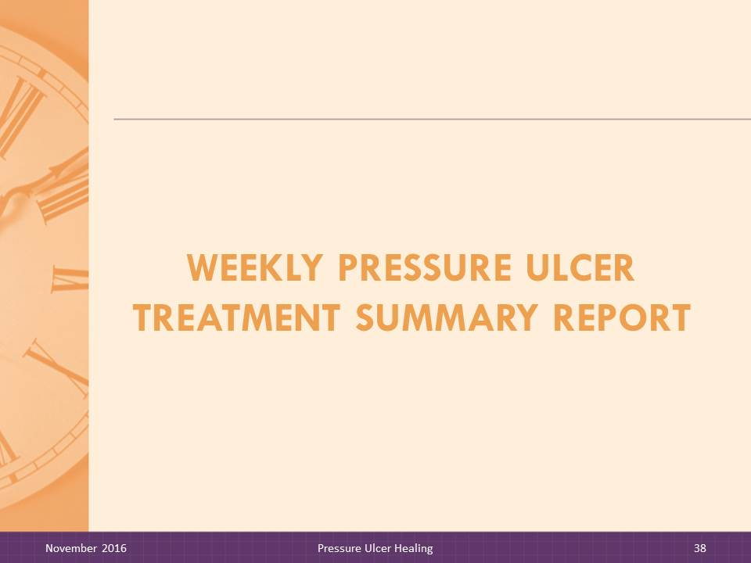
Slide 38: Weekly Pressure Ulcer Treatment Summary Report title slide
SAY:

Now let’s look at the Pressure Ulcer Treatment Summary Report.

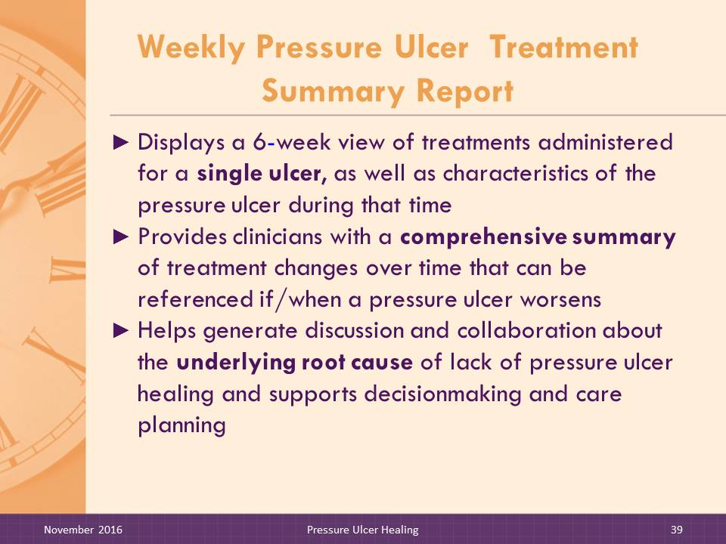
Slide 39–40: Weekly Pressure Ulcer Treatment Summary Report
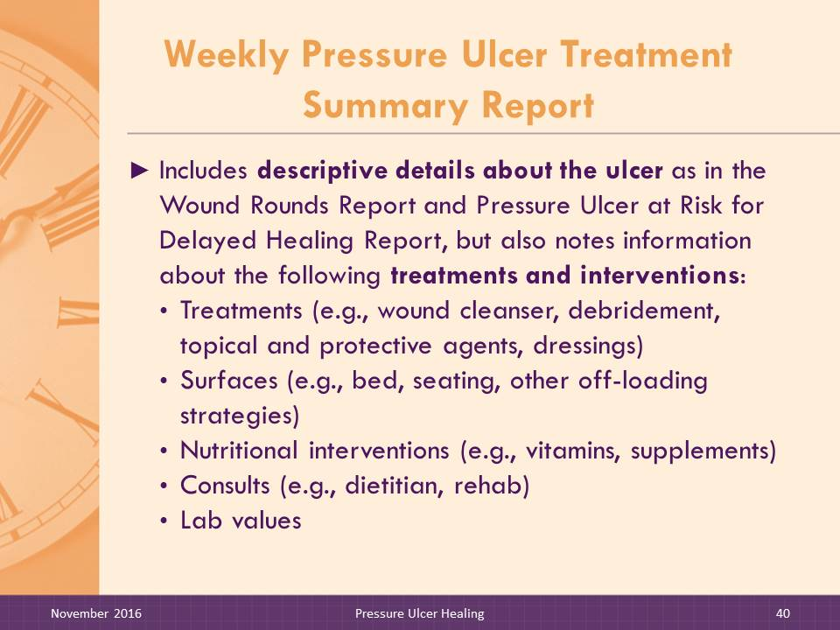
The Weekly Pressure Ulcer Treatment Summary Report displays a 6-week view of pressure ulcer treatments and characteristics for each individual pressure ulcer. This report provides an at-a-glance view of treatment strategies over time. The wound nurse, wound physician, and other disciplines attending wound rounds can see quickly which treatments have been in effect each week while also reviewing the Weekly Wound Rounds Report. For example, if an ulcer’s surface area is unchanged for 2 consecutive weeks, as noted on the Weekly Wound Rounds Report or the Pressure Ulcers at Risk for Delayed Healing Report, the team can see quickly which treatments and individualized clinical interventions were in effect during this time.
Information that displays on the Weekly Pressure Ulcer Treatment Summary Report, the Weekly Wound Rounds Report, and additional health status details found on the Weekly Resident Clinical, Functional, and Intervention Profile Report generate team discussion and collaboration about the underlying root cause for lack of pressure ulcer healing and support team decisionmaking about the current treatment plan.
The Weekly Pressure Ulcer Treatment Summary Report includes descriptive details on the pressure ulcer, including dimensions, stage, and signs of delayed healing, as well as treatments (e.g., cleansing, dressings, and debridement), interventions to facilitate healing (e.g., support surfaces, nutritional support), consultations, and laboratory values.

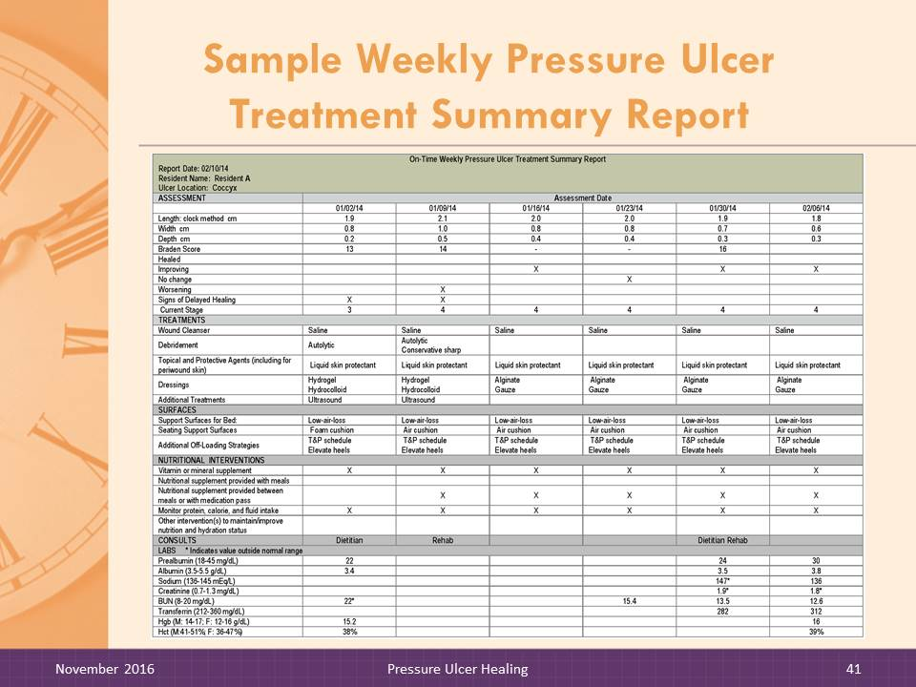
Slide 41: Weekly Pressure Ulcer Treatment Summary Report
DO:
Instruct trainees to look at the Pressure Ulcer Treatment Summary Report handout. Review the report contents and point out special features.
On-Time Weekly Pressure Ulcer Treatment Summary Report
Report Date: 02/10/14
Resident Name: Resident A
Ulcer Location: Coccyx
ASSESSMENT | Assessment Date
 | 01/02/14 | 01/09/14 | 01/16/14 | 01/23/14 | 01/30/14 | 02/06/14
Length: clock method cm | 1.9 | 2.1 | 2.0 | 2.0 | 1.9 | 1.8
Width cm | 0.8 | 1.0 | 0.8 | 0.8 | 0.7 | 0.6
Depth cm | 0.2 | 0.5 | 0.4 | 0.4 | 0.3 | 0.3
Braden score | 13 | 14 | - | - | 16
Healed
Improving |  |  | X |  | X | X
No change |  |  |  | X
Worsening |  | X
Signs of delayed healing | X | X
Current stage | 3 | 4 | 4 | 4 | 4 | 4
TREATMENTS
Wound cleanser | Saline | Saline | Saline | Saline | Saline | Saline
Debridement | Autolytic | Autolytic  Conservative sharp
Topical and protective agents (including for periwound skin) | Liquid skin protectant | Liquid skin protectant | Liquid skin protectant | Liquid skin protectant | Liquid skin protectant | Liquid skin protectant
Dressings | Hydrogel  Hydrocolloid | Hydrogel  Hydrocolloid | Alginate gauze | Alginate gauze | Alginate gauze | Alginate gauze
Additional treatments | Ultrasound | Ultrasound
SURFACES
Support surfaces for bed | Low-air-loss | Low-air-loss | Low-air-  loss | Low-air-  loss | Low-air-  loss | Low-air-  loss
Seating support surfaces | Foam cushion | Air cushion | Air cushion | Air cushion | Air cushion | Air cushion
Additional off-loading strategies | T&P schedule  Elevate heels | T&P schedule  Elevate heels | T&P schedule  Elevate heels | T&P schedule  Elevate heels | T&P schedule  Elevate heels | T&P schedule Elevate heels

On-Time Weekly Pressure Ulcer Treatment Summary Report
Report Date: 02/10/14
Resident Name: Resident A
Ulcer Location: Coccyx
NUTRITIONAL INTERVENTIONS
Vitamin or mineral supplement |  | X |  | X |  | X |  | X |  | X |  | X
Nutritional supplement provided with meals
Nutritional supplement provided between meals or with medication pass |  |  |  | X |  | X |  | X |  | X |  | X
Monitor protein, calorie, and fluid intake |  | X |  | X |  | X |  | X |  | X |  | X
Other interventions to maintain/improve nutrition and hydration status
CONSULTS |  | Dietitian |  | Rehab |  |  |  |  |  | Dietitian/  Rehab
LABS * Indicates value outside normal range
Prealbumin (18-45 mg/dL) | 22 |  |  |  |  |  |  |  | 24 |  | 30
Albumin (3.5-5.5 g/dL) | 3.4* |  |  |  |  |  |  |  | 3.5 |  | 3.8
Sodium (136-145 mEq/L) |  |  |  |  |  |  |  |  | 147* |  | 136
Creatinine (0.7-1.3 mg/dL) |  |  |  |  |  |  |  |  | 1.9* |  | 1.8*
BUN (8-20 mg/dL) | 22* |  |  |  |  |  | 15.4 |  | 13.5 |  | 12.6
Transferrin (212-360 mg/dL) |  |  |  |  |  |  |  |  | 282 |  | 312
Hgb (M: 14-17; F: 12-16 g/dL) | 15.2 |  |  |  |  |  |  |  |  |  | 16
Hct (M: 41-51%; F: 36-47%) | 38% |  |  |  |  |  |  |  |  |  | 39%
Notes: T & P = turning and positioning.
Normal lab value ranges noted above represent those reported in the Merck Manual (2013), available at http://www.merckmanuals.com/professional/appendixes/normal_laboratory_values/normal_laboratory_values.html. This information is provided as a guide only and nursing home staff should refer to their own laboratory’s normal range references and confer with the physician and other interdisciplinary team members when determining the individual resident’s desired lab values.

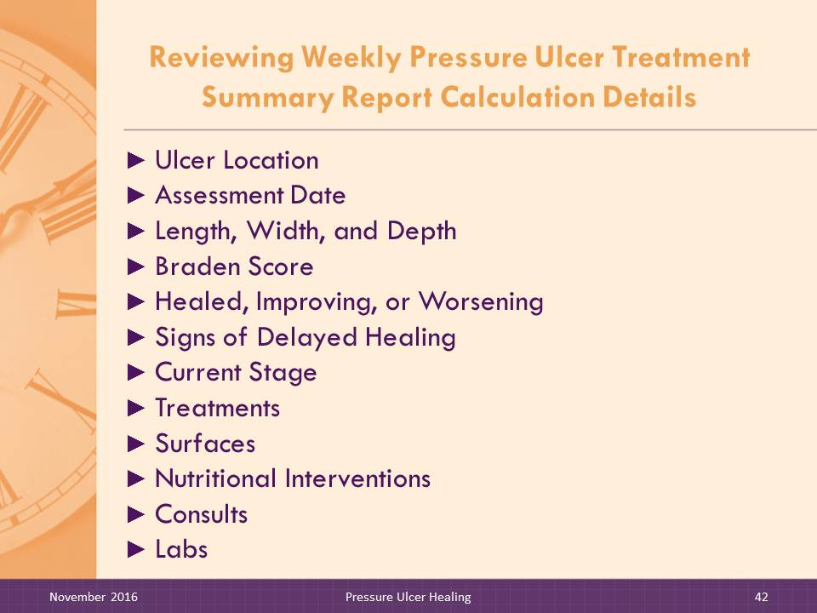
Slide 42: Reviewing Weekly Pressure Ulcer Treatment Summary Report Calculation Details
DO:

Review the calculation details with facilitator trainees.
SAY:

The On-Time software performs various calculations to display the relevant information. We will review how the different fields are determined.
The following items are displayed on the Weekly Pressure Ulcer Treatment Summary Report as recorded on the corresponding weekly Pressure Ulcer Assessment.

Assessment
- Ulcer Location. This is a code to indicate the location of the pressure ulcer on the resident’s body using the same table of possible locations as shown for the Existing Pressure Ulcers Report.
- Assessment Date. The current pressure ulcer assessment is used for all report calculations and displays. The pressure ulcer assessment with the most recent assessment date closest and prior to the report end date is considered the most recent or current pressure ulcer assessment. The assessment to be used for report calculations and displays must have an assessment date within 9 days of the report date to be considered the current assessment. If there are two assessments for the same pressure ulcer within the prior 9 days, then the assessment having an assessment date closest and prior to the report date is used.
- Length. This is the measurement of the ulcer length using the facility’s method (i.e., either at longest aspect or per clock method [12 to 6 o’clock]) recorded in centimeters.

- Width. Width is the widest point of the ulcer perpendicular to the length recorded in centimeters.
- Depth. This is the depth of ulcer measured at the deepest point in centimeters as recorded on the wound assessment.
- Braden Score. If a Braden Score is available and the Braden Score date falls within the week parameters for the report, the Braden Score will display in the appropriate column.
- Healed. If the pressure ulcer has healed, an X will display in the dated column when first noted. This information comes from the wound assessment.
- Improving. If the pressure ulcer is improving, as recorded on the wound assessment, an X will display in the appropriate week column.
- Worsening. If the pressure ulcer is worsening, as recorded on the wound assessment, an X will display in the appropriate week column.
- Signs of Delayed Healing. If the pressure ulcer shows signs of delayed healing, as recorded on the wound assessment based on the items listed above in the description of the Pressure Ulcers at Risk for Delayed Healing Report, an X will display in the appropriate week column.
- Current Stage. The current stage of the pressure ulcer as recorded on the wound assessment will display in the appropriate week column. Since reverse staging is not used, this item will display the highest recorded stage of the pressure ulcer.

Treatments
- Wound Cleanser. The type of wound cleanser in use (saline, soap and water, commercial product without antimicrobial, antimicrobial cleansing agent, or other) is displayed in each week column. If no wound cleanser is in use, the cell will be blank.
- Debridement. The type of debridement in use (autolytic, enzymatic, mechanical, conservative sharp, surgical/sharp, or other) is displayed in each week column.
- Topical and Protective Agents (Including Periwound Skin). The type of topical and protective agents in use (cream or ointment, liquid skin protectant, or other) is displayed in each week column.
- Dressings. The type of dressing in use (hydrocolloid, transparent film, hydrogel, alginate, foam, silver impregnated, honey impregnated, cadexomer iodine, gauze, silicon, collagen matrix, none, or other) is displayed in each week column.
- Additional Treatments. Any additional treatments (growth factors, electromagnetic biophysical agents, ultrasound, negative pressure wound therapy, hydrotherapy, oxygen therapy, or other) are also displayed. If no additional treatments are in use, the cell will be blank.

Surfaces
- Support Surfaces for Bed. The type of bed support surface (foam mattress or overlay, fluid-filled mattress or overlay, alternating pressure air mattress or overlay, low-air-loss mattress or overlay, or other) is displayed. If none of these types of support surfaces are in use, the cell will be blank.
- Seating Support Surfaces. The type of seating support surface (foam cushion, fluid-filled cushion, air cushion, or other) is displayed. If none of these seating supports are in use, the cell will be blank.
- Additional Off-Loading Strategies. Other types of off-loading strategies (splint or orthotic, off-loading boot or shoe, pillows to elevate heels, schedule for turning and repositioning, or other) are displayed. If none of these strategies are in use, the cell will be blank.

Nutritional Interventions
- Vitamin or Mineral Supplement. If vitamin or mineral supplement is in use, an X will display.
- Nutritional Supplement Provided With Meals. If a nutritional supplement (e.g., high calorie or high protein beverage or fortified food) are provided with the meal, an “X” will display.
- Nutritional Supplement Provided Between Meals or With Medication Pass. If a nutritional supplement is provided between meals or with the medication pass, an X will display.
- Monitor Protein, Calorie, and Fluid Intake. If protein, calories, and fluid intake are being monitored, an X will display.
- Other Interventions To Maintain/Improve Nutrition and Hydration Status. If other interventions are noted on the wound assessment, an X will display.

Consults
Any consultations that occurred during the week are recorded. If more than one consultation occurred, all are listed.

Labs
Available lab values for the following lab tests are displayed. Values outside the normal range (per the facility’s laboratory) are flagged with an asterisk (*).
- Prealbumin
- Albumin
- Sodium
- Creatinine
- BUN
- Transferrin
- Hemoglobin (Hgb)
- Hematocrit (Hct)

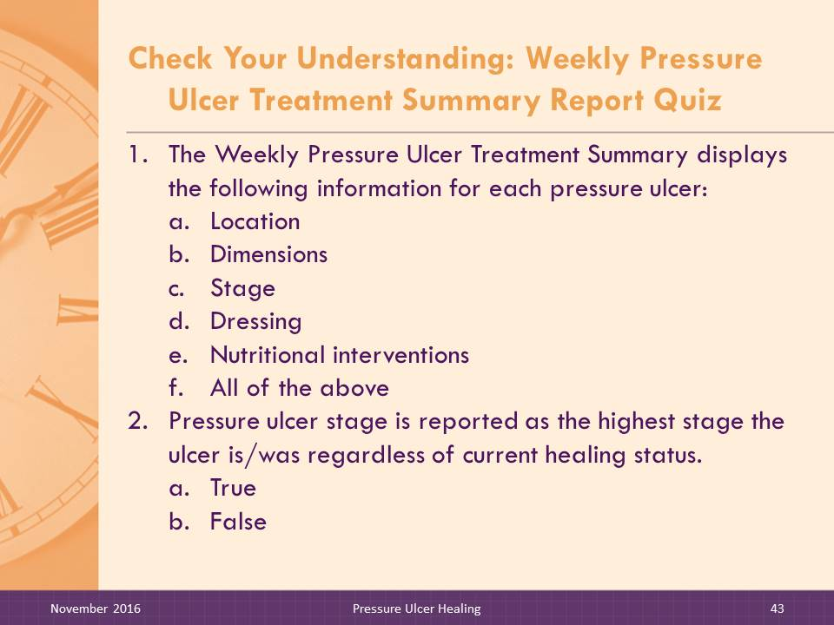
Slide 43–44: Check Your Understanding: Weekly Pressure Ulcer Treatment Summary Report Quiz
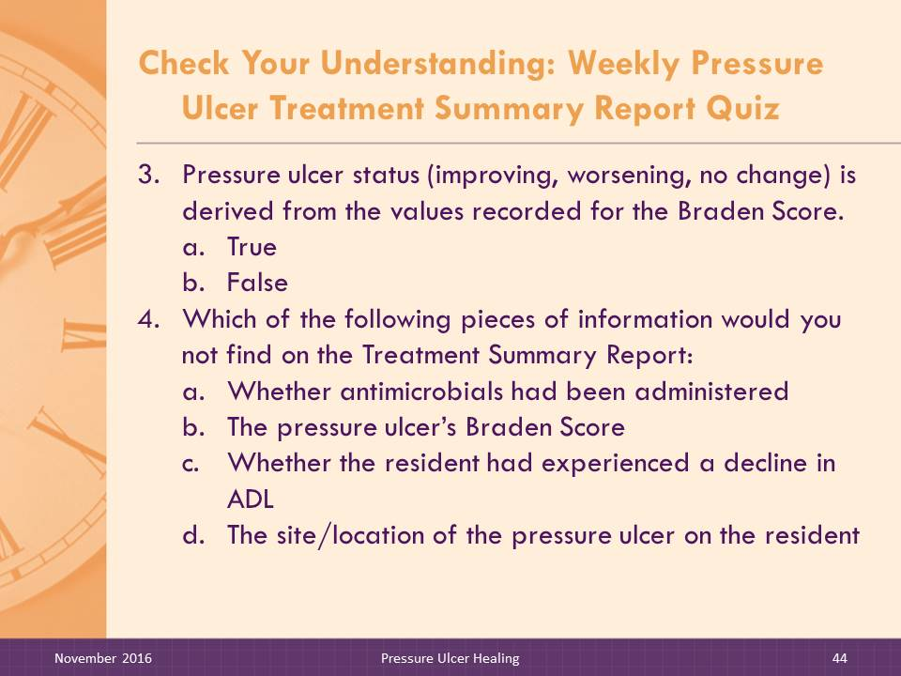
DO:

Ask participants to answer the quiz questions independently and then discuss as a group.
- The Weekly Pressure Ulcer Treatment Summary Report displays the following information for each pressure ulcer:

- Location
- Dimensions
- Stage
- Dressing
- Nutritional interventions
- All of the above

ANSWER: f
- Pressure ulcer stage is reported as the highest stage the ulcer is/was regardless of current healing status.
- True
- False
ANSWER: a
- Pressure ulcer status (improving, worsening, no change) is derived from the values recorded for the Braden Score.
- True
- False
ANSWER: b
- Which of the following pieces of information would you not find on the Weekly Pressure Ulcer Treatment Summary Report:
- Whether antimicrobials had been administered
- The pressure ulcer’s Braden Score
- Whether the resident had experienced a decline in ADLs
- The site/location of the pressure ulcer
ANSWER: c

Slide 45: Pressure Ulcer Counts by Month Report title slide
SAY:

Now let’s look at the Pressure Ulcer Counts by Month Report.

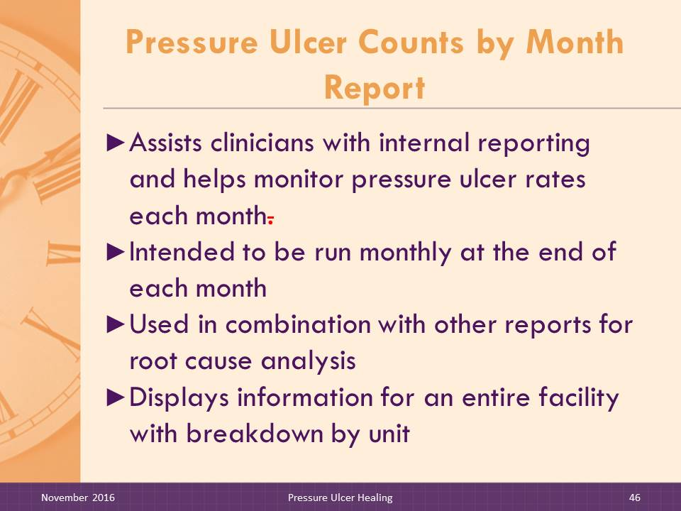
Slide 46–47: Pressure Ulcer Counts by Month Report
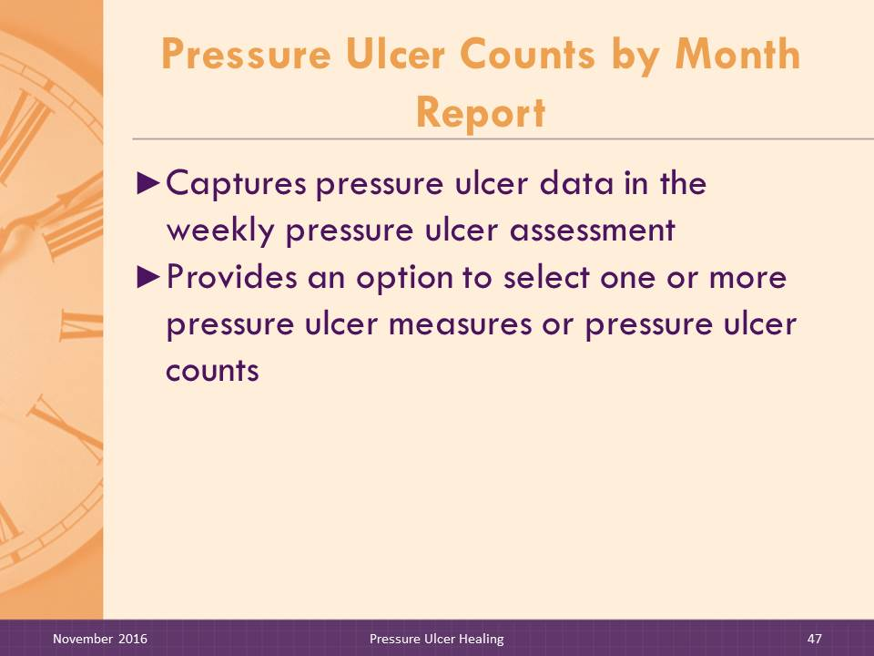
The Pressure Ulcer Counts by Month Report assists clinicians with internal reporting and helps monitor pressure ulcer rates each month. This report is intended to be run on a monthly basis at the end of each month. The Pressure Ulcer Counts by Month Report allows clinicians to use their EMR to quickly see the information on this report rather than compiling the information manually each month. This is just one example of how On-Time streamlines workflow and allows for better use of clinicians’ time.
The report may be used in combination with other reports for root cause analysis. For example, the Pressure Ulcers At Risk for Delayed Healing Report; Weekly Wound Rounds Report; Resident Clinical, Functional, and Intervention Profile Report; Trigger Summary Report; and Intervention History for Nutrition Risk Report may be used to analyze reasons for delayed healing.
Facilities also can select one or more pressure ulcer measures to display on the Pressure Ulcer Counts by Month Report. The Pressure Ulcer Counts by Month Report compiles pressure ulcer data captured by nurses on the weekly Pressure Ulcer Assessment. This report displays pressure ulcer information for one full calendar month for an entire facility, with breakdown of data by nursing unit.

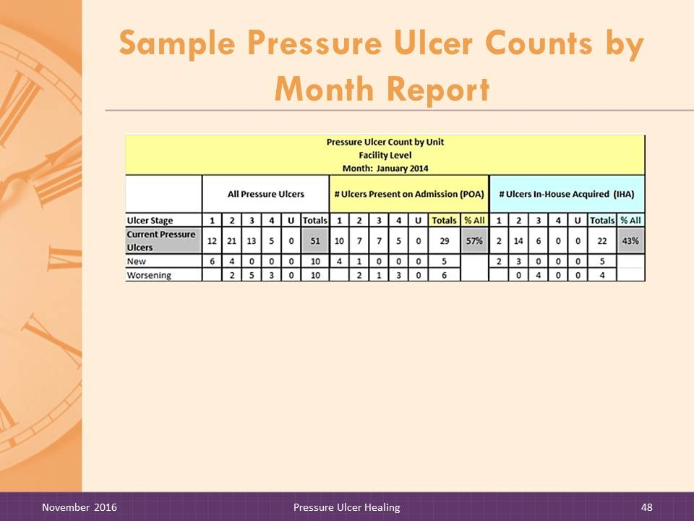
Slide 48–50: Pressure Ulcer Counts by Month Report
DO:

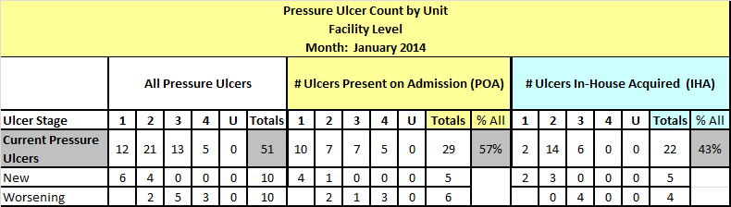
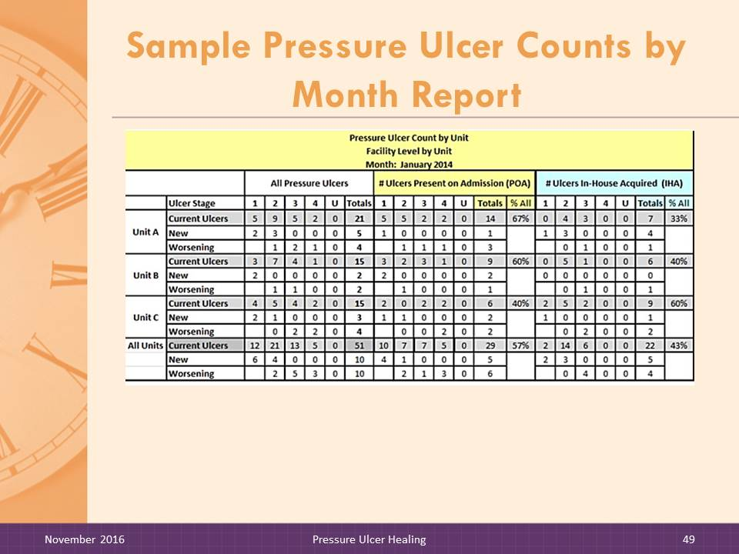
Instruct trainees to look at the Pressure Ulcer Counts by Month Report handout. Review the report contents and point out special features.
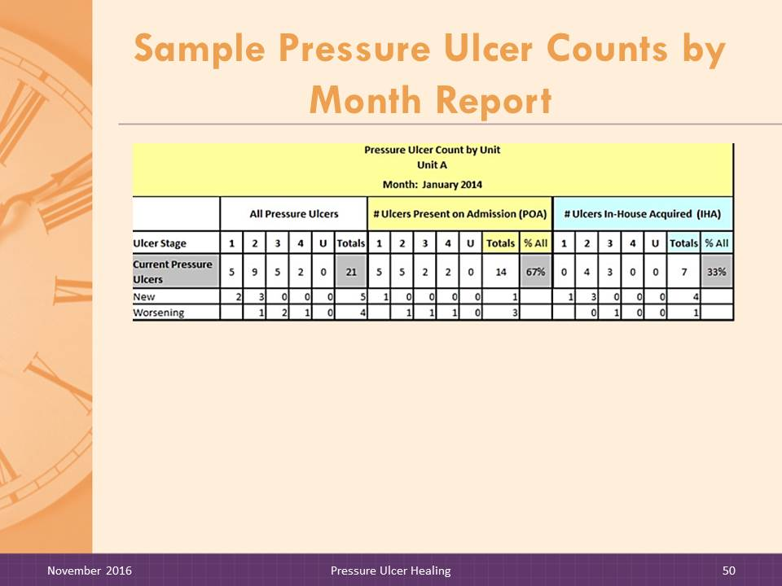
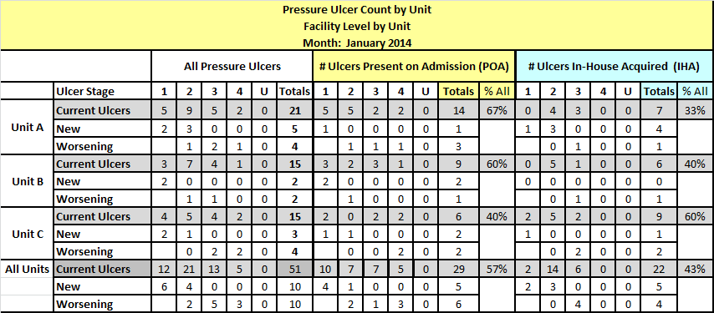
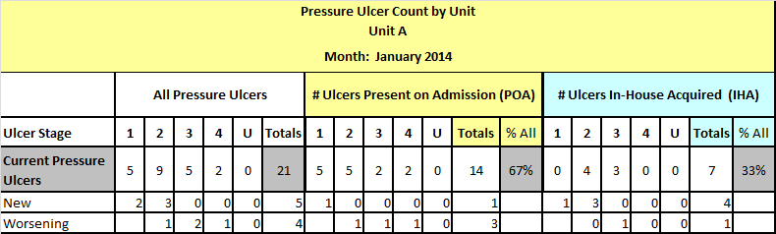

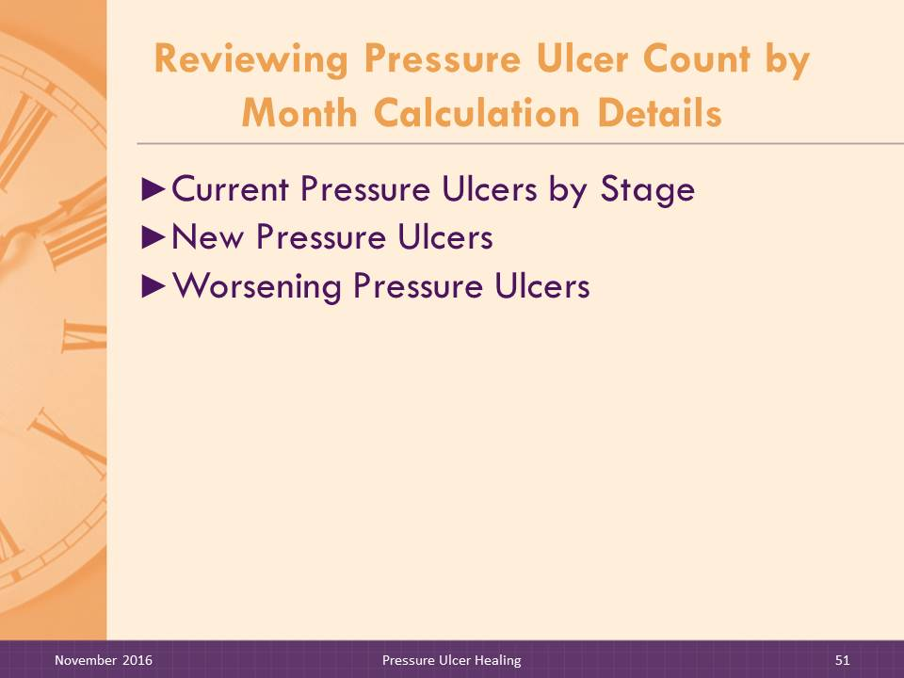
Slide 51–54: Reviewing Pressure Ulcer Count by Month Report Calculation Details
DO:

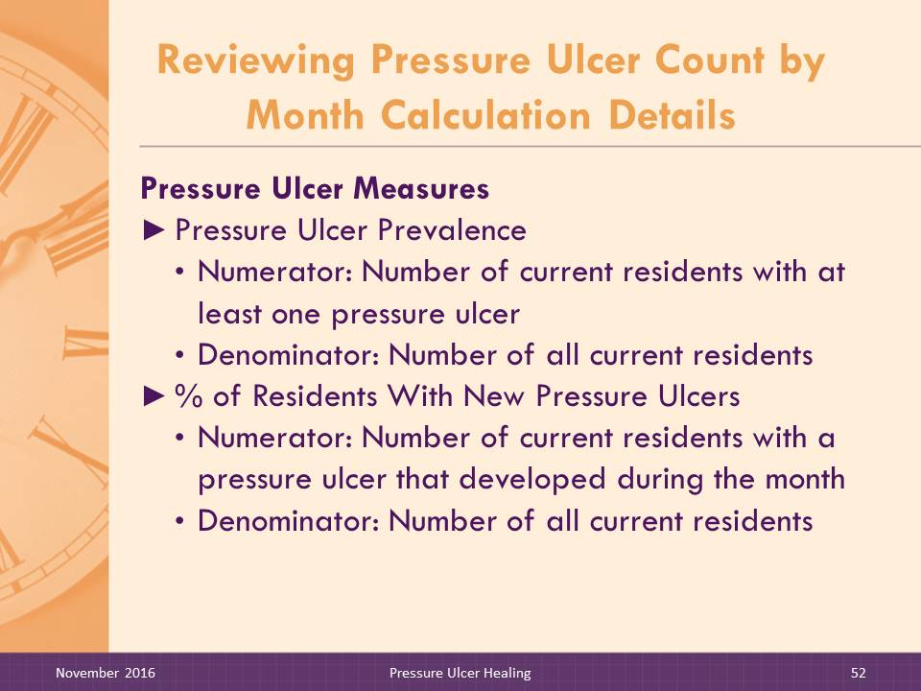
Review the calculation details with facilitator trainees.

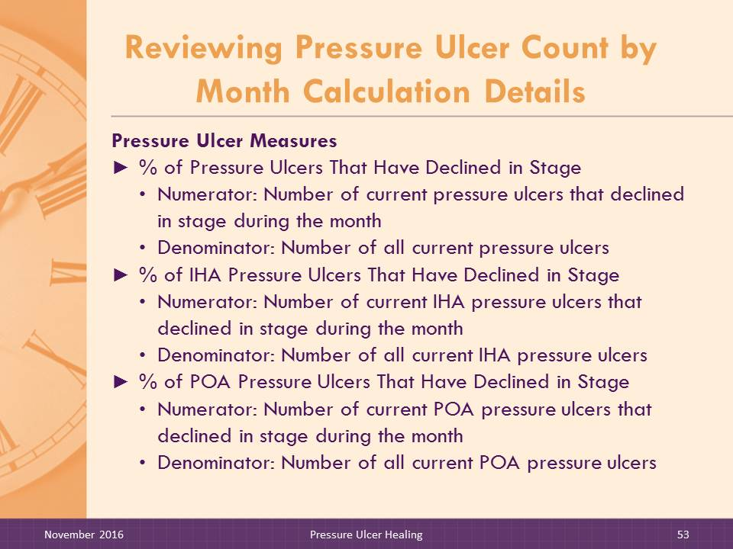
SAY:

The On-Time software performs various calculations to display the relevant information. We will review how the different fields are determined.
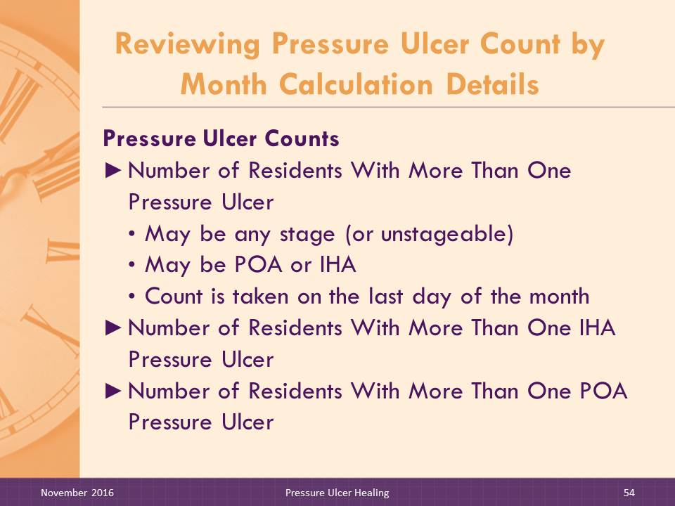
The following items are displayed on the Pressure Ulcer Counts by Month Report as recorded on the corresponding weekly Pressure Ulcer Assessment.
Current Pressure Ulcers by Ulcer Stage. This is a count of ulcers recorded by their highest stage. The count is taken on the last day of the report month. Current pressure ulcers are also categorized as to whether they were present on admission (POA) or in-house acquired (IHA). The facility should follow its policy for categorizing pressure ulcers that are not visible on the day of admission, but are visible very shortly after admission.
New Pressure Ulcers. This is a count of pressure ulcers that developed during the report month. It includes new pressure ulcers on residents who did not previously have a pressure ulcer and additional pressure ulcers on residents who already had one or more pressure ulcers. New Pressure Ulcers are also categorized as POA or IHA.
Worsening Pressure Ulcers. This is a count of pressure ulcers that worsened during the report month. These are pressure ulcers that are at a higher stage at the end of the month than they were earlier in the month. Worsening Pressure Ulcers are also categorized as POA or IHA.

Pressure Ulcer Measures. Users can select and display one or more of the following pressure ulcer measures. All measures (both numerator and denominator) are calculated based on the number of persons or the number of pressure ulcers in the facility on the last day of the month.
- Pressure Ulcer Prevalence. This is a measure of the number of residents with at least one pressure ulcer at a specific point in time (e.g., the last day of the report month). It includes all pressure ulcers, regardless of whether they were POA or IHA. It describes the number of pressure ulcers currently being cared for in the facility.
- Numerator: Number of residents with at least one pressure ulcer
- Denominator: Number of all current residents
- % of Residents With New Pressure Ulcers. This measure is based on the number of residents with a new pressure ulcer (i.e., a pressure ulcer that developed during the report month). It includes residents who previously had not had a pressure ulcer and developed one and residents with a previously developed pressure ulcer who develop a new pressure ulcer.
- Numerator: Number of residents with a pressure ulcer that developed during the month
- Denominator: Number of all current residents
- % of Pressure Ulcers That Declined. This measure is based on the number of pressure ulcers that have increased in stage or worsened during the report month. It includes all pressure ulcers that have declined regardless of whether they were POA or IHA.
- Numerator: Number of pressure ulcers that declined in stage during the month
- Denominator: Number of all current pressure ulcers
- % of IHA Pressure Ulcers That Declined. This measure is based on the number of IHA pressure ulcers that have declined in stage during the report month. It includes only pressure ulcers that developed at the nursing home during the report month and worsened.
- Numerator: Number of IHA pressure ulcers that declined during the month
- Denominator: Number of all current IHA pressure ulcers
- % of POA Pressure Ulcers That Declined. This measure is based on the number of POA pressure ulcers that increased in stage or worsened during the report month. It includes only pressure ulcers that were POA and worsened during the report month.
- Numerator: Number of POA pressure ulcers that declined during the month
- Denominator: Number of all current POA pressure ulcers
Pressure Ulcer Counts
- Number of Residents With More Than One Pressure Ulcer. This is a count of residents with more than one pressure ulcer. Pressure ulcers may be any stage (or unstageable) and may have been present on admission or developed at the nursing home. Each resident with two or more pressure ulcers is counted only once regardless of the number of pressure ulcers the resident has. The count is taken on the last day of the month.
- Number of Residents With More Than One IHA Pressure Ulcer. This is a count of residents with more than one IHA pressure ulcer. Pressure ulcers may be any stage (or unstageable). Each resident with two or more IHA pressure ulcers is counted only once regardless of the number of IHA pressure ulcers the resident has. The count is taken on the last day of the month.
- Number of Residents With More Than One POA Pressure Ulcer. This is a count of residents with more than one pressure ulcer that was present on admission. Pressure ulcers may be any stage (or unstageable). Each resident with two or more POA pressure ulcers is counted only once regardless of the number of pressure ulcers the resident has. The count is taken on the last day of the month.

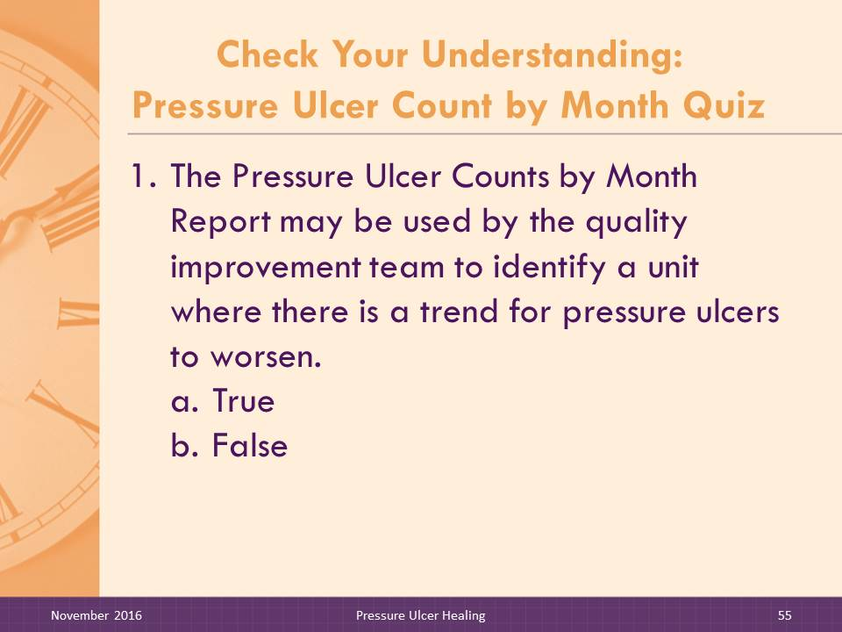
Slide 55–57: Check Your Understanding: Pressure Ulcer Counts by Month Report Quiz
DO:

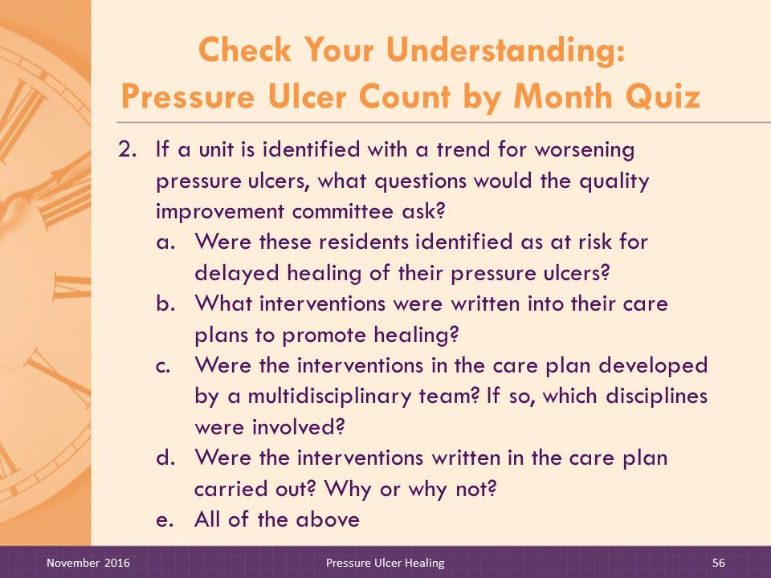
Ask participants to answer the quiz questions independently and then discuss as a group.
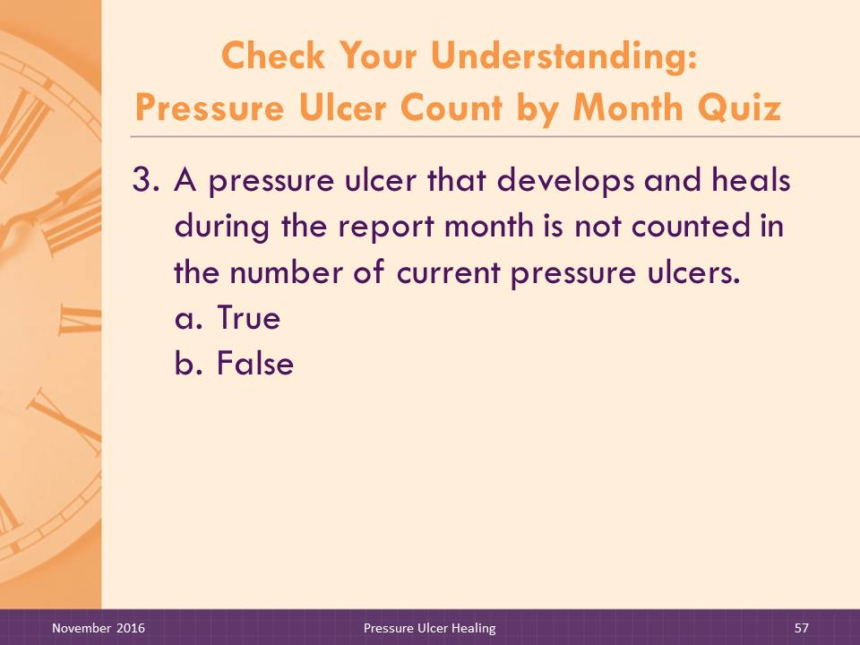
- The Pressure Ulcer Counts by Month Report may be used by the quality improvement team to identify a unit where there is a trend for pressure ulcers to worsen.
- True
- False
ANSWER: a
- If a unit is identified with a trend for worsening pressure ulcers, what questions would the quality improvement committee ask?
- Were these residents identified as at risk for delayed healing of their pressure ulcer(s)?
- What interventions were written into their care plans to promote healing?
- Were the interventions in the care plan developed by a multidisciplinary team? If so, which disciplines were involved?
- Were the interventions written in the care plan carried out? Why or why not?
- All of the above
ANSWER: e
- A pressure ulcer that develops and heals during the report month is not counted in the number of current pressure ulcers.
- True
- False
ANSWER: a
DO:

In preparation for the next day’s session, give the participants the reading assignment—simulated change team Self-Assessment meeting led by the Program Champion and the completed Self-Assessment Worksheet.
SAY:

I’d like to end the training today by giving you a reading assignment. The assignment is to read a handout that illustrates how a change team champion may work with the change team to discuss and fill out the Self-Assessment Worksheet. Also included is a completed self-assessment. Please review this for discussion tomorrow.
Facilitators are expected to encourage the change team to fill out the self-assessment and to review the completed self-assessment. The Self-Assessment Worksheet is a good introduction for the team and you to help identify ways the reports can be integrated into workflow.
Thank you and we will reconvene tomorrow.

Haesler E, ed. National Pressure Ulcer Advisory Panel, European Pressure Ulcer Advisory Panel, and Pan Pacific Pressure Injury Alliance. Prevention and treatment of pressure ulcers: quick reference guide. Perth, Australia: Cambridge Media; 2014.
The Resident Clinical, Functional, and Intervention Profile Report is included in On-Time Pressure Ulcer Prevention.
The Resident Clinical, Functional, and Intervention Profile Report, Trigger Summary Report, and Intervention History for Nutrition Risk Report are included in On-Time Pressure Ulcer Prevention.

