AHRQ’s Safety Program for Nursing Homes

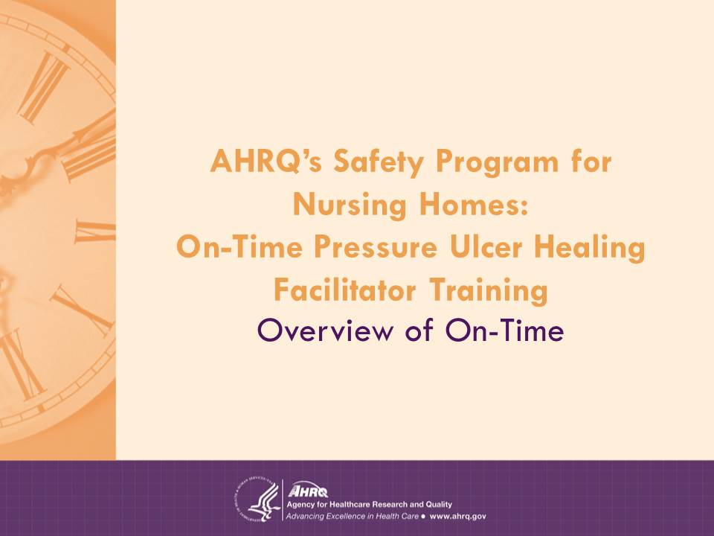
On-Time Pressure Ulcer Healing Facilitator Training

Overview of On-Time

Note: This version of the On-Time introduction is for training Facilitators who have not had pressure ulcer prevention training. If they have had that training, this set of slides can be omitted or may be used as a refresher.

Slide 1: Overview of On-Time

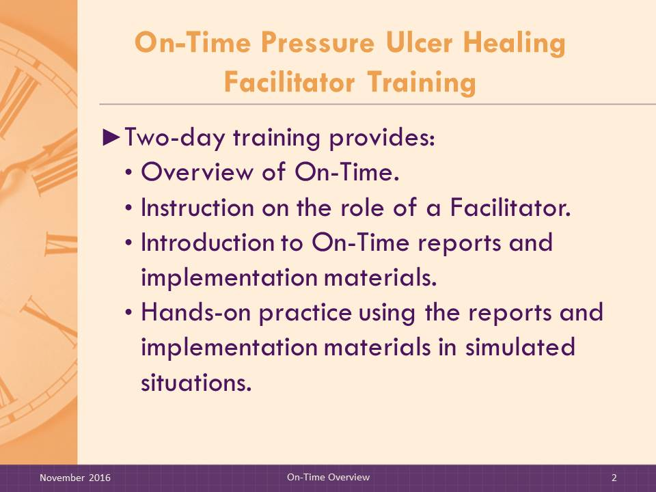
Slide 2: On-Time Pressure Ulcer Healing Facilitator Training
SAY:

Welcome to the On-Time Pressure Ulcer Healing Facilitator Training. This 2-day Facilitator training will provide an overview of On-Time, including the use of electronic reports and a common implementation strategy that uses a Self-Assessment Worksheet, a Menu of Implementation Strategies, and the Implementation Steps and Timeline. The training also explains the role of the Facilitator in working with the nursing home change team to integrate reports into existing workflow.
The training will then provide detailed instruction for Facilitators on the content of all materials used to improve healing of pressure ulcers. Participants will then gain hands-on practice using the reports and implementation materials. In addition, they will engage in test exercises to help them master the basic information needed to facilitate the integration of the electronic reports into a nursing home’s workflow.

Slide 3: Introduction to On-Time
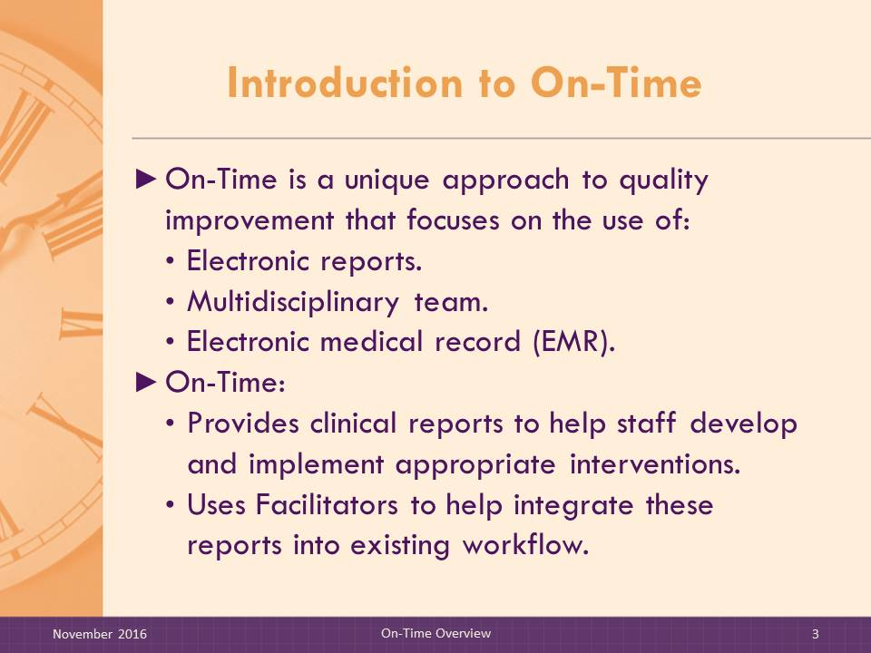
On-Time is a unique approach to quality improvement that focuses on the use of electronic reports and multidisciplinary team collaboration to support clinical decisionmaking and prevent adverse events that affect nursing home residents. It uses the electronic medical record, or EMR, data to make staff aware of residents at risk of adverse events such as pressure ulcers and falls. On-Time provides clinical reports to help staff develop and implement appropriate interventions. Finally, it uses Facilitators to help integrate these reports into existing workflow.

Slide 4: What Problem Are We Trying To Solve?
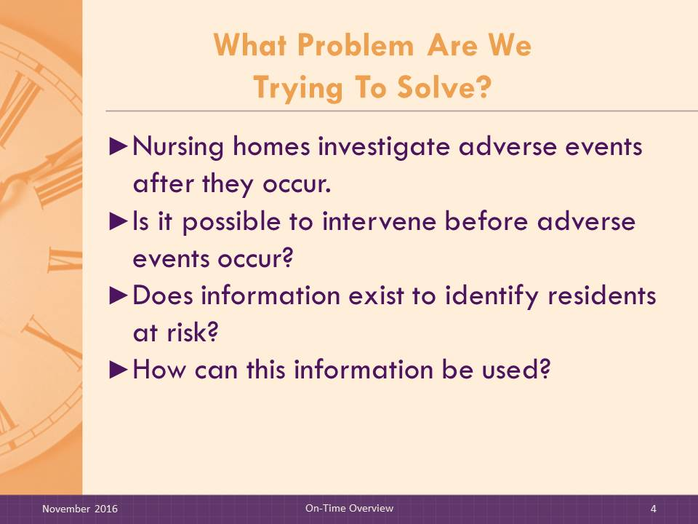
SAY:

What problem are we trying to solve?
- Nursing home staff generally do a good job of investigating and following up after an adverse event, such as a fall or the development of a pressure ulcer. We talk to the resident and staff to figure out what happened when that resident fell or how that pressure ulcer developed. It is more difficult for staff to identify which residents are at risk for a future adverse event or if the pressure ulcer will heal appropriately. Although the information is available, it is not organized so that staff can easily identify those with changing risk and get sufficient information about their condition and treatments to make timely changes to care plans. What if we could get in front of these events? In other words, if we knew who was at high risk or had a recent change in risk, would we do things differently to intervene before the event occurred?
- For example, if we were aware that Mrs. Jones had had a change to her medications that might make her a little dizzy, wouldn’t we be sure to instruct the nursing assistant to stay close by when she was ambulating, to prevent a fall?
- Similarly, if we knew that Mr. Smith’s meal intake had recently declined, that he’d lost a little weight, and that he had become incontinent at night, wouldn’t we be sure to consult the dietitian, update his physician, revise his care plan, and huddle with the nursing assistants to ensure that his skin was kept dry and protected from pressure?

Trainer Note: Engage participants in a discussion using the questions below. Customize the questions to fit the audience.

Slide 5: Discussion
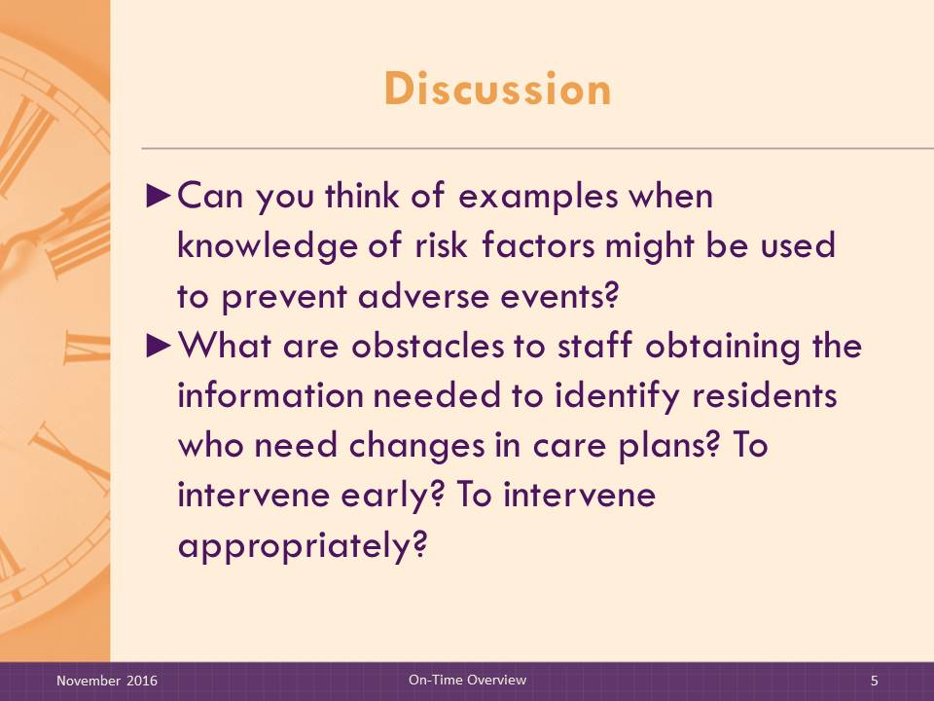
- Can you think of any other examples when knowledge of risk factors might be used to prevent these adverse events for residents?
- What are obstacles to staff obtaining the information needed to identify residents who need changes in care plans? To intervene early? To intervene appropriately?

Slide 6: On-Time Reports for Four Adverse Events
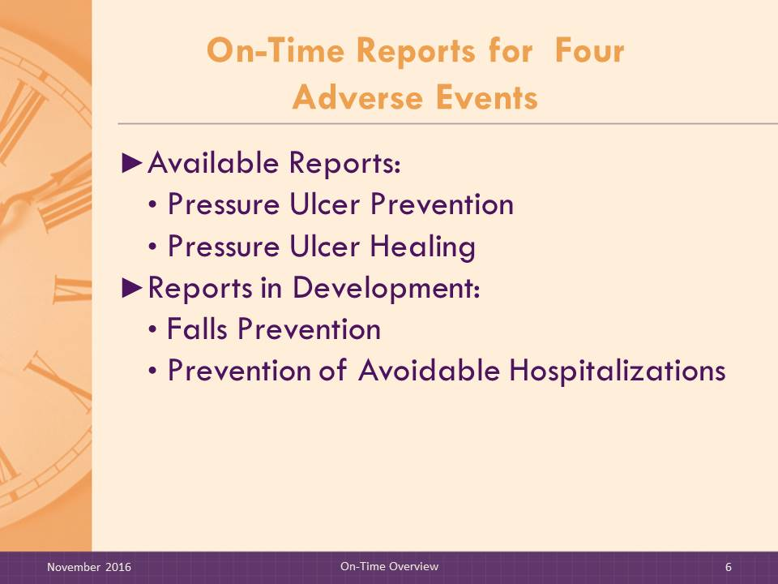
SAY:

There are four sets of On-Time reports to help prevent four adverse events: pressure ulcers, pressure ulcers that are not healing appropriately, falls, and avoidable hospitalizations. . On-Time reports for preventing falls and avoidable hospitalizations are currently in development.
Note to Trainer:
Sample materials used during this session are provided in the Overview Materials packet. In the packet are the following On-Time Pressure Ulcer Healing documents:
- Existing Pressure Ulcers Report
- Pressure Ulcers at Risk for Delayed Healing
- Weekly Wound Rounds Report
- Weekly Pressure Ulcer Treatment Summary Report
- Pressure Ulcer Counts by Month Report
- Pressure Ulcer Healing Self-Assessment
- Menu of Implementation Strategies
- Implementation Steps and Timeline
Each participant should be provided with the Overview Materials packet before you begin the session.

Slide 7: Common Elements of On-Time
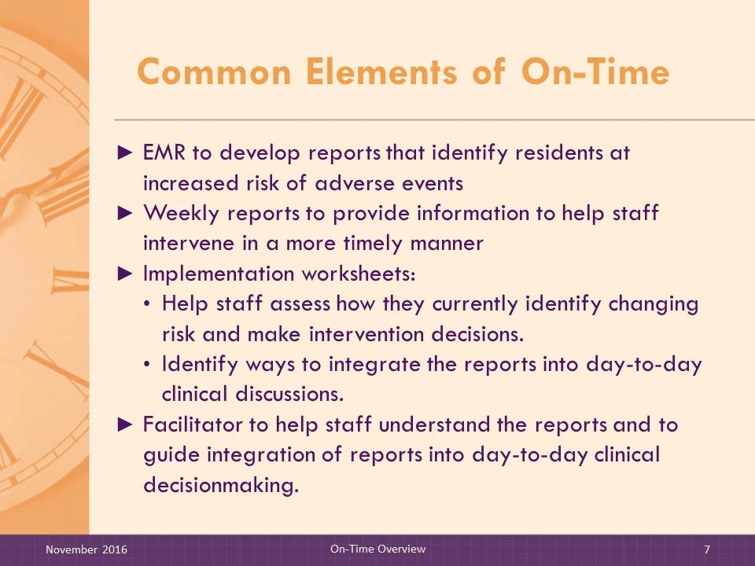
SAY:

On-Time prevention uses a set of electronic reports and implementation materials. The implementation materials include a Self-Assessment worksheet, a Menu of Implementation Strategies, and the Implementation Steps and Timeline.
On-Time has the following features:
- Includes reports developed from EMRs that identify residents with increased risk who may need changes in care to prevent adverse events;
- Provides clinical information in weekly reports that help clinical staff intervene in a more timely and appropriate way;
- Provides worksheets to help staff members assess how they currently identify changes in risk, make intervention decisions, and identify ways to integrate On-Time reports into day-to-day clinical discussions;
- Uses a Facilitator to help staff understand the reports and to guide them on how to integrate these reports into day-to-day clinical decisionmaking; and
- Encourages discussions of at-risk residents on a weekly basis using electronic reports with input from relevant staff (e.g., nursing assistants, director of nursing [DON], wound nurses, dietary, rehab, and pharmacy).
The goal is for the nursing home team to use the On-Time risk reports on a weekly basis and encourage multidisciplinary input (e.g., certified nursing assistants [CNAs], DON, wound nurses, dietary, rehab, primary care physician, and pharmacy) to identify timely interventions that will help prevent adverse events.

Slide 8: Role of the Facilitator
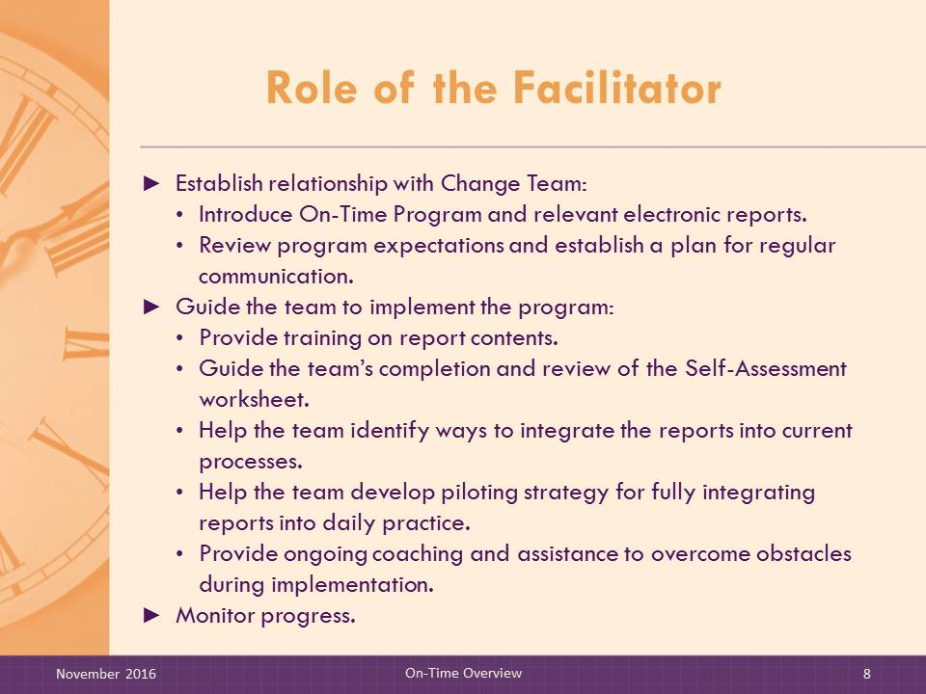
SAY:

When agreeing to participate in an On-Time program, the nursing home will establish a multidisciplinary change team, including a champion to help lead the effort in the nursing home. The role of the Facilitator is to educate the nursing home change team about On-Time and guide them through the implementation process. It is expected that the Facilitator will have one onsite visit and mostly interact by telephone conference calls with the change team. The intensity and duration of help provided may depend on the facility team’s progress.
Once the reports are available in the EMR, facilitation with the change team will take place over a period of 6 to 9 months. The Facilitator will also monitor the team to ensure they can sustain the program. After that, the facility should be able to make this program part of their policies and procedures and no longer need the help of a Facilitator.
The On-Time Facilitator will:
- Establish a relationship with the change team.
- Introduce On-Time and relevant electronic reports.
- Develop and customize a plan to implement the electronic reports with the team based on the Implementation Steps.
- Review program expectations and establish a plan for regular communication.
- Guide the change team to implement the program.
- Provide ongoing support and coaching to the team members to provide training on report contents and guide implementation of reports into day-to-day practice.
- Encourage the team to complete the Self-Assessment worksheet to understand current processes used by the nursing home for risk identification, staff communication, and clinical decisions to help prevent the adverse event of interest.
- Study the completed self-assessment to identify ways that the On-Time reports can help staff make adjustments in care plans to prevent adverse events.

- Help the team use the Menu of Implementation Strategies to identify ways to integrate reports into current preventive practices.
- Help the team develop a piloting strategy for fully integrating reports into daily practice.
- Help the team problem solve obstacles that occur during the implementation process.
- Monitor progress by:
- Tracking implementation progress based on accomplishing Implementation Steps; and
- Tracking impact with process and outcome measures. This includes helping to identify measures the change team can use to monitor its own progress.

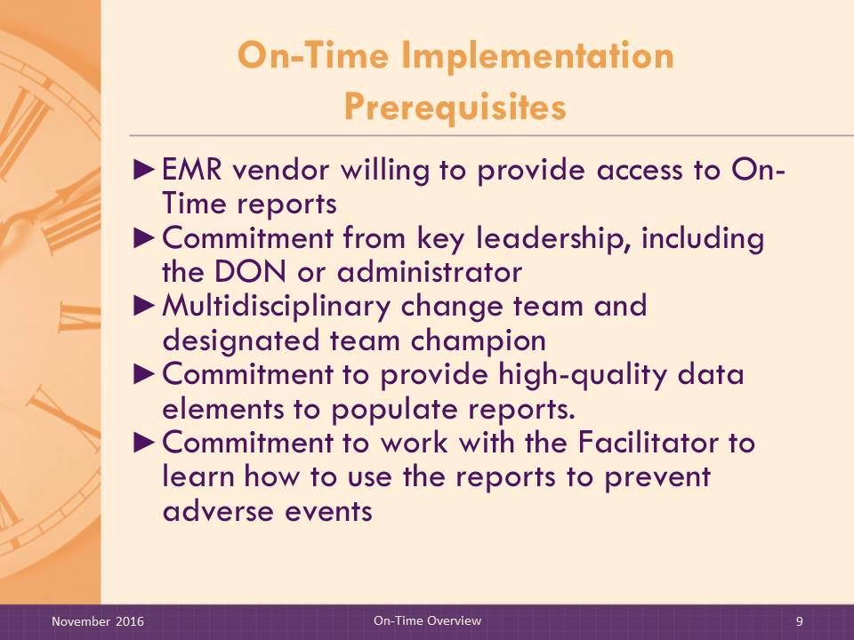
Slide 9: On-Time Implementation Prerequisites
SAY:

Nursing homes that want to implement an On-Time program must have the following in place:
- EMR vendor willing to provide access to On-Time reports.
- Commitment from key leadership, including the DON or administrator.
- Commitment to provide high-quality data elements to populate reports.
- Multidisciplinary change team and designated team champion.
- Commitment to work with a Facilitator to learn how to use the reports to prevent adverse events.

Slide 10: Functional Specifications and EMR Vendors
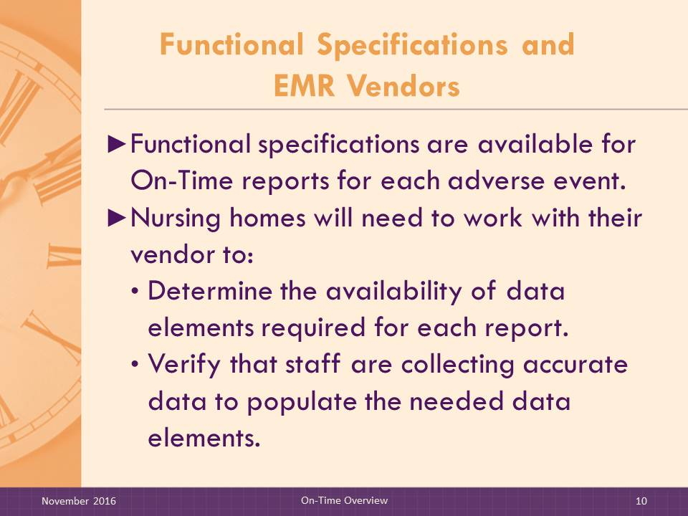
SAY:

Technical specifications are available for EMR vendor programmers to develop the reports as designed. Nursing homes would need to work with their vendor to determine the availability of data elements required for each report and to verify that staff are collecting accurate data to populate the needed data elements and collecting information needed for the reports. Nursing homes must be aware of any software updates that may affect availability of reports.

Slide 11: Facilitator Role: Preliminary Support
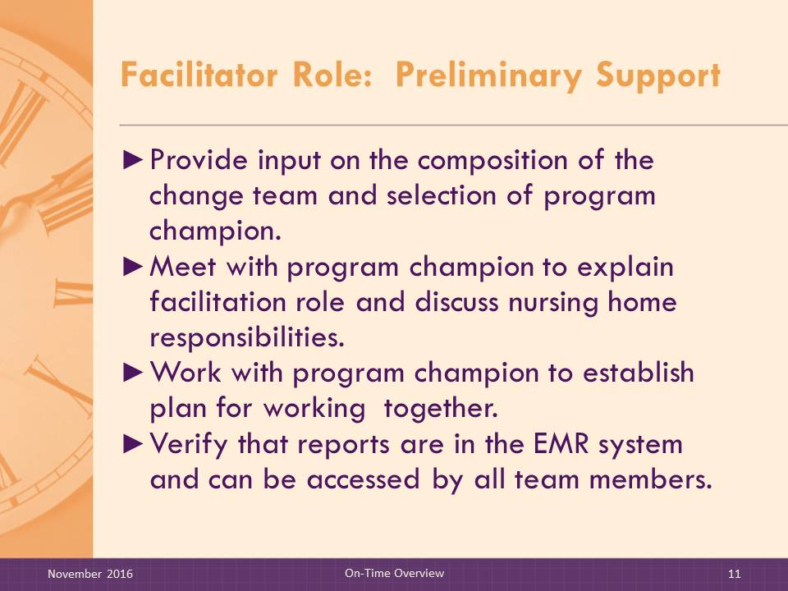
SAY:

Before the On-Time training begins, the Facilitator should:
- Provide input on the composition of the change team and selection of the program champion. The team should be multidisciplinary, and there is a core team of essential members, depending on the adverse event selected and the key risk factors involved. For example, the dietitian is an important member of a pressure ulcer healing team because declining nutrition is a key risk factor. The core team should minimally include clinical leadership (DON or assistant DON [ADON]), nurse managers, and nursing assistants. The staff educator may be important as well if retraining is needed, for example, due to turnover of staff. The program champion should be someone with a high level of interest in and enthusiasm for the program and with the authority to make assignments as needed.
- Meet with the program champion to explain the Facilitator’s role in the implementation process, discuss the responsibilities of the facility, and plan how the program champion and Facilitator will work together.
- Verify that the reports are in the system and can be accessed in a timely manner. Ask each team member to access the report to ensure that all have “permission” to see the report, and test that the report can be printed.

Slide 12: Evidence Base for On-Time Reports
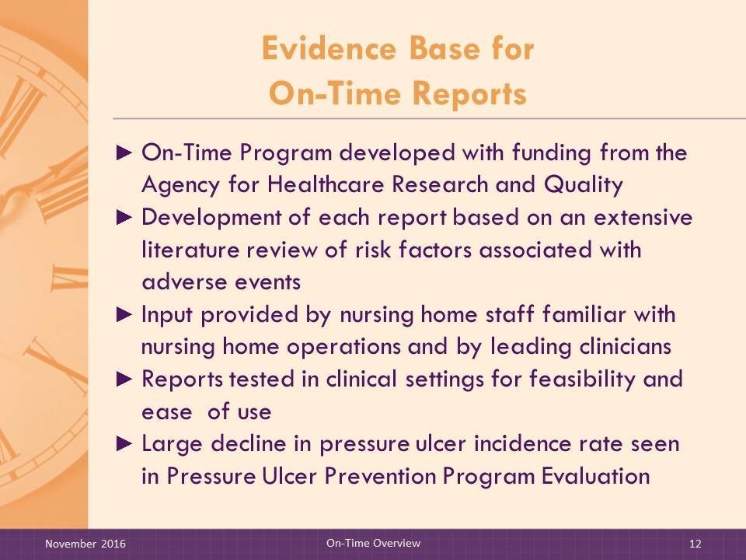
SAY:

Work on On-Time started in 2003. It was developed with funding from the Agency for Healthcare Research and Quality (AHRQ).
Development of each set of reports began with a detailed literature review of risk factors associated with the adverse event of interest. The reports were designed with input from a workgroup composed of nursing home staff with knowledge of nursing home operations. They provided input on the design and content of the reports and helped assess the reports for usefulness, appropriateness, and feasibility. Clinicians and leading medical experts also provided input.
Reports were then tested in actual clinical settings to confirm that reports were feasible for use in clinical practice and did not impede clinical workflow. The design process resulted in functional specifications for nursing home EMR vendors to use in developing the software to generate the reports.
Some of the parts have been subjected to evaluation studies to assess their impact on patient outcomes. For example:
- Pressure Ulcer Prevention has been pilot tested in more than 50 nursing homes across the country; several studies have shown significant reductions in pressure ulcer incidence rates when On-Time pressure ulcer prevention reports were integrated into day-to-day workflow.
- Pressure Ulcer Healing, Falls, and Avoidable Hospitalization reports and worksheets have been tested for feasibility and usefulness and content is based on review of the published literature concerning the risks and treatments associated with the adverse outcome of focus.

Slide 13: Overview of On-Time Reports
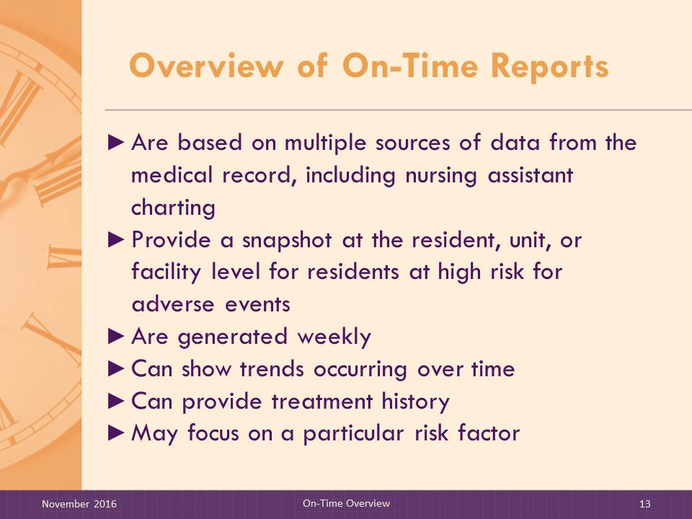
SAY:

Each report is designed to identify residents at risk for the adverse event of interest (e.g., pressure ulcers, falls, avoidable hospitalization or emergency department visit) and to provide clinical information that clinical staff can use to develop and implement appropriate interventions. These snapshots may be displayed at the resident, unit, or facility level.
Some of the reports provide data from multiple time points to allow staff to observe trends over time (e.g., pressure ulcer treatment summary). Some identify a profile of risk factors; others focus on a particular risk factor. Others help identify a history of changes in risk factors or treatment to help understand underlying causes of risk changes.
For each report, examples are provided of meetings and huddles where report information could be added to the agenda. Some suggested uses may require staff to establish a new huddle or meeting to focus on the report’s content rather than incorporating its discussion into an existing staff meeting.
New reports are updated weekly.
It is important for you to become familiar with each report so you can answer questions. That way, the change team can understand what is being presented and will trust the accuracy of the reports. If there are continued concerns with accuracy, the team may need to check report data with actual records. This process is covered later in the training.

Slide 14: Examples of On-Time Reports
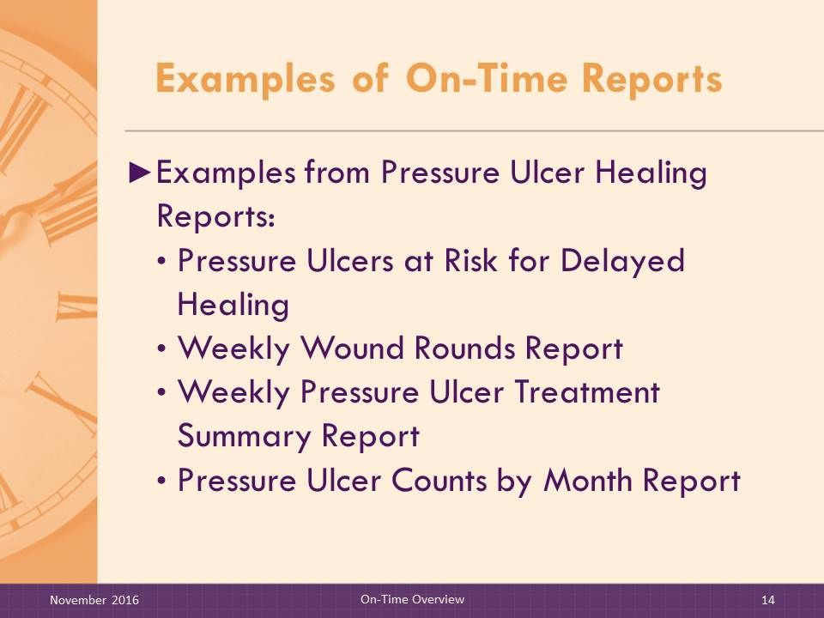
SAY:

To become more familiar with various types of electronic reports used in On-Time, let’s look at a sample of reports that are used for Pressure Ulcer Healing. These are included in your Overview Materials Packet.
DO:

- Review the On-Time Healing Reports.
- Point out the features and organization of report information.
- The Existing Pressure Ulcers Report provides the clinician with a comprehensive list of all residents currently in the facility with at least one existing pressure ulcer during the report week.
- The Pressure Ulcers at Risk for Delayed Healing Report is intended to alert staff to residents with pressure ulcers showing signs of potential delayed healing.
- The Weekly Wound Rounds Report provides clinical details that alert staff to factors that may affect the pressure ulcer healing process.
- The Weekly Pressure Ulcer Treatment Summary Report displays a 6-week view of pressure ulcer treatments and characteristics for each individual pressure ulcer. This report provides an at-a-glance view of treatment strategies over time.
- The Pressure Ulcer Counts by Month Report assists clinicians with internal reporting and helps monitor pressure ulcer rates each month. This report is intended to be run on a monthly basis at the end of each month. The Pressure Ulcer Counts by Month Report allows clinicians to use their EMR to quickly see the information on this report rather than compiling the information manually each month.

MATERIALS:
- Existing Pressure Ulcers Report
- Pressure Ulcers at Risk for Delayed Healing Report
- Weekly Wound Rounds Report
- Weekly Pressure Ulcer Treatment Summary Report
- Pressure Ulcer Counts by Month Report

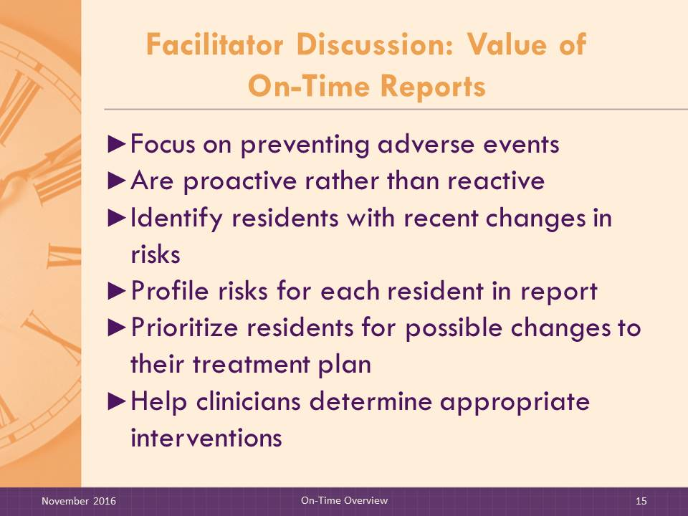
Slide 15: Facilitator Discussion: Value of On-Time Reports
DO:

Use the following questions to lead a discussion with Facilitator trainees:
- In your experience, is the type of information displayed on the On-Time Healing reports currently available to nursing home staff? If so, where would they find it? How current would the information be?
- Do nursing home staff members rely on the Minimum Data Set (MDS) for this type of information? What do you see as a limitation in relying on the MDS? What other sources might they use?
- How do nursing home staff members pick up on subtle changes in residents’ risk status? Do they rely on verbal reports from nursing assistants? How is this information shared with the team?
- Can you see how these reports might be useful to nursing home staff?
DO:

[Reinforce the following points.]
The reports:
- Focus on preventing adverse events.
- Are proactive rather than reactive.
- Show recent changes in risks.
- Profile risks for each resident in the report.
- Prioritize residents for possible changes to their treatment plan.
- Help clinicians determine appropriate interventions.

Slide 16: Teaching On-Time Reports
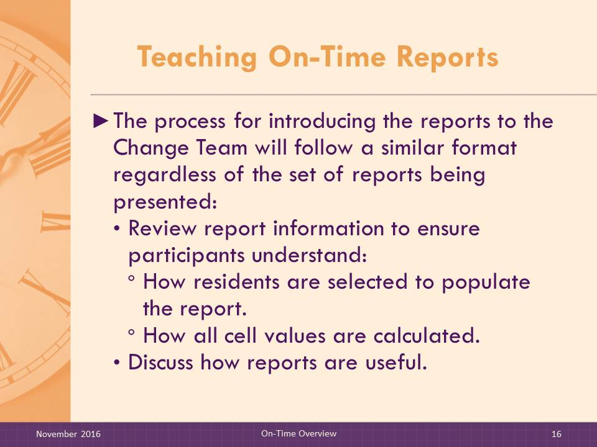
SAY:

Introducing the On-Time reports to nursing home staff will follow a similar process regardless of which reports you are teaching. When teaching a report, review the report information with trainees so they understand which documentation is used to populate the report and how all cell values are calculated.
DO:

Provide a sample report from the Materials to use as an example.
SAY:

When discussing reports with the team:
- List the contents of the reports, explain the rules that determine which residents are included in the report, provide the report element definitions and sources of data, and answer questions that arise.
- Engage the team in a discussion of how they could obtain the information on the report without the report. The discussion should highlight the difficulties and time burden that would be required, using some of the questions below:
- Is the information displayed on the On-Time reports currently available to you? If so, where would you find it? How current would the information be?
- How do you pick up on subtle changes in residents’ risk status? Do you rely on verbal reports from nurses’ aides? How is this information shared with the care team?

Slide 17: Facilitator Role: Checking the Accuracy of On-Time Reports
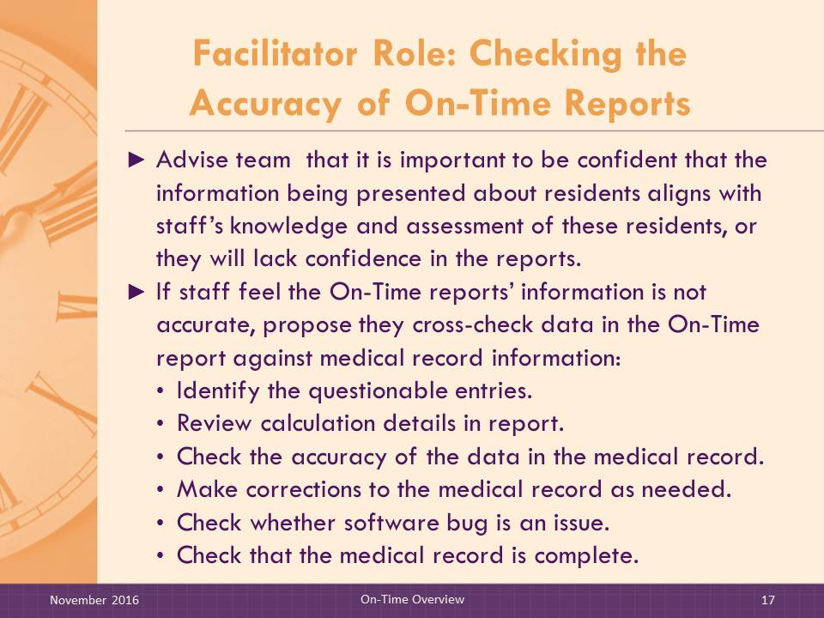
SAY:

Nursing home staff implementing On-Time need to verify the accuracy of the reports. When reports are generated, staff will want to make sure that the information being presented on the residents agrees with their knowledge and assessment of these residents. If staff members lack confidence in the reports, it will limit their use of the reports.
If staff report that they believe the information on the On-Time reports is not accurate (e.g., residents appear on the reports who should not be there, residents are missing from reports, residents are less functional than report suggests, or information is illogical), the Facilitator should help the team arrive at an approach for checking accuracy. If a new problem arises, check if it is due to any software update.
The following steps represent one approach. The team may have other suggestions.
- Cross-check data in the On-Time report against medical record information.
- Identify the questionable report variables.
- Review the calculation details for the questionable variables. Check the accuracy of the data in the medical record contributing to the report variables.
- Make corrections to the medical record as needed and rerun the report.
- If inaccuracies persist after the medical record is accurate, a software bug may be the issue. In this case, the facility should confer with their EMR vendor.
  - Check that EMR data are complete. Report elements will not generate unless at least 75 percent of the necessary documentation is available. Most EMR programs can run reports to show documentation completeness. Reports will vary based on EMR vendors but should help in identifying particular units or shifts where staff may need additional education or retraining, or individual employees who may need additional education or retraining.

Slide 18: Implementation Materials
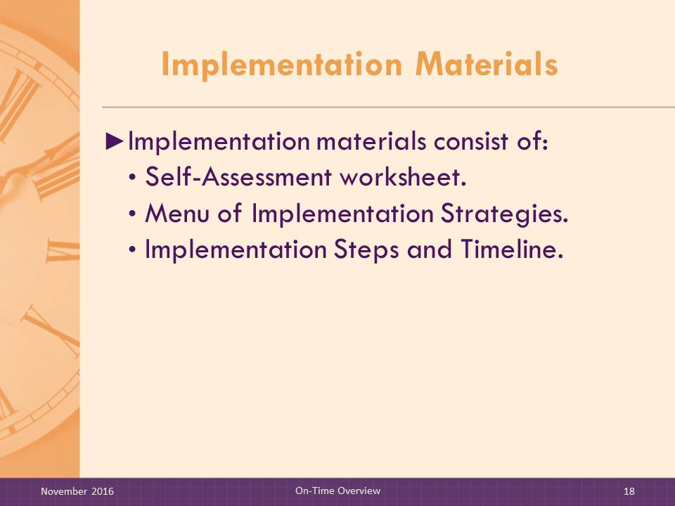
SAY:

Implementation materials consist of:
- Self-Assessment Worksheet.
- Menu of Implementation Strategies.
- Implementation Steps and Timeline.
The purpose of using these materials is to help the nursing home change team integrate the reports that they choose into day-to-day practice and to encourage multidisciplinary input into clinical decisionmaking to help prevent adverse events.

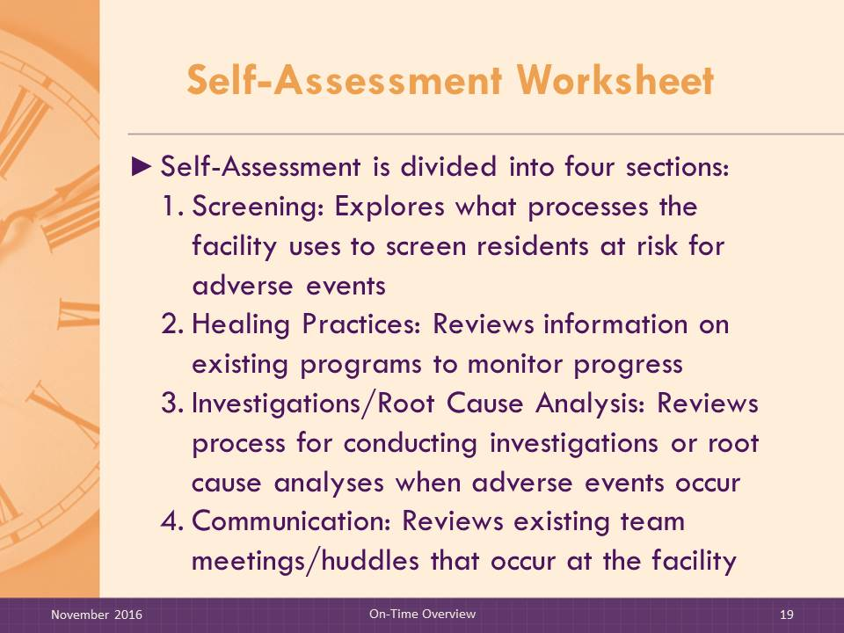
Slide 19: Self-Assessment Worksheet
SAY:

The Self-Assessment is divided into four sections:
- Screening. These questions explore how the facility screens for risk of an adverse event (e.g., risk for delayed pressure ulcer healing). Questions seek details on the facility’s risk assessment approach and what, if any, type of standardized assessment tool they use, how frequently the assessment is completed, and by whom.
- Healing Practices. This group of questions seeks information on what is included in their various healing programs. For example, does their pressure ulcer healing program include guidance on nutritional interventions and treatment protocols?
- Investigations/Root Cause Analysis. This section asks the facility to describe their process for conducting investigations or root cause analyses when pressure ulcer healing is delayed.
- Communication. This section asks what types of prevention care planning is discussed at staff meetings. It also asks which staff members are invited, who leads the meeting, and how often it occurs. Also included in this section are questions on what types of training have been offered.
DO:

Provide a copy of the Pressure Ulcer Healing Self-Assessment for participants to follow along as you describe the sections and questions.
MATERIALS:
- Pressure Ulcer Healing Self-Assessment

Slide 20: Self-Assessment Worksheet (cont.)
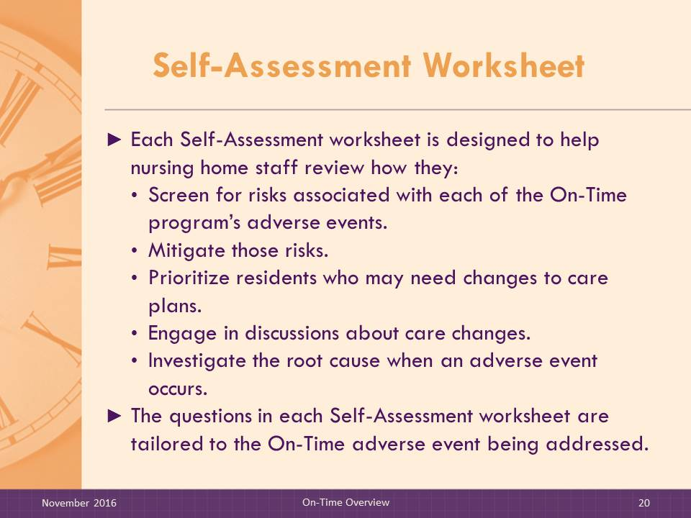
SAY:

The Self-Assessment worksheet is designed to help nursing home staff review how they:
- Screen for risks;
- Mitigate risk;
- Prioritize residents who may need changes to care plans;
- Discuss care changes that are needed; and
- Investigate root causes when an adverse event occurs.
The questions in each Self-Assessment are tailored to the On-Time adverse event being addressed.

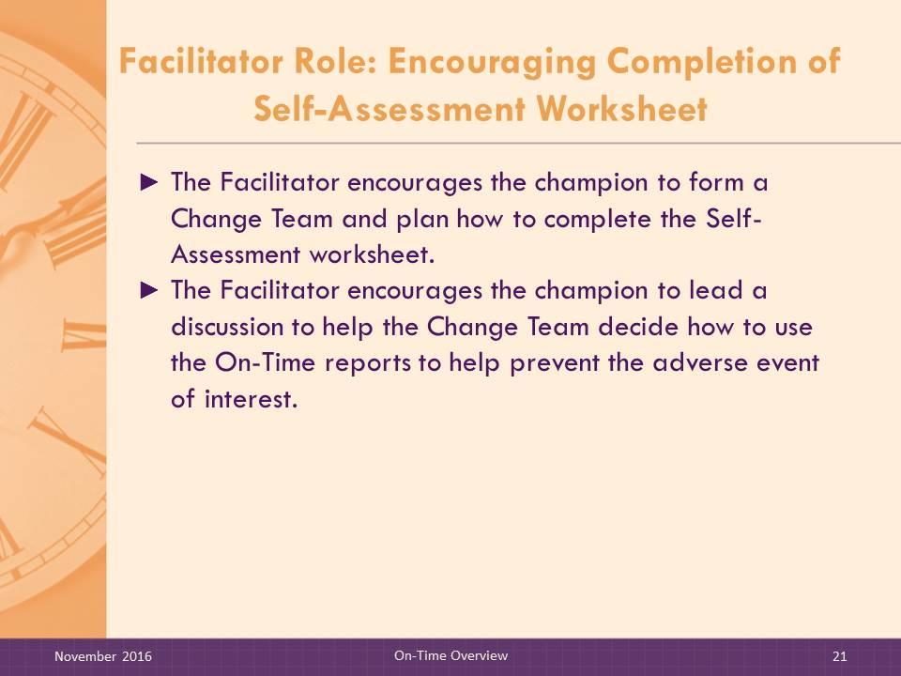
Slide 21: Facilitator Role: Encouraging Completion of Self-Assessment Worksheet
SAY:

The Facilitator encourages the team to complete the Self-Assessment Worksheet. The Facilitator reviews the completed Self-Assessment to help the team identify which On-Time reports to use.
The goal is to focus on prevention improvement. The ultimate purpose is to identify specific ways the electronic reports can help the team:
- Identify opportunities to improve risk identification.
- Communicate risk changes as they occur.
- Improve the way residents are prioritized for possible treatment changes.
- Improve the process for recommending new interventions.
- Improve root cause analyses when adverse events occur.
The communication section of the Self-Assessment identifies current meetings and huddles that focus on prevention of the adverse event of interest. The identification of existing meetings provides a basis for determining ways to integrate reports into existing processes.
The process for facilitating the completion of the Self-Assessment and discussion with the change team of its findings is the same regardless of which set of reports is being implemented. Discussion questions are tailored to the On-Time adverse event being addressed.
Steps for ensuring completion of the Self-Assessment Worksheet are:
- The Facilitator encourages the champion to form a change team and plan how to fill out the Self-Assessment Worksheet.
- The Facilitator encourages the champion to lead a discussion of the completed Self-Assessment Worksheet to help the change team decide how to use the On-Time reports to help prevent the adverse event of interest.
- If needed, the Facilitator may be included in that discussion to help suggest ways the reports can be integrated into their workflow.

Slide 22: Menu of Implementation Strategies
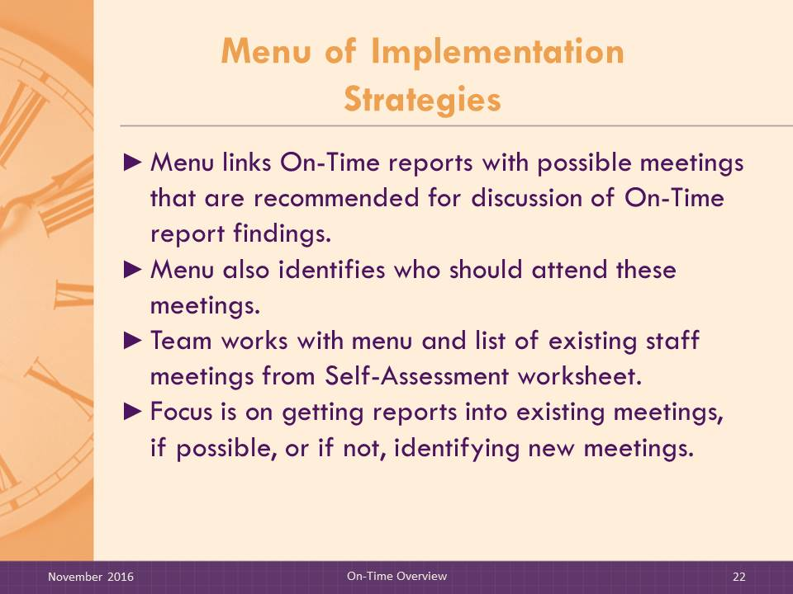
SAY:

The menu is a list of various types of meetings and interdisciplinary huddles that nursing home staff are asked to consider as options for incorporating the risk reports into their daily workflow. Some of the suggested meetings may already occur at the nursing home but may need to be restructured to incorporate the reports into resident care discussions.
For each meeting listed, the team can decide if an existing meeting would be enhanced if it included a discussion of a particular risk report, or if a new meeting is needed. The team may also opt to add meetings that are not listed on the worksheet. The menu also identifies recommended staff who should attend these meetings.
The menu includes meetings directly related to the adverse event of interest, but additional uses of these reports are included that may help in more general ways to improve preventive practices by focusing on a particular risk factor.
The menu is intended to be used with the list of existing meetings from the Self-Assessment Worksheet. Offering a menu of possible implementation strategies allows the change team to consider which strategies best fit within their workflow and meet the unique needs of their facility, avoiding a “one size fits all” approach.
DO:

Review an example of the Menu of Implementation Strategies for Pressure Ulcer Healing. Point out how the menu is organized (by report) with options listed for types of meetings where the report could be used and who should attend. Two columns provide space for users to check which meetings already exist and which have to be created.
MATERIALS:
- Menu of Implementation Strategies

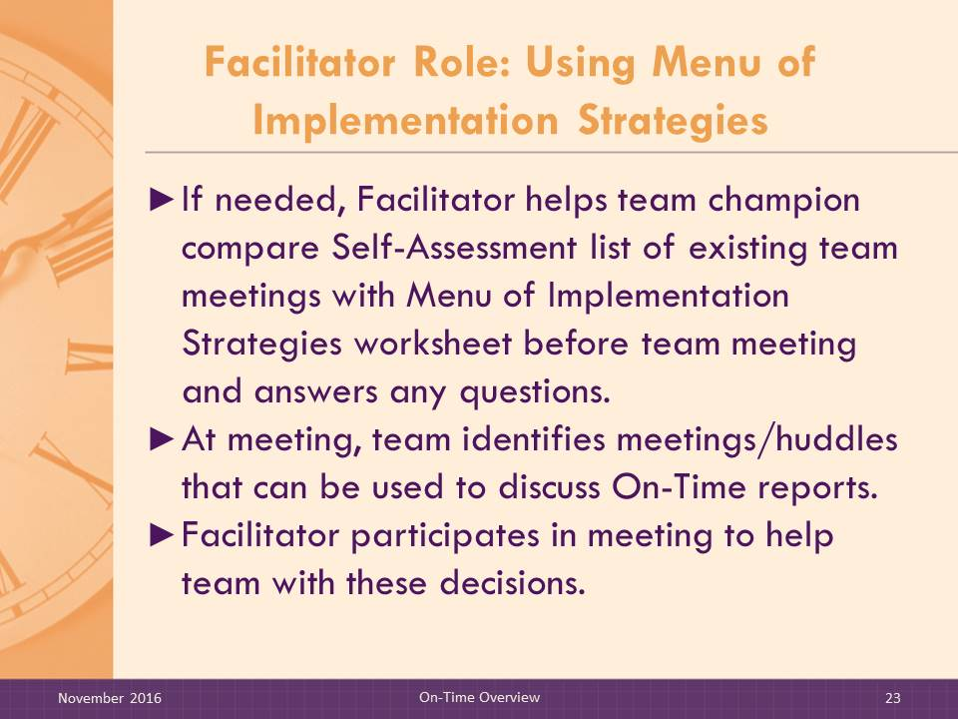
Slide 23: Facilitator Role: Using Menu of Implementation Strategies
SAY:

The role of the Facilitator is to help the change team use the Menu of Implementation Strategies and the list of existing meetings from the Self-Assessment Worksheet to choose which On-Time reports they want to use at which meetings.
The process for reviewing the list of meetings on the Menu is the same regardless of which reports are being implemented:
- Facilitator helps champion review the Self-Assessment list of existing team meetings and the Menu of Implementation Strategies, if needed.
- At a change team meeting, Facilitator helps change team use these tools to select team meetings or huddles and On-Time reports they want to discuss in these meetings. The Facilitator’s role is to help the team make decisions, answer questions, and describe how the reports can be used.
MATERIALS:
- Menu of Implementation Strategies

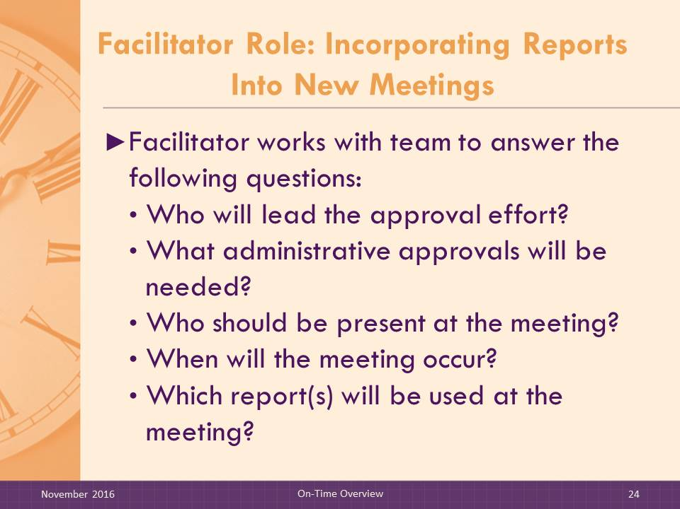
Slides 24 and 25: Facilitator Role: Incorporating Reports Into New Meetings
SAY:

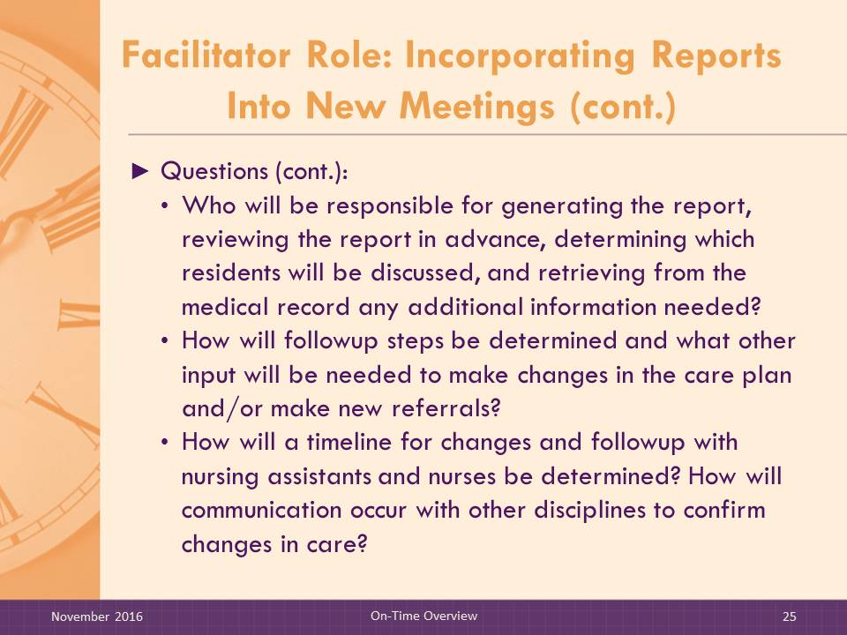
Once the team has chosen which reports are going to be used and the meetings or huddles that will be involved, the Facilitator’s role will be to help the change team consider their options for incorporating the On-Time reports into an existing meeting or creating a new meeting.
When the change team is thinking about adding a meeting, the Facilitator will use the following questions to help the team review all the relevant issues.
- Who would lead the approval effort?
- What administrative approvals would be needed?
- Who should be present at the meeting (remember that the On-Time reports are meant to be used by multiple disciplines)? Would two meetings using the same reports be more efficient if multiple disciplines should be present and scheduling to include everyone is difficult?
- When would the meeting occur? Include nurse aide input to select the meeting time that is least disruptive to their daily routine since they may have the least flexibility.
- Which reports will be used at the meeting?
- Who will be responsible for generating the report, reviewing the report in advance, determining which residents will be discussed at the meeting, and retrieving from the medical record any additional information needed? How will followup steps be determined and what other input will be needed to make changes in the care plan and/or new referrals?
- How will a timeline for changes and followup with CNAs and nurses be determined? How will communication occur with other disciplines to confirm changes in care?

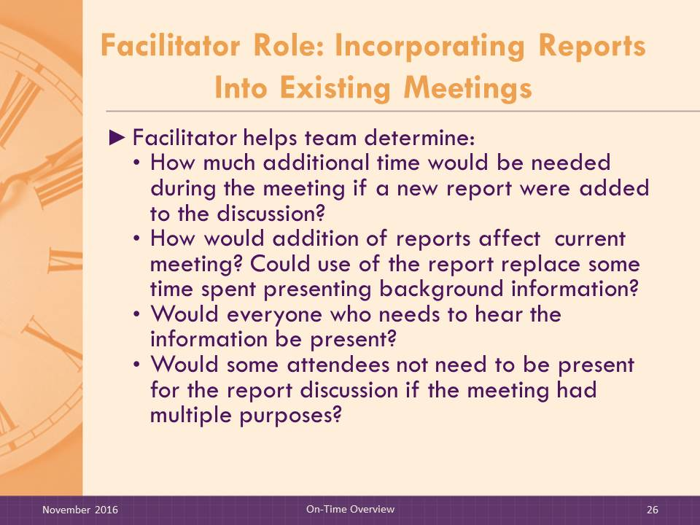
Slide 26: Facilitator Role: Incorporating Reports Into Existing Meetings
SAY:

When working with a change team that is considering using an existing meeting, work with the change team to consider the following:
- How much time would need to be added to the meeting if a new report were added for discussion?
- How is the meeting structured? Could the new report discussion replace some of the time spent previously? Keep in mind, the goal is to minimize disruptions in how staff members share information about residents when adding reports to existing meeting discussions.
- Would everyone who needs to hear the information be present?
- Would some of the current attendees not need to be present for the report discussions if the meeting had multiple purposes?

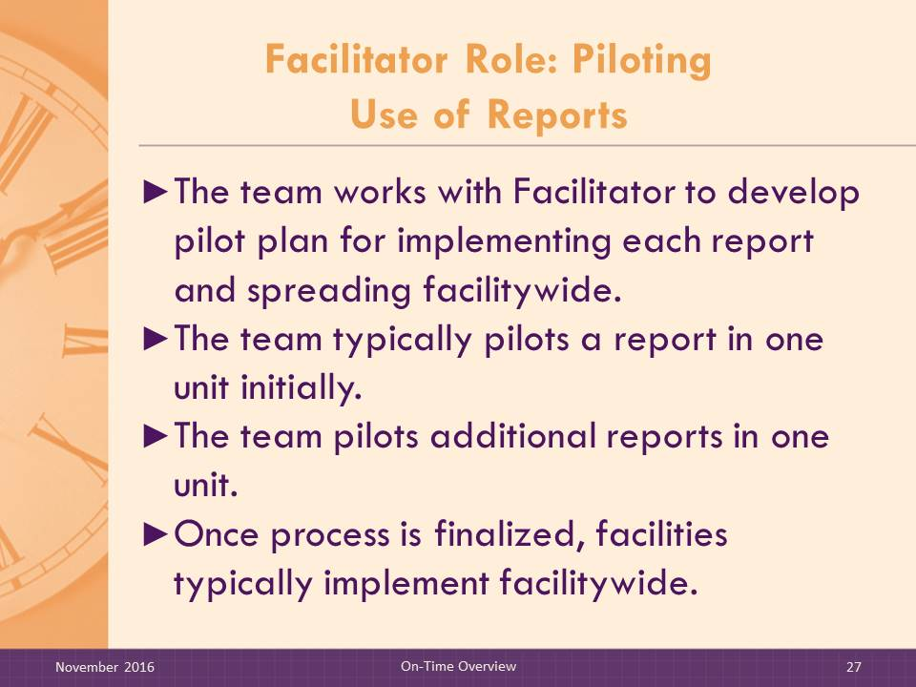
Slide 27: Facilitator Role: Piloting Use of Reports
SAY:

The change team may have preferences for how they pilot the reports. Experience suggests that:
- Typically facilities pilot one report in one unit to make the report review process as focused and short as possible.
- The team then pilots additional reports in one unit.
- Once the implementation of all reports in one unit is finalized, facilities typically implement facilitywide.

Slide 28: Implementation Steps and Timeline
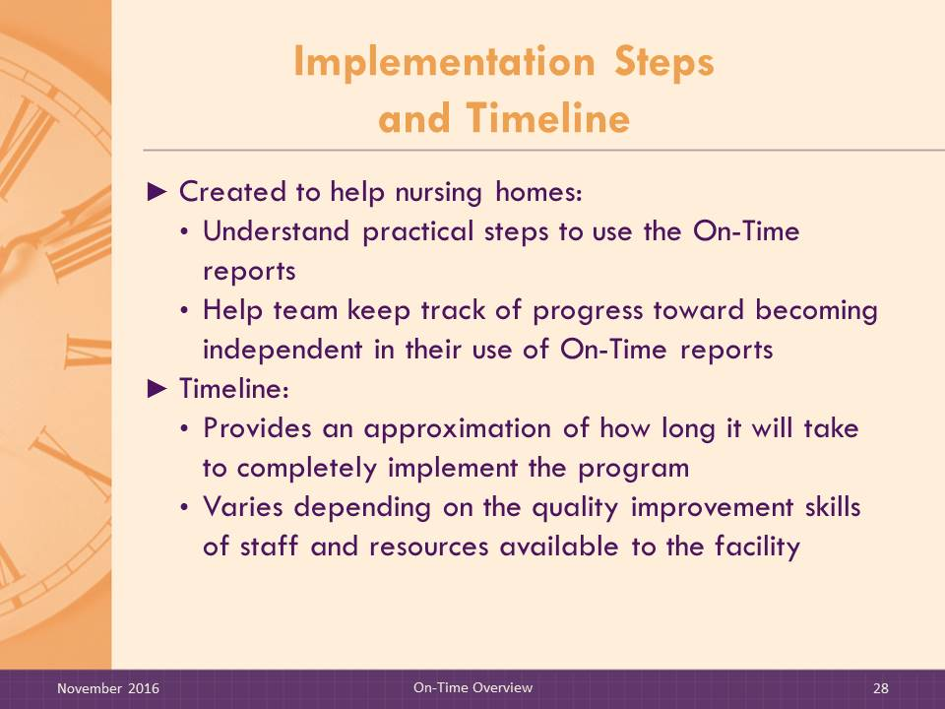
SAY:

The goal of the On-Time implementation strategy is to incorporate the On-Time reports into day-to-day prevention activities and to ensure that multidisciplinary input is included in clinical intervention decisions.
The Implementation Steps were created to help nursing homes understand the practical steps that need to be completed to independently use the On-Time reports, as well as the likely timeline to make the reports part of daily practice. It is intended to be used by the team champion and the change team members to help keep the effort on track and methodical.
The timeline is meant as a guide because quality improvement project timelines often vary depending on the quality improvement skills and resources available to the participating facilities.
DO:

Use Generic Implementation Steps and Timeline handout.
Review Steps and discuss role of Facilitator.
MATERIALS:
- Implementation Steps and Timeline

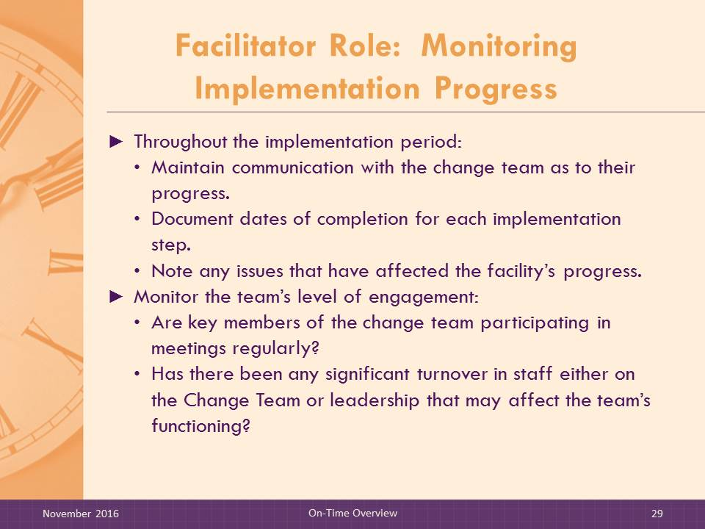
Slides 29 and 30: Facilitator Role: Monitoring Implementation Progress
SAY:

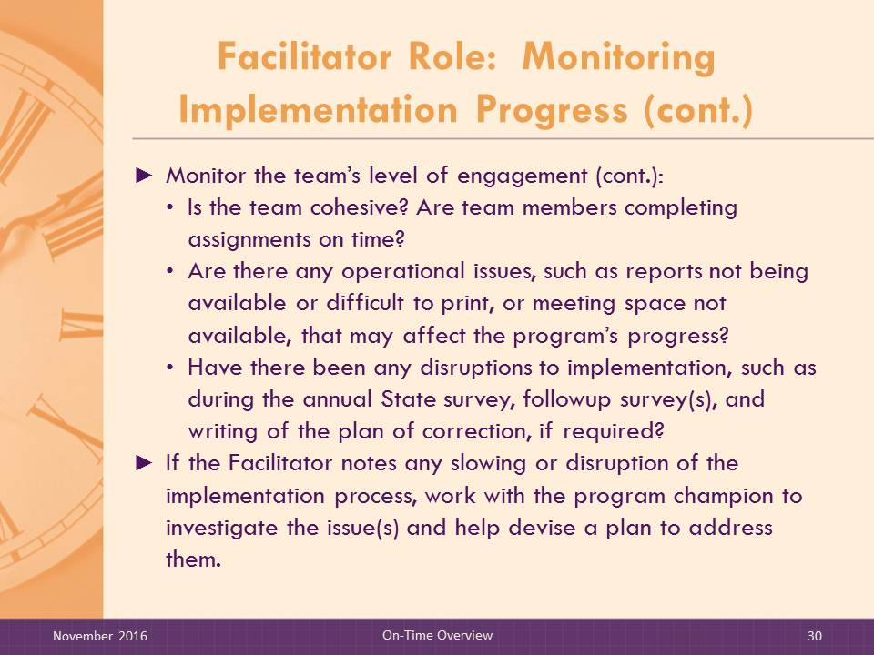
As a Facilitator, you will monitor the progress of the implementation process. Throughout the implementation period, the Facilitator will communicate with each change team as to their progress through the various implementation steps. The Facilitator is expected to document dates of completion for each step and to note any issues that have affected the facility’s progress.
Equally important will be the Facilitator’s monitoring of the team’s level of engagement. The Facilitator should continuously consider the following questions:
- Are key members of the change team participating in meetings on a regular basis? If not, determine who is missing and why.
- Has there been any significant turnover in staff either on the change team or leadership that may affect the functioning of the team? If so, the Facilitator may need to engage the nurse educator and the champion to establish a process for educating these new staff members to orient them to their role in relation to this project.
- Is the team cohesive? Are team members completing assignments on time? Do any barriers need to be addressed?
- Are there any operational issues, such as reports not available or difficult to print, or meeting space not available, that may be affecting the program’s progress?
- Have there been any major disruptions to implementation that may affect the continuity of the program? For example, staff may be involved with the annual State survey, followup surveys, or writing of the plan of correction, if required. These issues will likely take precedence over program implementation. The team may need some support and guidance to re-engage and get back on track.
If the Facilitator notes any slowing or disruption of the implementation process, the Facilitator will work with the program champion to investigate the issues and help him or her devise a plan to address them.

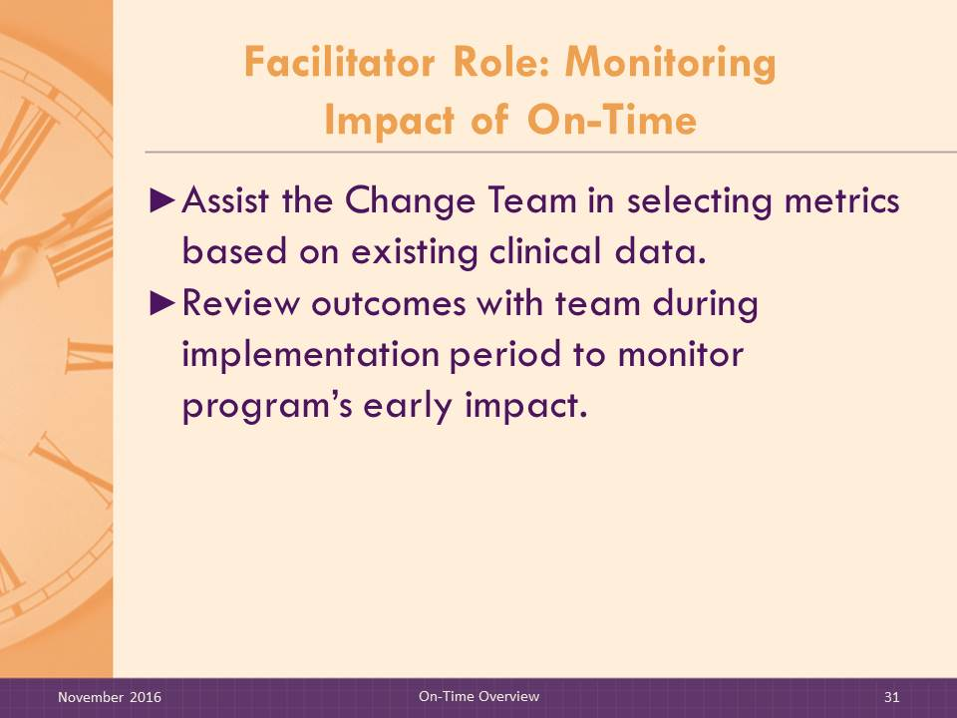
Slide 31: Facilitator Role: Monitoring Impact of On-Time
SAY:

Monitoring the impact of On-Time will be of interest to the change team and to facility management. Your role as Facilitator will be to assist the change team in selecting an outcome metric based on existing clinical data they collect. If the vendor already has programmed one of the aggregate reports, such as the Pressure Ulcer Counts Report in Pressure Ulcer Healing, the facility will be able to identify unit changes in in-house acquired pressure ulcers on a monthly basis for each unit and for the nursing home as a whole.
Alternatively, the nursing home can track in-house acquired pressure ulcers manually, if this is not possible from the EMR. Month-to-month rates may fluctuate but a trend over 6 months or longer would suggest an impact. The CMS quality measures, reported on Nursing Home Compare, may also be used to monitor outcome trends, but these measures are reported less frequently.
The Facilitator should work with the champion to identify the best approach for measuring program outcomes.

Slide 32: Check Your Understanding
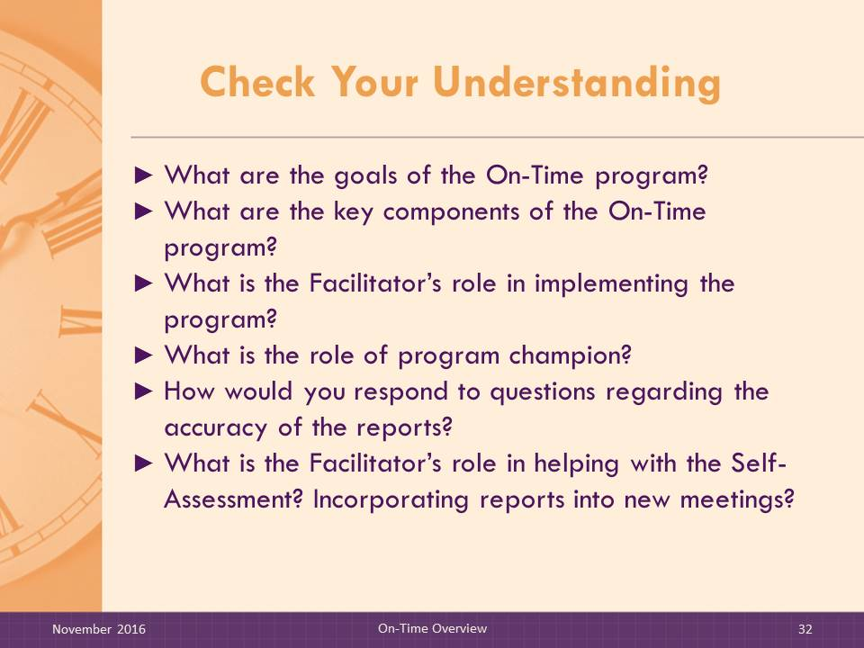
DO:

Select from the list below several questions to discuss with the group to verify their understanding of On-Time.
- What are the goals of On-Time?
- What are the key components of On-Time?
- List the Facilitator’s roles in implementing On-Time.
- What is the role of the program champion?
- How would you respond to questions regarding the accuracy of the reports?
- What is the Facilitator’s role in developing the piloting plan?
- What is the Facilitator’s role in prioritizing progress and impact of the program?
- How is the Menu of Implementation Strategies used in the implementation process?
- What is the Facilitator’s role in the Self-Assessment?

